Courtney Lee
Dr. Morris
Restaurant Review
29 April 2015

Healthy home-style cooking with an Asian twist
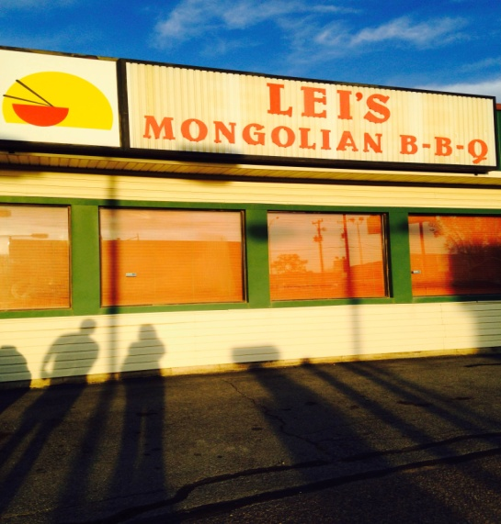
You may be thinking it is hard to choose which Asian restaurant in the Pocatello area is most worth your time, appetite, and money. With so many choices to choose from, finding Lei’s Mongolia BBQ in Chubbuck is like finding a hidden gem that not many people know about.
Lei’s Mongolia BBQ certainly provides a low-key atmosphere that makes you feel comfortable enough to eat as many endless bowls of Asian noodles as you can possibly fit into your stomach. It’s obvious the establishment has not been updated in years but the dated décor with old school booths and tables adds to the ambience of the traditional Asian cuisine that is offered.
Lei’s Mongolian BBQ opened its doors the summer of 1997. With a wide variety of traditional homemade Asian dishes, Mongolian BBQ offers spicy entrees, specialty dishes, and a one-time-through or an all-you-can-eat noodle buffet. Although the menu is small and the restaurant space is very simplistic, the environment is intriguing enough to catch your senses in a whirlwind and spark your curiosity.
The aroma of garlic and onion being stir fried with teriyaki and Mongolian BBQ sauce fills the air as you walk into the cozy restaurant. The style of stir fry originates from Chinese culture and represents traditional Asian cooking to a tee.
The only employee working at the time happened to be the owner herself. With three other tables full of hungry customers, Mary Lei had her hands full as she waitressed, cooked, and rang people up after they were finished eating.
In 1991, Mary came over to the United States from the city of Taishan in Southern China; it wasn’t until 1994 when her husband, Jack, was able to join her here in the states. Mary was thirty years old when she arrived in Pocatello and did not know a word of English at the time.
Because Mary did not know English, she first began working at her relatives the local restaurant Bamboo Garden. There she was able to gain experience in the restaurant business and was able to learn the English language.
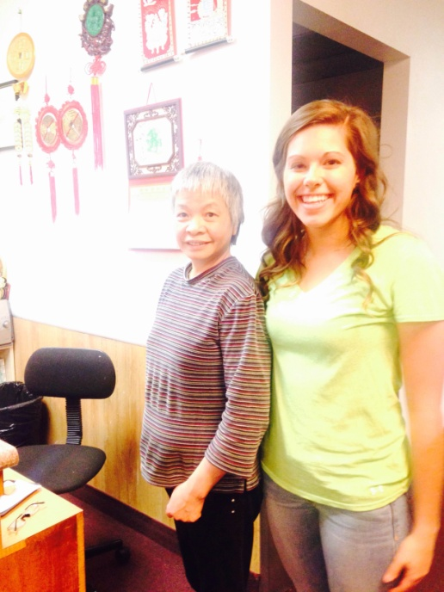
After working at Bamboo Garden for 6 years, Mary and Jack decided to open up their own Asian inspired restaurant. With a still obvious language barrier, Mary told me through her broken English that learning the language was one of the most difficult obstacles she had to face.
“Overcoming the language barrier from Chinese to English was a learning process,” Mary said.
After being in the United States for nearly twenty-four years, Mary and Jack are certainly prospering in the restaurant world and have launched a well-functioning establishment.
As a thriving college student, the obvious menu choice is the all-you-can-eat buffet ($9.99). However, there is also the option of one-time-through buffet or even the one-time-through to go buffet ($8.99) in case you are in a hurry or trying not to break the bank.
Once I had settled on the all-you-can-eat buffet, the food making was really up to me. In large refrigerated food containers was a variety of vegetable, noodle and meat options. Being able to make your own noodle dish gives you the opportunity to choose the flavors you want by combining your favorite veggies, meats, and sauces. Frozen crab, beef, pork and chicken were all options of meat to choose from as well as vegetables like carrots, zucchini, onions, water chestnuts, lettuce, green peppers, etc.
After loading my bowl with a melody of vegetables and meats, I headed to the numerous sauce options. When I asked another patron, who looked like a seasoned Mongolian BBQ customer and was also loading up his noodle bowl if he had any advice for me, he encouraged me to put on a multitude of every sauce that “sounded good!”
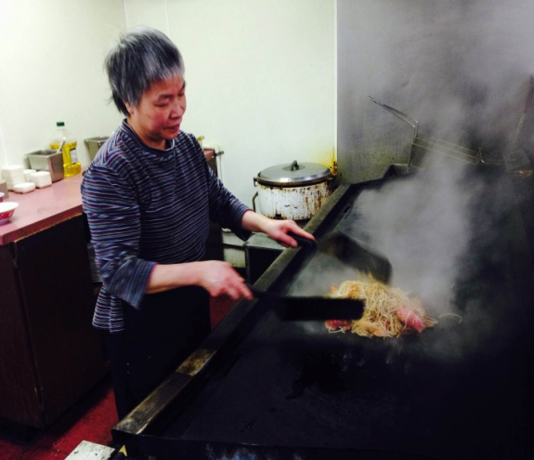
“No matter how much you put on or what kinds you choose, it’s going to taste good. I promise,” my fellow restaurant goer, Brendon said.
Once I finished creating my own noodle dish, Mary took my bowl and threw it on the fryer. It only took a few minutes for her to toss my noodles around and they were done.
With at least a dozen sauce options including sesame oil, garlic oil, house sauce, Mongolia sauce, noodle sauce, and many more that I had included in my bowl, I was nervous about the taste of my noodles.
To my surprise, they were delicious and perfectly flavored. The meat had been cook to perfection while the noodles and vegetables had soaked in all of the wonderful flavors the sauces had to offer. Alongside my noodle dish came a small bowl of fried rice, a bowl of egg drop soup, and a mini egg roll with dipping sauce.
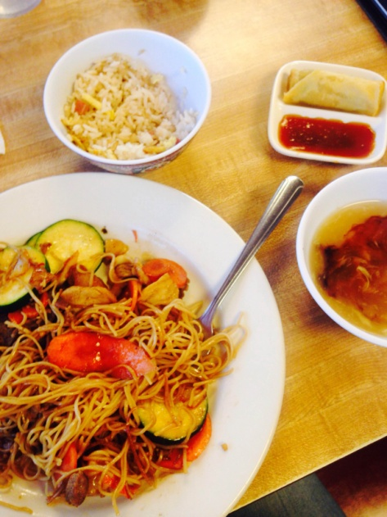
Overall, the experience moistened my taste buds and filled my stomach to its fullest. The food was satisfying and was definitely worth the $10. Although the place isn’t fancy or modern by any means, it is well worth your time, appetite, and money.
Mary started a restaurant of her own because she wanted to give customers the option of healthy home-style Asian cooking so that’s what she did.
“The food here looks like the food you have at home,” Mary said.

