DNEM EMB WCMS Content Managers Pilot Training

Questionnaire

1. Which describes your role(s) and skillset? Select all that apply. [Check all that apply]

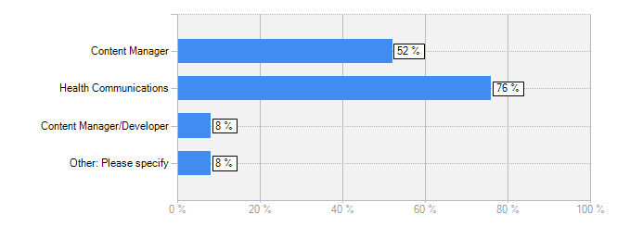

Answer | Count | Percent
Content Manager | 13 | 52%
Health Communications | 19 | 76%
Content Manager/Developer | 2 | 8%
Other: Please specify | 2 | 8%
answered question | 25
skipped question | 0

Other: Please specify
Different tasks
Team lead

2. How proficient are you with the following? Select all that apply. [Check all that apply]

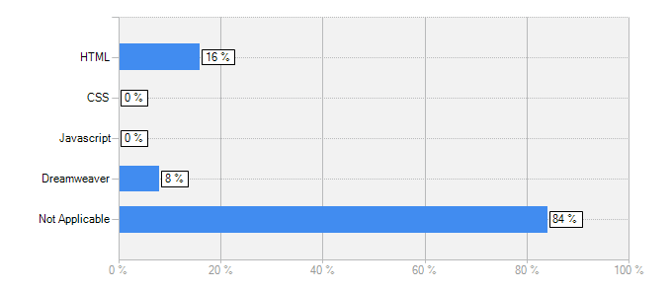

Answer | Count | Percent
HTML | 4 | 16%
CSS | 0 | 0%
Javascript | 0 | 0%
Dreamweaver | 2 | 8%
Not Applicable | 21 | 84%
answered question | 25
skipped question | 0

3. Which web activities do you perform, on your current site? Check all that apply.

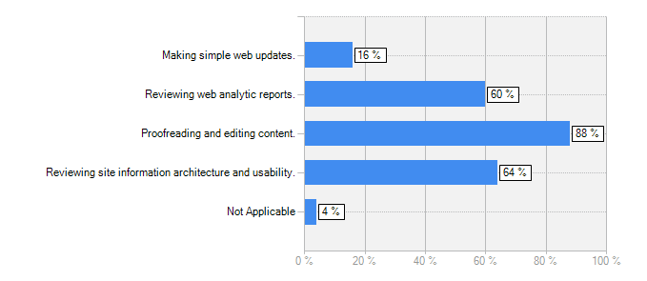

Answer | Count | Percent
Making simple web updates. | 4 | 16%
Reviewing web analytic reports. | 15 | 60%
Proofreading and editing content. | 22 | 88%
Reviewing site information architecture and usability. | 16 | 64%
Not Applicable | 1 | 4%
answered question | 25
skipped question | 0

4. On average, how much time do you spend on web activities per WEEK?

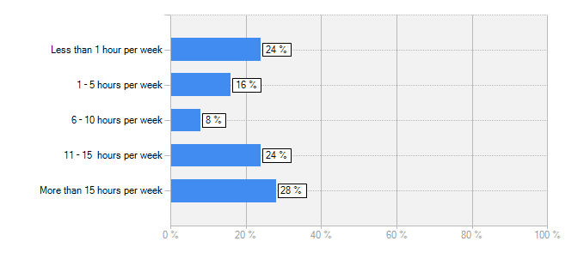

Answer | Count | Percent
Less than 1 hour per week | 6 | 24%
1 – 5 hours per week | 4 | 16%
6 – 10 hours per week | 2 | 8%
11 – 15 hours per week | 6 | 24%
More than 15 hours per week | 7 | 28%
answered question | 25
skipped question | 0

5. Please rate your agreement with the following statement about WCMS training:

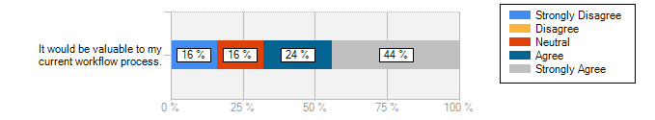
Answer | Strongly Disagree | Disagree | Neutral | Agree | Strongly Agree | Total
It would be valuable to my current workflow process. | 16% (4) | 0% (0) | 16% (4) | 24% (6) | 44% (11) | 25
answered question |  |  |  |  |  | 25
skipped question |  |  |  |  |  | 0

6. Please rate the importance of the following Percussion WCMS features. How important would the feature be to you?

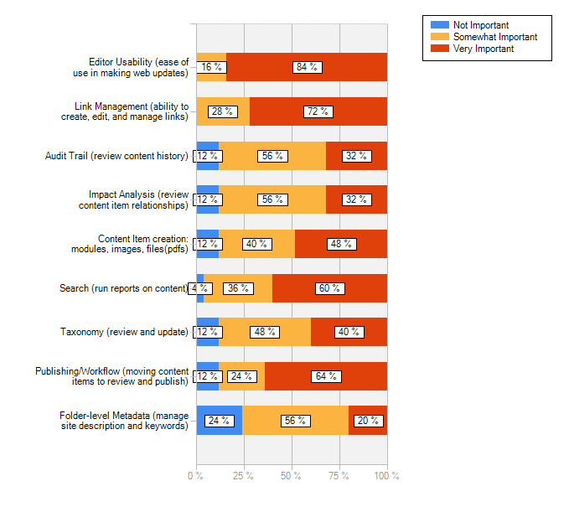
Answer | Not Important | Somewhat Important | Very Important | Total
Editor Usability (ease of use in making web updates) | 0% (0) | 16% (4) | 84% (21) | 25
Link Management (ability to create, edit, and manage links) | 0% (0) | 28% (7) | 72% (18) | 25
Audit Trail (review content history) | 12% (3) | 56% (14) | 32% (8) | 25
Impact Analysis (review content item relationships) | 12% (3) | 56% (14) | 32% (8) | 25
Content Item creation: modules, images, files(pdfs) | 12% (3) | 40% (10) | 48% (12) | 25
Search (run reports on content) | 4% (1) | 36% (9) | 60% (15) | 25
Taxonomy (review and update) | 12% (3) | 48% (12) | 40% (10) | 25
Publishing/Workflow (moving content items to review and publish) | 12% (3) | 24% (6) | 64% (16) | 25
Folder-level Metadata (manage site description and keywords) | 24% (6) | 56% (14) | 20% (5) | 25
answered question |  |  |  | 25
skipped question |  |  |  | 0

7. Do you have any additional comments about the WCMS pilot training? [Non-Mandatory]

Answer
This training will be critical for me to support my division. I look forward to learning foundational skills.
no
I have no idea what many of the terms on the previous question meant. So if this is really for health communicators I think you will have to take the assumed knowledge down another notch.
This training is really very important to me because it will increase my efficiency and will assist me to ease the tasks required to publish web content to web sites.
Looking forward to the training and learning more about how we will benefit from WCMS.
I took the training and it definitley needs to be re-designed for content developers and content managers. It was fine as an over-view, somewhat intimidating but it did provide me with the background to understand the basic concepts. I would not be able to remember or preform any editing -way too much was thrown at me all at once. Most of it I’ll never be doing such, as changing menu’s, creating slides shows etc. This technology is complex enough that whoever is creating or even updating pages will have to do it regularly, to maintain the skills. There will have to be regular (help) support even for the programmers. I felt like the course was designed for developers and by developers. I have more of technical background than most writers editors and web/content managers but I definitely feel it needs to be redesigned by instructional designers for the non-programming folks. Thanks for all your efforts to move this technology forward.
based on the questions, it seems "management" types would need something very different than the actual programmers. I am interested in dynamic content and mobile-friendly/cross-platform capabilities.
No
answered question | 9
skipped question | 16

