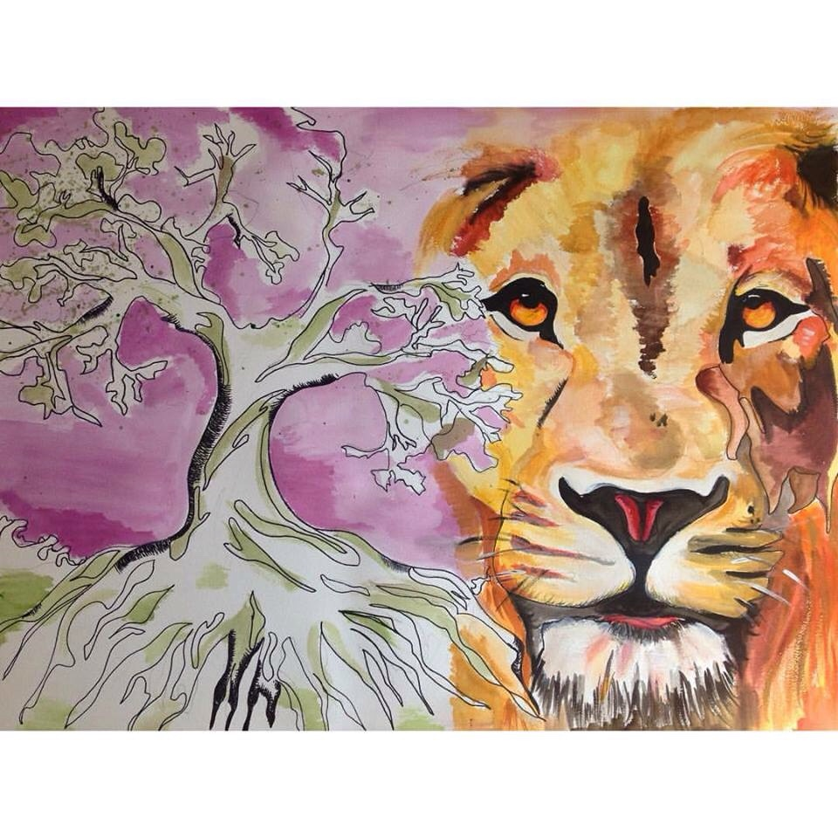
LaFonte, Cassandra R. (October 2015), Calm in the Wild. Artist Statement: I wanted to portray the calmness in two contrasting elements of the wild—ominous vs aggressive life. The eyes are sophistically painted in a way to welcome the viewer instead of creating the notion of fear while the tree of life extends the olive branch of serenity. I incorporated sharpie and watercolor to contrast different mediums in addition to a complementary color scheme.”

