Brief Analysis of the Energy Industry

LeAndre Prince
BADM 230: Advanced Communication Skills
Professor Rodney Reynolds

A Brief History
The Energy Industry is the totality of the industries involved in the production and sale of energy, including extraction, manufacturing, refining and distribution. Current day society consumes large amounts of fuel, and the energy industry is a crucial part of the infrastructure and maintenance of society in the majority of countries. By the late 1800s, a new form of fuel was catching on: petroleum. For years it had been a nuisance, contaminating wells for drinking water. Initially sold by hucksters as medicine, oil became a valuable commodity for lighting as the whale oil industry declined. By the turn of the century, oil, processed into gasoline, was firing internal combustion engines. With the low-cost automobile and the spread of electricity, our society's energy use changed forever. Power plants became larger and larger, until we had massive coal plants and hydroelectric dams. Power lines extended hundreds of miles between cities, bringing electricity to rural areas during the Great Depression. The cheap car made suburbs possible, which in turn made cheap cars necessary, feeding the cycle of suburban sprawl. Energy use grew quickly, doubling every 10 years. The cost of energy production was declining steadily, and the efficient use of energy was simply not a concern. After World War II unleashed nuclear power, the government looked for a home for "the peaceful atom." They found it in electricity production. Over 200 nuclear power plants were planned across the country, and homes were built with all-electric heating systems to take advantage of this power that would be "too cheap to meter." Gasoline use grew unchecked as well. Cars grew larger and heavier throughout the 1950s and 1960s. By 1970, the average mileage of an American car was only 13.5 miles per gallon, and a gallon of gas cost less than a quarter.

Industrial Growth
Renewable energy markets surged in the United States in the first half of this year despite uncertainty over federal tax credits and a sluggish national economy, according to mid-year figures.
Wind, solar, and geothermal energy are all on the rise. At least 17,000 megawatts (MW) of these three energy sources are now under construction. According to the Energy Information Administration, renewable energy will account for about one-third of new electricity generation added to the U.S. grid over the next three years.
Wind energy is leading the way with 19,500 MW of installed capacity at mid-year, including more than 1,000 MW added in the last six months. The American Wind Energy Association (AWEA) second-quarter report [PDF] predicts that total additions for the year will come to 7,500 MW, boosting U.S. wind capacity by 45 percent. In Texas alone, more than 4,200 MW of wind capacity has been installed this year or is currently under construction. Iowa is in second place with 1,770 MW.
Geothermal energy is expanding as well, although at a slower rate. Nearly 3,000 MW is currently on-line and about 4,000 MW is under development, the U.S. Geothermal Energy Association said in its August report [PDF]. Nevada is the hotbed for U.S. geothermal, with as much as 1,900 MW in different phases of development. At a government auction last week, a record $28.2 million of leases was sold for geothermal energy exploration, which suggests that additional projects may soon begin.
While U.S. solar energy data for 2008 are not yet available, last year's Solar Energy Industries Association report [PDF]said demand for photovoltaic (PV) panels, concentrated solar plants, and solar water heaters continues to expand. An additional 150 MW of PV panels were installed last year, 45 percent more than in 2006. Less than 500 MW of concentrated solar power - utility-scale solar plants that use mirrors to produce heat for power generation - is operational, but another 4,000 MW is in the works.
The accelerated growth of renewable energy projects is a response to the powerful combination of high energy prices and growing state government support. In addition, fears that Congress will not renew the federal tax credits before they expire at the end of this year have led developers to rush to connect their projects to the grid by December 31. The tax credits are crucial for renewables industries to remain competitive with the fossil fuel industries that receive regular government support.

Government Regulations

Energy Policy and Conservation Act of 1975
Modern energy regulation is characterized by a cautious but optimistic approach to deregulated markets and an interest in long-term development of low-cost energy sources, especially from a diversified resource base. The history of modern energy policy begins with the Energy Policy and Conservation Act of 1975, which, not coincidentally, was a response to an oil price spike after an OPEC embargo in 1973-4. The Act not only created the Strategic Petroleum Reserve to counter severe disruptions in the nation's oil supply, but also introduced for the first time Corporate Average Fuel Economy (CAFE) standards for automobile manufacturers, requiring that average fuel economy of vehicles sold by auto manufacturers in the U.S. achieve double in fuel efficiency (to 27.5 mpg) from 1974 to 1985.
Why you should care: The CAFE standards have set the baseline for all future discussions of automobile emissions standards, and continue to be hotly debated by the auto industry. Increasing fuel economy remains one of the low-hanging fruit for mitigating CO2 emissions as well. The Strategic Petroleum Reserve has become the "hot potato" issue, reawakened by every President when oil prices spike as a method to offer reassurance to consumers suffering from high gasoline prices.

Clean Air Act (and subsequent revisions)
In a 1990 revision to the Clean Air Act, the government instituted a cap on sulfur emissions, and a cap-and-trade system to effect this cap, in order to reduce acid rain and other environmental hazards. This system has actually worked well, and in fact helped pioneer the emissions trading systems that are developing today for CO2.
The Clean Air Act (and its revisions) also laid out detailed standards for oxygen content, benzene, and sulfur content of gasoline products. Largely left to states and municipalities to implement, these standards have created a patchwork of legislative hoops for refiners and gasoline marketers to jump through in order to make sure they are refining and delivering locally appropriate finished gasoline products. While environment standards for gasoline have increased, the end result, in addition to depressing refining margins, has been to decrease the flexibility of the American refinery network and its ability to respond to sudden demand shocks, as finished product is often not transferable from one area of the country to the other.
Why you should care: If you're considering investing in oil refineries, understanding the local market for their products is critical, as well as the future path of legislation on air quality.

Energy Policy Act of 1992
The Energy Policy Act of 1992 introduced one of the key drivers of the renewable energy industry to-date, the Production Tax Credit (PTC), which offers to power independent power producers a subsidy of roughly 1.5 cents per kwh generated from renewable sources for a period of 10 years from the beginning of power generation. Considering that the cost to generate electricity from coal can be as low as 1.5-2 cents per kwh, this represents a hefty subsidy, and at the time, it spurred significant investment in renewables, especially in wind energy, the most commercially viable form of renewable energy at the time. Ironically, the PTC has a built-in sunset clause which requires it be renewed every few years by Congress. The result has been a boom and bust of investment in wind projects in particular, depending on whether the PTC is due to expire.
Why you should care: The PTC determines the financial feasibility of many renewable energy projects, but especially on-grid renewable projects such as wind and solar. PTC was also beefed up in the most recent Energy Policy Act of 2005. Moreover, the investment cycle in PTC-eligible projects has a large impact on suppliers and project owners.

Federal Energy Regulatory Commission
An independent regulatory agency within the Department of Energy, the Federal Energy Regulatory Commission (FERC) is perhaps the leading regulatory body in determining the impact of energy on the average consumer of energy. FERC has jurisdiction over electricity pricing, licensing for hydroelectric plants and liquid natural gas (LNG) terminals, and oil pipeline transport rates. Part rate administrator, part licensing body, FERC is perhaps most infamous for its lack of oversight of market manipulation of energy prices by Enron. Going forward, however, FERC will continue to play a large role in determining the extent of utility deregulation, as well as oversight of major natural gas, hydropower, and LNG projects.
Why you should care: Investors trying to identify attractive electric utilities need to parse through the cobweb of local regulations to understand who has pricing authority and which aspects of the business are subject to a regulated Return on Investment (ROI) and which are unregulated. As energy demand grows, those with more pricing power, and reduced regulation, will be more likely to benefit. FERC has also recently finalized rules to enable interstate natural gas storage facilities, a first step towards deregulating natural gas storage markets, which have caused problems in times of short supply in the past and may present investment opportunities in the natural gas storage sector.

Energy Policy Act of 2005
What to make of a law that does everything from extending Daylight Savings Time to authorizing $50 million in grants for biomass energy projects to changing the depreciation allowances for natural gas distribution lines? First, it signals that Congress has woken up to the possibility that higher oil prices are here to stay and therefore, something needs to be done about the long-run cost of energy in the U.S. Second, it speaks to Congress' preference for subsidies over belt-tightening (which is more palatable to voters, a subsidy for fuel cell development or stricter CAFE standards). Third, Congress' catch-all approach to energy policy suggests that we don't really know where future energy supplies are going to come from, so we need to hedge our bets, sprinkling subsidies as a venture capitalist sprinkles investments, and hoping that several hit it big and help solve the energy crisis.

Market Share

Oil & Gas
1.35 % | 22.48 % | 4.20tn | 6 | 2,176
TODAY'S CHANGE | 1 YEAR CHANGE | MARKET CAP IN USD | INDUSTRIES | COMPANIES
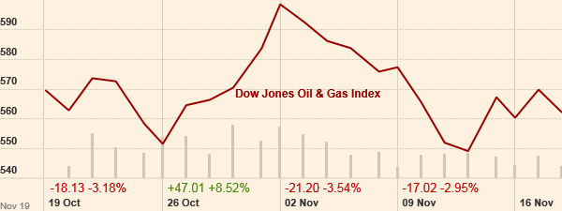

Industries
Industry | Today's  change | 1 year change | Market cap  in USD | Low52-weekHigh
Alternative Fuels | -0.07 % | -36.53 % | 138.77bn
Renewable Energy Equipment | -0.51 % | -23.56 % | 6.72bn
Integrated Oil & Gas | -0.85 % | -17.46 % | 2.06tn
Exploration & Production | -1.66 % | -21.04 % | 1.08tn
Pipelines | -1.67 % | -38.49 % | 505.57bn
Oil Equipment & Services | -1.78 % | -26.55 % | 413.76bn

Market movers
- % Gainers %gainer %loser
 | IC View | Last | Change
Velocys PLC  VLS:LSE |  | 61.00  GBX | +10.00  +19.61 %
Interoil Exploration and Production ASA  IOX:OSL |  | 2.31  NOK | +0.21  +10.00 %
InterOil Corp  IOLA:FRA |  | 36.91  EUR | +2.96  +8.72 %
Shandong Molong Petroleum Machinery Co Ltd  568:HKG |  | 3.48  HKD | +0.27  +8.41 %
Flotek Industries Inc  F2I:BER |  | 10.63  EUR | +0.78  +7.96 %
Huaneng Renewables Corp Ltd  958:HKG |  | 2.46  HKD | +0.17  +7.42 %
Slovnaft as  SLV:BER |  | 59.40  EUR | +3.95  +7.12 %
GP Petroleums Ltd  GULFPETRO:NSI |  | 67.70  INR | +4.05  +6.36 %
Sunflower Sustainable Investments Ltd  SNFL:TLV |  | 739.80  ILA | +43.70  +6.28 %
Mangalore Refinery and Petrochemicals Ltd  MRPL:NSI |  | 56.95  INR | +3.35  +6.25 %

Market Size
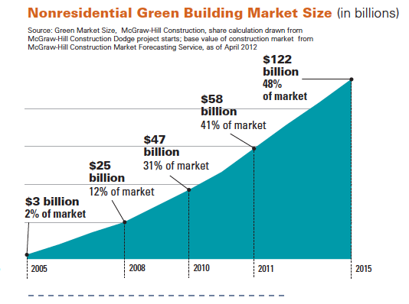

Consumer Demographics
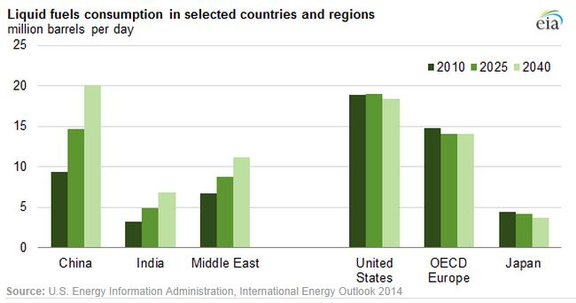

The table illustrated above shows the liquid fuel and energy consumption in selected countries and regions calculated by a million barrels of oil a day.

More short-term demands, lower supplies
Officials with the Edison Electric Institute, which represents investor-owned power utilities, were unable to respond to ICF's findings Friday.
In its latest data on coal consumption by utilities, the U.S. Energy Information Administration said power plants consumed 10.3 million short tons over the first 11 months of 2014, roughly 1 percent more than during the same period of 2013.
In the short term, experts said U.S. coal plants will continue to be dispatched for baseload power, despite the fact that coal stockpiles are trending near 10-year lows. The ICF outlook also projects that utilities will have sufficient coal supplies to meet winter demand unless the nation experiences another sustained cold snap or rail deliveries to coal plants become hampered by weather or maintenance issues.
Over the longer term, ICF projects that U.S. coal consumption will remain relatively flat at about 915 million metric tons annually through 2025. That's because utilities are expected to run remaining coal units at higher capacity factors than before. Domestic coal producers have also placed greater focus on export markets, but ICF forecasts difficult conditions around U.S. exports due to the low global coal prices and stiff competition from other exporters like Colombia and South Africa.
A continued oversupply of domestic natural gas will help keep gas competitive, according to ICF, with Henry Hub spot prices this winter expected to average $4.50 per million British thermal units. That's more than $1 lower than January 2014, when a wedge of Arctic air sent temperatures plummeting to record lows across much of the country for a number of weeks.
Last week's cold snap, which affected more than 100 million people in the Midwest, East and South, did not trigger a repeat of last year's run-up in gas prices, in part because of abundant domestic supplies and ample imports of liquefied natural gas (LNG) to Eastern markets, according to the tracking firm Natural Gas Intelligence.

Stiff competition from natural gas, renewables
ICF said the natural gas market "is entering the new year with decidedly bearish price signals," spurred by a mild December and production rates that continue to outpace demand. Prices will rise and fall due to seasonal price swings, however, and projected demand growth for gas move prices upward in 2016, analysts said.
Gas consumption in North America should increase at a rate of roughly 1.4 percent annually through 2025 to nearly 130 billion cubic feet per day, with the electric power sector accounting for 70 percent of the total increase. Exports of U.S. gas via pipelines to Mexico and LNG terminals on the coasts will also drive up production, according to ICF.
Renewable energy is also expected to see continued expansion through 2030, but the growth will vary depending on a number of factors, including costs of renewable energy and state laws requiring utilities to meet a percentage of their electricity sales using renewable resources.
"Wind and solar technologies will continue to dominate the renewable build mix, but low capacity factors keep their share of total generation nearly constant through 2030, growing slightly in share to 20 percent by 2040," ICF said.
In a separate report, EEI said last week that its members and independent transmission companies invested a record $37.7 billion in transmission and distribution infrastructure in 2013. Officials said the transmission investment was driven by a number of factors, including the adoption of new technologies for improved system reliability, development of new infrastructure to ease congestion, the interconnection of new sources of generation and support for production of shale gas. The higher expenditures on distribution lines -- which deliver power to homes and businesses -- were largely associated with storm hardening efforts and improved system reliability, including underground infrastructure.
Citations
https://en.wikipedia.org/wiki/Industry
http://www.ucsusa.org/clean_energy/our-energy-choices/a-short-history-of-energy.html#.Vk42cNKrTcs
http://www.eenews.net/stories/1060011455

