“Tiny Tots Infant & Toddler Home Daycare Center”

Brittany Vidales
CHLD 456
Final Project

Table of Contents
Title Page
Cover Page 1
Table of contents 2
Community Information 3
Program Description 4
Program Philosophy 5
Organizational Structure Chart 6
Indoor Classroom Diagram 7
Outdoor Classroom Diagram 8
Equipment Needs 9
Financial Plans 10-11
Job Descriptions 12-13
Staff Hiring 14
Staff Training 15
Operating Schedule 16-17
Health and Safety Guidelines 18
Family Involvement 19

A. Community Information

Santa Cruz is a quaint, coastal town located in California’s Central Coast. It has a population of 62,824. Its gorgeous views and small town charm are what draws so many to its beaches annually. The median income for residents of Santa Cruz County is $62,755 with a home ownership rate of 49.9%. 4.3% of their population is under the age of five years old. These figures are significant when considering opening a childcare center to fit your community’s needs. Knowing the people you serve in your community allows the ability to give the highest quality care that one can afford. Incorporating quality, affordable care to the community is vital for it to thrive. These days, one or both parents are in the workforce so it is comforting knowing that their child is in good hands while they are out providing for their families.
B. Program Description

Tiny Tots is a home daycare in beautiful Santa Cruz, California that provides excellent care for young children in our community ages 4 months up to age 3. We have a maximum enrollment of fifteen children, with a waitlist provided if we are at capacity. Our amazing staff provides a 1:3.75 adult to child ratio enabling the best care out there. Our center’s tuition is based on how many hours your child attends our center; part-time or full-time. Tuition rates are as follows:
FULL TIME CARE (5+ hours/day) = $55 daily, $275/week, $1100/month
PART TIME CARE (under 5 hrs/day) = $35 daily, $175/week, $700/month
***All tuition rates are inclusive of meals while your child is in our care. Please let us know in advance of any food allergies your child may have so that we are able to accommodate.

C. Program Philosophy:

Our program is designed to guide and encourage the growth and development of infant and toddler children. We provide an environment rich in tools to foster their creative approach, emotional, physical, language and cognitive development. Providing a strong adult to child ratio is important to us to allow the children’s needs to be met at all times. Daily structure will serve as a learning tool in trust, routine, personal care, as well as encourage healthy habits. Your child will be able to explore the world around them, whether it be with a friend, in groups, or at times where solitary play is desired. Providing a trusting center for not only children, but their families is our number one priority, and we value working together to ensure that each child and their family’s needs are met. We strive to meet the needs of your child, and their healthy growth and development is our main priority.

D. Organizational structure/chart
Tiny Tots Infant/Toddler Daycare Center
Director

AM Master Teacher |  | PM Master Teacher

AM Teacher’s Aide |  | PM Teacher’s Aide |  | PM Teacher’ Aide |  | PM Teacher’s Aide
Director:
Salary @ $25,000/ year
2 Master Teachers:
27.5 hrs/wk at $11.50/hr
AM Master hours 7:00am-12:30pm
PM Master hours 12:30pm-6:00pm
2 Aides:
22.5 hrs/week at $9/hr
AM Aides hours 7:30am-12:00pm
PM Aides hours 12pm-5:30pm

E. Classroom Indoor Diagram 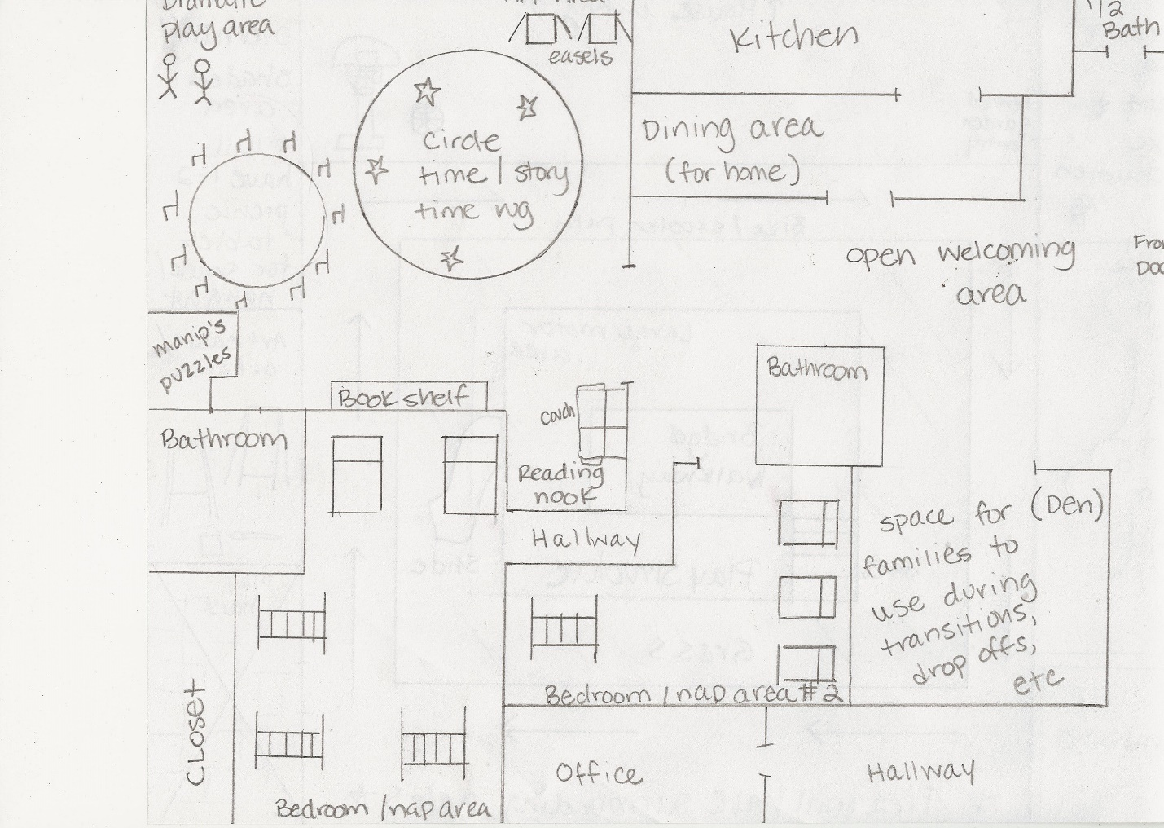
F. Outdoor Diagram
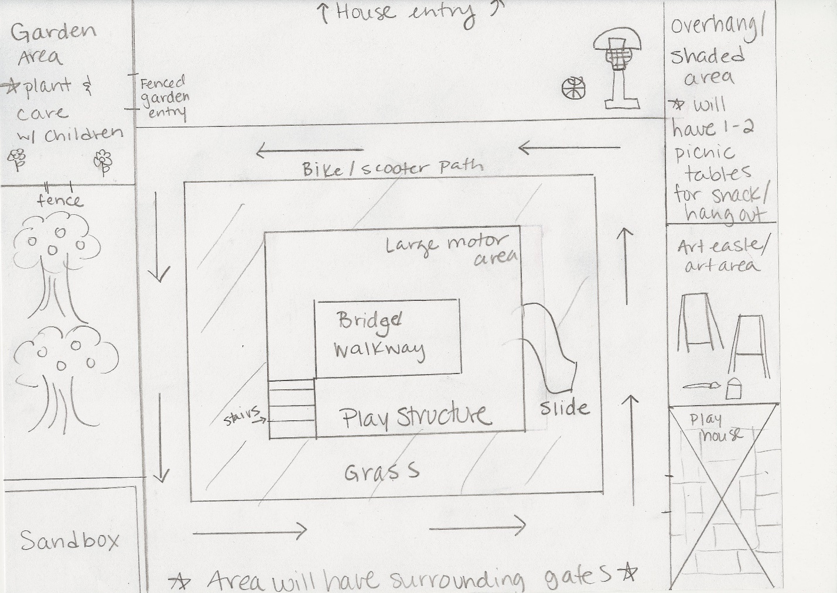

G. Equipment needs

Basic Environment Equipment | Housekeeping Supplies |  | Health and Safety Materials
Carpet | Brooms |  | bandages (all kinds)
Cabinets | Dust pan |  | ointment
Chairs (adult) | Sponges |  | cotton balls
Chairs (child) | towels |  | lotions
Cots/per child | paper towels |  | ice pack
Cribs/per infant | cleaners |  | disinfectant
Infant swings | swiffer |  | medical tape
Cubbies | handheld vacuum |  | gauze
Changing Table | trash cans |  | thermometer
Tables | tray |  | tissue
Clothing hamper | disinfectants |  | tweezers
stroller | soap |  | scissors
mirror | Dish towels |  | gloves
crib/play pen | pots |  | baby powder
high chairs | pans |  | diaper changing pads
dishwasher | dishware |  | mattress pads
microwave |  | sheets
safety gate | Blankets
refrigerators | Bibs
serving carts for food |  | silverware
Toilets |  | rubbing alcohol
sinks |  | trash cans
shelves |  | washer/dryer
totes |  | plates
vacuum |  | cups
training potty |  | dishware
washer/dryer |  | serving pitchers
trash cans |  | smocks
curtains for windows
cushions/small couch
rocking chair

H. Financial Plans
Payment fee schedule
FULL TIME
$55/day $275/wk $1100/month
HALF TIME
$35/day $175/wk $700/month
**Payments are due the 1st and 3rd Monday of each month with a late fee of 10% per payment. Payments are broken down bi-monthly for tuition costs.
** Parents please note, if you are late picking up your child you will be charged a 3% penalty per minute.

Salary Schedule
Employees will be paid the 1st and 3rd Friday of each month. Salaries are as follows:
Master Teachers: $11.50/hr $316.25/wk $15,180/yr
Aides: $9/hr $202.50/wk $9720/yr

 |  |  |  |  |  | Annual Operational Budget
INCOME
*Prices reflect full enrollment |  |  | with a scenario of 8 full time and 7 part time children
Full time tuition income $55/day $275/wk $1100/yr x 8 children = 105, |  |  |  |  |  |  | $105,600
Half time tuition income $35/day $175/wk $700 |  |  |  |  | 700/yr | X 7 children $58,800
OUTPUT
Salaries | $84,800 | No fringe due to workers being part time**
Rent | $30,000
Utilities | $2,400
Electricity | $3,500
Food | $6,500
Equip. | $10,000
Insurance | $2,500
Advertise | $300
 | Total | $164,400 income $140,000 Output = $24,400 +

I. Job Descriptions
Director:
Licensing/Certification/Accreditation
Prepare Annual Budget/Operate funds/Pay Bills
Hire staff
Recruit families/Select Children
Arrange Staff Meetings
Work With Public
Builds relationships quickly with prospective and currently enrolled families
Never Rarely Sometimes Often Always
1 2 3 4 5
Ensures compliance with all federal, state, and local laws, as well as company policies and procedures
Never Rarely Sometimes Often Always
1 2 3 4 5
Efficient planning and allocation of center resources in alignment with children’s needs and budget guidelines
Never Rarely Sometimes Often Always
1 2 3 4 5
Consistently executes plans that ensure the company’s mission of serving families and children, in alignment with company values, policies and national accreditation standards
Never Rarely Sometimes Often Always
1 2 3 4 5
Monitors the success of each child by consistently checking portfolio documentation and family communication strategies from teachers
Never Rarely Sometimes Often Always
1 2 3 4 5

Master Teacher:
Morning Teachers will make sure things are clean from previous day, begin meal prep for the AM shift. Any curriculum that needs to be set up or switched around will be done so by the AM staff. Once this is done you will greet children and families upon arrival and make sure to ‘check-in’ with each family to see how they are doing and if anything needs to be noted about their child that day.
Afternoon teachers will have PM meal prep ready, as well as arrive on time and prompt to relieve morning shift. You will be there to ‘check-in’ afternoon arrivals as the AM shift will be leaving for the day. Aides will be on hand to help at all times so that you may spend time checking in with parents, etc. Master teachers will oversee the performance of their aides to ensure quality care provided at all times. Minimum of 25 units Child Development or ECE. Child Degree certificate a plus.

Aides:
You are an important asset to our program. Your job duties include assisting your head teachers at all times. They will guide you in showing you positive guidance for the children in our program. You will need to oversee and be an ‘extra set of eyes’ and ears for our teachers at the center. You may also be asked to do meal prep on occasion. Daily duties will include cleaning up at transitions, helping children with whatever needs arise. You will also be asked to plan curriculum at certain points. We prefer that you have 12 units of Child Development or ECE training.

J. Staff Hiring

1. What is the highest education you have completed? Eg: High School, Some college, Associate’s, Bachelor’s.
2. Have you taken any Child Development, or Early Childhood Education classes? Please list, or list how many units you have taken.
3. Do you have the ability to multi-task throughout the workday?
4. Have you ever worked directly with families of small children before? Are you comfortable doing so?
5. What are your goals professionally?
6. Would you be willing to attend any staff workshops in the future?
7. What do you enjoy about working with young children?
8. Are you able to develop curriculum that is developmentally appropriate for the children in our center on a daily basis?
9. What do you like to do in your free time?
10. Two children are fighting over use of the same toy, what would you do to diffuse the situation?
11. A child has a difficult time saying goodbye to their parent at the beginning of the day. This includes holding onto their parent while crying loudly and refusing to let go. What are some strategies that you would use in order to help with this transition?
12. Please include a list of three references and their contact information.

K. Staff Training
Wonderful Tiny Tots Staff,
Here you will find our monthly schedule regarding training dates to keep our program up and running as flawlessly as possible. Please let me know in advance if you are unable to make any of these training dates and we may try to accommodate accordingly.
Meal Prep Training:
We will meet every 3rd Thursday of the month to plan our monthly food menu. We will also go over food safety and training to ensure the best meal preparation standards out there. Having the menu done ahead of time will save a lot of headaches down the road and keep us well prepared.

Curriculum Planning:
Each week one of our lovely staff will be in charge of curriculum for our center. Since we are a home based daycare this will consist of art activities, books and activities for circle time as well. We will not necessarily need to meet each week or even month to do so, but if any questions or concerns arise please feel free to contact me directly if it is your week and you are having trouble coming up with ideas to keep our little ones engaged.

Parent workshop:
Every odd month we will have a workshop focused on dealing with families and what we can do to make our communication the best it can be. I will check in the month prior to see which date works best for our staff as well as our parent workshop educator.

L. Operating Schedule

7:30 AM Tiny Tots opens
7:30-8:30 AM Free choice activities/Breakfast
8:30 AM Transition to circle time
9:00 AM Activity time
9:45 AM Morning snack time
10 AM Outdoor play time
10:45 AM Transition back inside as group
11:15 AM Lunch Time
11:45AM- Nap/Quiet time
1:30PM

1:30PM- Transition from nap time and PM arrivals
2PM

2PM Snack time
2:30PM Circle time
2:50PM Small group/craft/art
3:20PM Outdoor play time
4PM Transition back inside
4PM-5:30PM Free choice
5:30 PM Pick-ups/Tiny Tots closed

WEATHER DAY SCHEDULE
Our schedule will follow the same routine, with the exception of not having the option of going outdoors.
*From 10-10:45am: instead of outdoor time, we will have an indoor large group activity which involves a lot of movement so that the children can still get some of that pent up energy out.
*From 3:20-4pm, we will supplement the time with a group movie or indoor group activity. Since there is a pretty wide range of free time from 4pm until pick up they could utilize the free time to roam around and play inside to make up for not being able to move around outside.

M. Health and Safety Guidelines
A)
B) Health Policies for Infection Control
Please do not bring your child(ren) if they display the following symptoms:
- Fever of 100F or higher
- Any new signs of persistent or uncontrollable cough
- Diarrhea or vomiting
- Any type of discolored discharge: eyes, nose, ears. Inclusive of chicken pox symptoms, or hand, foot and mouth symptoms or sores.
- Unexplained loss of appetite, fatigue or irritability

N. Family Involvement

Here at Tiny Tots we encourage a parent or family member to volunteer at least one day a month in our program. This way you are able to see what our program has to offer first hand, as well as what a typical day for your little one looks like. Here at Tiny Tots we value the importance of family involvement and are more than happy to share the enjoyable experiences we have with your children on a daily basis. There is a sign-up sheet posted near the entrance so that you may choose a day of your convenience. Each child will also be sent home with an updated family contact list at the beginning of each month so that you can coordinate with other parents regarding these days (if things change and you need to switch dates), or to arrange play dates outside of the classroom if you desire. We will hold parent group meetings the first Tuesday of each month so that we are able to check in with one another and voice any thoughts or concerns you may have regarding your child or the program. We encourage you to participate in these as they are not mandatory, but could be greatly beneficial to your child’s growth and development while here at Tiny Tots.

