Monarch Butterfly

Kingdom: Animalia
Phylum: Chordata
Class: monarch butterfly
Family: Danaidae
Genus: Danaus
Species: Danaus plexippus

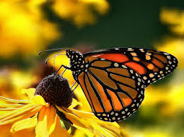
The monarch butterflies are mainly known for their mass migration from California to Mexico each year. Only North American monarchs and monarchs born in late summer or early fall are the ones to make this massive journey of up to 3,000 miles. These butterflies are known to be seen all around the world. They live throughout most of the United Sates, South America, and some Mediterranean countries. Since they are found all over the world, so is their prey. Monarchs tend to feed on larvae, milkweed foliage, and flower buds. They can only sip their food through a tube- like tongue which uncoils when needed and is able to coil up in a spiral again when it is not in use. Monarchs are considered poisonous butterflies because they eat milkweed which is known to make animals very sick that try to eat them.
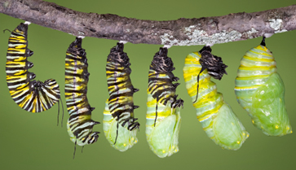
There are three stages that a butterfly will go through before becoming an adult. After the mating occurs, the offspring starts its life off as a very tiny egg. In about 3 to 5 days, the egg will hatch and the offspring is now considered a larva. The larva will come out of its egg and then proceeds to eat the egg as well. The larva will shed its skin four times as it grows into becoming an adult and, after each shedding, the larva will eat its molted skin. Once the larva is two inches long, it will find a place to pupate. Now that the larva is now a pupa, it will spin silk from its spinners and form a cocoon. After the cocoon is in place it takes about 10 to 12 days until a butterfly will emerge. Overall this whole process takes around a month for a full adult to develop.
Monarchs, like all butterflies, are beautiful. They have large scaly wings, six jointed legs, a pair of antennae, compound eyes, and an exoskeleton. Their three main body parts are the head, thorax, and abdomen. The thorax contains the muscles that make the legs and wings move. They are bright orange with black tips on the wings. The wings also have white spots on the outer area, and three orange patches found near the top of the forewings. A monarch’s wingspan is 3.5 to 4 inches with their body being only 2.75 inches tall. The life span of this butterfly varies depending on the season in which it emerged from the pupa. Adults that emerged in the early summer have the shortest life spans being only two to five weeks. The butterflies with the longest life spans are the migratory monarchs, which emerge from the pupa in late summer and then migrate south. The lifespan of this season of butterflies is closer to 8 or 9 months. Monarchs are one of the more popular butterflies that are known and loved throughout the world.

Works Cited

"Monarch Butterfly - EnchantedLearning.com." Monarch Butterfly - EnchantedLearning.com. N.p., n.d. Web. 26 Feb. 2014. <http://www.enchantedlearning.com/subjects

"Monarchs ." Sea World . N.p., n.d. Web. 26 Feb. 2014. <http://www.seaworld.org/en/animal-info/animal-bytes/arthropods/monarchbutterfly/>.

