Character Trait Ball
Teacher Job Aid
Preparation before class –
- Supplies needed include ball template, colored copy paper (12 sheets per group), staplers (one or two per group), scissors, curling ribbon, markers.
- Copy the template; use different colors of copy paper.
- Make 12 copies per ball. You will need 1 ball per group of students.
- You may want to cut out the circles before class. If not, the students will have to cut them out in their groups.
Step 1 – Designing & Writing
- Students (in groups of 4) are given 3 circles each. If you have not cut out the circles, they will need to cut out the circles from the template before proceeding to step 2. (Reason: anything written outside of the circle will be cut out.)
- Each group will make a list of 12 character traits from each part of the plot pyramid (exposition through resolution) – all traits may not come from rising action. Students may choose to “borrow” traits from the plot pyramid, but will be required to choose additional traits, as there are only 8 traits on the pyramid from the Characterization through Conflict lesson extension.
- Each group will assign 3 traits for each student (for groups of four). For groups of three, each student is assigned 4 traits.

- The student will write one character trait on each circle and draw an emoji for that trait.
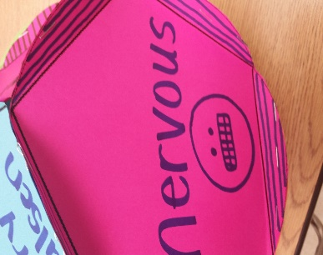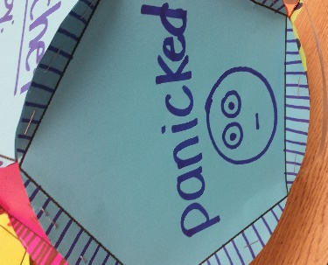

- The student will identify where the trait occurs on the plot pyramid by writing a label on the circle (exposition, rising action, etc.).
- The student will then need to write a summary statement (one sentence) providing evidence from the novel. The sentence IS NOT A QUOTE, but is written in the student’s own words.
- The students should vary their sentence structure so that they include a simple, compound, and complex sentence (a different sentence type for each circle).
- The student will decorate the 5 edges.
- See grading rubric for detailed requirements of each circle – this will allow you to determine an individual grade for each student.

Step 2 - Construction
- Groups will need a bit of space for construction of the balls. They will also need 1 or 2 stapler(s) and a yard of curling ribbon.
- Students should carefully fold each edge on each circle; they should fold exactly on the line and fold up.
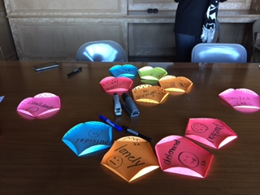
- The students will choose the trait circle from exposition and the circle from resolution and place them separate from each other.
- Students group the traits around the exposition circle, matching edges – one circle on each edge so that it forms a “flower.” Repeat for the resolution circle. There will be 2 “flowers” when the process is complete.
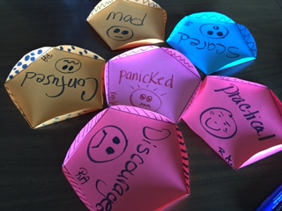
- Students work in pairs to staple all the edges around the center circle. Two staples per matched edge is a good idea. One is not enough. Repeat process for each set of “flowers.”
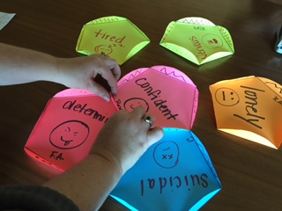
- Students work in pairs to hold up each “flower.” When they pick up the “flower,” they will see where the sides need to fit together. Staple sides together, again matching edges.
- Each set of flowers will then need to be fit together; the sides will fit like jagged teeth. Again, pairs are needed to hold and staple.

- Attach the curling ribbon on one of the edges so that the ball may be hung in the classroom.
- See grading rubric for group ball construction.
- For best results, make a sample ball before class for students to see the end product.

