Sexual Consent: Changing the Gender Stereotype
Maria Isabel T. Paraan and Allyson E. Yarsinske
Longwood University

Abstract
Hickman and Muelenhard (1999) coined the term “traditional sex script,” which describes initiator and gatekeeper behavior. Initiator behavior is that of a male seeking consent while the gatekeeper is a female that gives consent. Is there gender bias influencing sexual consent and if so, can a campaign poster about sexual consent change that bias? Participants were 220 American students enrolled in psychology classes at a small mid-Atlantic liberal arts university. Three campaign posters served as the independent variable; male consenter, female consenter, and alcohol. Participants were randomly assigned to one of the conditions within the study. The dependent variables were gender stereotypes represented by questions combined and labeled as initiator, gatekeeper, initiator 2, and gatekeeper 2. Prior to viewing the campaign posters, participants completed a survey containing demographic and knowledge questions. Following the viewing of the campaign posters, participants completed a second survey with question pertaining to initiator and gatekeeper behavior. There was one significant difference between two conditions with the remaining results showing no significance. This study could be used to influence sex education and understanding non-traditional sex scripts.
Keywords: gender, traditional sex script, sexual consent

Introduction
Research about sexual consent conducted in the past decade, or so, focused on the purpose of educating college students about its ties with sexual assault. Sexual assault is a current issue that demands attention so that preventative measures can be made in order to protect people from sexual assault. In a law review of Title IX programs, Silbaugh (2015) notes that there have been a great number of initiatives that address the appropriate actions taken following a sexual assault case, but too few initiatives that address an appropriate way to prevent sexual assault on college campuses.
Sex is a consensual act between two people and sexual assault is typically defined as the absence of consent (Jozkowski & Peterson, 2013). Sexual consent is defined by both verbal and non-verbal communication between two individuals who want to engage in sexual activities (Hickman & Muehlenhard, 1999). Jozkowski, Peterson, Sanders, Dennis, and Reece (2014) specifically look at understanding how college students conceptualize sexual consent. Ineffective education programs focused on context of obtaining consent versus understanding contributing factors that influence college students’ perceptions of sexual consent. The misinterpretation of signals that men and women experience when initiating sex have possibly led to the misperception of an individual giving consent, or refusing consent, to participate in sex (Hickman & Muehlenhard, 1999). Miscommunication in regards to consent have serious implications related to sexual assault for both men and women (Jozkowski et al., 2014).
Societal views on gender roles have a significant impact on sexual consent, bringing forth attention to how it is that gender stereotypes and biases influence the way men and women pursue sexual relationships (Marston & King, 2006). Gender bias is the way in which men and women follow the traditional sexual script. The traditional sexual script was conceptualized by Jozkowski and Peterson (2013), who describe two roles in which men are sex initiators, pursuers of sex, and women are sex gatekeepers, who make the decision whether or not sex occurs. Women, because they feel reluctant to initiate sex and damage their social image by agreeing to sex too fast, participate in a behavior called token resistance. Token resistance is when a woman says “no” to sex but really means “yes” (Hickman & Muehlenhard, 1999). This enforces their role as the gatekeeper, and also emphasizes men’s roles as the initiator by leading them to pursue women for sex even past the point when a woman would reject the man (Jozkowski & Peterson, 2013). If it is only women who are capable of giving consent, then it can be assumed that men are always consenting because they are the ones initiating sex (Jozkowski et al., 2014). Contemporary college students in Jozkowski and Peterson’s (2013) study support this gender stereotype by saying things such as “I’m a guy, we always want it [...]” and “guys always consent, haha.” This set up a sexual double standard in which men are praised and encouraged to pursue sex with multiple partners, where sexually active women are perceived negatively (Littleton, Tabernik, Canales, & Backstrom, 2009). Yet if a man were to refuse sex, he would be ridiculed, where a woman would be praised (Marston & King, 2006).
This can lead women to believe in the gender stereotype that men always want sex, even when a man could lack interest in sex at the time, an idea reinforced in media (Pinkleton, B. E., Austin, E. W., Cohen, M., Chen, Y. Y., & Fitzgerald, E., 2008). Ward and Rivadeneyra (1999) found that women who identified more with television characters that they watched, believed and expected their male peers to be more sexually active and experienced. In a study conducted on the association between reading magazines and college students’ sexual consent negotiation, it was found that being male was associated with low refusal of unwanted sex (Hust et al., 2014). In a college setting, common place media that advertises selective campaigns and campus activities occur commonly in the form of poster visuals.
Alcohol can greatly influence an individual’s ability to consent to sex, leaving a man or woman more susceptible to social pressure to have sex when that may not be desirable (Abbey, 2002). As suggested in Jozkowski and Wiersma’s (2015) study, intoxication changes an individual’s ability to ascertain certain cues from their partner, as well as inhibiting the decision making process necessary to consent, completely enabling a person from consenting.
This research that focuses on consent, focuses on the impact that it has on women, with men mentioned as side notes or perpetrators of sexual assault. The purpose of this study is to challenge gender bias in sexual consent interactions by introducing a situation that suggests that sexual consent ought to be equally sought after by both men and women when initiating sex. A set of campaign posters were constructed with the intent that the posters could later inspire educational campaigns directly addressing the importance of sexual consent. By adhering to the structure of the traditional sexual script, the campaign poster which depicts the interaction between a male gatekeeper and female initiator creates a parallel for the participant to think about changing their perceptions of sexual consent interactions. The hypothesis is participants who view a campaign poster focusing on a male giving consent will change the participants’ perception on sexual consent than a poster focusing on a female giving consent or a neutral poster.
Methods
Participants
Participants for the current study are students currently enrolled in psychology classes at a small mid-Atlantic liberal arts university. There were a total of 221 participants who voluntarily signed up via an online experiment management system for the study, ages of the participants ranged between 17 and 28 years. Approximately 77% of the participants were women, with the remaining participants being men. The participants received class credit as compensation for their participation.
Procedures and Materials
Researchers designed consent campaign posters that exemplified the gender bias of sexual consent for the participants to view, with a third poster acting as the control. The posters (see appendix A) were originally created by the researchers and composed using a photo editing software. All of the posters feature a man and woman enjoying drinks together, smiling and giving the appearance of having a good time. The first poster, the female consenter, focuses on the woman’s ability to give her consent while she is under the influence of alcohol. The second poster, the male consenter, focuses on the man’s ability to give his consent, in reality neither can consent because both the man and the woman in the poster scenario are drinking. The third poster, the alcohol poster, focuses on drinking responsible with no sexual interaction between the couple.
Participants were randomly assigned to one of the three conditions during each session. To measure this change for the participants, the researchers had the participants complete two surveys (see appendix B). The first survey contains questions about demographics (i.e. “What is your age?” “What is your gender?”), two knowledge based questions (i.e. “In your own words define what consent means.” and “Which of the following can influence or inhibit a person’s ability to consent to sex?”). The second, survey given after the participants view their assigned campaign poster, contains the manipulation check (i.e. “Who in the poster was being asked for consent?”) and six questions testing the knowledge and stereotypes on consent (i.e. “Who do you think typically initiates sex?” “Who do you think is usually responsible for giving consent to engage in sex?”). The questions in the second survey were taken and modified from the Consent to Sex Scale created by Jozkowski and Peterson (2014). These questions will be measured on a Likert scale, 1 (always men) to 5 (always women) with 3 meaning both, instead of the original Likert scale (strongly disagree, disagree, agree, strongly agree).
To test for the dependent variable, initiator and gatekeeper stereotypes, the six questions in the second survey (Appendix B) were used or combined. Question two was named Initiator1 and question three was named Gatekeeper1. Questions four and six were combined to make Initiator2 using the ‘computer a variable’ function in IBM Statistical Package for the Social Sciences (SPSS). To justify combining the two variables a bivariate correlation was run, r(201) = .37, p < .01. Questions three and five were combined to make Gatekeeper2 using the same process as Initiator2 in SPSS. This action was justified with a bivariate correlation, r(201) = .26, p < .01.
Results
Eight participants were excluded from this study because their manipulation check was not graded, two were excluded from incompletions, and nine were excluded because they failed to define consent correctly. The final participant pool was N = 202.
Due to the wording of the manipulation check, many people got the manipulation check wrong but due to the poster and the nature of its content many people also got the manipulation check right because whoever was giving consent could not technically consent because they were under the influence. Due to this complication, the researchers did no exclude participants based on the manipulation check. The way the manipulation check was answered for each condition can be seen in Table 1.
A one way ANOVA was used to test whether or not the gender bias on consent would be significantly influenced if participants viewed the male consenter poster, rather than the female consenter poster or the alcohol poster. For the initiator dependent variable there was no significant difference between all three conditions but there was a trend, F(2, 201) = 2.78, p = .07. This trend then led the researchers to use a Tukey post hoc test and there was a significant difference between the alcohol poster (M = 2.65, SD = .52) and the female consenter poster (M = 2.44, SD = .50) at p = .05. For the gatekeeper dependent variable, there was no significant difference between all three conditions F(2, 201) = 2.27, p = .11.
There was no significant difference for the Initiatior2 dependent variable, F(2, 201) = 1.69, p = .19 and the Gatekeeper2 dependent variable, F(2, 201) = .03, p = .97. The results do not support the hypothesis that the male consenter poster would influence the gender stereotypes more so than the other posters.
Discussion
The trend that was seen in the Initiatior1 variable is interpreted as the female consenter poster reinforcing the traditional sex script. The alcohol poster and the male consenter poster had no significant influence over the Initiator1 variable.
The manipulation check (Appendix B) was originally set up to grade participants’ answers as either ‘right’ or ‘wrong.’ However, in the grading process, researchers found that the participants were not passing the manipulation check. Under further scrutiny of the manipulation question and comparing the descriptive statistics in Table 1, the technical correct answer for the female consenter poster is that Evie was giving consent, or being asked to give her consent, and only six people answered the manipulation check ‘correctly.’ The ‘correct’ answer is no one since it has been established in the poster that Evie could not give consent, but the answers are spread out between all three potential answers. Overall, Table 1 is how people answered the manipulation check and it seems that the female consenter poster supported the role women have as the gatekeeper, and men have as the initiator, in the traditional sex script.
Limitations
This study required more time than what was anticipated by the researchers. The study’s methods need substantial improvements. The wording of the survey questions and manipulation check was problematic from the beginning and the end product reflected these problems. What the manipulation check was asking of the participants was clear to the researchers, however, as the results have indicated the participants interpreted the question differently. This kind of mistake can be attributed to creator bias and would be rectified through a series of pilot testing sessions. The wording of the survey questions, following the viewing of the campaign poster, were taken from a preexisting scale but were modified to fit the study and thus the original scale also changed (Jozkowski & Peterson, 2014). This study needs to have multiple studies to build up to what was currently being done. There needed to be at least one, or two, more phases to compile the survey questions to make them reliable tests of measure.
Other limitations to this study can be attributed to the participant pool. The sample consisted solely of college students attending a liberal arts school and in keeping with contemporary times, these participants are more progressive in their social views. The posters did not influence the participants because the participants already held progressive social views. If the sample contained a wider age range of adults, then more significant results could be found in the data and it would also be a study that would generalize better to the general population.
Future Research and Conclusion
Future directions for this study could be explored with other sex scripts. Going further than the traditional sex script between a man and a woman, there is interest in studying the interaction between same sex couples. Doing so would establish the base for research on how same sex couples interact and how consent is established in these scenarios.
Another area of interest is in high school students and pubescent adolescents. Pinkleton et al. (2008) did a study on media literacy program to see if opinions on sex would change regarding sexual decision making. While the results cannot be generalized, elements from that particular study and this study can be examined. Pinkleton et al. (2008) also found that peers are viewed to be more knowledgeable about sex than adults, even though that may be a false conception. Another takeaway from Pinkleton et al.’s (2008) study is that there is some so link between the media and sex in that media does influence views about sex, especially in teenagers.
Proper sex education is important. It should not exclusively be about abstinence (Pinkleton et al. 2008) but it should also include other aspects of sex, such as the use of contraceptives and the importance of consent. Not only should be modifications to sex education, there also needs to be appropriate sexual assault prevention education on college campuses. Current Title IX programs are brief and only one session which is not enough for a long-term change in behavior (Silbaugh, 2015). Sexual violence is serious and applies to all people, it should not be taken lightly. While this study focuses on gender stereotypes, the inspiration for this study comes from the overrepresentation of females as victims and males as perpetrators and the overall presence of sexual assault on college campuses including the institution where this study was conducted. There is constant room for improvement but as this study shows, there is already a change taking place with the residents on college campuses. They express their desire for gender equality and by projecting this desire onto society, change will take root and humanity can progress towards gender equality in regards to the importance of sexual consent and the prevention of sexual assault.

References
Abbey, A. (2002). Alcohol-related sexual assault: A common problem among college students.
Journal of Studies on Alcohol, 14, 118-128.
Hickman, S. E. & Muehlenhard, C. L. (1999). By the semi-mystical appearance of a
condom: How young women and men and communicate sexual consent in heterosexual situations. Journal of Sex Research, 36(3), 258-272. doi: 10.1080/0022449909551996
Hust, S. J. T., Marett, E. G., Ren, C., Adams, P. M., Willoughby, J. F., Lei, M., Ran, W.,
& Norman, C. (2014). Establishing and adhering to sexual consent: The association between reading magazines and college students’ sexual consent negotiation. Journal of Sex, 51(3), 280-290. doi: 10.1080/00224499.2012.727914.
Jozkowski, K.N., Peterson, Z.D., Sanders, S. A., Dennis, B., Reece, M. (2014). Gender
differences in heterosexual college students’ conceptualizations and indicators of sexual consent implications for contemporary sexual assault prevention education. Journal of Sex Research, 51(8), 904-916. Doi:10.1080/00224499.2013.792326
Jozkowski, K. N. & Peterson, Z. D. (2014). Assessing the validity and reliability of the
perceptions of the Consent of Sex Scale. Journal of Sex Research, 51(6), 632-645. doi: 10.1080/00224499.2012.757282
Jozkowski, K. N. & Peterson, Z. D. (2013). College student and sexual consent: Unique
insights. Journal of Sex Research, 50(6), 517-523. doi: 10.1080/00224499.2012.700739.
Jozkowski, K. N. & Wiersma, J. D. (2015). Does drinking alcohol prior to sexual activity
influence college students’ consent? International Journal of Sexual Health, 27(2), 156-174. doi: 10.1080/19317611.2014.95105.
Littleton, H., Tabernik, H., Canales, E. J., & Backstrom, T. (2009). Risky situation or harmless
fun? A qualitative examination of college women’s bad hook-up and rape scripts. Sex Roles, 60, 793-804. doi: 10.1007/s11199-009-9586-8.
Marston, C., & King, E. (2006). Factors that shape young people's sexual behaviour: a
systematic review. Lancet (London, England), 368(9547), 1581-1586
Pinkleton, B. E., Austin, E. W., Cohen, M., Chen, Y. Y., & Fitzgerald, E. (2008). Effects of a
peer-led media literacy curriculum on adolescents' knowledge and attitudes toward sexual behavior and media portrayals of sex. Health Communication, 23(5), 462-472. doi:10.1080/10410230802342135
Silbaugh, K. (2015). Reactive to proactive: Title IX's unrealized capacity to prevent campus
sexual assault. Boston University Law Review, 95(3), 1049-1076.
Ward, L. M. & Rivadeneyra, R. (1999). Contributions of entertainment television to adolescents
sexual attitudes and expectations: The role of viewing amount versus viewer involvement. Journal of Sex Research, 36(3), 237-249.

Appendix A
Alcohol Poster
Female Centered Poster
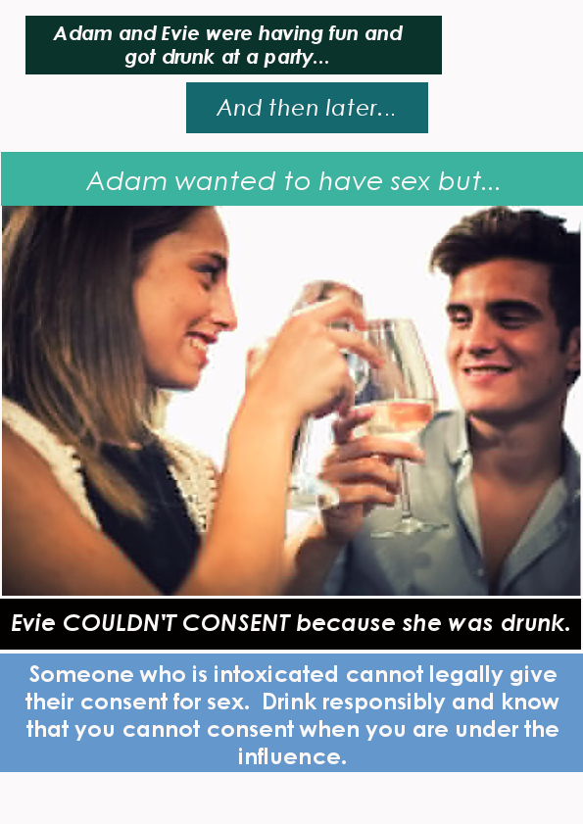
Male Consenter Poster
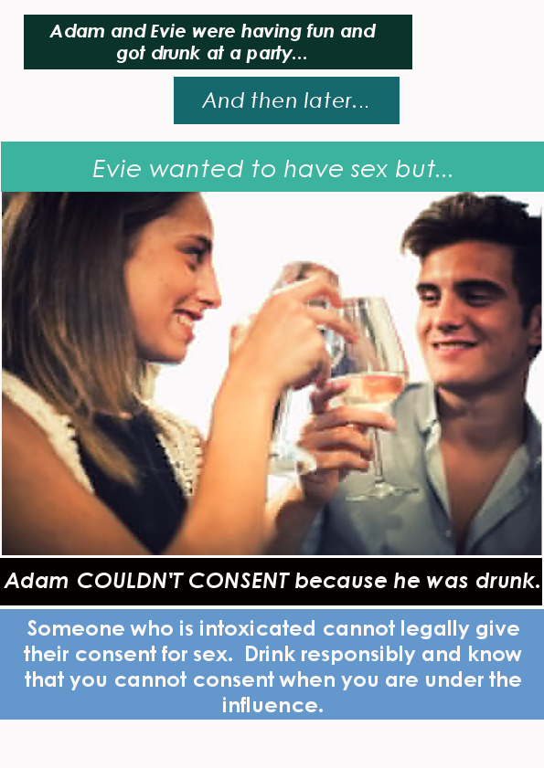
Appendix B
Before Poster Survey
1. What is your age? ________
2. What is your gender?
Male Female Other
3. What class are you in?
Freshman Sophomore Junior Senior Graduate
4. In your own words define what sexual consent means. (Be as detailed as possible)

5. What do you think can influence, or inhibit, a person’s ability to give consent to sex?

After Poster Survey
1. In your poster, who was giving consent?
a. Evie
b. Adam
c. No one

For questions 2-7 please circle the number that corresponds with whom you think best answers the question given.
1= Always Men, 2= Mostly Men, 3= Both Sexes, 4= Mostly Women, 5= Always Women

2. Who do you think typically initiates sex?
1 2 3 4 5
Always Men Mostly Men Both Sexes Mostly Women Always Women

3. Who do you think is usually responsible for giving consent to engage in sex?
1 2 3 4 5
Always Men Mostly Men Both Sexes Mostly Women Always Women

4. Who do you think typically initiates sex and then sees if their partner reciprocates the same desire to have sex?
1 2 3 4 5
Always Men Mostly Men Both Sexes Mostly Women Always Women

5. Who would let their partner initiate sex and then not tell them to stop, even if they did not want to have sex?
1 2 3 4 5
Always Men Mostly Men Both Sexes Mostly Women Always Women

6. Who do you think typically makes a move to initiate sex and checks their partner’s reactions?
1 2 3 4 5
Always Men Mostly Men Both Sexes Mostly Women Always Women

7. Who would typically not push their partner away even if they don’t want to have sex?
1 2 3 4 5
Always Men Mostly Men Both Sexes Mostly Women Always Women

Table 1
Manipulation Check Participant Answers
IV Manipulation | Alcohol Poster | Female Consenter | Male Consenter
Evie | 0 | 6 | 26
Adam | 0 | 21 | 19
No one | 59 | 41 | 28
Adam and Evie | 1 | 0 | 0
Total | 60 | 68 | 73

Note. This table shows how participants answered the manipulation check in their assigned conditions. The correct answers per condition were: no one for the alcohol poster, Evie for the female consenter, and Adam for male consenter. For the manipulated conditions the participants’ answers varied across all three possible choices, indicating that the participants understood that consent cannot be given under the influence.

