Chocolate Mania

Recipes by
Amber Brouillette, Emily Rohan,
& Jessica Moehling

Caprese Salad
Chocolate twist on a classic dish - tomato, mozzarella, and basil drizzled with a chocolate balsamic dressing

Aubergine Caponata
Eggplant and butternut squash stew with a
white chocolate dusting

Cacao Nib Encrusted Tenderloin
Beef tenderloin with a dark chocolate glaze and cacao nib crust, fennel and chocolate jus, served with roasted asparagus and rutabaga puree

Fennel & Chocolate Jus
Beef stock and red wine reduction with flavors
of fennel and chocolate

Rutabaga Puree
Smooth and creamy rutabaga puree

Chocolate Tofu Mousse
Bitter chocolate pudding slightly sweetened with honey served with fresh sliced strawberries

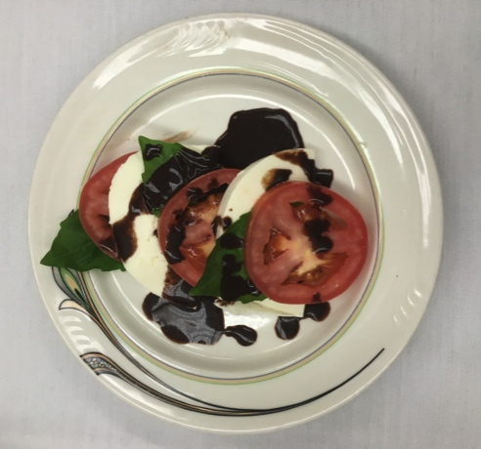
Caprese Salad
Serves: 6
Serving Size: 1 salad

INGREDIENTS

- 6 slices fresh mozzarella cheese (1 1/2 oz per slice)
- 18 Roma tomato slices, approximately 3 tomatoes (1/4 inch slices)
- 18 basil leaves, fresh
- 1 1/2 t olive oil
- 3 T balsamic vinegar
- 1/2 t brown sugar
- 1 1/2 t cocoa powder

Calories | 139
Fat (g) | 8
Saturated Fat (g) | 5
Carbohydrate (g)  Fiber (g) | 4  1
Protein (g) | 13
Sodium (mg) | 11
Cholesterol (mg) | 23

Nutrition Facts

INSTRUCTIONS

- Slice the mozzarella and tomatoes. Slice each of the 6 mozzarella slices in half and pick the basil leaves from the stems. Set aside.
- In a blender combine the olive oil, balsamic vinegar, brown sugar, and cocoa powder. Blend until smooth and no clumps are visible.
- Layer 3 slices of tomato, 3 basil leaves, and 2 of the half slices of mozzarella on a plate alternating each item. Drizzle 1 teaspoon balsamic dressing over the salad.

Nutrition Tip: A caprese salad is a delicious alternative to the classic mixed green salad. The Roma tomatoes provide a sweet flavor however, using heirloom tomatoes would provide even more color to this refreshing side dish.

Fun Fact: The amount of caffeine found in chocolate varies depending on the type and amount of cocoa powder, cocoa butter, and chocolate liquor used in processing.

1 Hershey’s Milk Chocolate Bar (1.55 oz) contains only about 9 mg of caffeine, where the dark chocolate bar contains 20 mg compared to a cup of coffee that contains 65-110 mg of caffeine.

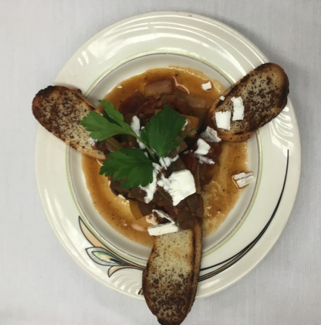
Aubergine Caponata
Serves: 6
Serving Size: 1/2 cup

INGREDIENTS

- 1 cup eggplant, cubed
- 1 tsp olive oil
- 1 1/2 T garlic minced
- 1/2 cup butternut squash, cubed
- 1/2 medium onion, chopped
- 3 green olives, chopped
- 1 stalk celery, chopped
- 1/4 cup red wine vinegar
- 1/2 can (14 oz) diced tomato, low sodium
- Pepper to taste
- 1/4 cup parsley, chopped
- 1 loaf French bread, sliced thinly (~18 pieces)
- Cocoa powder to dust
- 1 T white chocolate, grated

Calories | 86
Fat (g) | 2
Saturated Fat (g) | 1
Carbohydrate (g)  Fiber (g) | 15  2
Protein (g) | 2
Sodium (mg) | 122
Cholesterol (mg) | 2

Nutrition Facts

INSTRUCTIONS

- In a medium sauté pan, heat the olive oil over low to medium heat. Add the garlic and cook for 10 seconds until the garlic is transparent (be careful not to burn). Add the onions and sauté until translucent (about 3-4 minutes)
- Add the eggplant, butternut squash, olives, and celery and sauté for 5 minutes.
- Add the red wine vinegar and tomatoes. Season with pepper.
- Cover and allow to simmer until all vegetables are tender, about 15-20 minutes.
- Once vegetable mixture is tender, add the fresh parsley and stir until incorporated.
- Thinly slice French bread and toast or grill French bread slices. Place 3 slices on plate and lightly dust with cocoa powder.
- Portion caponata onto the plate and sprinkle with 1/2 teaspoon of white chocolate

Nutrition Tip: Aubergine is French for eggplant! Anthocyanins are pigments that give eggplants their dark purple color and have been shown to help prevent cognitive decline by inhibiting neuroinflammation and promoting blood flow to the brain!
Fun Fact: White Chocolate is actually not considered chocolate. According to the FDA, in order to be called ‘chocolate’ it must contain cocoa solids. White chocolate is made up of cocoa butter, milk solids, milk fat, sugar, and vanilla.

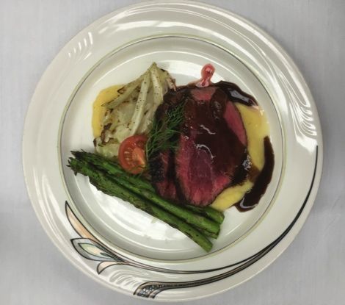
Cacao Nib Encrusted Tenderloin
Serves: 5
Serving Size: 3 oz (cooked weight)

INGREDIENTS

- 1 beef tenderloin (1 pound), raw
- 2 T dark chocolate, melted
- 2 T cacao nibs, crushed
- 2 oz Chocolate jus (see recipe attached)
- 20 stalks of asparagus
- 1/2 fennel bulb, sliced thick (about 5 slices)
- Pepper to taste
- ½ cup rutabaga puree (see recipe attached)

Calories | 334
Fat (g) | 15
Saturated Fat (g) | 8
Carbohydrate (g)  Fiber (g) | 21  6
Protein (g) | 25
Sodium (mg) | 170
Cholesterol (mg) | 61

Nutrition Facts

INSTRUCTIONS

- Preheat the oven to 350ºF.
- Heat a large cast iron skillet, on high heat and spray with cooking spray. Brown the tenderloin on all sides. Set aside. The meat should still be partially uncooked.
- Place cacao nibs in a bag and crush using the bottom of a heavy pan or a kitchen mallet.
- Melt the chocolate using a double boiler. Brush the melted chocolate over the cooked tenderloin and sprinkle with black pepper. Roll in the crushed cacao nibs.
- Transfer to greased wire rack on baking sheet. Bake until the tenderloin reaches an internal temperature of 140ºF. Once tenderloin reaches an appropriate internal temperature, remove from the oven. Allow to rest for 10 minutes. Slice into 3 oz portions.
- While the tenderloin is baking, clean the asparagus by cutting the bottoms of the stalks, removing any white portions. Transfer asparagus and fennel to baking sheet spread evenly in one layer. Spray with cooking spray and season with pepper. Bake at 350ºF until tender.
- Serve with rutabaga puree, fennel chocolate jus, asparagus and sliced fennel.

Nutrition Tip: Beef tenderloin is a high quality cut of beef and the fat content varies depending on how it is trimmed. When completely trimmed of fat, 3 oz. of beef tenderloin will contain ~6 grams of fat. It is not completely fat free due to the veins of fat marbling that provides buttery flavor to this dish!
Fun Fact: Cacao nibs are dried and fermented bits of cacao beans, the purest form of chocolate. They are easily found at most grocery stores (Mariano’s, Whole Foods, Walmart) however known to be expensive at $9-11 per 8oz bag.

Fennel and Chocolate Jus
Serves: 6
Serving Size: 2 oz

INGREDIENTS

- 1 quart beef stock, low sodium
- 1 cup red wine
- 1 bay leaf
- 1 T whole peppercorns
- 1 medium carrot, chopped
- 1 medium onion, chopped
- 1 medium fennel bulb, chopped
- 1 oz dark chocolate

Calories | 63
Fat (g) | 2
Saturated Fat (g) | 1
Carbohydrate (g)  Fiber (g) | 4  0
Protein (g) | 2
Sodium (mg) | 87
Cholesterol (mg) | 0

Nutrition Facts

INSTRUCTIONS

- In a large stock pot bring the beef stock, red wine, bay leaf, peppercorns, carrot, onion, and fennel to a boil.
- Simmer until the liquid is reduced by half or the sauce coats the back of a spoon.
- Strain the sauce through a fine mesh strainer.
- Melt the chocolate into the jus.
- Serve hot.

Nutrition Tip: Dark chocolate is considered a polyphenol as it has been shown to decrease blood pressure in individuals with stage 1 hypertension and excess body weight when they ate 50 grams of dark chocolate (70% cocoa solids) per day for 4 weeks.

Fun Fact: Dark chocolate can have up to 70% of cocoa solids which means the majority of the chocolate is from the cocoa bean and less from added sugars and oils.

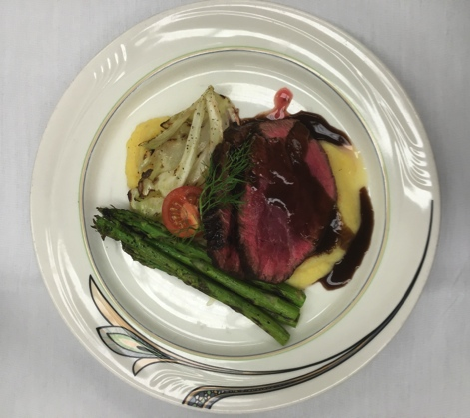
Rutabaga Puree
Serves: 5
Serving Size: ½ cup

INGREDIENTS

- 2 cups rutabaga, peeled, chopped and boiled
- 1/2 cup skim milk
- White pepper to taste
- Water
- Pinch of salt

Calories | 44
Fat (g) | 0
Saturated Fat (g) | 0
Carbohydrate (g)  Fiber (g) | 9  2
Protein (g) | 2
Sodium (mg) | 30
Cholesterol (mg) | 1

Nutrition Facts

INSTRUCTIONS

- Peel rutabaga, ensuring all wax is removed.
- Chop peeled rutabaga into large chunks.
- Place rutabaga chunks into boiling water, cook until fork tender about 18 minutes.
- In a blender, combine the rutabaga, milk, white pepper and pinch of salt. Blend until very smooth.
- If required add small amounts of water until the mixture is a smooth puree.

Nutrition Tip: Rutabagas are known as a cruciferous vegetable and contain phyto-chemicals. Research suggests that there may be protective benefits against cardiovascular disease, cancer, type 2 diabetes, and neurodegeneration when consuming fruits and vegetables high in phytochemicals.

Fun Fact: Rutabagas are harvested in the fall/autumn and then dipped in wax to preserve them and prevent moisture loss over the winter. Thus, it is very important to peel and remove all thick skin and wax prior to cooking!

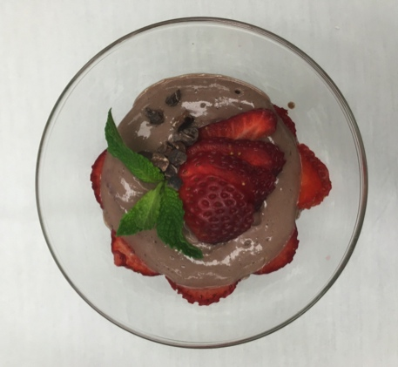
Chocolate Tofu Mousse
Serves: 4
Serving Size: ½ cup

INGREDIENTS

- 2 cups soft tofu
- 4 tsp cocoa powder
- 2 tsp honey
- 2 tsp olive oil
- 2 tsp vanilla
- 2 pinches ground cloves
- Pinch of cinnamon
- Pinch of salt
- 8 medium strawberries, sliced thin

Calories | 137
Fat (g) | 6
Saturated Fat (g) | 1
Carbohydrate (g)  Fiber (g) | 13  3
Protein (g) | 8
Sodium (mg) | 10
Cholesterol (mg) | 0

Nutrition Facts

INSTRUCTIONS

- In a food processor, blend the tofu, cocoa, honey, vanilla extract, clove, cinnamon, salt and olive oil.
- If desired, let the mousse set up in the refrigerator in a covered container for 1-2 hours. This will allow the mousse to set up, resulting in a firmer mousse.
- Portion and garnish with strawberries.

Nutrition Tip:
Tofu is a great source of protein that comes from fermented soybeans. It is naturally gluten free and does not contain any cholesterol and minimal sodium thus, tofu can be considered heart healthy!

Fun Fact: Mousse was first created in France and originally named Mayonnaise de Chocolat because like mayonnaise, it consists of whipped eggs. Eventually it was termed “Mousse” which means “foam” in French.

