NHANES Research Project

Amber Brouillette
NTR 555, Dr. Tangney
December 4th, 2015

Table of Contents
List of Tables 3
List of Figures 4
Research Question 5
Objectives 5
Introduction 6
Methods 8
Data Collection 8
Subjects and Variables 8
Statistical Analysis 9
Results 9
Discussion 24
Limitations 25
Conclusion 26
References 27
Appendix A: Population Schematic 29
Appendix B: Variable List 30
Appendix C: Output Files 32

List of Tables
Table 1: Demographic Variables Defined by Cycle Year . . . . . . . . . . . . . . . . . . . . . . . . . . . . 11

Table 2: Changes in Sugar Intake Over Time Categorized by Age Group (n=21,853) . . . . 14

List of Figures
Figure 1. Consumption of Sugar as a Percentage of Calories by Age Group in NHANES 2007-2008 . . . . . . . . . . . . . . . . . . . . . . . . . . . . . . . . . . . . . . . . . . . . . . . . . . . . . . . . . . . . . . . . . . . . . . . . . . . . . . 16

Figure 2. Consumption of Sugar as a Percentage of Calories by Age Group in NHANES 2009-2010 . . . . . . . . . . . . . . . . . . . . . . . . . . . . . . . . . . . . . . . . . . . . . . . . . . . . . . . . . . . . . . . . . . . . . . . . . . . . . . 17

Figure 3. Consumption of Sugar as a Percentage of Calories by Age Group in NHANES 2011-2012 . . . . . . . . . . . . . . . . . . . . . . . . . . . . . . . . . . . . . . . . . . . . . . . . . . . . . . . . . . . . . . . . . . . . . . . . . . . . . . 18

Figure 4. Percentage of Calories from Carbohydrates in Adults 18 Years and Older by BMI Classifications in NHANES Cycles 2007-2008, 2009-2010, and 2011-2012 . . . . . . . . . . . . . . . 21

Figure 5. Percentage of Calories from Sugar in Adults 18 Years and Older by BMI Classifications in NHANES Cycles 2007-2008, 2009-2010, and 2011-2012 . . . . . . . . . . . . . . . 22

Figure 6. Grams of Fiber per 1,000 Calories in Adults 18 Years and Older by BMI Classifications in NHANES Cycles 2007-2008, 2009-2010, and 2011-2012 . . . . . . . . . . . . . . . 23

Research Question
How have the national estimates of dietary sugar consumption changed over time among specific age groups from 2007 to 2012? Does the percent of total daily calories from sugar differ by weight status or demographic variables?

Objectives
- To determine the changes over time of sugar intake (as a percentage of calories from sugar) using a nationally representative sample of the United States population (NHANES 2007-2012).
- To examine the demographic distribution of participants and differences in sugar consumption between demographic variables using a nationally representative sample of the United States population (NHANES 2007-2012).

Introduction
The United States (US) is among the most obese countries globally; 30-40% of men and women above the age of 20 were obese in 2013. The US has the most obese citizens out of any country¹. Obesity is define as a body mass index (BMI) >30.0. A major contributing factor in weight gain is excess sugar; excess fructose and sucrose intake over long periods of time will lead to increased hepatic lipogenesis. This results in hyperlipidemia and increased stores in adipose tissue². Obesity has been shown to contribute to altered lipid metabolism^{2,3}, weight gain⁴, and heart disease⁵, along with other comorbidities.
The World Health Organization’s (WHO) recommendation for calories from added sugar is no more than 10% of daily calories. The WHO completed systematic reviews to examine the association between sugar intake and body weight. The WHO determined that a reduction of intake of free sugars was associated with a decrease in body weight (–0.80 kg; 95% confidence interval [CI]: –1.21, –0.39)⁶. These findings support the statement that added sugar may lead in increased adipose tissue and weight gain.
Using the National Health and Nutrition Examination Survey (NHANES), data from 1999-2010 were used to determine changes in overweight and obesity trends among the US population. The prevalence of obesity in US adults did not differ from 1999 to 2010. In 2009-2010, the prevalence of obesity was 35.5% among adult men and 35.8% among adult women ⁷. In children and adolescents, the prevalence of high weight-for-recumbent weight was 9.7% for infants and toddlers and 16.9% of children between the ages of 2 and 18 were obese. The prevalence of obesity in boys, aged 2 to 18, increased significantly from 1999 to 2010 (odds ratio, 1.05; 95% CI, 1.01-1.10)⁸. Although there were no significant changes in the prevalence of obesity in US adults, there was a significant increase in prevalence of obesity in adolescent males. It is hypothesized that sugar intake has increased and higher BMI adults will have a greater percentage of calories coming from sugar intake. The purpose of this study is to determine differences in sugar intake as a percent of total calories between different age groups and BMI status, and changes over time of total sugar intake.

Methods

Data Collection
NHANES is a national program that is designed to assess the health and nutritional status of adult and children in the US. Trained interviewers collect data regarding demographic, socioeconomic, dietary, and health-related questions. Willing participants will also go through a physical examination. NHANES combines both an interview and a physical examination, which makes it a unique tool ⁹.
The demographics¹⁰⁻¹², two dietary recalls per cycle year¹³⁻¹⁸, and the body measurements from each cycle¹⁹⁻²¹ from the NHANES 2007-2008, 2009-2010, and 2011-2012 year will be downloaded from the Centers of Disease Control and Prevention. These files will be uploaded in SPSS Version 18 for analysis.

Subjects and Variables
A subset (n=21,864) of the total NHANES 2007-2008, 2009-2010, and 2011-2012 cycles (n= 30,442) was utilized for this analysis. Participants were excluded if they did not complete both 24-hour dietary recalls, if the participant was less than two years of age, and if the participant did not have a recorded BMI (See Appendix A for population schematic).
Participants were dichotomized based on the cycle year in which they participated in the NHANES data collection. The total number of participants remaining after exclusions were 21,864 people; 7,131 participants in the 2007-2008 cycle, 7,723 participants in the 2009-2010 cycle, and 7,010 participants in the 2011-2012 cycle. Demographic variables analyzed included categorical variables measured on a nominal scale (gender, age, race/ethnicity, poverty-to-income ratio (PIR), education level, annual household income, and BMI classification) (see Appendix B for variables list).

Statistical Analysis
Descriptive analyses were used to describe the study sample. Frequencies [n, (%)] were used to determine demographic characteristics for the categorical variables. All demographic variables were collapsed into categories and reported using frequencies. To meet objective 1, ANOVA tests were performed to examine the differences of sugar intake (represented as a percent of calories from sugar) in each age group between the cycle years. To meet objective 2, ANOVA tests were performed to examine differences in sugar intake (represented as a percent of calories from sugar) among demographic variables. Percent of calories from sugar in each cycle were found to be equally distributed with the used of histograms. A p-value of >0.05 was set at a level of significance.

Results
Table 1 represents the demographic variables of each cycle year. The PIR data were collected from the reference adult. The sample only includes these participants. The education level represents the reference adult who took the survey; therefore, the sample size does not reflect children who the reference adult served as a proxy for. The household income includes responses for all participants who completed the appropriate questions. The sample excluded any missing values. BMI should not be used as a classifying measurement for children and adolescent weight status because those age groups are still growing. Body measurements should be classified as weight and height percentiles in children under 18 years. Because BMI cannot be used as a measurement of weight status in children, the BMI sample size only includes ages 18 and up.
The distributions of demographic characteristics are similar across the three cycle years. In 2011-2012, there was an increase in the number of “Other Race” participants. NHANES researchers were specifically looking for a more diverse racial/ethnicity breakdown. All other characteristics stayed relatively stable throughout the years.

Table 1: Demographic Variables Defined by Cycle Year (n=21,864)
 | 2007-2008  (n = 7,131) | 2009-2010  (n= 7,723) | 2011-2012  (n= 7,010)
Gender, n (%)
Male | 3519 (49.3) | 3771 (48.8) | 3451 (49.2)
Age, n (%)
2-5 years | 650 (9.1) | 700 (9.1) | 693 (9.9)
6-11 years | 897 (12.6) | 960 (12.4) | 1,025 (14.6)
12-17 years | 757 (10.6) | 833 (10.8) | 798 (11.4)
18-34 years | 1,240 (17.4) | 1,449 (18.8) | 1,366 (19.5)
35-54 years | 1,564 (21.9) | 1,773 (23.0) | 1,455 (20.8)
> 55 years | 2,023 (28.4) | 2,008 (26.0) | 1,673 (23.9)
Race/Ethnicity, n (%)
Non-Hispanic White | 3,074 (43.1) | 3,424 (44.3) | 2,284 (32.6)
Non-Hispanic Black | 1,572 (22.0) | 1,395 (18.1) | 1,930 (27.5)
Mexican American | 1,393 (19.5) | 1,655 (21.4) | 930 (13.3)
Other Hispanic | 830 (11.6) | 808 (10.5) | 725 (10.3)
Other Race | 262 (3.7) | 441 (5.7) | 1,141 (16.3)
PIR◊, n (%) | (n=6,547) | (n=7,068) | (n=6,515)
< 1.3 | 2,279 (32.0) | 2,625 (34.0) | 2,553 (36.4)
1.3-3.5 | 2,456 (34.4) | 2,597 (33.6) | 2,211 (31.5)
> 3.5 | 1,812 (25.4) | 1,846 (23.9) | 1,751 (25.0)
Education Level□, n (%) | (n=4,618) | (n=4,982) | (n=4,252)
Less than 9th Grade | 565 (7.9) | 576 (7.5) | 358 (5.1)
9-11th Grade (includes 12th  grade with no diploma) | 792 (11.1) | 764 (9.9) | 581 (8.3)
High School Grad/GED or  equivalent | 1,154 (16.2) | 1,135 (14.7) | 874 (12.5)
Some College of AA  Degree | 1,212 (17.0) | 1,434 (18.6) | 1,303 (18.6)
College Graduate of Above | 895 (12.6) | 1,073 (13.9) | 1,136 (16.2)
Household Income, n (%) | (n=6,911) | (n=7,379) | (n=6,738)
< $20,000 | 1,573 (22.1) | 1,599 (20.7) | 1,624 (32.2)
$20,000-$54,999 | 3,008 (42.2) | 3,207 (41.5) | 2,734 (39.0)
< $55,000 | 2,330 (32.7) | 2,573 (33.3) | 2,380 (34.0)
BMI Classification†, n (%) | (n=4827) | (n=5230) | ( n=4494)
Underweight (<18.5) | 86 (1.8) | 82 (1.6) | 94 (2.1)
Normal (18.5-24.9) | 1,325 (27.4) | 1,407 (26.9) | 1,343 (29.9)
Overweight (25.0-29.9) | 1,654 (34.1) | 1,741 (33.3) | 1,425 (31.7)
Obese Class I (30.0-34.9) | 1,021 (21.2) | 1,126 (21.5) | 904 (20.1)
Obese Class II (35.0-39.9) | 445 (9.2) | 500 (9.6) | 406 (9.0)
Extreme Obesity (>40.0) | 296 (6.1) | 374 (7.2) | 322 (7.2)

◊PIR – Poverty-to-Income Ratio; <1.3 is low income, 1.3-3.5 is middle income, and >3.5 is high income.
□Education Level includes only participants 20 years and older. GED-General Educational Development; AA-Associates Degree
† Only BMI for participants 18 years and older will be used for BMI classifications.

To meet objective 1—determine the change over time of sugar intake—a one-way analysis of variance was conducted to explore the difference in sugar intake (represented as a percent of total calories) in age categories by NHANES cycle year (2007-2008, 2009-2010, and 2011-2012). Post hoc comparisons were completed using a Scheffe correction. As reported in Table 2, sugar intakes were significantly different across years.
In the 2-5 years of age category, there was a statistically significant difference in sugar intake for the three groups: (F_{2,2029} = 3.30, p < .001). Despite reaching statistical significance, the actual difference in mean sugar intake between the groups was small (effect size using eta squared =.009). Post hoc comparisons indicated that the mean sugar intake of children aged 2-5 in the 2007-2008 cycle (28.5 + 7.0 percent, n=650) was significantly higher when compared to the mean sugar intake of children aged 2-5 in the 2011-2012 cycle (27.0 + 6.6 percent, n=687), (p < .001).
In the 6-11 years of age category, there was a statistically significant difference in sugar intake for the three groups: (F_{2,2879} = 7.64, p < .001). Despite reaching statistical significance, the actual difference in mean sugar intake between the groups was small (effect size using eta squared =.005). Post hoc comparisons indicated that the mean sugar intake of children aged 6-11 in the 2007-2008 cycle (26.2 + 6.7 percent, n=897) was significantly higher when compared to the mean sugar intake of children aged 6-11 in the 2011-2012 cycle (25.1 + 6.2 percent, n=1025), (p = .001).
In the 12-17 years of age category, there was a statistically significant difference in sugar intake for the three groups: (F_{2,2385} = 8.63, p < .001). Despite reaching statistical significance, the actual difference in mean sugar intake between the groups was small (effect size using eta squared =.007). Post hoc comparisons indicated that the mean sugar intake of adolescents aged 12-17 in the 2007-2008 cycle (25.3 + 8.1 percent, n=757) was significantly higher when compared to the mean sugar intake of adolescents aged 12-17 in the 2011-2012 cycle (23.7 + 7.5 percent, n=798), (p < .001).
In the 18-34 years of age category, there was a statistically significant difference in sugar intake for the three groups: (F_{2,4052} = 11.45, p < .001). Despite reaching statistical significance, the actual difference in mean sugar intake between the groups was small (effect size using eta squared =.005). Post hoc comparisons indicated that the mean sugar intake of young adults aged 18-34 in the 2007-2008 cycle (23.6 + 8.8 percent, n=1240) was significantly higher when compared to the mean sugar intake of young adults aged 18-34 in the 2011-2012 cycle (22.1 + 8.7 percent, n=1366), (p < .001).
In the 35-54 years of age category, there was a statistically significant difference in sugar intake for the three groups: (F_{2,4789} = 4.80, p = .008). Despite reaching statistical significance, the actual difference in mean sugar intake between the groups was small (effect size using eta squared =.002). Post hoc comparisons indicated that the mean sugar intake of adults aged 35-54 in the 2009-2010 cycle (22.3 + 9.2 percent, n=1773) was significantly higher when compared to the mean sugar intake of adults aged 35-54 in the 2011-2012 cycle (21.4 + 9.4 percent, n=1455), (p = .014). There were no statistically significant differences in sugar intake for the three groups of older adults, > 55 years of age, among the cycle years.

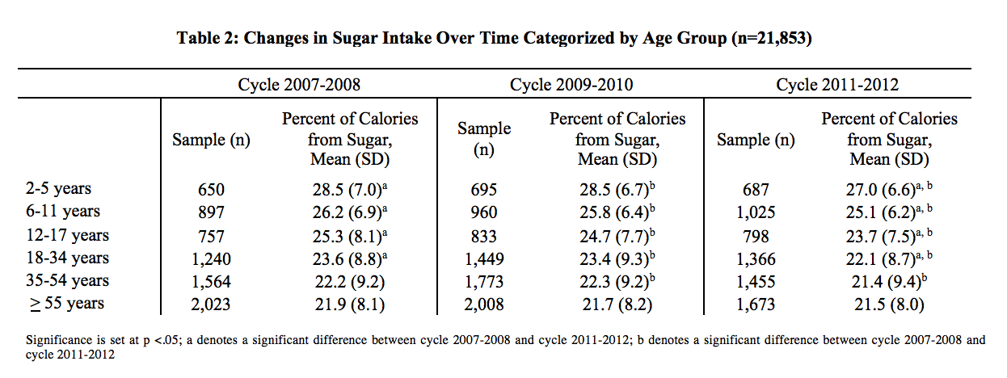
Significance is set at p <.05; a denotes a significant difference between cycle 2007-2008 and cycle 2011-2012; b denotes a significant difference between cycle 2007-2008 and cycle 2011-2012

To meet objective 2—which is to determine differences in sugar intake by demographic variables—ANOVA tests were completed for differences in sugar intake between age groups and different BMI classifications. A one-way analysis of variance was conducted to explore differences between age categories in 2007-2008 and sugar intake (represented as a percent of total calories). Post hoc comparisons were completed using a Scheffe correction.
Figure 1 represents these differences. There was a statistically significant difference in sugar intake between the six groups: (F_{5,7125} = 96.9, p < .001). The clinical difference in mean sugar intake between the groups was moderate (effect size using eta squared = .064). Post hoc comparisons indicated that the mean sugar intake of children aged 2-5 years (28.5 + 7.0 percent, n=650) was significantly higher than mean sugar intake of all other groups—6-11 years (n=897), 12-17 years (n=757), 18-34 years (n=1240), 35-54 years (n=1564), and > 55 years (n=2023)—with mean (SD) ranging from 21.9% (8.1) and 26.2% (6.9) (p < .001). Ages 6-11 years also differed significantly from all other age categories (p > .001) except for ages 12-17 years. As age increases, percent of calories from sugar decreases significantly.
Similar trends were seen in cycles 2009-2010 and 2011-2012. Shown in Figure 2 and Figure 3, represent the differences in sugar consumption between age groups. ANOVA tests were performed with Scheffe corrections. Figure 2 represents the cycle 2009-2010. The clinical difference in mean sugar intake between the groups was moderate (effect size using eta squared = .055). Trends in sugar intake significantly decreased as age increased (p < .001). Figure 3 represents the cycle 2011-2012. The clinical difference in mean sugar intake between the groups was moderate (effect size using eta squared = .052). Trends in sugar intake significantly decreased as age increased (p < .001).

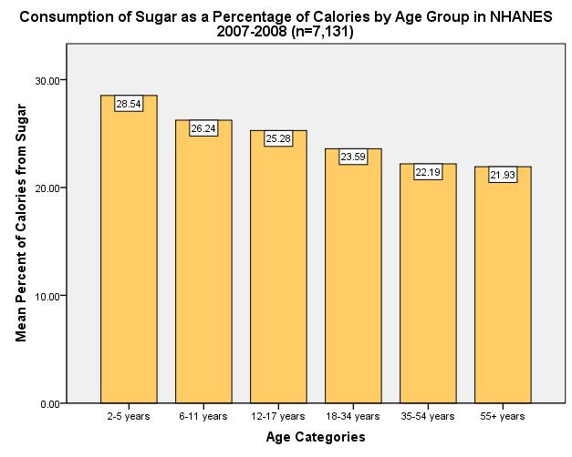
Figure 1. ANOVA analysis indicates a significant difference between age categories (2-5 years, 6-11 years, 12-17 years, 18-34 years, 35-54 years, and > 55 years) and sugar intake as a percent of calories (p < .001).

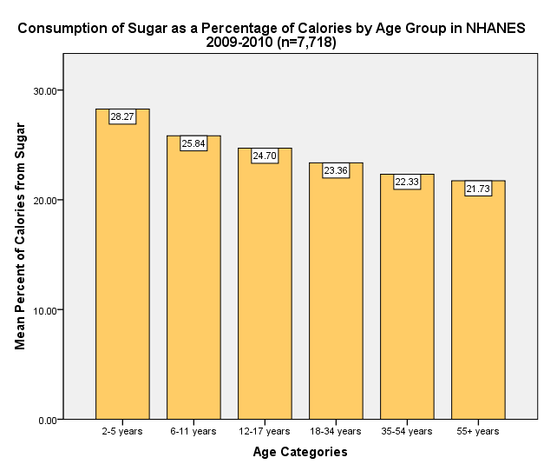
Figure 2. ANOVA analysis indicates a significant difference between age categories (2-5 years, 6-11 years, 12-17 years, 18-34 years, 35-54 years, and > 55 years) and sugar intake as a percent of calories in NHANES 2009-2010 data (p < .001).

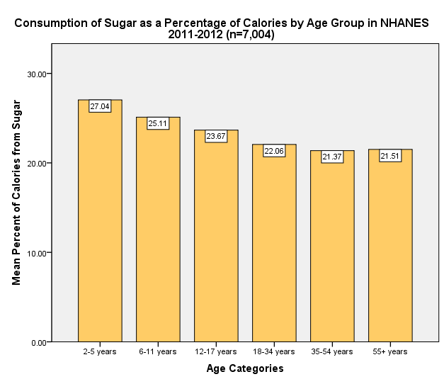
Figure 3. ANOVA analysis indicates a significant difference between age categories (2-5 years, 6-11 years, 12-17 years, 18-34 years, 35-54 years, and > 55 years) and sugar intake as a percent of calories in NHANES 2011-2012 data (p < .001).

To determine differences in mean sugar intake between BMI classifications, one-way analysis of variance was conducted. In the 2007-2008 cycle, there was a statistically significant difference in sugar intake for the groups (F_{5,4821} = 3.81, p = .002). Effect size using eta squared was 0.004, representing a small effect size. Post hoc comparisons indicated that the mean sugar intake of adults with a BMI < 18.5 (25.4 + 11.7 percent, n=86) was significantly higher than the mean sugar intake of adults with a BMI of 30.0-34.9 (21.8 + 8.8 percent, n=1021), (p = .017). Additionally, there was also a significant difference in grams of fiber per 1,000 calories between BMI groups (F_{5,4821} = 6.43, p < .001). Effect size was small, at 0.007. Post hoc comparisons indicated that the mean grams of fiber per 1,000 calories of adults with a BMI < 18.5 (6.7 + 3.8 grams, n=86) was significantly lower than the mean fiber intake of adults with a BMI of 18.5-24.9 (8.3 + 3.8 grams, n=1325, p = .014), 25.0-29.9 (8.5 + 3.9 grams, n=1654, p = .002), and 30.0-34.9 (8.3 + 3.6 grams, n=1021, p = .012).
In the 2009-2010 cycle, there were no statistically significant differences in sugar intake between the BMI classifications. There was a significant difference in grams of fiber per 1,000 calories between BMI groups (F_{5,5224} = 4.69, p < .001). Effect size was small, at 0.004. Post hoc comparisons indicated that the mean grams of fiber per 1,000 calories of adults with a BMI > 40.0 (7.8 + 3.5 grams, n=374) was significantly lower than the mean fiber intake of adults with a BMI of 18.5-24.9 (8.6 + 3.9 grams, n=1407, p = .044), 25.0-29.9 (8.8 + 3.9 grams, n=1741, p = .001), and 30.0-34.9 (8.7 + 3.7 grams, n=1126, p = .013).
In the 2011-2012 cycle, there were no statistically significant differences in sugar intake between the BMI classifications. There was a significant difference in grams of fiber per 1,000 calories between BMI groups (F_{5,4488} = 6.28, p < .001). Effect size was small, at 0.007. Post hoc comparisons indicated that the mean grams of fiber per 1,000 calories of adults with a BMI > 40.0 (7.8 + 3.4 grams, n=322) was significantly lower than the mean fiber intake of adults with a BMI of 18.5-24.9 (8.9 + 4.1 grams, n=1343, p = .003) and 25.0-29.9 (8.6 + 4.1 grams, n=1425, p = .001).

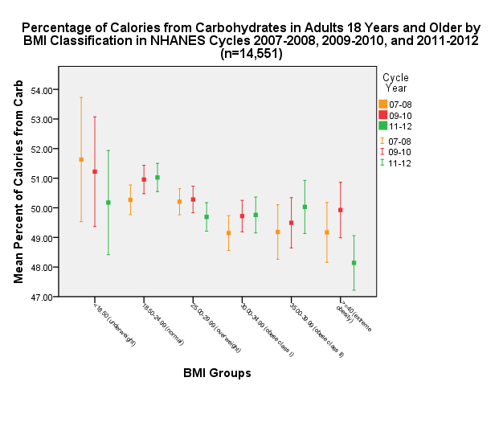
Figure 4. ANOVA analysis indicates a significant difference between BMI categories (underweight, normal, overweight, obese class I, obese class II, and morbid obesity) and carbohydrates as percent of calories in NHANES 2007-2008 (p = .003), 2009-2010 (p = .006), and 2011-2012 (p < .001).
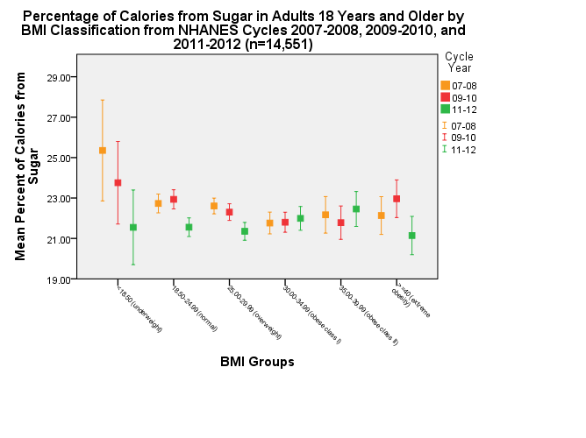
Figure 5. ANOVA analysis indicates a significant difference between BMI categories (underweight, normal, overweight, obese class I, obese class II, and morbid obesity) and sugar intake as percent of calories in NHANES 2007-2008 (p = .002) and 2009-2010 (p = .006).

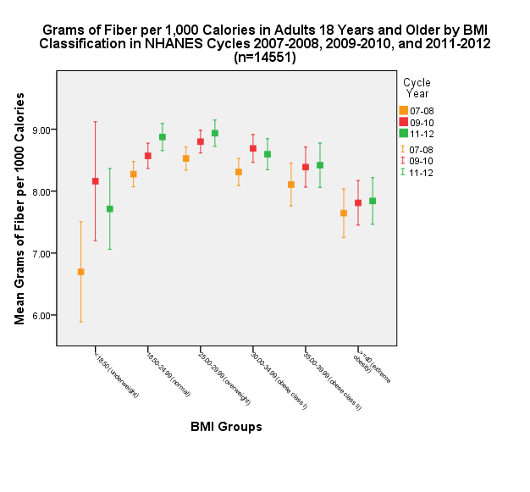
Figure 6. ANOVA analysis indicates a significant difference between BMI categories (underweight, normal, overweight, obese class I, obese class II, and morbid obesity) and fiber in grams per 1,000 calories in NHANES 2007-2008 (p < .001), 2009-2010 (P < .001), and 2011-2012 (p< .001).

Discussion
NHANES data suggests that the amount of sugar as a percent of calories has slowly been decreasing. From NHANES 2007-2008 cycle to 2011-2012 cycle, sugar as a percentage of total calories decreased in all age groups encompassing 2-54 year olds. Although many of the results were statistically significant, the clinical significance was less pronounced. For example, the mean sugar intake of 2-5 year olds decreased from 28.5% (SD 7.0) in 2007-2008 to 27.0% (SD 6.6) in 2011-2012. Based on a 2,000 calorie diet, this difference in percent of calories from sugar would only represent a 30 calorie decrease. One of the biggest concerns with increased sugar consumption is the overall affect it has on the diet. In other terms, sugar is replacing a percentage of calories that would be utilized by more healthy foods in the American diet.
Results from this analysis showed that more obese individuals were eating less calories from sugar compared to non-obese individuals. It is important in further research to consider other possibilities for obese status. There are many contributing factors to weight gain—including genetics, caloric intake and diet composition, and physical activity.
A cross sectional study, which aimed to determine particular foods and food groups associated with childhood obesity, found that more obese children ate more meat and meat alternative, grain products, sugar-sweetened beverage, and potato chips—which all contributes to a high fat, high sugar diet. Sugar-sweetened beverage consumption was only significantly greater in boys ²². This coincides with findings by Ogden and colleagues, which endorsed and increase in obesity among adolescent males ⁸. Gillis et al. found that fruit and vegetable consumption was similar between non-obese and obese children; however, the obese children ate more high fat and high sugar foods. Ultimately, the obese children were eating significantly more calories per day [mean (SD), 2720 (950)] than their non-obese counterparts [2143 (562)] (p < .001) ²². These findings suggest that total calories, along with high sugar intake, may contribute to childhood obesity.
As stated earlier, overall trends of sugar intake seem to be decreasing based on the findings of this study. Previous researchers who conducted a similar cross-sectional study using NHANES data found similar results from 1999-2008 ²³. Welsh and colleagues found that the percentage of total energy from added sugars decreased from 18.1% to 14.6% from 1999 to 2008²³.
The percent of calories from sugar is higher in lower BMI classifications. This is not conclusive with the studies hypothesis. Additionally, fiber intake in underweight (< 18.5 BMI) is significantly lower than overweight and obese individuals. This suggests that the diet composition of underweight individuals is less healthy than obese individuals.

Limitations
A major strength to this study is the use of a nationally representative sample. For this reason, the results are generalizable to the US. Additionally, the sample size was large enough to find significance.
A limitation to this study is the study design. Because the study is an epidemiological cross-sectional study, the results are not able to demonstrate causation. This type of study is only able to determine associations. Additionally, there may be recall bias. Because the participants are asked to provide a diet recall, more overweight individuals-especially women—are more likely to underestimate their daily caloric intake. For this reason, the results may be skewed.

Conclusion
With the knowledge that sugar consumption as a percent of total calories is highest in children aged 2-5 and obesity has significantly increased in adolescent boys, dietetic professionals can target these two groups. Additional studies need to examine the long-term effects of increased sugar consumption, especially considering the high percentages of calories from sugar in children.

References
1. Ng M, Fleming T, Robinson M, et al. Global, regional, and national prevalence of overweight and obesity in children and adults during 1980-2013: A systematic analysis for the global burden of disease study 2013. Lancet. 2014;384(9945):766-781.
2. Stipanuk M. Carbohydrate metabolism: Synthesis and oxidation. In: Biochemical, physiological, and molecular aspects of human nutrition. Elsevier Health; 2013:209-210-255.
3. Welsh JA, Sharma A, Abramson JL, Vaccarino V, Gillespie C, Vos MB. Caloric sweetener consumption and dyslipidemia among US adults. J Am Med Assoc. 2010;303(15):1490-1497.
4. Bigornia SJ, Lavalley MP, Noel SE, Moore LL, Ness AR, Newby P. Sugar-sweetened beverage consumption and central and total adiposity in older children: A prospective study accounting for dietary reporting errors. Public Health Nutr. 2015;18(7):1155-1163.
5. Huang C, Huang J, Tian Y, Yang X, Gu D. Sugar sweetened beverages consumption and risk of coronary heart disease: A meta-analysis of prospective studies. Atherosclerosis. 2014;234(1):11-16.
6. Geneva: World Health Organization. Sugars intake for adults and children. . 2015.
7. Flegal KM, Carroll D, Kit BK, Ogden CL. Prevalence of obesity and trends in the distribution of body mass index among US adults, 1999-2010. J Am Med Assoc. 2012;307(5):491-497.
8. Ogden CL, Carroll MD, Kit BK, Flegal KM. Prevalence of obesity and trends in body mass index among US children and adolescents, 1999-2010. J Am Med Assoc. 2012;307(5):483-490.
9. Centers for Disease Control and Prevention, National Center for Heath Statistics. About the national health and nutrition examination survey. http://www.cdc.gov/nchs/nhanes/about_nhanes.htm.
10. Centers for Disease Control and Prevention, National Center for Heath Statistics. National health and nutrition examination survey, 2011-2012, demographic variables and sample weights (DEMO_G). http://wwwn.cdc.gov/Nchs/Nhanes/2011-2012/DEMO_G.htm.
11. Centers for Disease Control and Prevention, National Center for Heath Statistics. National health and nutrition examination survey, 2009-2010, demographic variables and sample weights (DEMO_F). http://wwwn.cdc.gov/Nchs/Nhanes/2009-2010/DEMO_F.htm.
12. Centers for Disease Control and Prevention, National Center for Heath Statistics. National health and nutrition examination survey, 2007-2008 data, demographic variables and sample weights (DEMO_E). http://wwwn.cdc.gov/Nchs/Nhanes/2007-2008/DEMO_E.htm.
13. Centers for Disease Control and Prevention, National Center for Heath Statistics. National health and nutrition examination survey, 2011-2012, dietary interview - total nutrient intakes, second day (DR2TOT_G). http://wwwn.cdc.gov/Nchs/Nhanes/2011-2012/DR2TOT_G.htm.
14. Centers for Disease Control and Prevention, National Center for Heath Statistics. National health and nutrition examination survey, 2011-2012, dietary interview - total nutrient intakes, first day (DR1TOT_G). http://wwwn.cdc.gov/Nchs/Nhanes/2011-2012/DR1TOT_G.htm.
15. Centers for Disease Control and Prevention, National Center for Heath Statistics. National health and nutrition examination survey, 2007-2008, dietary interview: Total nutrient intakes -- second day (DR2TOT_E). http://wwwn.cdc.gov/Nchs/Nhanes/2007-2008/DR2TOT_E.htm.
16. Centers for Disease Control and Prevention, National Center for Heath Statistics. National health and nutrition examination survey, 2009-2010, dietary interview - total nutrient intakes, second day (DR2TOT_F). http://wwwn.cdc.gov/Nchs/Nhanes/2009-2010/DR2TOT_F.htm.
17. Centers for Disease Control and Prevention, National Center for Heath Statistics. National health and nutrition examination survey, 2009-2010, dietary interview - total nutrient intakes, first day (DR1TOT_F). http://wwwn.cdc.gov/Nchs/Nhanes/2009-2010/DR1TOT_F.htm.
18. Centers for Disease Control and Prevention, National Center for Heath Statistics. National health and nutrition examination survey, 2007-2008, dietary interview: Total nutrient intakes -- first day (DR1TOT_E). http://wwwn.cdc.gov/Nchs/Nhanes/2007-2008/DR1TOT_E.htm.
19. Centers for Disease Control and Prevention, National Center for Heath Statistics. National health and nutrition examination survey, 2007-2008, body measures (BMX_E). http://wwwn.cdc.gov/Nchs/Nhanes/2007-2008/BMX_E.htm.
20. Centers for Disease Control and Prevention, National Center for Heath Statistics. National health and nutrition examination survey, 2009-2010, body measures (BMX_F). http://wwwn.cdc.gov/Nchs/Nhanes/2009-2010/BMX_F.htm.
21. Centers for Disease Control and Prevention, National Center for Heath Statistics. National health and nutrition examination survey, 2011-2012, body measures (BMX_G). http://wwwn.cdc.gov/Nchs/Nhanes/2011-2012/BMX_G.htm.
22. Gillis LJ, Bar-Or O. Food away from home, sugar-sweetened drink consumption and juvenile obesity. J Am Coll Nutr. 2003;22(6):539-545.
23. Welsh JA, Sharma AJ, Grellinger L, Vos MB. Consumption of added sugars is decreasing in the united states. Am J Clin Nutr. 2011;94(3):726-734.

Appendix A: Population Schematic
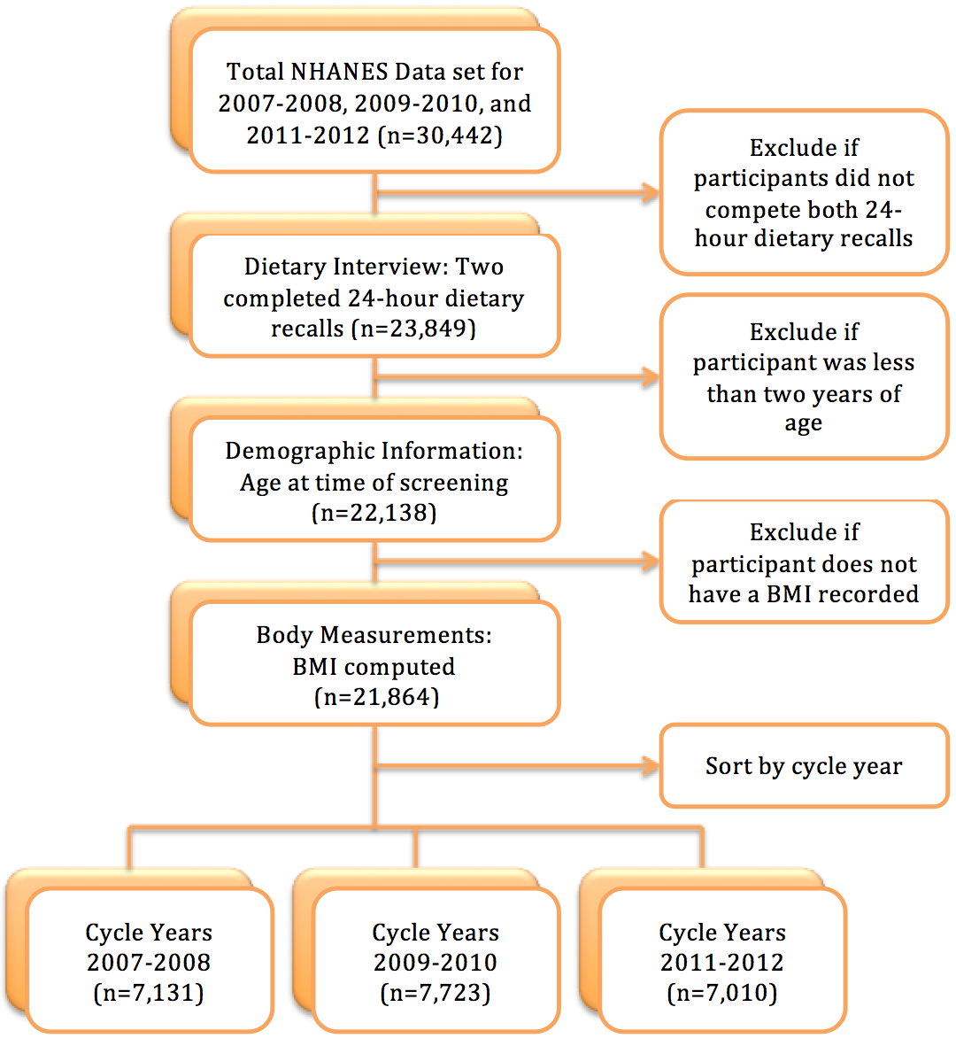

Appendix B: Variable List
Gender
Responses to RIAGENDR
1 = male
2 = female

Age
Responses to RIDAGEYR
Number of Years ≥ 2 and collapsed
1 = 2-5 years
2 = 6-11 years
3 = 12-17 years
4 = 18-34 years
5 = 35-54 years
6 = ≥ 55 years

Race/Ethnicity
Responses to RIDRETH1
1 = Non-Hispanic White
2 = Non-Hispanic Black
3 = Mexican American
4 = Other Hispanic
5 = Other Race

Poverty-to-Income Ratio (PIR)
Responses to INDFMPIR
Range from 0 – 5 (collapsed)
1 = <1.3
2 = 1.3-3.5
3= >3.5

Education Level
Responses to DMDEDUC2 (Reference Adult)
1 = Less than 9th grade
2 = 9-11th grade
3 = High school graduate/GED
5 = some college or AA graduate
5 = College graduate or above

Annual Household Income
Responses to INDHHIN2
Range from $0-$100,000+ (collapsed)
1 =$20,000
2 = $20,000-$54,999
3 = < $55,000

BMI Classification
Responses to BMXBMI
Range of values from 12.4 to 82.1 (collapsed)
1 = Underweight (<18.5)
2 = Normal (18.5-24.9)
3 = Overweight (25.0-29.9)
4 = Obese Class I (30.0-34.9)
5 = Obese Class II (35.0-39.9)
6 = Extreme Obesity (>40.0)

Appendix C: Output Files

