Pearle Vision: Seeing Clearly

By: Daniel Schneider, Benjamin Studt, Rishi Shah
Marketing Strategy: 550
December 11, 2014

History:
Dr. Pearle started Pearle Vision in 1951 out of a 5-employee office in Savannah, Georgia. The eye-care company underwent rapid expansion, with the company going public in 1963. By the end of 1966, the company had grown to over 100 stores located throughout the nation. Consumers formed a connection with the brand image and message Pearle Vision was promoting at the time. These campaigns featured a personable doctor; Dr. Pearle was the actual inspiration, who gave individual attention to each patient that came through the door. Coupled with the slogan “Nobody cares for eyes more than Pearle” exemplified the personal touch with consumers that Pearle was trying to promote.
In 1981, the company felt secure enough in their position within the market to license out their brand to other eye doctors. These franchises of course would pay a royalty, 15%, back to Pearle Vision for revenue purposes, as well as funding a companywide advertising campaign. Pearle Vision had also decided to head into the vision insurance business launching a vision benefits company which provided plans to care providers. The success of Pearle Vision had garnered the attention of Grand Metropolitan; a global food and beverage Company based out of the U.K. who acquired Pearle Vision in 1985 with the hopes of expanding the brand into the global market. By 1990, Pearle Vision had grown to over 1,200 stores spread throughout the United States as well as an international presence in Japan and parts of Europe.
However, despite this success, all was not well with Pearle Vision. A combination of factors including a recessed economy, growing competition within the market, and Pearle Vision’s rapid expansion without a clear company goal led to financial trouble. Pearle Vision scrambled to re-establish itself as the premiere eye-care company in the market. Leadership within the company was divided on to move forward and consumers began to become dissociated with the Pearle Vision brand. LensCrafters capitalized on Pearle Visions indecisiveness, taking the position of the world’s premiere eye-care retailer from Pearle Vision in 1994.
Cole-National, an international optical retailer acquired Pearle Vision in 1996. Having already acquired Sear’s and Target Optical, the acquisition of Pearle Vision made Cole-National the second largest optical retailer in the United States. Despite this change in leadership, the Pearle Vision brand still underperformed within the market. In 2004, Luxottica acquired Cole-National and immediately began to consolidate the company’s newly acquired brands within its offices located in Cincinnati, Ohio. At the time, Pearle Vision was operating around 800 store locations. Half of which were franchise locations and the other half corporately owned stores. Luxottica operated 18 distribution centers worldwide, including 8 in the U.S. The Lenscrafter brand was also under Luxottica’s brand portfolio, giving the company the number 1 and 2 leaders in the eye care market. Luxottica’s goal was clear eliminate any competition, penetrate emerging markets on the global level, and exploring new methods of distribution of their eye care brands.

Strengths:
Despite the struggles of Pearle Vision, the company has many key strengths that can play a role in revitalizing the brand. First, consumers will always have a need for the eyeglass wear that Pearle Vision is selling. Adults with vision problems account for 75% of the U.S. adult population, a total 181 million total people. The size of this customer base alone is enormous. On average, these customers need to make repeat purchases every 2.2 years. Pearle Vision’s service to their customers is one way the company could focus to differentiate from the competition. Upon entering a store, customers typically have not decided have what to buy and lack the knowledge to shop for the best deal available. The convenience of being able to receive an eye exam from an Optometrists or Ophthalmologists and then immediately shop for glasses afterwards is a convenience that customers value. This also goes back to the original message that connected costumers with the Pearle Vision brand, the doctor patient relationship. Keep in mind this accounts for consumers who actually have a need for the product to be able to see properly. This does not take into account fashion trends of buying eyeglasses to wear.

Weaknesses:
Pearle Vision has weaknesses that could impede the recovery process unless corrected. Consumers have come to view retailers such as LensCrafters and Pearle Vision who carry premium brand frames as overpriced. Pearle Vision offers a wide variety of products priced across several ranges. The expensive line of frames, with brands such as Burberry and Versace, were sold for $200 to $400 a piece. While medium level frames, Ray-Ban or Vogue, typically ran for $150 to $250. Pearle Visions lower level frames run from $80 to $150. With the economy being in recession, Pearle Vision suffered from consumers being unwilling to pay the higher price for their products and chose instead to purchase cheaper substitute products.
From a different angle, many consumers look to shop at retailers that are covered under personal vision insurance plans. VSP (Vision Service Plan) the largest vision insurance provider within the United States was not in business with Pearle Vision at the time, eliminating a large portion of potential customers. Luxottica had been trying to compete by promoting their vision insurance provider, Eye-Med.
Also a concern for Pearle Vision was the uneven service and performance among store locations, primarily the franchise stores. This lack in service was attributed to two variables, a lack of involvement from the stores (both corporate and franchise locations) within the surrounding community. Quality of stores locations also varied with many operating out of low customer volume areas.
On the service level, a standard Pearle Vision store will offer customers the opportunity to complete the entire eye care experience with a single visit. Optometrists or Ophthalmologists, which could perform eye exams regularly, were also seeing less return business.

Opportunities:
Pearle Vision can look to take advantage of the new resources available to their stores after being acquired by Luxottica. For example, Luxottica is piloting providing all store locations under their corporate umbrella the ability to sell the entirety of Luxottica frames collection. With Luxottica’s goal being to limit the amount of outside vendors their store locations are able to buy from. Currently, an estimated 64 other vendors were selling 640 brands to Luxottica owned brand stores, which has led to an oversaturation of brands within stores. Luxottica hopes to narrow that number down to 5 national vendors that Luxottica affiliates will exclusively buy from. This in turn could eliminate confusion among stores and help lessen the price of frames.
Pearle Stores were underperforming due to poor location, staffing standards, and overall condition of the buildings. Due to this, Pearle Vision is condensing their corporate store count to a total of 50 to refocus on quality of both service and location. In moving forward with franchise locations, Pearle Vision will push to have greater control on the areas selected as well as standardizing the customer experience offered by each location.
Another issue to be addressed is incentivizing young eye doctors that are recent medical school graduates to staff store locations. The pitch to these doctors includes the opportunity to gain knowledge, experience, and well-paying job straight out of school. Perhaps these doctors would one day want to open their own practice? Pearle Vision wants to offer that opportunity as well. Having a doctor who is heavily invested in the success of the store could lead to greater store success, including re-establishing a relationship with the community through branding. This could be an opportunity for Pearle Vision to bring back a previous successful consumer brand image with a friendly familiar doctor within the store to help bring back a personal feel.

Threats:
A threat impeding Pearle Vision’s success lies with their own vision insurance company EyeMed, who is also owned by Luxottica. EyeMed is currently the second largest insurance provider at just over 23 million members. With a network of over 17,000 eye doctor employees across the U.S and nearly 5000 companies who accept EyeMed insurance. A membership with EyeMed allows consumers to shop at a discount at any Luxottica retail store. It estimated that 50% of consumers choose their eye retailer based on where they receive coverage. While these are perceived benefits that many consumers will be satisfied with, Pearle Vision must reach out to consumers not under EyeMed benefits as well.
Pearle Vision was also suffering from the threat of becoming obsolete within the consumers mind. The keywords that consumers applied to their brand image of Pearle Vision included “expensive and fading”. This type of negative connotation with brand identity could threaten future new and continued customer business.

Problems:
The primary problem within Pearl Vision is that they were seeing declining market shares spurred on by fading consumer trust and loyalty and the recession. Pearl Vision, once the largest optical retailer in the world, was over taken by LensCrafters in 1994 and was unable to rebound. Since 2006 the sluggish economy caused the eyewear market to flatten due to consumers foregoing eye exams and new purchases or trading down to over the counter “readers”.
Pearle Vision’s secondary problems are numerous and include the recession that had continued since 2006, years of inconsistent marketing, a lack of discipline within the retail stores themselves as well as in real estate selection for the corporate stores, loss of consumer loyalty, Pearle Vision’s integration into the Luxottica group, and changes in the insurance landscape.

Proof and Symptoms:
Pearl Vision had lost its mark as the largest optical retailer in the world when overtaken by LensCrafters in 1994. Based on the 2012 Pearle Vision Study (Exhibit 3) Pearle Vision was seen as “trusted but fading eye care brand” and “convenient, expensive, but discounted”. Consumers did not see them as a cost, eye care, or fashion leader. They were largely seen as in the middle ground in all categories but unable to give the best value in any category to the consumer. Exhibit 10, Positioning of Pearle Vision Brand, 2009 shows that they are high in price and good in fashion but not the best. Exhibit 11, Clarity of Optical Retailers’ Brand Image, Consumer Survey Results, Q4 2012 shows that consumers ranked Pearle Vision in the lower half of retailers for Brand Image clarity. Consumers did not know what Pearle stood for and what benefits they offered. Exhibit 15, Traffic Funnel, Optical Retailers, Q4 2012 gives further proof to the fact that consumers did not understand what Pearle Vision stood for. Even though 76% of consumers were aware of Pearle Vision, only 16% were highly likely to consider them, and even less, 7%, had actually shopped there in the past year.
Inconsistencies seen throughout the network of stores as well as the discontent between owners/managers and doctors also show that Pearle Visions problems are real. Due to the weak onboarding and oversight of franchisees, store processes and customer experiences varied widely. Only some franchisees participated in the STARS program to buy frames while others bought frames from other sales representatives. Some stores advertised locally while others relied solely on the corporate efforts. The doctor-franchisee relationship at some locations was rocky at best while others were great. Customer A could go to a select well-lit store and receive great customer service via an eye exam, a wide selection of frames, and friendly staff to help them through the choosing process, while customer B could go to a different store, not receive his exam since the doctor was not in, have a smaller variety of frames, and less help in choosing.

Problem Relation:
Many of Pearle Visions’ problems are due to the lack of onboarding, managing contractual rights, aligning standardized operating processes, maintaining focus on a singular marketing tactic, and the continued recession. By allowing each owner to make up their own rules and running many different marketing campaigns in short succession, they confused potential customers and left them unsure of what Pearle Vision stood for. Due to the recession and increased consumer awareness, customers were choosing to either save money and go with cheaper options or go with fashion and choose LensCrafters or equivalent stores, this was being done to get the best value from their purchase.

Ramifications:
Due to the inconsistencies within Pearle Vision and the problems they were facing, short term consequences included Pearle Vision facing loss of market share and revenue flows, brand image confusion and detraction, and loss of customer loyalty. In the long term, if not managed properly, their store image would further confuse consumers and push them away losing their loyalty. If this continues, they will see profit loss which, if significant, could cause Luxottica to sell the business or discontinue the brand and shut it down.

Formulating and Evaluating Alternatives

Tighter controls on Franchisees
The Luxottica Group and Srinivas Kumar are aligned to closing down underperforming corporate stores while focusing on maintaining and expanding franchisee locations of Pearle Vision. Focusing on expanding more on franchisees will reduce capital costs for the Luxottica Group while expanding the Pearle Vision brand. Through franchisees, the Pearle Vision brand can more easily expand sales through new locations while diversifying risk between the franchisee and Luxottica. Having a strong franchisee Pearle Vision business will provide a competitive advantage and a point of differentiation in Luxottica’s brand portfolio in the eye care space. However, managing a relationship with entrepreneurs present unique challenges: how can you harmonize brand identity and equity with a multitude of brand owners many having different objectives, goals, and expectations.
Since Pearle Vision would like to establish a stronger brand identity, the corporation may think about placing tighter controls on franchisees to create harmonized brand equity across store locations. However, the corporate office must decide on specific elements to strongly control. For instance, mandating each Pearle Vision location to have in-store labs could have several advantages and disadvantages for different parties within the franchisee-franchisor relationship. Harmonizing in-store labs could create ample brand management since customers know they will get technical service backing premium eye care service as part of Pearle Vision. However, extra capital must come from the franchisee creating extra burden on the small business owner. Ultimately, the franchisor must identify whether having in-store labs creates quicker turnaround time for the product to the customer. Also, they must identify whether the quicker turnaround time generates value to the customer creating repeat transactions and cheap word-of-mouth marketing. Identifying and distilling this data could provide an attraction for franchisees to spend more capital on an in-store laboratory to help boost sales and repeat purchases. Creating locations with mandatory in-store labs could help provide relational value for customers placing stronger emphasis on speed of getting their eye care products.

Focus on Small Business Optometrists Only
Luxottica should focus on finding optometrists (OD) to become small business entrepreneurs to run Pearle Vision Franchises instead of finding opticians and ophthalmologists to manage store locations. Since optometrists can be dual-hatted, leading the eye care exams and manage the eye wear business, there would be a reduction in leadership personalities within each store location. Reducing these personalities can allow for faster decision-making and transparent accountability for the store’s business performance. A common theme for struggling franchisees lead by an optician and an eye doctor was a difference of opinion and blame of the other party for certain short-comings when the business was not performing appropriately. Also, since opticians have only an annual income of $33,000, there would be considerable financial strain and dependence on the OD solely making revenue via eye exams. A strong and healthy relationship between the optician franchisee and the OD can create a successful Pearle Vision business. Also, it’s easier for Pearle Vision to communicate the financial advantages of having an OD-owned franchise since a Pearle Vision OD makes more income than an independent OD-owned practice (Exhibit 13). The financial benefit for ophthalmologists having a Pearle Vision franchise may be difficult to communicate since the starting average salary for ophthalmologists are so high. Pearle Vision should be catering to influence small business owners through their harmonized tools to collectively build the small business and brand. Pearle Vision should not babysit and manage the potential cantankerous relationship between doctor and the optician franchisee, which a key distraction differentiating successful and weak franchises.

Case Study of Warby Parker to improve customer value
A radical change for Pearle Vision could be to focus on improving online sales in order to diversify from brick-and-mortar stores. A relatively new competitor called Warby Parker (WP) sends glasses and sunglasses directly to homes providing relational value through convenience, great customer online service, and emphasizing corporate social responsibility. Warby Parker started from placating a key consumer tension by making designer glasses more affordable to consumers. WP designs and manufactures its own frames and lenses that focus on providing stylish and designer looking options to young consumers aged 13-35. These consumers will go online to pick their desired styles of eye wear, and Warby will mail the glasses directly to the consumer (Exhibit 2 and 3).
Warby provides convenience to consumers by shipping glasses and sunglasses directly to the consumer with a no questions asked money-back guarantee. A key convenience and customer service feature for Warby is the free 5-pair home trial service. Customers can go online to pick their 5 best frames to add into the trial cart. These 5 pairs will ship directly to the customer. The customer will try on the different frames, and have a five day limit to send the 5 pairs back to Warby Parker free of charge. The customer can either purchase the desired pair(s) or pick another 5 to try on. Once the final frame style is decided, the customer will take a webcam facial picture and send the doctor’s eye prescription to assemble an appropriate pair of glasses. Even if the purchased frame fitted with the prescription lenses does not provide a satisfying look, the customer can send the whole pair of glasses back to Warby Parker with a full refund. Warby creates exceptional customer service forming a trusted relationship by providing convenience and flexibility through its online platform.
Recently, Warby created brick and mortar stores in several US cities to attract an older audience less apt and apprehensive of purchasing frames and lenses online. Diversifying with brick and mortar coupled with a strong online stores will cause Luxottica to lose retail share on frames. Strengthening Pearle Vision’s online capability to create online sales is imperative to win with the 21st century consumer. Currently, prospective customers can only view, but not purchase frames from the Pearle Vision website. The final Pearle Vision sale is still contingent on the customer traveling to the store to buy a pair of frames. This model could become archaic and less cost effective to the customer similar to contact lenses. Contact lenses sold online are on average $15 less expensive than those sold offline.
Warby Parker provides emotional value to the customer through its corporate social responsibility plan called “Buy A Pair, Give A Pair”. When customer purchase a pair of glasses, Warby Parker will donate a pair of glasses to a non-profit organization based in third world countries such as India and San Salvador. These non-profit organizations will train local eye glass sellers to sell these eye glasses for a fraction of the true retail value. This “Buy A Pair, Give A Pair” program has provided over a 1 million pairs of glasses to people in need of a cheap solution. The non-profit organization that receives the glasses can train and create local employees creating jobs in these less fortunate countries. The program ultimately helps those in need of eye wear for much cheaper solution through Warby’s donations. This CSR program is deeply rooted in the Warby Parker culture creating a philanthropic benefit to customers and employees. This creates undeniable value since customers make a higher order difference with a purchase of Warby Parker glasses – this should create lifelong repeat customers.
Pearle Vision’s OneSight program provides valuable eye care programs to help identify eye care problems in less fortunate areas, but does not facilitate the purchase of glasses of those in need. Also, the OneSight program asks for donations from customers creating an additional step for customers to help in their corporate social responsibility program. Consequently, each Warby Parker customer is directly involved in their corporate social responsibility plan by making a purchase – no further donations are needed. This easy process creates a personalized connection among the customer, Warby Parker, and the less fortune, nonprofit agent. While some may think that spending too much on CSR can negatively affect returns, the opposite is true. Kellogg University found that companies whose CSR spending exceeds investor expectations experience more positive stock returns. Pearle Vision may want to create more personalized approaches to their CSR programs to help gain the emotional customer value.

Recommendations
The Pearle Vision corporate office should continue to harmonize and tighten their controls on format of the store to encourage a harmonized brand identity. A key recommendation would be to ensure that the same customer can access the same products and receive the same level of customer service with different Pearle Vision locations. For instance, each Pearle Vision should have an in-store lab to ensure the customer receives the same level of service when purchasing lenses. Making sure there is the same wait time for processing and assembling of lenses at each Pearle Vision location establishes harmonized service. The corporate company should help providing funds to develop a functioning and quality laboratory. The Pearle Vision franchise development team would need to own this initiative of putting labs in each Pearle Vision location. The labs should be relevantly small, but should allow proper assembling of lenses to frames. Creating this service would be similar to the Amazon Prime service of 2-day shipping. The Pearle Vision marketing team would need to provide a similar approach by saying “ready lenses in 2 hour”. The marketing team could investigate a campaign and feasibility of getting both eye exam and lenses in 2 hours - “See Clearly in Two Hours”. This campaign could reinforce the strength of providing fast, efficient eye exams, frame repair, or assembling of lenses. First, the corporate office could investigate whether each location has the resources to support quality service and claim.
A successful outcome for Pearle could be similar to the customer experience at other brand franchises such as McDonald’s or Holiday Inns. For example, if consumers can pinpoint similar experiences with Pearle Vision, then this would carve out a brand identity and equity. For instance, when consumers go to a McDonalds, they know they can always get a Big Mac and fries satisfying their hunger. Consumers staying at a Holiday Inn Express know they can get a complimentary hot breakfast and high-speed wifi. These clear benefits are articulated consistently amongst consumers independent of store location. Customers must agree that they can get quick eye care with quick lenses assembly at each location. “Seeing Clearly” in less time could be the competitive advantage and brand identity for Pearle Vision.
The Pearle Vision team would need to decide on which Warby Parker’s elements to use to further drive customer service. Pearle Vision could utilize their existing website, which has several frame styles pictures but no option to try on. An option on site could be to pick and send these styles to consumers’ homes. They could try these styles at home, and give them back to the nearest Pearle Vision store. This could provide relational value to consumers looking for convenience. In order to deliver on this customer service idea, Pearle Vision would need to invest heavily on logistics and shipping of frames. There may be significant synergies with the marketing department to create campaigns with their new look with their new glasses. This could provide inspirational and marketing provided by the customer instead of the parent company. Pearle Vision could also invest in a deeper CSR program to help low income consumers in various regions acquire reading glasses to help them in schools.

Exhibit 1. Pearle Vision Website Screenshoot. This image only has the brand names and no pictures of real frames.
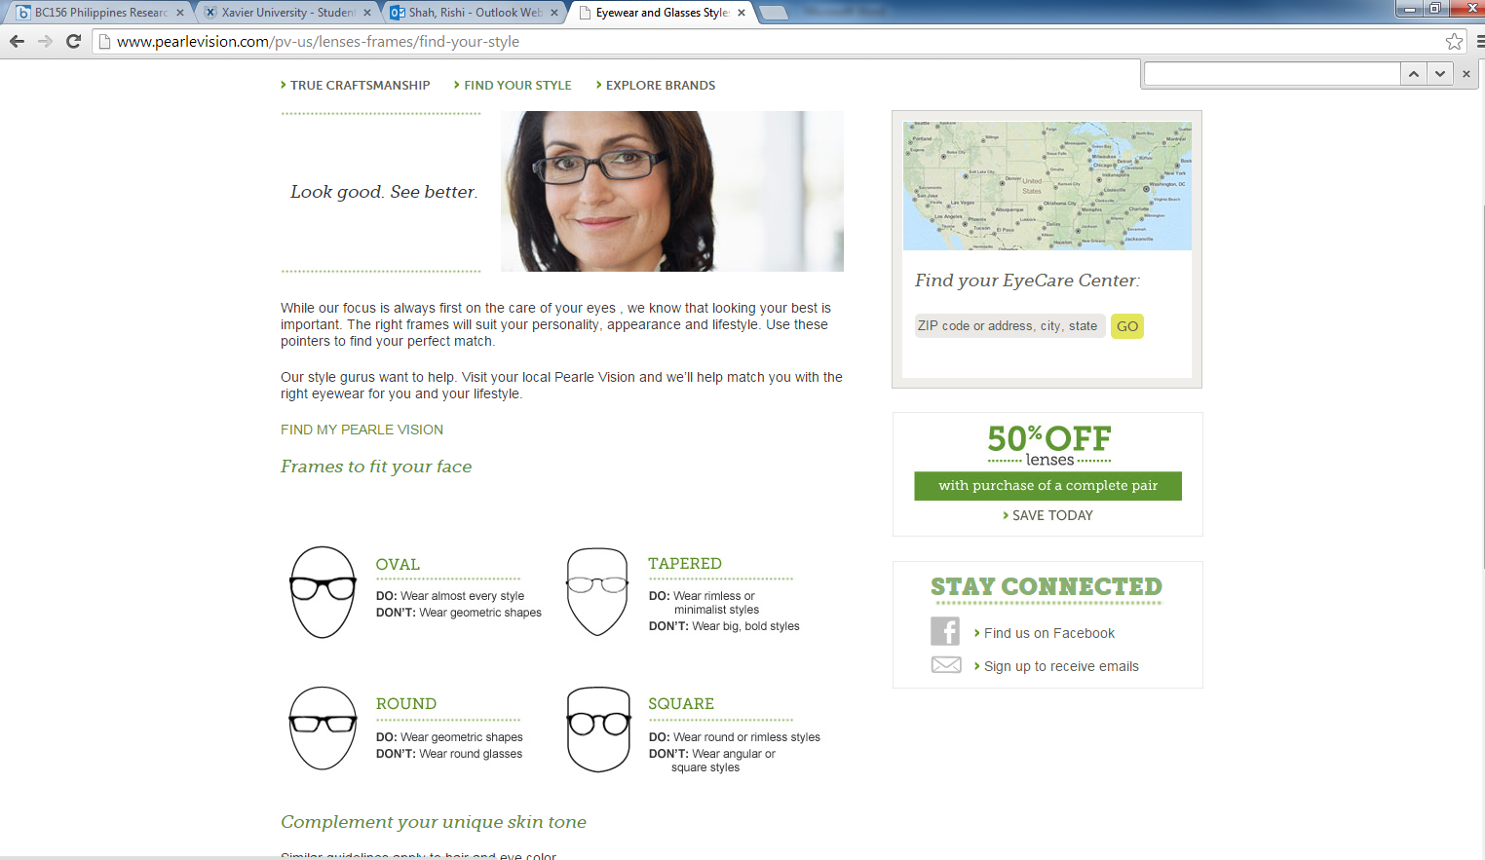

Exhibit 2. Warby Parker Website. Shows different frame styles.
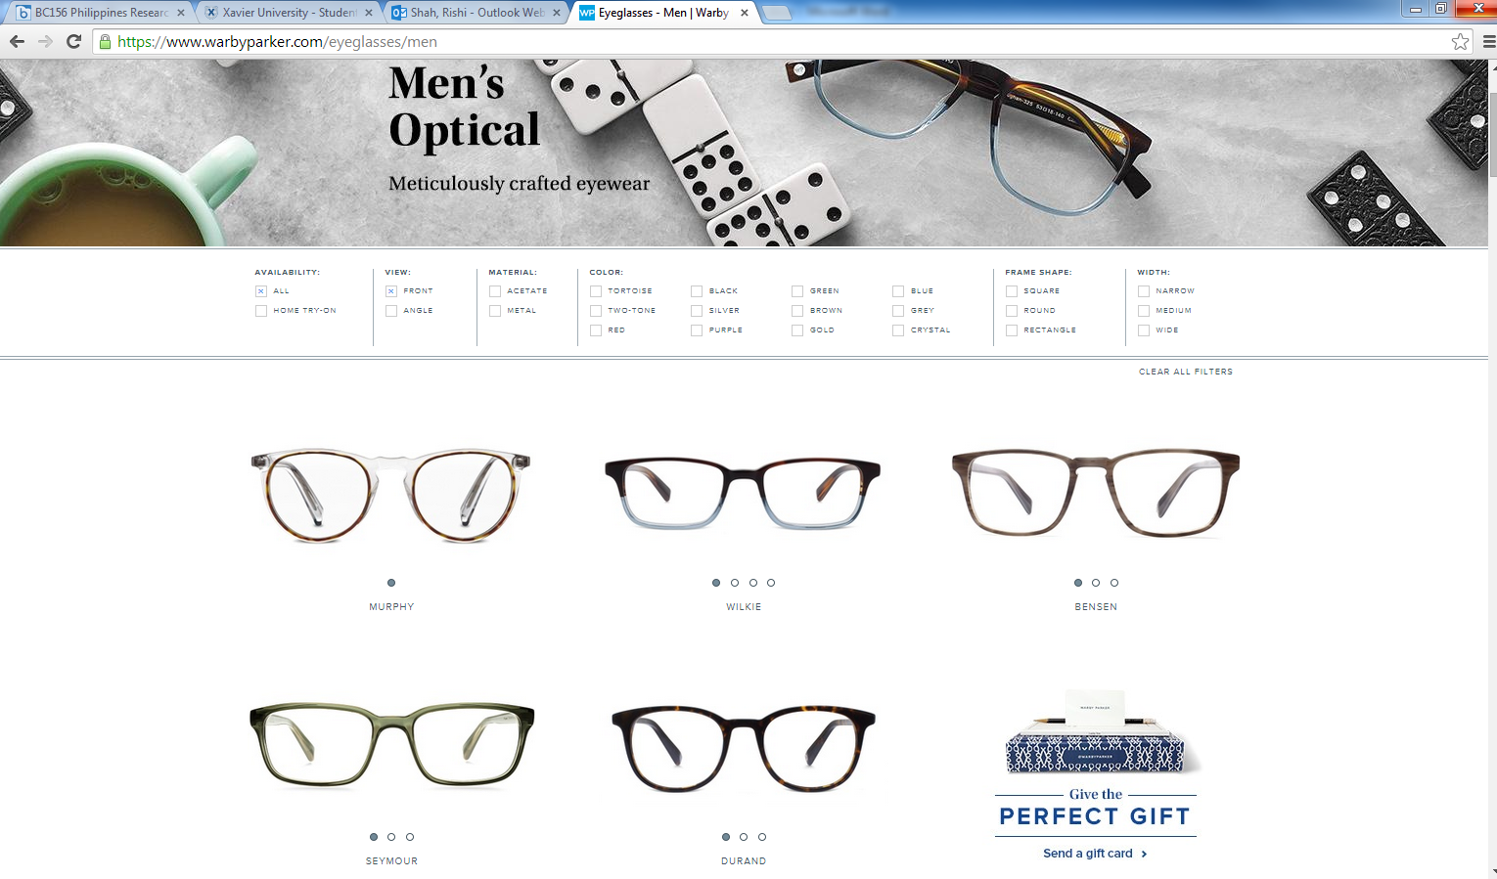

Exhibit 3. Warby Parker Buying/Trying Options
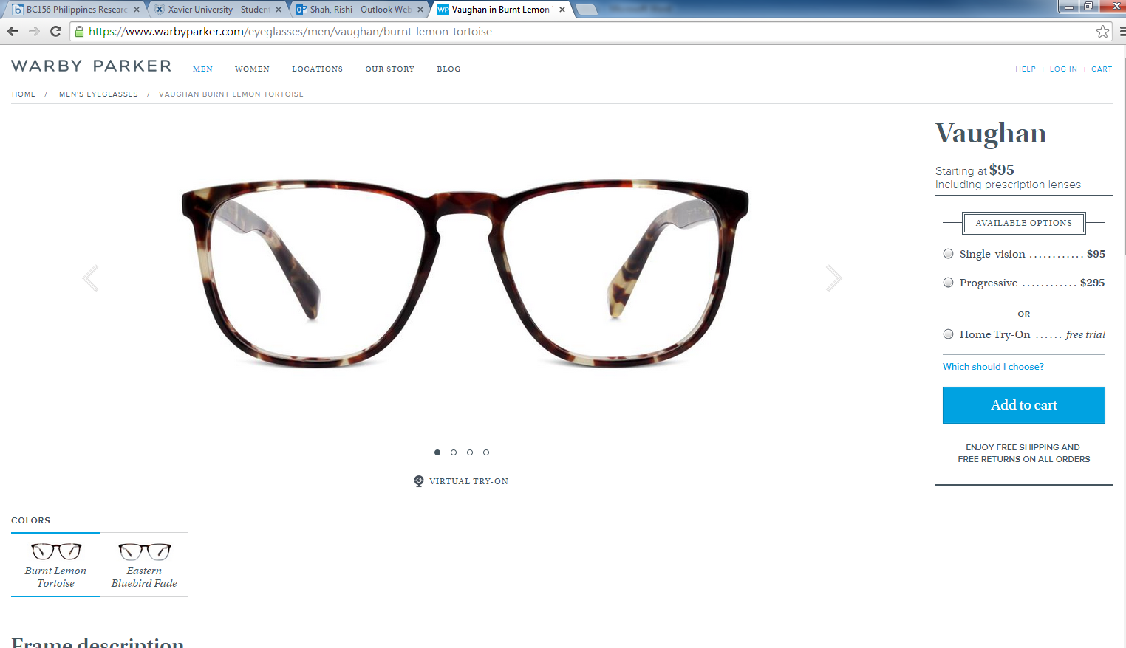

https://www.warbyparker.com/history 06 December 2014.
The Strength of Competition in the Sale of Rx of Contact Lenses: An FTC Study. < <http://www.ftc.gov/sites/default/files/documents/reports/strength-competition-sale-rx-contact-lenses-ftc-study/050214contactlensrpt.pdf>
https://www.warbyparker.com/buy-a-pair-give-a-pair 06 December 2014
https://www.warbyparker.com/buy-a-pair-give-a-pair 06 December 2014
Lys, Thomas, et al. “Pinpointing the Value in CSR.” March 4 2013. http://insight.kellogg.northwestern.edu/article/pinpointing_the_value_in_csr/ visited 05 December 2014

