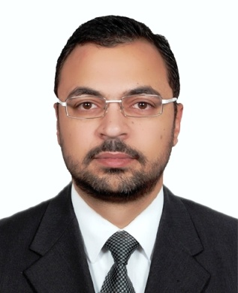

Personal information

Name: | Haitham Mamdouh Elkenani
Born: | 12 MAR 1981
Marital Status: | Married
Nationality: | Egyptian
Address: | Doha, Qatar
Phone: | 00974 66838335
E-mail: | Haythm_1000@Hotmail.com

Education
Recent studies – 2014 - Diploma in Travel and Tourism, Skyline University College, UAE.
Bachelor of Psychology, faculty of art, Mansoura University - Egypt.2000 – 2005.

Work Experience

Senior Travel Consultant in Link Travel & Tourism Doha, Qatar - from 01 Nov 2014 up to now .
Link Travel is member of FE TIJARAH is founded and owned by Sheikh Mohammed Bin Suhaim Al Thani in 2011.
FET is the trading division for FEP (First Equity Partners) and is in charge of a broad and diversified group of companies that operate in the MENA region. It is in charge of the strategic planning and management of these firms.

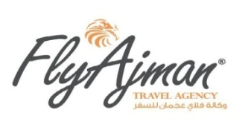
Branch Manager in Fly Ajman Travel, Ajman, UAE - From 01 Mar 2013 to 10 Sep 2014.
Fly Ajman Member of R Holding founded and owned by Sheikh Rashid bin Humaid Al Nuaimi - Ajman, UAE.
R HOLDING is a highly regarded, multi-faceted business group based in UAE. Our diversified business portfolio primarily includes businesses such as Real estate development, Construction, Hospitality & Leisure, Retail and Higher Education.
In 2005, R holding, as the master developer, established itself as the major business group in the Northern Emirates with the launch of USD 5 Billion urban township project – The Emirates City.
Travel Consultant in Tourist Travel Bureau, Doha, QATAR - from15 Mar 2008 to 30 Aug 2012.
Tourist Travel Bureau is member of Tourist Group International.
Beginning its operation in 1973 as a travel management company, Tourist Travel Bureau expanded its business portfolio from airline ticketing and hotel reservation to acquiring and managing hotels, restaurant, residences and others in the last 40 years.
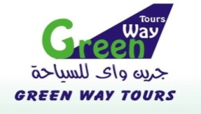
Ticketing Airlines in Green Way Tours, Cairo, EGYPT - from 01 Jan 2007 to 15 Feb 2008.
Ticketing Airlines in Wellfare Tours,Cairo,EGYPT - from 01 Jun 2006 to 30 Dec 2006.

CERTIFICATIONS
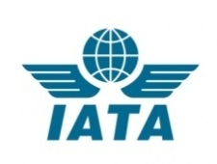
IATA-UFTAA Certificate

2014 – IATA/UFTAA –Training and Development Institute, Montreal, Canada.
- Successfully completed course in:

Foundation in Travel and Tourism.
- The Travel and Tourism Industry and the Travel Professional.
- Geography in Travel Planning.
- Travel Formalities.
- Air Transport Essentials.
- Land Transport–Introduction to Rail Products.
- Land Transport–Car and Camper.
- Hotels Products and Services.
- Water Transport–Ferries and Cruise.
- Tour Packages1.
- Serving the Travel Customer Service.
- Technology in the Travel Industry.
- Air Fares and Ticketing
- Electronic booking tools (EBT)
Amadeus Certificate
- 2013–Amadeus Gulf - Dubai, UAE.
- Update &Successfully completed course in:
- Basic Functionality Course.
- Advanced Ticketing Course.
- Electronic Miscellaneous
- Document (EMD).
- 2007– Amadeus Egypt- Cairo, Egypt.
- Successfully completed course in:
Amadeus Basic Course with a Degree Granted (A+).

English Certificate
- 2013– Newadmin Training Center - Ministry Of Education, Ajman, UAE.
- Successfully completed course in:
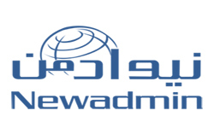
- English language Level 3.
- English language Level 4.
- English language Level 5.
- English language Level 6.

- 2007 – American University in Cairo, Egypt.
- Successfully completed course in:
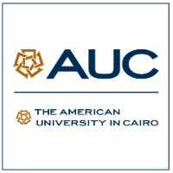
English language final grade (A-).

ICDL Certificate
- 2008 – Mansoura University, Scientific Computer Center, Egypt.
- Successfully completed course in:
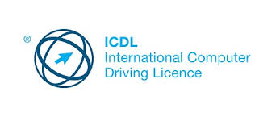
International Computer Driving License* Syllabus Version 4.0, Serial number (UN 06108071), Date (02-03-2008).

Computer Certificate
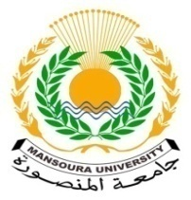
2006 – Mansoura University, Scientific Computer Center, Egypt.
- Successfully completed course in:

- Dec 2006 - "Using the computer and managing files"
- Dec 2006 - Word Processing "WORD”.
- Dec 2006 - Spread Sheets "EXCEL”.
- Apr 2007 - Presentation "POWER POINT”.
- Apr2007 - Basic Concepts of Information Technology. "IT”.
- May 2007 - Information and Communication "Internet”.
- May 2007 - Data Base "ACCESS”

Galileo Certificate
2006 – Egypt air, Cairo, Egypt.
- Successfully completed course in:
Galileo Basic Course with Degree Granted (A+).

Achievements

Almouad Althani
Coordination and issuance of all travel bookings and hotel reservations ceremony honoring the poet Prince Badr bin Abdul Mohsen, which was held at the Opera House in the cultural district, "Katara" 20/10/2011, in which months singers sung the most beautiful poems of Prince Badr has singers accompanied by many celebrities and VIPs in the country

Forum for Arab & International Relations
Coordination and issuance of all travel bookings and hotel reservations for the Center for Research and Studies, which was founded in 2011/1432, to contribute to the support of cultural and political development and the promotion of dialogue between the political and intellectual various parties mechanisms. As the Forum is keen to spread the views and positions which aims to develop the capacity of community groups and decision-makers to understand the views of each category, and promote dialogue to reach better solutions to local, regional and international issues.
Asian Cup 2011
Coordination and issuance of all travel bookings and hotel reservations for the 2011 AFC Asian Cup finals were held in Qatar on 7–29 January 2011. It was the fifteenth time the tournament has been held, and the second time it has been hosted by Qatar.

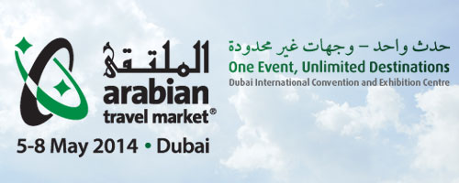
Arabian Travel Market
Participation in the Arabian Travel Market, one of the most important tourism events, most notably the global tourism sector expatriate and overseas in the Middle East and displays your annual meeting of more than 2,800 product companies and tourist destination from all over the world for nearly 26,000 professional visitors and shoppers Tourism Services during the four days in which the exhibition is held in Dubai International Convention and Exhibition Centre .
Sout al khaleej
Coordination and issuance of all travel bookings and hotel reservations for all sessions guests Voice of the Gulf of the elite group of actors and actresses from the Gulf and the Arab world who are hosting radio programs across different .

Responsibilities

- Experties in(GDS) Booking, Issues, Reissues, Void , Refunding, and Part refunding, Revalidation, Use BSP and issue VMPD, EMD and all online tickets.
- Ability to construct airfares.
- Handling various corporate and walk-in clients.
- Selling travel products and tour packages.
- Follow up with clients for payments.
- Understanding of company policies that deal with us.
- Promoting and marketing the business.
- Reconciles invoices
- ADM Handling
- Ensures all fare rules are adhered too to minimize risk of ADM
- Uses BSP Link to communicate with airlines regarding disputed ADM’s
- Dealing with customer enquiries and aiming to meet their expectations.
- Overseeing the smooth.
- Liaising with travel partners, including airlines, to manage bookings and schedules.
- Constantly motivating the sales team to hit their targets and ensure company profitability.
- Dealing with customer complaints.
- Provide assistance and support for all stuff.
- Other administrative and fulfillment related tasks as appropriate.

