7 Golden Rules You Must Follow For Excellent Customer Service
-
An Info graphic

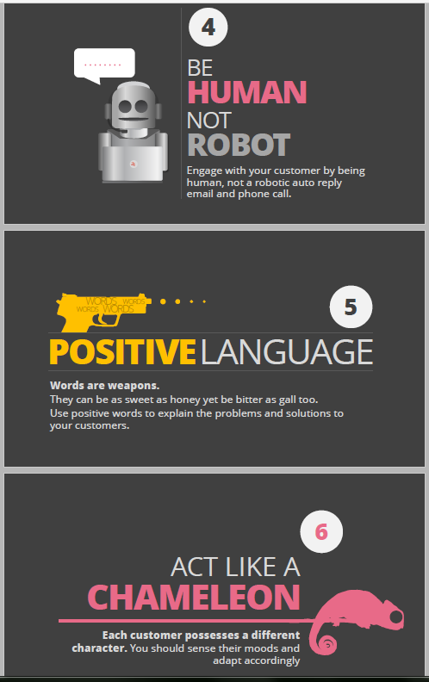

Also Read:
- 11 Most Popular Customer Services Infographics Of 2016 (So Far…)
Read Related Research Papers:
- . Sky UK Technical Handbook 2016 A Complete Reference Customer Guide.docx
- https://www.scribd.com/doc/303366046/A-Beginner-s-Study-Guide-for-Computer-Apps-Competency-Doc
- https://www.researchgate.net/publication/297579136_Make_Customer_Service_Happen_-_Findings_UK_Support_Numbers_Made_Easy
- https://www.academia.edu/23027654/STUDY_GUIDE_FOR_COMPUTER_APPLICATIONS_-_A_Basic_Computer_Knowledge
- https://www.researchgate.net/publication/297577997_A_Beginner's_Study_Guide_for_Computer_Apps_Competency_Doc
Top Companies Which Provide Best Customer Support Services in UK

Ebay | Sky | BT | Paypal | Apple | SwiftCover

