Industry Analysis

Jaguar land rover ltd
Coventry west midlands cv3 4lf England
www.jaguar.com
www.jaguarlandrover.com

Jaguar is the British Automotive Industry which is managed by India Tata Motors produced luxury cars and sold to 100 countries. Before Tata Motors, Ford Motors was the owner and after some economy issues the Jaguar and Land Rover are sold to India Tata Motors. The company has been working since 1922.

Average number of employees

Profit after tax ( $ M)
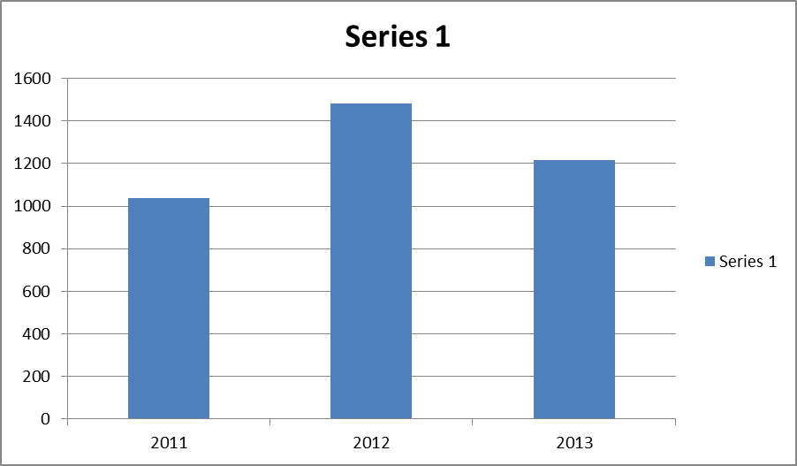
Revenue ($ M)

Product investment ($ M)

Competitors:
Jaguar recognizes the Daimler and Porsche and BMW, the three Germany car industries, as major competitors which sound working better than jaguar. The varieties of products of three Germany companies are more than but the qualities of Jaguar cars are better than them. For example, in 2013 the Vehicle ownership Satisfaction survey (VOSS) said that Jaguar is the best cars in the UK compering with 28 brands. Or in 2013 jaguar F-type won the best design the year.

