PRESS RELEASE
New book explains how it’s easier for the average person to win a political election than they realize
The Art of the Political Campaign: How to run for elected office with no money, name recognition or political connections, is the new “how-to” campaign book by nationally syndicated columnist and former political candidate, Brian Duewel.
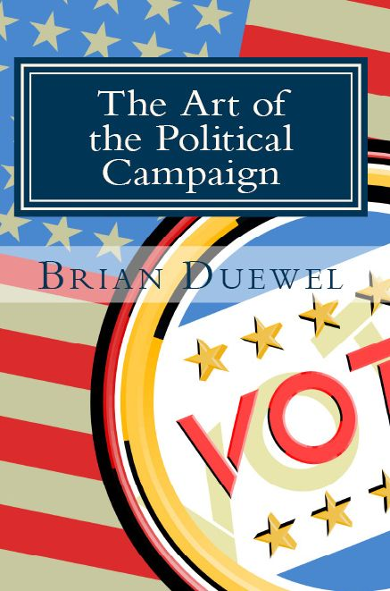
Because every election these days is so important to the future of our great nation, the desire for the average American to choose a side and get involved is greater than ever. The size of the office being sought is insignificant; the will to invoke change is there. But most people don’t know where, how or even when to start.
The average American doesn't have the money, connections or name recognition to get elected. That’s where The Art of the Political Campaign, comes in.
As a former candidate for political office, Brian quickly found out that there was little resource for the regular guy to make the jump into politics. That’s why he authored, The Art of the Political Campaign: How to run for elected office with no money, name recognition or political connections.
As he was campaigning, Brian decided to document how an ordinary person could run for public office. In addition to what he learned on the campaign trail, Brian decided to ask other successful politicians what they encountered. After years of searching, investigating and interviewing those officials, Brian compiled a thorough list of advice and stories. These stories come from politicians from across the country; from mayors and county board members to state representatives and state senators - no political stone was left unturned.
This is a political book that is politically free. No issues, agendas or political parties are brought into play. Brian wants people to enjoy the campaigning information, advice and stories without bias.
-----
The Art of the Political Campaign” How to run for elected office with no money, name recognition or political connections is published independently by Brian Duewel and is available on Amazon.com.
Print Length: 254 pages
Publication Date: July 8, 2013
ASIN: B00DTT8QZA

Brian is a former political candidate and nationally syndicated columnist that wanted to tell everyone the secrets he learned as he ran for office during the 2010 election season. He documented the process at every step and in the end, built the guide to end all political campaigning guides. In addition to his extensive writing background, Brian has more than twenty years of television producing experience to his credit, including the past 15 at Fox News in Chicago.

For immediate release
If you’d like more information about The Art of the Political Campaign: How to run for elected office with no money, name recognition or political connections, or to schedule an interview with Brian, please call 630.303.6924 or email brian@brianduewel.com.

