ABSTRACT: Architecture is as much an art form as it is a science .It is a perfect combination of the two, however, the architectural undergraduate syllabus remains very segmental in nature. This paper aims to bridge this divide by the introduction of Experimental laboratory, which encourages interdepartmental learning experience in the foundation years of the undergraduate course. It supports this theory by elaborating on a few hands on modelling experiments conducted and co-ordinated by the author during the course of her academic experience at D.B.H.C.O.A., Mumbai.
KEYWORDS : Experimental laboratory, Architecture, Tensile Architecture, Interdepartmental learning, Installation , Hands on Modelling
Experimental Laboratory: The need of the hour
An Interdepartmental learning experience in the foundation course of Architecture
Ar. Shreya Sen
Dr. Baliram Hiray College of Architecture, Mumbai
shreyasen1405@gmail.com

INTRODUCTION
Architectural undergraduate syllabus for long had been very segmented, where each subject was quite independent of the others, more so in the foundation years for the B.Arch degree course followed by colleges under Mumbai University.Fist hand experience showed that most of the students in the first semester do not understand the co-relation between subjects like Theory of Structures, Building construction and Architectural Design. After the shift from the yearly to the semester pattern subjects like Allied Design and college projects were introduced which in turn allowed flexibility and novelty in the subjects taught. However still doesn’t solve our initial problem of understanding the interconnectivity between subjects, which is of prime importance for both students as well as academicians interacting with the architects of tomorrow.
In such a scenario, an experimental lab is the need of the hour, providing the platform for Interdepartmental learning through hands on modelling where students can be encouraged to build their conceptual designs using cutting edge technology and devise basic joineries for the same referring to the specialised knowledge gained from subjects like Building Construction and Theory of Structures. This would broaden their knowledge pool and from the beginning itself, impress upon the young minds the interrelationship of Architecture and Technology.
OBJECTIVE
This paper aims to put forth the idea of an Experimental Laboratory as a compulsory subject to be introduced in the foundation years of the B.Arch syllabus under Mumbai University, the scope of the research being limited to the same. Therefore, It’s applicability to different undergraduate course structures for B.Arch in India may be opinionated by much senior academicians and readers of this paper.
A FRESH GRADUATE’S PERSPECTIVE
In the dynamic world of today, which faces new challenges on an almost daily basis, the architecture needs to be responsive in nature.Responsiveness in architecture calls for new systems. New and untested systems call for full scale prototyping for which an Experimental Laboratory may provide a platform [1].

Fresh Graduates, today are facing these expectations and are coming up with new and innovative solutions. When we ask them as to what was their soure of inspiration, they mention their basic design classes where they experimented with shapes, simple joineries, etc. However they do mention a great divide between theoretical learning and what practical experience taught them. An experimental lab introduced at the most elementary stages of an architectural student would therefore be valuable in the long run.
EXPERIMENT 1
As a practising faculty majorly interacting with First and Second year B.Arch. students, it was observed that their learning curve was greatly affected by experimental modelling and full scale prototyping in the foundation years. As I specialize in the field of tensile architecture , I would further elaborate this point with the help of a Tensile fabric architecture workshop, conducted on the grounds of D.B.H.C.O.A. from the 24th to 26th of January 2015.
Aim : Creating a canopy design for the college canteen utilizing minimum material and providing maximum coverage for an optimum design.
Objective : To understand the co-relation between design development, load transference, joinery details and design equilibrium throgh stagewise documentation of the entire process.
Methodology: In this workshop scale modelling was used as a technique of form generation which was later followed by building a 1:1 scale prototype.
Stage 1
The material was tested for it’s tensile strength by creating a basic cut and pulling the fabric in opposite directions creating an anticlastic form. This gave a rough idea about the ratio of :-
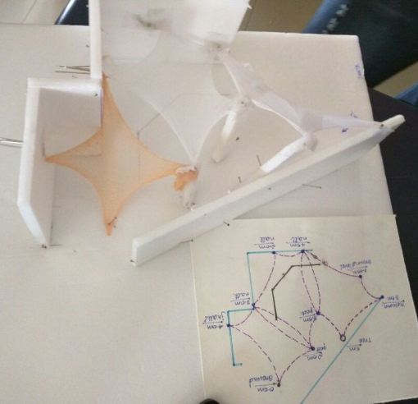
Cut Fabric Area v/s Area of space covered by stretched fabric.
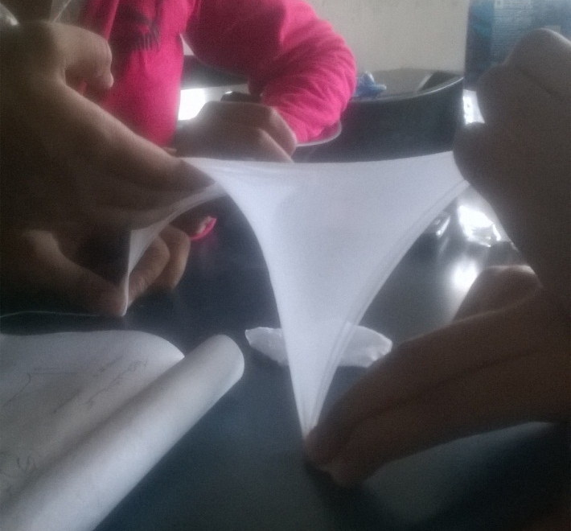
Fig 1 : Checking the tensile strength of the fabric.
Source : Author
Stage 2
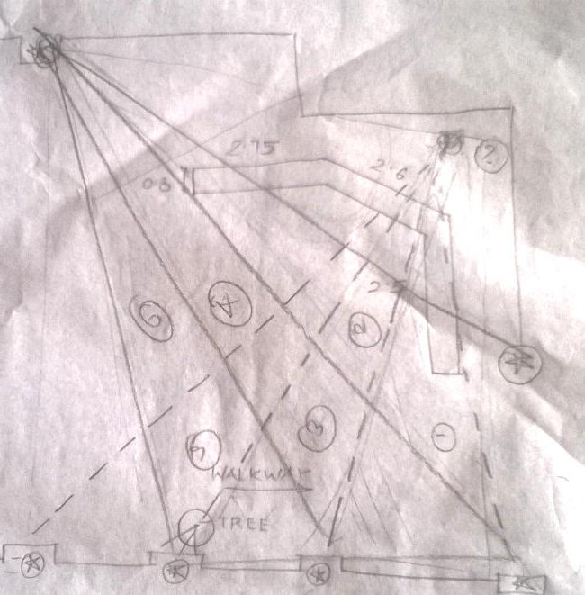
Site measurements were further taken to understand the extent of the project, and identify pottential anchor points for their designs. This stage essentially took their initial conceptual designs from their drawing boards to the site.
Fig 2 :On site measurements and planning of anchor points.
Source : Author
Stage 3
The tensile strength of the material is now tested again while devising and improvising on the design in a small scale model. This would be the prototype of the 1:1 scale installation. The designs were tested on the basis of three dimentional experience of the space.
Out of the many designs produced by the group of students, the one below was selected for the installation. On the basis of the same, the bill of quantities was devised.
Fig 3 : Preparing a miniature scaled model & corresponding drawing for the next stage of 1:1 scaled installation.
Source : Author
EXPERIMENTAL FORM FINDING
It was during the 1950’s that Frei Otto developed the engineering principles for building with membranes. The form finding methods of those days were purely experimental. Physical models made from stretched rubber, fabrics, nets and soap films were used to create forms that were in equilibrium. One famous built example in the field of Tensile Architecture which utilized this procedure of prototypuing as a part of form finding is the Pavilion of the Federal Republic of Germany, World Fair, Montreal, 1967. The prototype for which today houses the Institute of Lightweight structures, Stuttgart, Germany.
Stage 4
Installation of the entire canopy was broken down into short periods of 6 hours for 3 days. The stages of installation are as follows :-
- Fixing of J hooks at predecided anchorpoints.
- Cutting of fabric [latex nylon hybrid]
- On site manual stretching of fabric to eliminate folds.
- Revising the design based on site as well as material constraints.
- Final fixation of fabric to anchorpoints & devising ideal tie design.
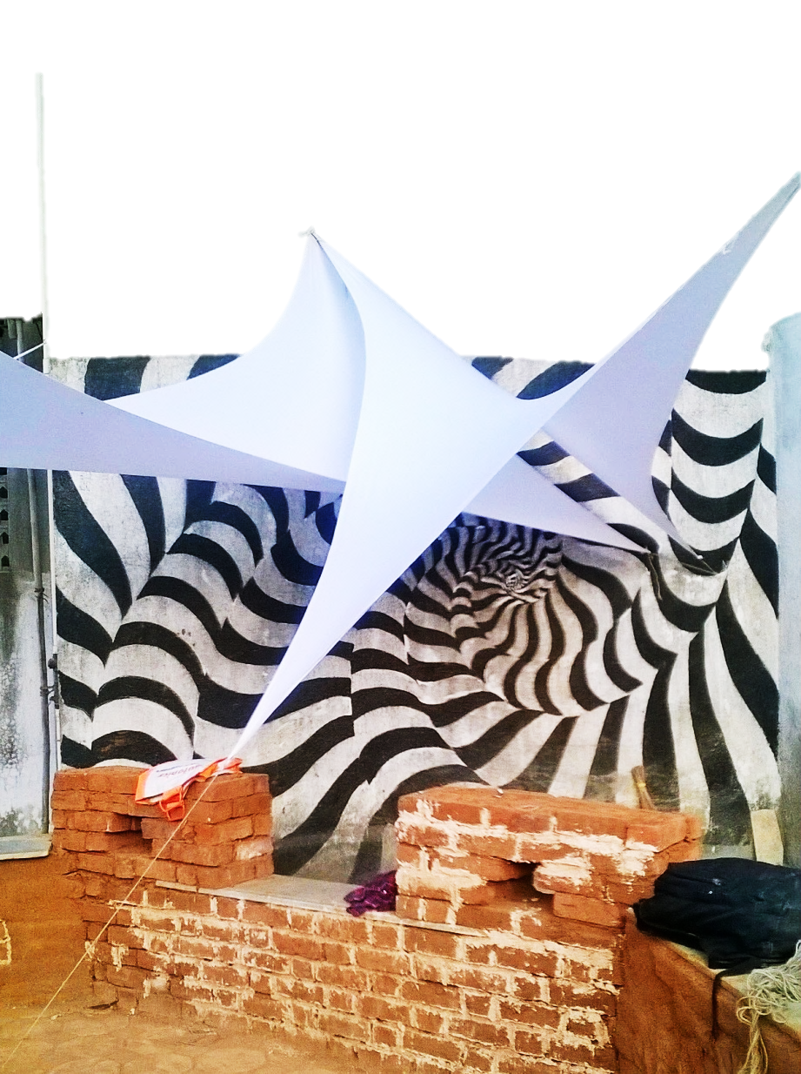
Fig 4 :On site manual stretching of fabric to eliminate folds
Legend
J hooks fixed at predecided anchor points.
Variable force pressure applied in the opposite direction giving rise to the anticlastic form. Since the shift at the base essentially means a corresponding rise/fall in the joinery at the opposite end. The exact location of both these anchor points was altered through the entire process of installation, and was highly affected by prevailing wind direction.[ Fig.4 & 7]

Fig 5 :On site manual stretching of fabric to eliminate folds.
Source : Author
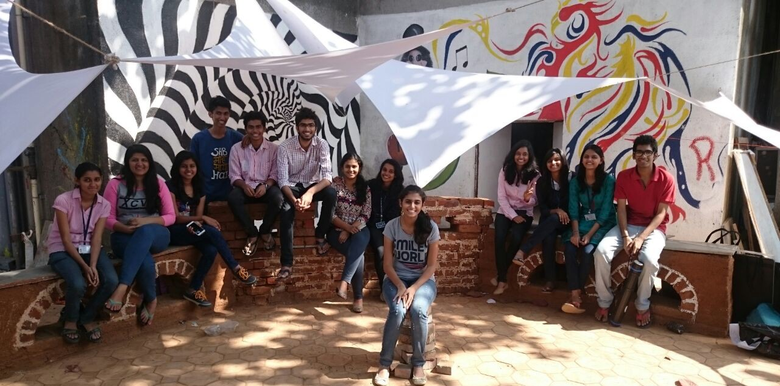
Fig. 8 :
Participants of the workshop :- Students of second year Div. A 2014-2015 batch at D.B.H.CO.O.A., Mumbai.

.
B
Fig 6: Revising the design based on site as well as material constraints.
Source : Author

Fig 7 & Fig 8 :
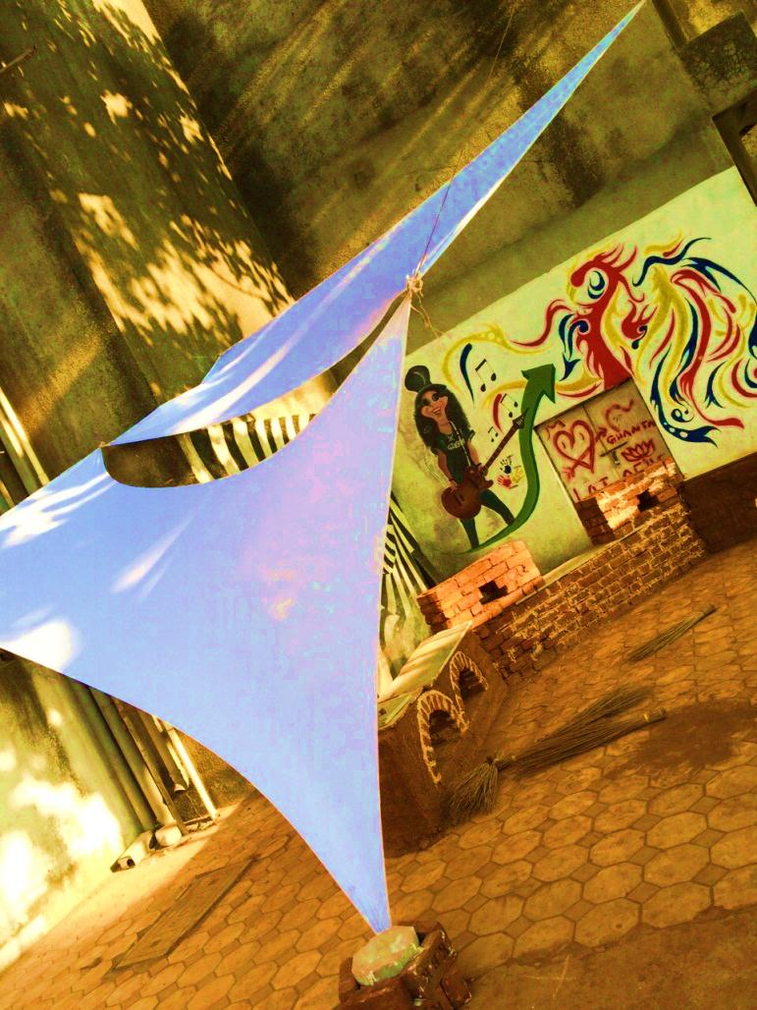
Highlight the shift the base anchorpoint, which moves from point A to B as the installation progresses. The students hereby understood the concept of relative pull.
A

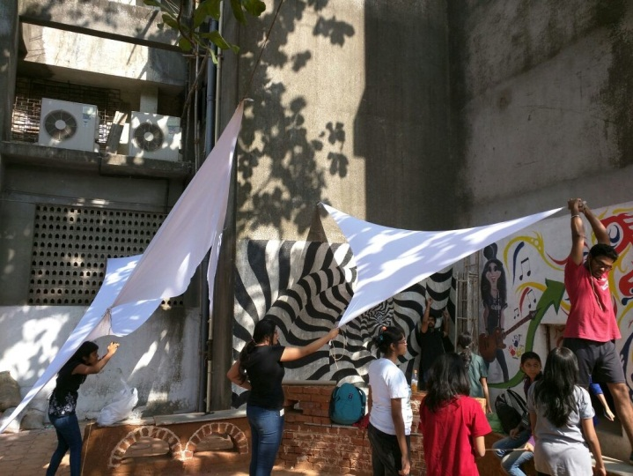

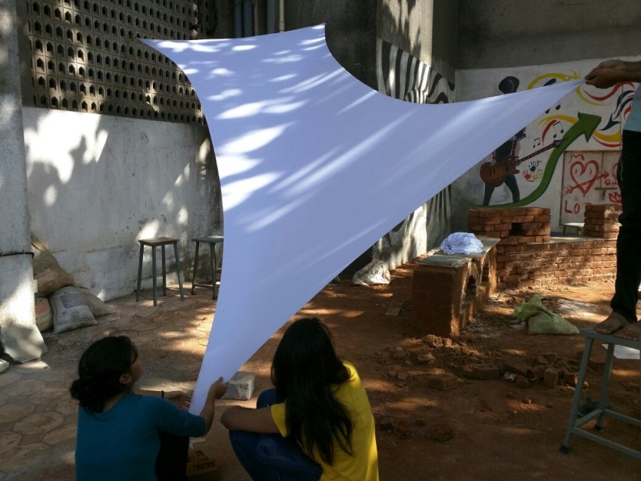
Hereby, Experiment 1 showcased the co-relation between design development, load transference, joinery details and design equilibrium throgh stagewise documentation of the entire process. All of this in a fun interactive mannr, thereby encouraging intrdepartmental learning.

EXPERIMENT 2
Similarly Soap Film Modelling has also been undertaken as a hands on workshop for two consecutive years in the First year B.Arch Batch of Tensile elective group as a form finding experiment.
Aim: It involves utilising the minimal surface technology of soap films “Doing more with less”, thus working on the basic principle of sustainability.
Objective & Methodology: The workshop stressed on the physical form finding process as it would be easily understood by students of the first semester. The reason being that with a physical rather than digital model, we not only have a shape of the object designed but also get a vague idea of it’s structural behaviour through elementary empirical tests that can be carried out on it.
Fig. 9 : Minimal surface soap film model confirming to flexible boundary condition.
Source : Author

As shown in the figure above the soap film automatically reorganizes it’s boundary in such a manner that the least minimal surface area is covered by the same within a space defined by randomly placed anchor columns.
This step is further followed by Photogrammetry and analysis of the form so generated

ON FIELD EXECUTION METHODOLOGY BY EXPERTS

Minimal surfaces, as tension equilibrium forms, are the ideal basis to build the most efficient lightweight tension membrane structures with a minimum of mass and materials [2]. However, this is just the first stage of form finding and is followed up by four other stages as detailed further in this paper. This execution methodology is followed by S.L.Rasch. GmbH ,one of the leading firms in this field of Tensile Architecture which follow a scientific method towards execution of a design project.

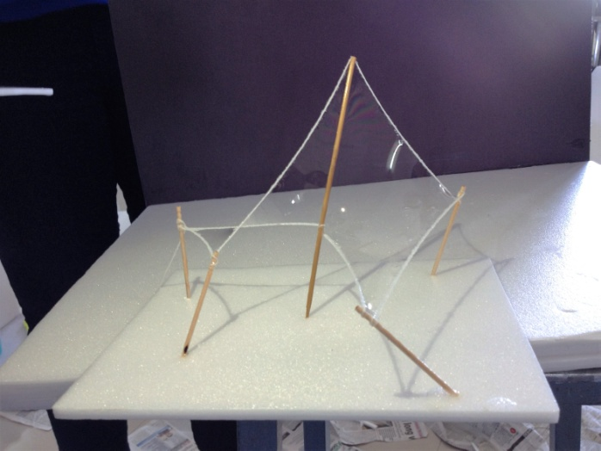
Fig. 10 : Photogrammetry of a soap film model.
Source : Author

Soap film modelling is further followed by a structural simulation whereby computational windengineering test is performed on the design as shown in Fig.11

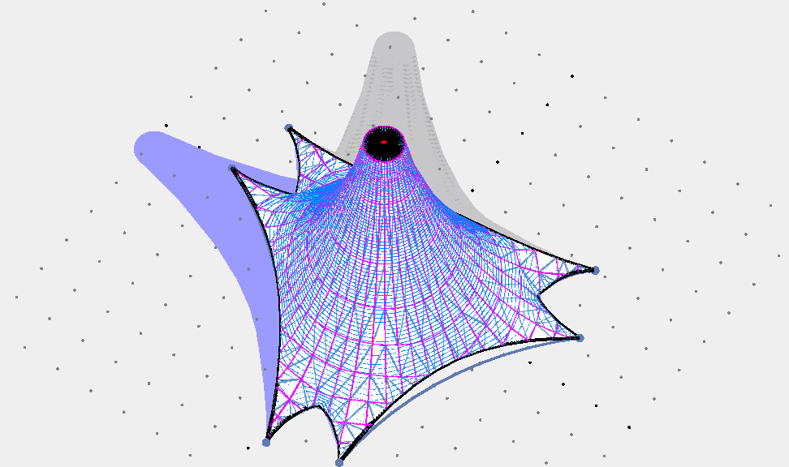
Fig. 11 : Structural simulation utilizing form finder software, highlighting the rainshadow zone in blue.
Source : Author

APPLICATION OF KNOWLEDGE GAINED
Lightweight Structures obtain their shape through the interplay of boundary conditions, external loads and/or internal states of pre-stress. It is necessary to incorporate the physics of the shape-finding process into the architectural and structural design process, since geometric shape and mechanical behaviour are coupled [2]. This form finding workshop exposed students to the first few stages of designing a lightweight structure.

It was observed that, by experimenting with the geometric shape [boundary condition] the resulting mechanical behaviour of the soap films were critically analysed through Photogrammetry . Thereby achieving the objective of the workshop i.e. to find the optimum design. This methodology could be used by them for any future project concerning lightweight structures.

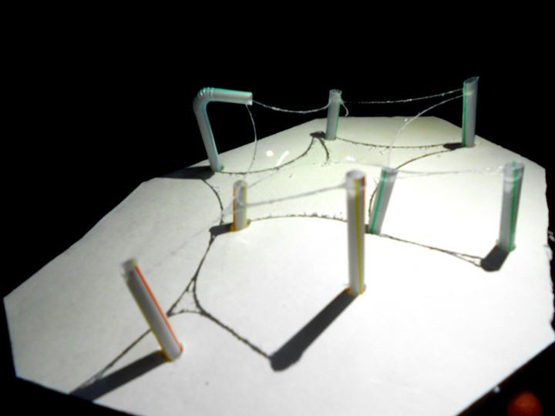
SIMILAR EXPERIMENTAL LABS
A global phenomenon

The foundation design lab in the School of Architecture+Design, Virginia Tech is primarily concerned with processes of design conception, as well as techniques used to analyze and represent constructed artifacts. Studies are undertaken in two and three dimensions using various materials and tools. Inquiries are focused on the process of design, discovering, through experiment, methods of working that develop aesthetic judgment and means of self-evaluation. All architecture, industrial design, interior design, and landscape architecture majors study together for the first year [3]. In a similar line of thought but at an andvanced stage of learning is the Architectural Association School of Architecture’s Design & Make programmes which are structured around a series of hands-on design-make studio projects of increasing scale and sophistication leading to the student construction of a design dissertation (B.Arch.) or a full scale prototype utilizing any building material [4]. On the other hand is the Global 30 Architecture and Urban Design Program (G30UDA) at the University of Tokyo is dedicated to interdisciplinary design research that connects architecture, engineering and computation to explore emerging discourses on architecture and urbanism. It seeks to develop and speculate new knowledge for architecture where the practice of design engages in both social constructs and material performances. It aims to explore the potential of architecture as the essential element to generate new ideas of and for the ever-evolving built environment [5]. This program aims to provide a platform for collaboration between various research laboratories within the Department of Architecture and also within the Graduate School of Engineering, linking design practices with scientific research projects. Even the Computational Design programme in the University of Stuttgart, Germany encourages interdepartmental learning by structuring it’s course curriculum around experimental laboratories where students are encouraged to explore their design through protyping models both within the college building as well as in a dedicated ICD Pavilion which showcases each unique design every semester.

CONCLUSION

The paper concludes with a thought that maybe the journey of an architectural student is a quest to understand the science behind the art. Are we veering more towards the art aspect and beginning to forget or ignore the science in the process of becoming an architect ? Why do we think of details towards the end of a design project ? Should it not be the basic module from which the entire design should evolve from. Interdisciplinary research is therefore the need of the hour, with an Experimental lab providing the setting for such a research.
It can be concluded that an experimental, hands on modelling approach to architectural education may pave the way forward towards a better future. Embedding in young minds the importance of structural stability for the futuristic new forms created. Thus resulting in a beautiful as well as responsible tomorrow.

REFERENCES

- David Benjamin,(2006). Living Architecture Lab [online] http://www.arch.columbia.edu/labs/living-architecture-lab [Accessed on 12.1.16].
- S.L.Rasch Gmbh Institute for scientific architecture,(2006). Design and analysis of Lightweight Structures.
- Foundation course syllabus Virginia Tech university, http://archdesign.vt.edu/architecture/b-arch [Accessed on 24.12.15]
- Design and Make Handbook, www.aaschool.ac.uk [Accessed on 24.12.15]
- Global 30 “Architecture and Urban design programme, University of Tokyo”, https://www.uni.international.mext.go.jp/course/detail/61 [Accessed on 18/1/16]
- Winfried Nerdinger, (2010) Frei Otto- Working for a better “Earth for mankind”
- Frei Otto. “hort endlich auf”, Burkhardt.1984 (note 2) , p. 142

Ar. Shreya Sen is a DAAD [Deutscher Akademischer Austausch Dienst] scholarship holder having having researched her master’s thesis from ILEK, Stuttgart, Germany and is currently associated with Dr. Baliram Hiray College of Architecture, Bandra, Mumbai.

ACKNOWLEDGEMENT:
Students of first semester B. Arch.– 2014 -15 batch. & third semester 2014-15 batch at D.B.H.C.O.A., Mumbai.

Photographs: Courtesy the authors.

