Mrs. Derdiger
World History II
The Plague Webquest
- Watch The Plague
  - When did the plague start?
  - How did trade routes help spread the plague?
  - Where did the plague start in Europe?
  - How much of the population of Europe was killed?
  - What effect did the plague have on how cities were run?
- Read Black Death: The Lasting Impact, “Society Turned Upside Down” and “Never the Same Again” ONLY
  - Explain how the plague helped bring about the destruction of the feudal system in Europe. Give at least 3 examples.
- Watch The Black Death Begins
  - According to the legend, what is the Mongol Pestilence?
  - What are the symptoms of the Plague?

- Read Anatomy of 14th Century Bubonic Plague Hazmat Suits
  - Label each part of the plague doctor’s outfit and describe what it is for 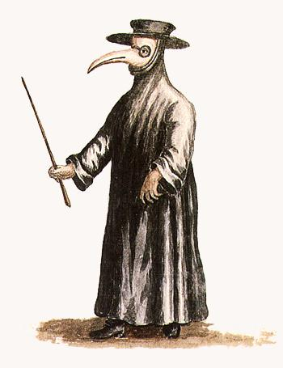

- Read The Black Death and Early Public Health Measures
  - How did people use religion to cope with the plague? Give 2 examples
  - What groups of people were blamed for the spread of the plague?
  - What were some “cures” for the plague?
  - What protective actions did cities take during the plague? Give 3 examples.
- Watch Coroner’s Report: Plague
  - Where does the bacterium that causes the plague live?
  - How do fleas spread the plague? Be detailed in your answer.
  - What happens during pneumonic plague?
  - What happens with the septicemic version of plague?
  - How long did it take for the plague to kill someone?
  - Why don’t people usually die of the plague today?
- Watch Plague
  - Why would a disease like the plague spread quickly today?
  - What might be effects of an outbreak on society today?

1. The Plague http://www.history.com/topics/black-death/videos/mankind-the-story-of-all-of-us-the-plague?m=528e394da93ae&s=undefined&f=1&free=false
2. Black Death: The Lasting Impact, “Society Turned Upside Down” and “Never the Same Again” ONLY http://www.bbc.co.uk/history/british/middle_ages/black_impact_01.shtml
3. The Black Death Begins http://www.history.com/topics/black-death/videos/the-black-death-begins?m=528e394da93ae&s=undefined&f=1&free=false
4. Anatomy of 14th Century Bubonic Plague Hazmat Suits http://mentalfloss.com/article/49217/anatomy-14th-century-bubonic-plague-hazmat-suits
5. The Black Death and Early Public Health Measures http://www.sciencemuseum.org.uk/broughttolife/themes/publichealth/blackdeath
6. Coroner’s Report: Plague http://www.history.com/topics/black-death/videos/coroners-report-plague?m=528e394da93ae&s=undefined&f=1&free=false
7. Plague http://www.history.com/topics/black-death/videos/plague?m=528e394da93ae&s=undefined&f=1&free=false

