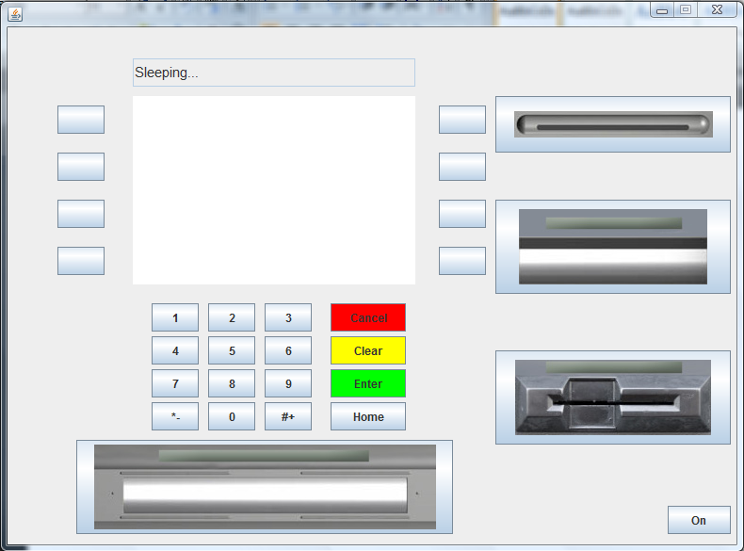
Sleeping screen when first started.
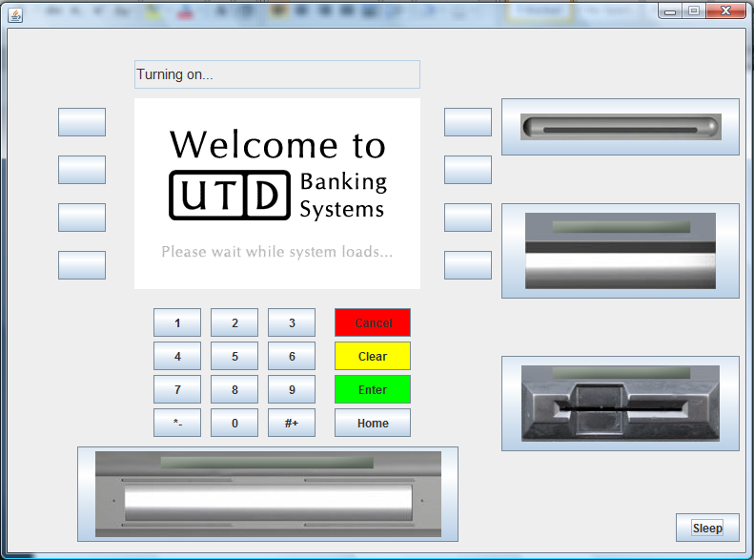
Loading screen when the On button is pressed.
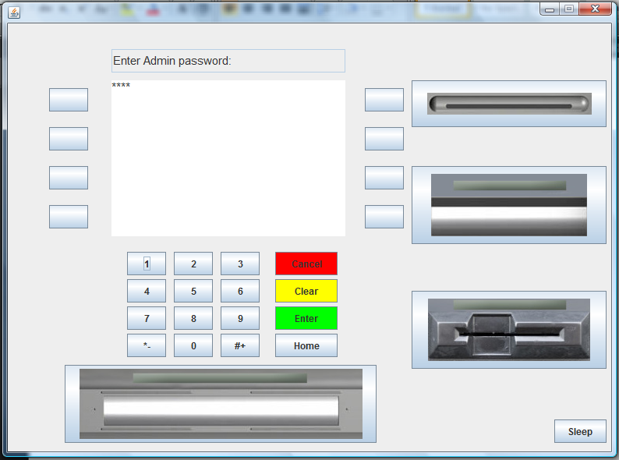
Admin enters password.
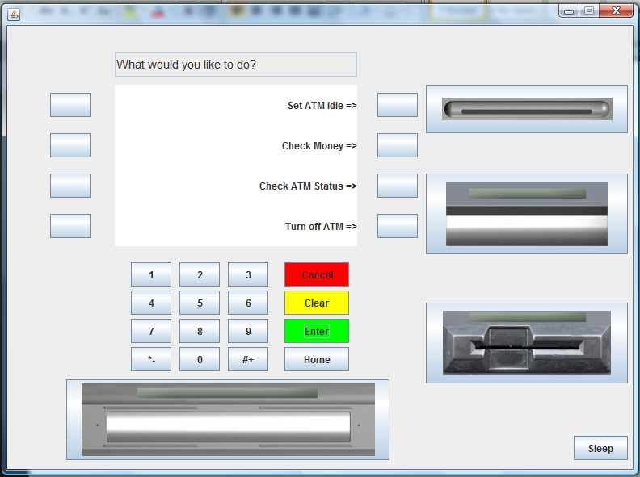
If the password was correct.
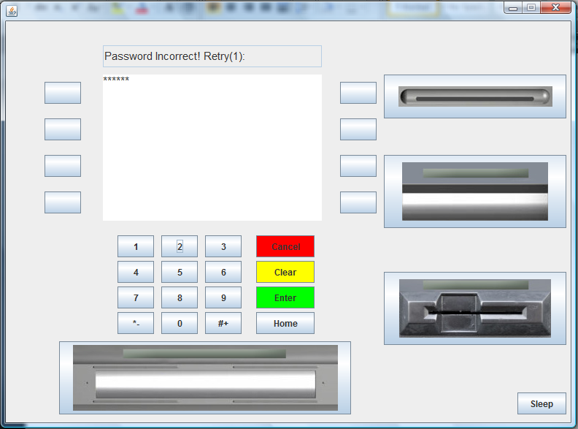
If password was incorrect.
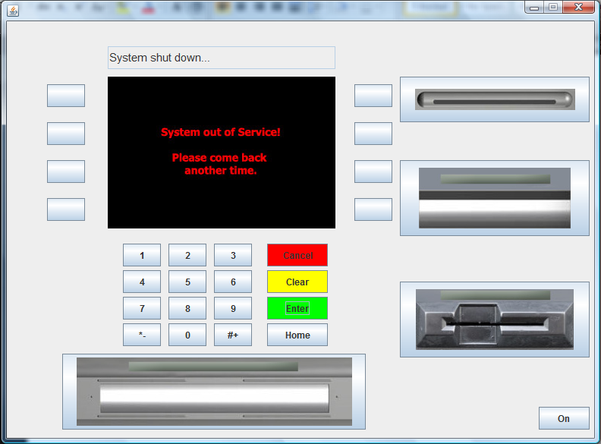
When the admin enter password wrong 3 times, then the system shuts down and notifies the bank.

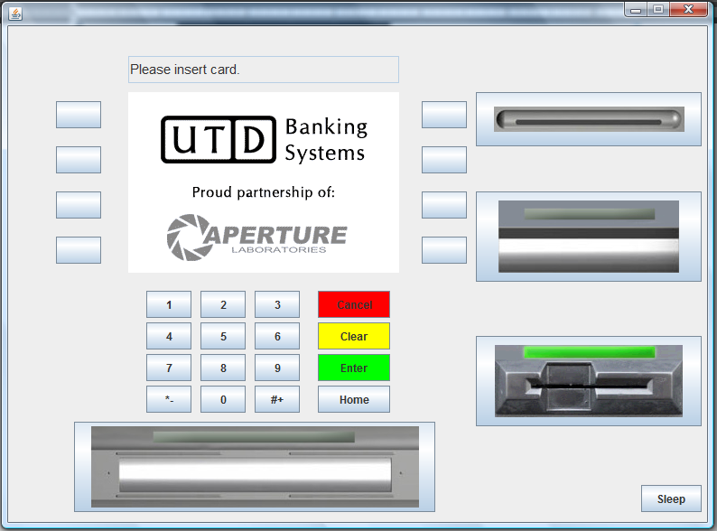
ATM idle screen, waiting for user to insert card.
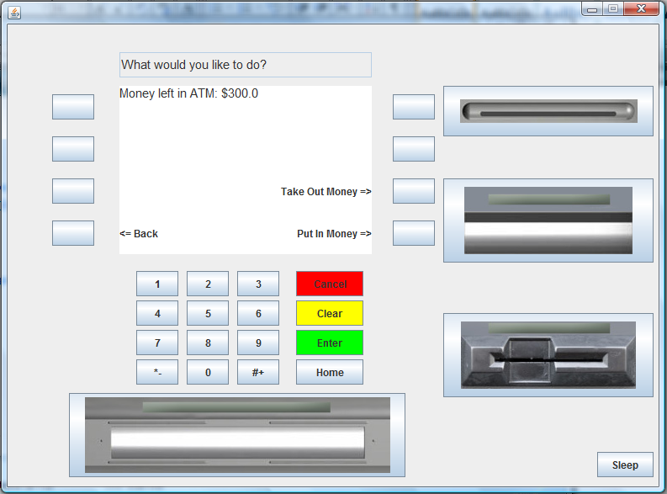
Admin check money left in ATM.
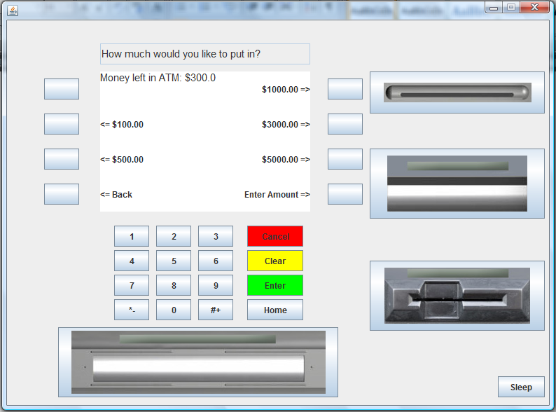
Admin put in money.
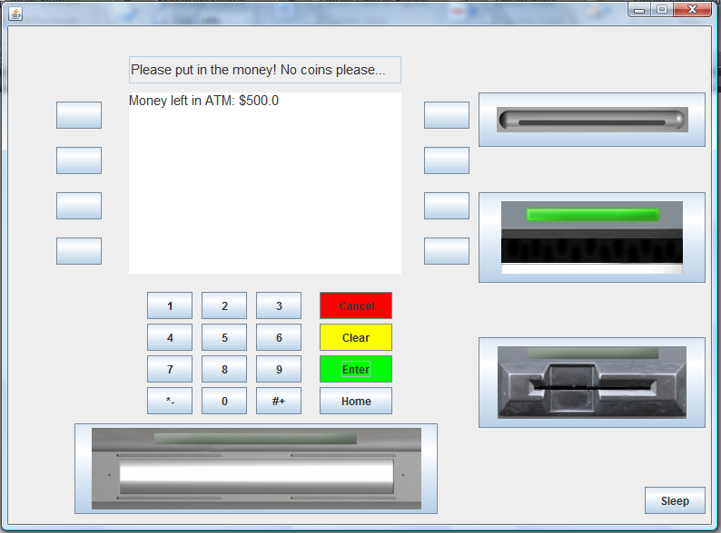
Admin enters the amount to put in ATM.
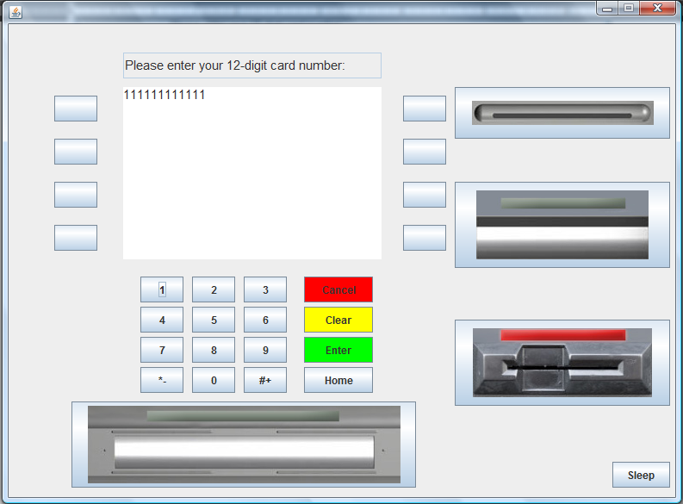
When user inserts card, ask the user to enter the card number.
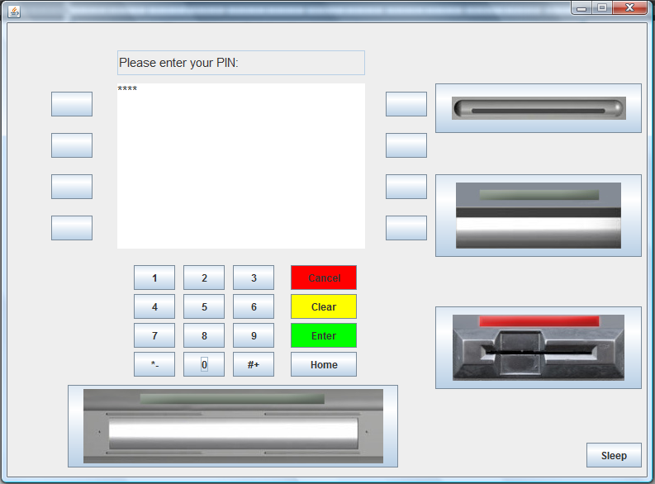
If the card number matches anyone in the system, then ask user for PIN.
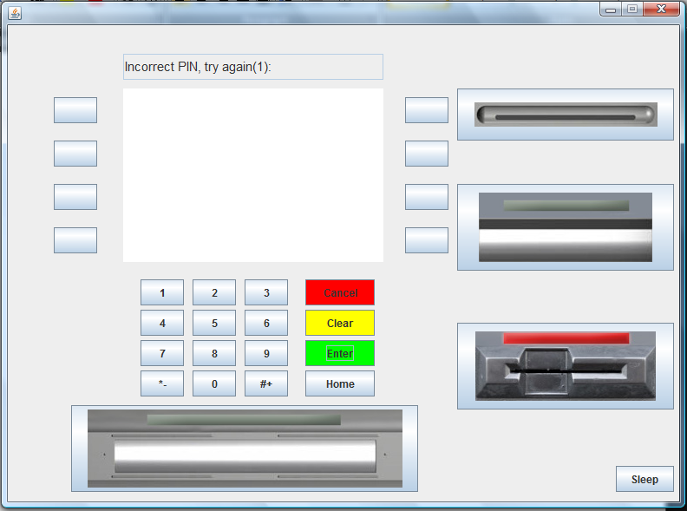
If user enters the incorrect PIN.
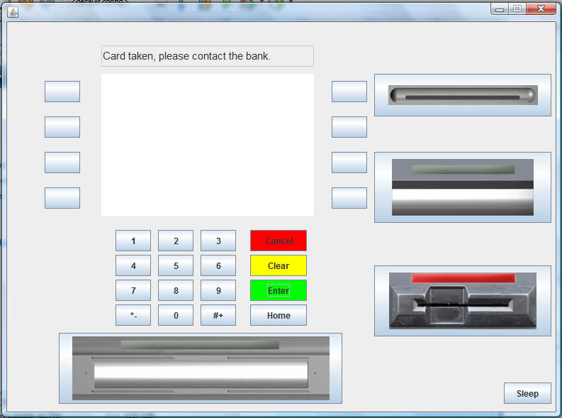
If PIN was wrong 3 times, the ATM will take the card, and ask the user to contact the bank.
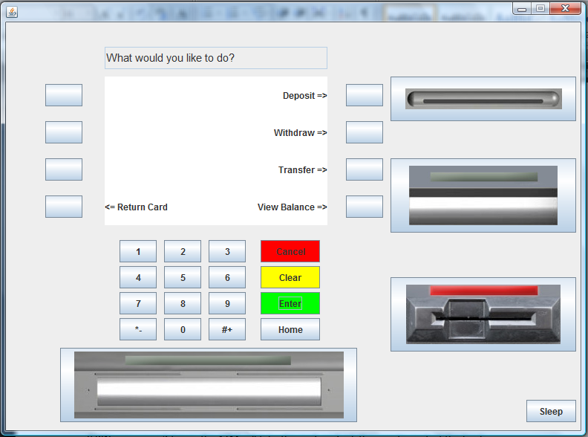
If user enters the correct PIN, goes to the user home page.
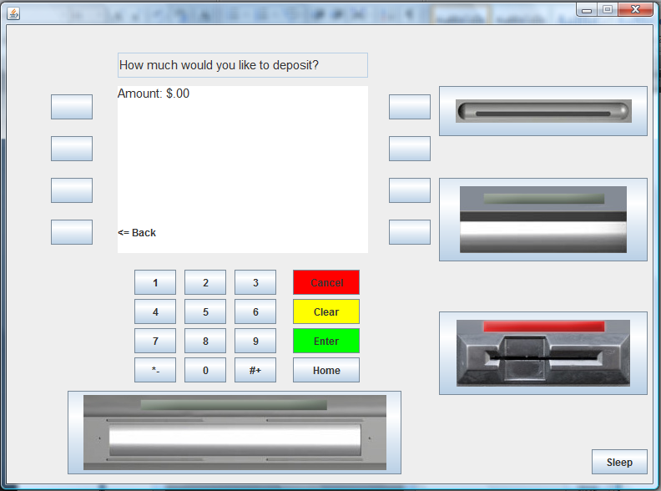
User chooses to deposit.
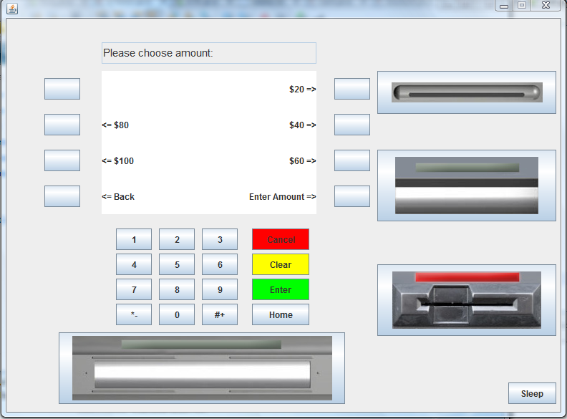
User chooses to withdraw.

