Derdiger
Am Lit
The Bell Jar Assessment
Maslow’s Hierarchy of Needs
For your assessment of The Bell Jar, you will be analyzing Esther Greenwood’s troubles based on Maslow’s Hierarchy of Needs, as depicted in the image below. Which of these levels are not met in Esther’s life and how does that contribute to her struggles with mental illness and in social situations?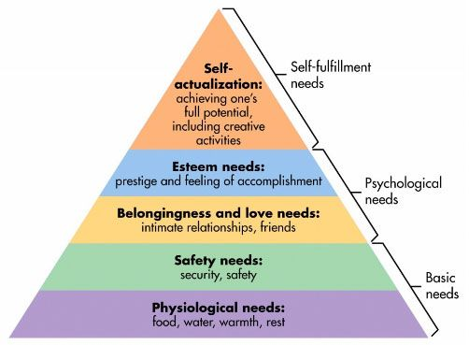
You will present your understanding in a poster. You will be graded on the following rubric:

Criteria | 4 | 3 | 2 | 1
Analysis of Hierarchy | Student thoroughly and accurately analyzed Esther’s needs according to Maslow. S/he made interesting and unique observations. | Student provided a detailed and accurate analysis of Esther’s needs according to Maslow. | Student provided an accurate but minimal analysis of Esther’s needs according to Maslow. | Student provided a vague and/or inaccurate analysis of Esther’s needs according to Maslow.
Analysis of Conflict | Student thoroughly and accurately analyzed Esther’s needs. S/he made interesting and unique observations. | Student provided a detailed and accurate analysis of Esther’s needs created conflict. | Student provided an accurate but minimal analysis of how Esther’s needs created conflict. | Student provided a vague and/or inaccurate analysis of Esther’s needs created conflict.
Evidence for Hierarchy | Student provided 2 or more pieces of strong evidence, properly cited, to support their analysis. | Student provided one strong piece, or more than one good piece, of evidence, properly cited, to support their analysis. | Student provided one piece of evidence that related to their analysis but did not support it. | Evidence provided was not related to or supportive of analysis.
Evidence for Conflict | Student provided 2 or more pieces of strong evidence, properly cited, to support their analysis. | Student provided one strong piece, or more than one good piece, of evidence, properly cited, to support their analysis. | Student provided one piece of evidence that related to their analysis but did not support it. | Evidence provided was not related to or supportive of analysis.
Organization | Presentation of material was organized in a clear an logical manner | No 3 possible | No 2 possible | Presentation of material was disorganized.
Conventions | There were no errors in grammar or conventions. | There were few errors in grammar and conventions, but they did not interfere with the clarity of the writing. | There were errors in grammar and conventions which interfered with the clarity of the writing. | There were many errors in grammar and conventions, which made the writing very difficult to understand.
Total:_______/24

