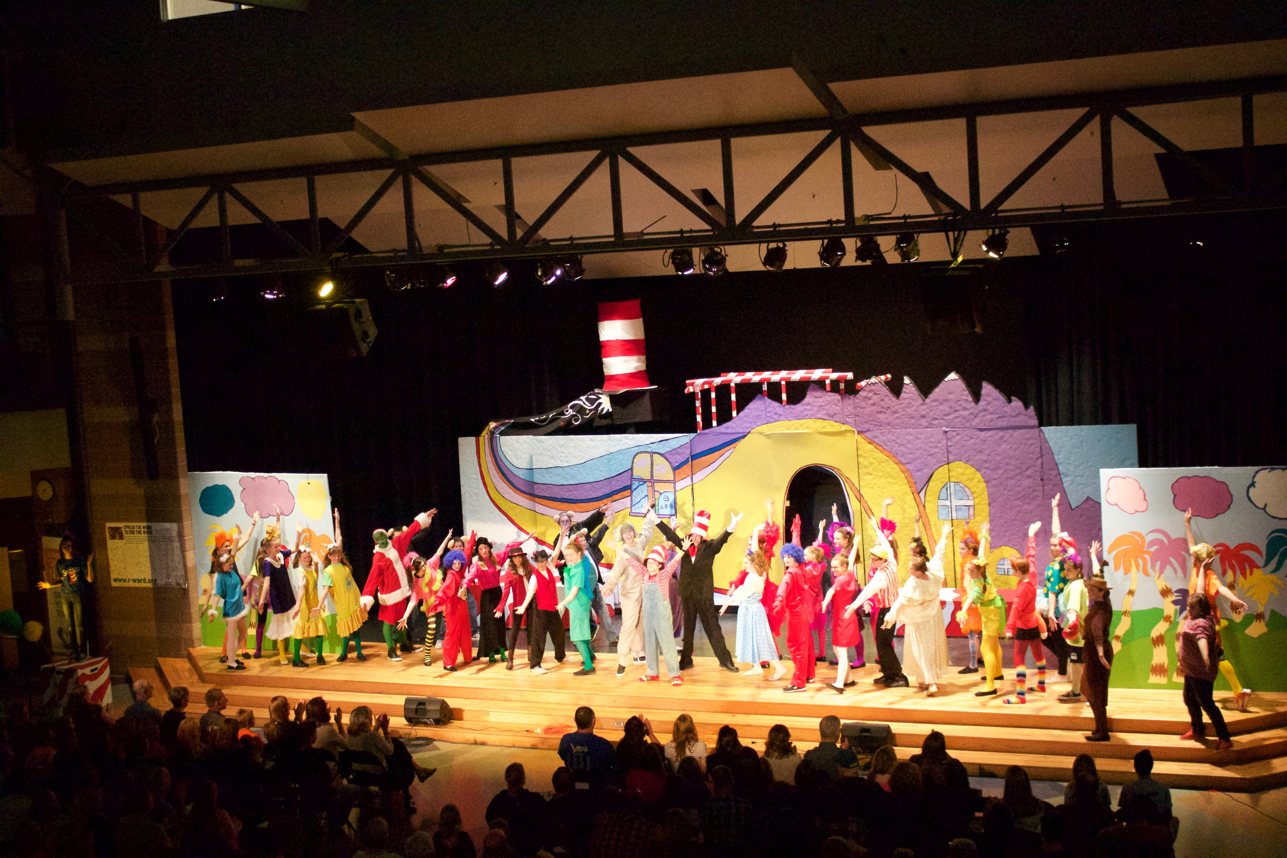
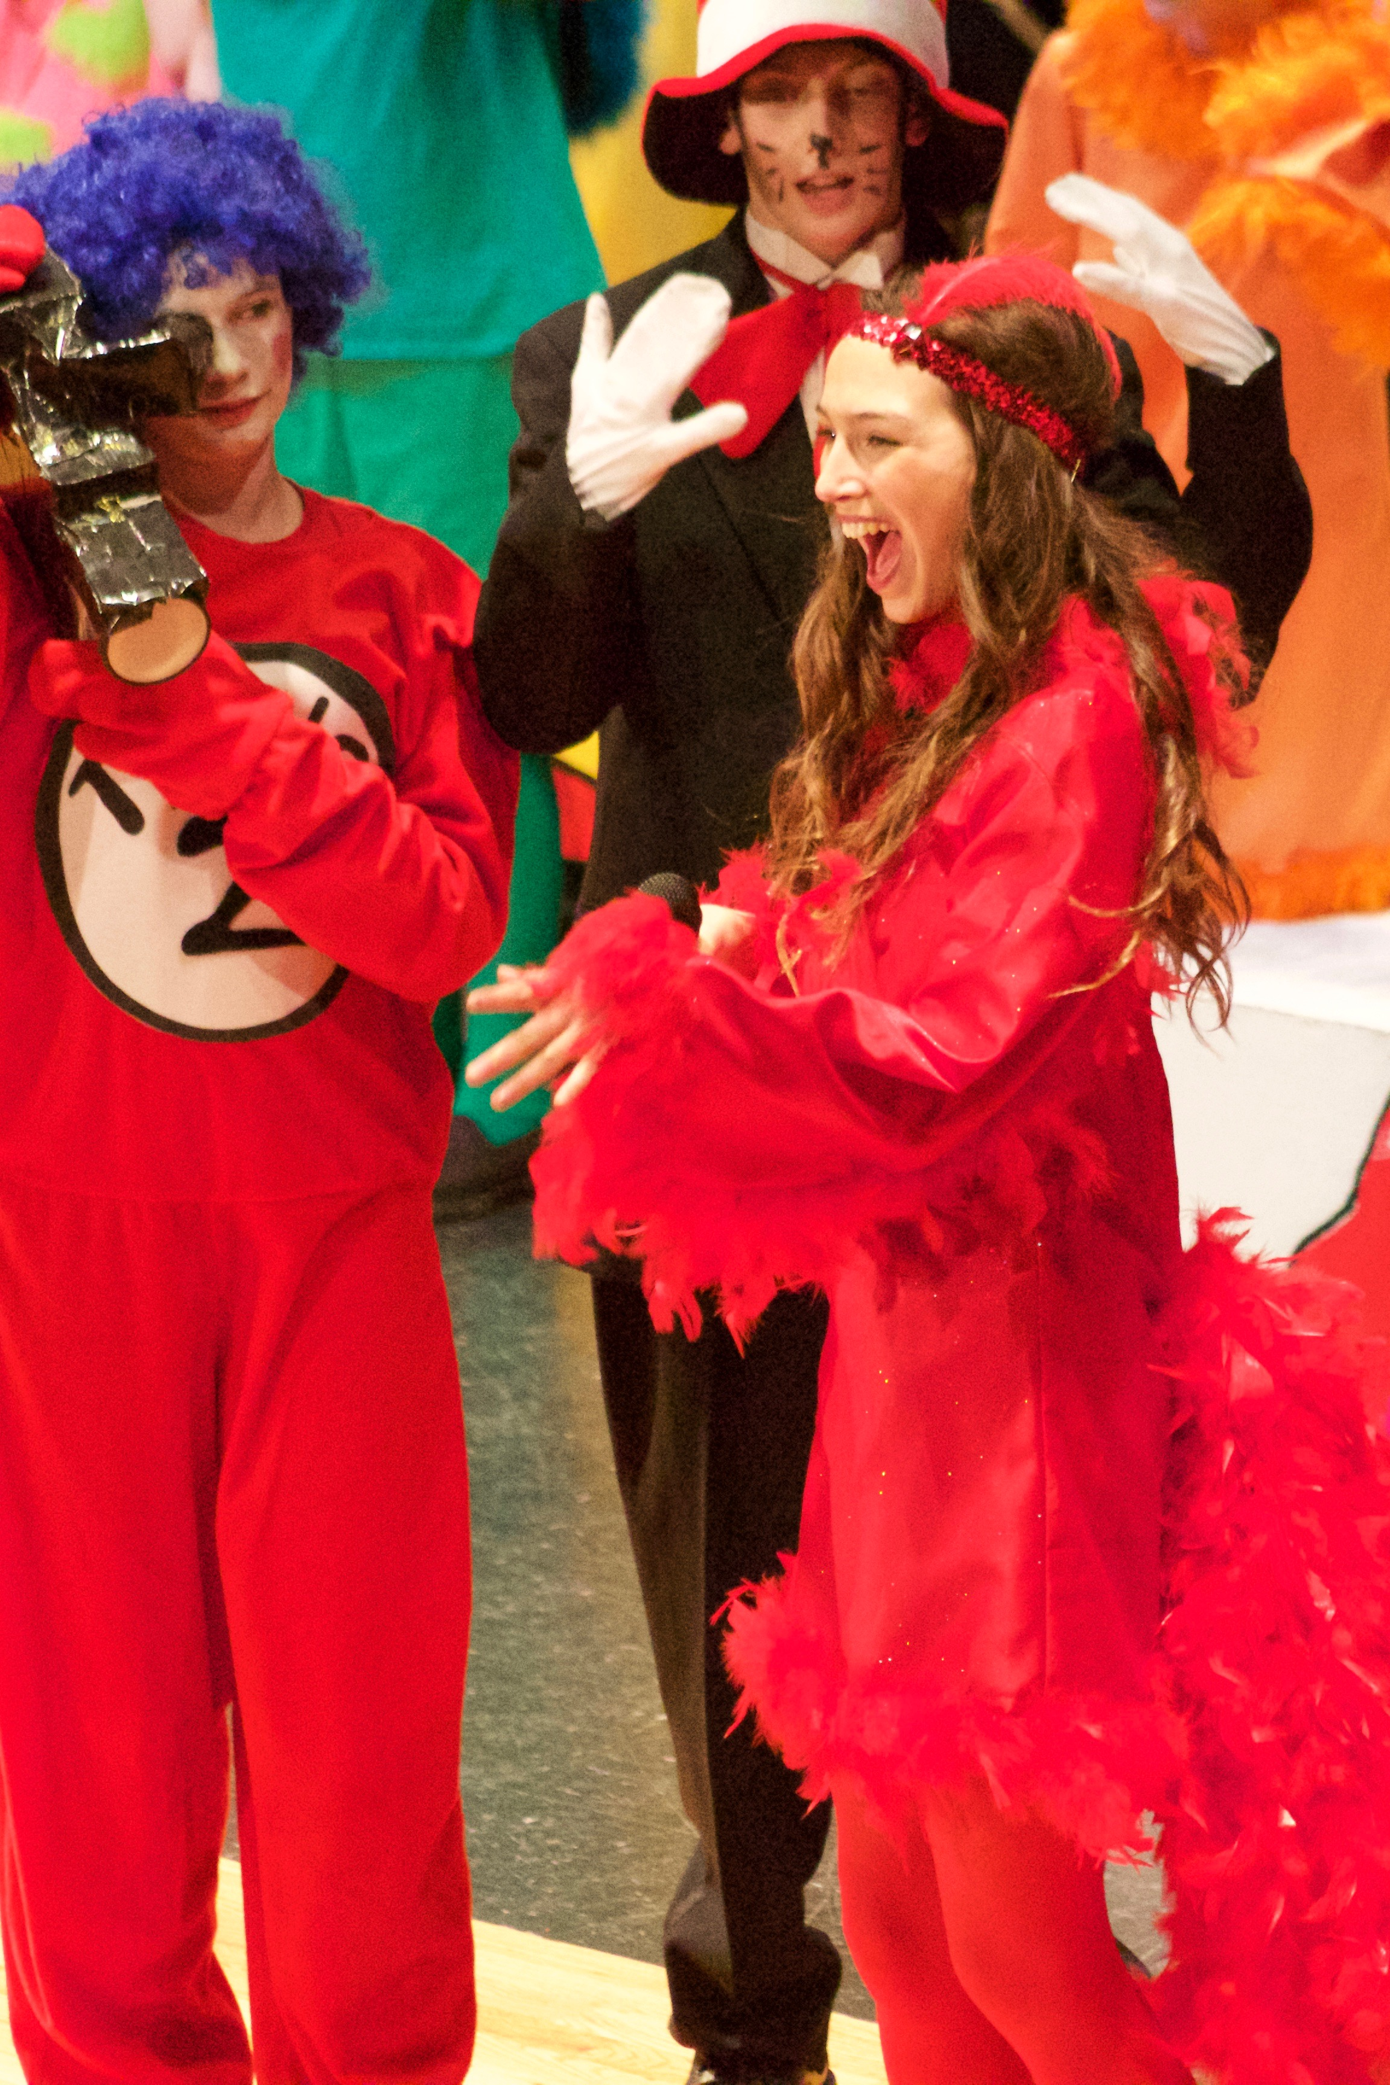

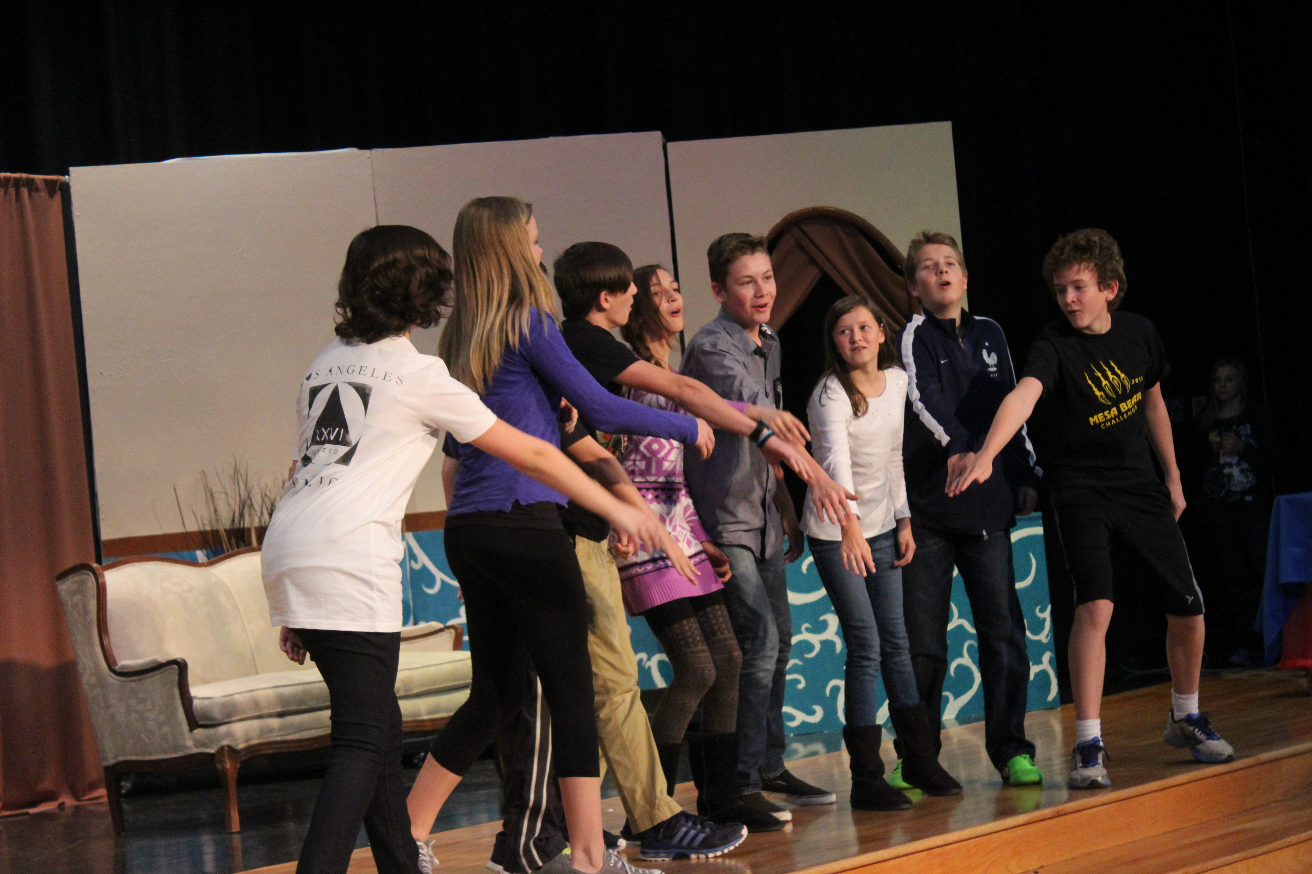

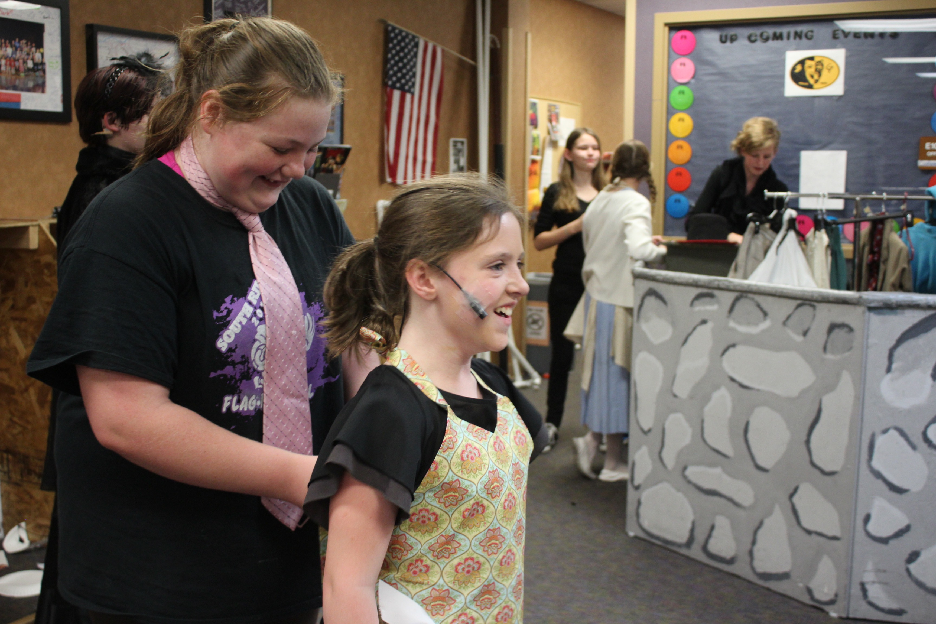
MESA THEATRE

Our int’l & local award-winning program has great opportunities!
Every year, we…

- Introduce 300+ students to Theatre during and after school
- Produce two Shows that are Created and Designed by Students
- Offer Tech Theatre Training and Experiences in Tech Ninjas
- Perform at the Colorado State Thespian Conference
- Honor Student Work via International Thespian Troupe #89186
- Offer Leadership Opportunities in Thespian Council
- Perform at Junior Theatre Festival West in Sacramento, California

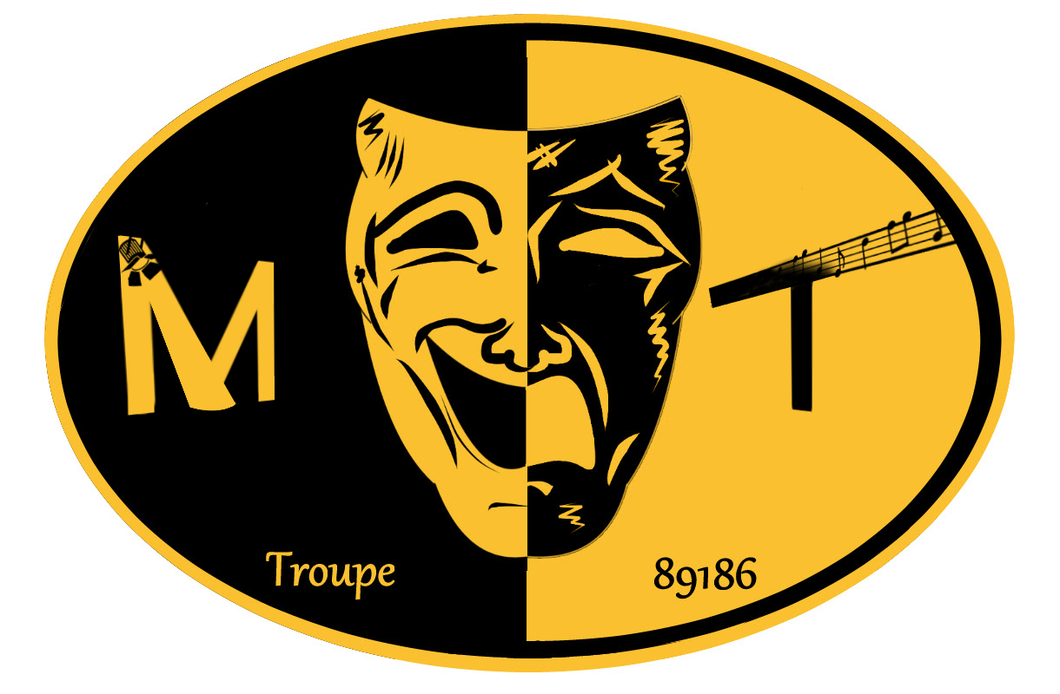

MESA THEATRE VISION & MISSION

“We envision a place where students can explore new ideas, express themselves, and be accepted by others.”

“We will be a creative outlet where students, teachers, and families can work and communicate with each other to achieve great performances and experiences. We will use all of the IB Learner Profile and ROAR traits to create a fun environment for everyone at Mesa Middle School.”
- Credit: Mesa Thespian Council

QUESTIONS? EMAIL MR. JARAMILLO aljaramillo@dcsdk12.org

