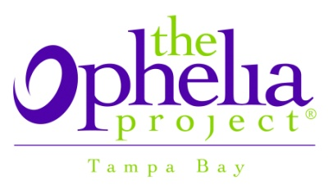
WHAT MATTERS MOST TO GIRLS IN TAMPA BAY….THE OPHELIA PROJECT
Making Tampa Bay the Best Place to be a Girl!
Tampa, FL-There is an organization right here in Tampa Bay that is standing up for bullying and bringing a positive voice to girls ages 8-18 in Hillsborough County.
The Ophelia Project Tampa Bay has reached out to over 1,500 girls in Hillsborough County over the last five years. It began with a mission to become a “catalyst to better culture for girls, connect with organizations, schools and individuals to create a lasting positive change in the community,” stated Nancy Dalence, Communications and Marketing Director for The Ophelia Project Tampa Bay.
The initiators of The Ophelia Project started with a vision to promote a society where girls have a strong sense of self and experience growth and opportunity for success through healthy and safe connections with peers, adults and the community.
“In the United States alone, 160,000 children miss school each day due to fear of being tormented by classmates (National Education Association),” stated Dalence. The Ophelia Project serves youth and adults who are affected by relational and other nonphysical forms of aggression by providing them with a unique combination of tools, strategies, and solutions. To achieve long-term systemic change, we help build capabilities to measurably reduce aggression and promote a positive, productive environment for all. We are dedicated to creating safe social climates.
According to Dalence, relational aggression is defined as behavior that is intended to hurt someone by harming their relationships with others. Examples of relational aggression can include exclusion, gossiping or rumor spreading, alliance building and cyberbullying.
The Ophelia Project Tampa Bay provides programs to answer the challenges girls face today. They include:
- Bullying and Violence Prevention
- Leadership Development
- Empowerment and Positive Peer Support
- Girls’ Health and Well-being
It also provides community education and networking through their speaker’s bureau. Several expert-level presentations are available for parents groups, church groups, non-profits, and personal organizations. The Ophelia Project also reaches out through Tampa Bay Girls Network and Schools Consortium.
Andrea Ciotti stated, “Ophelia has given me opportunities to develop into a more self confident and well rounded young lady, as well as given me the leadership experience to pass on what I have learned to younger girls.” Ciotti was a Teen Ambassador from 2004-2007, and graduated in 2007 from Middleton High School.
For more information on how your daughter can get involved in one of The Ophelia Project programs, contact the organization at 813-514-9555 or info@opbi.org.

