WHAT YOU WANT IN A SPORTS PERSONALITY…
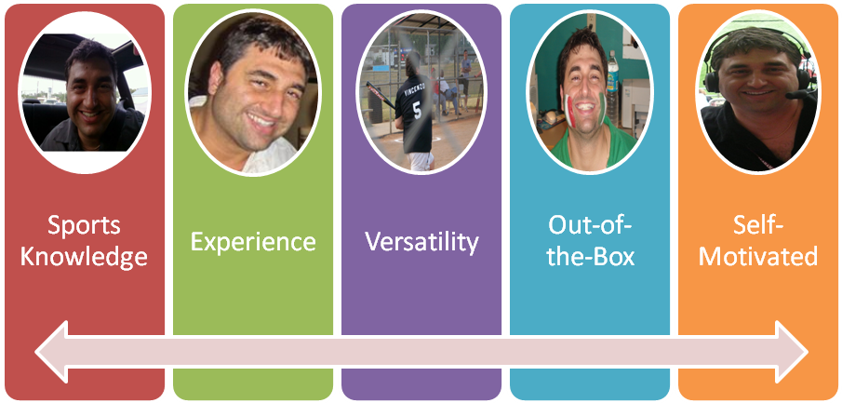
…WHAT YOU GET IN VINCE FERRARA
Vince Ferrara has a background and years of experience in much more than sports…

Vince Ferrara brings even more to the table…


