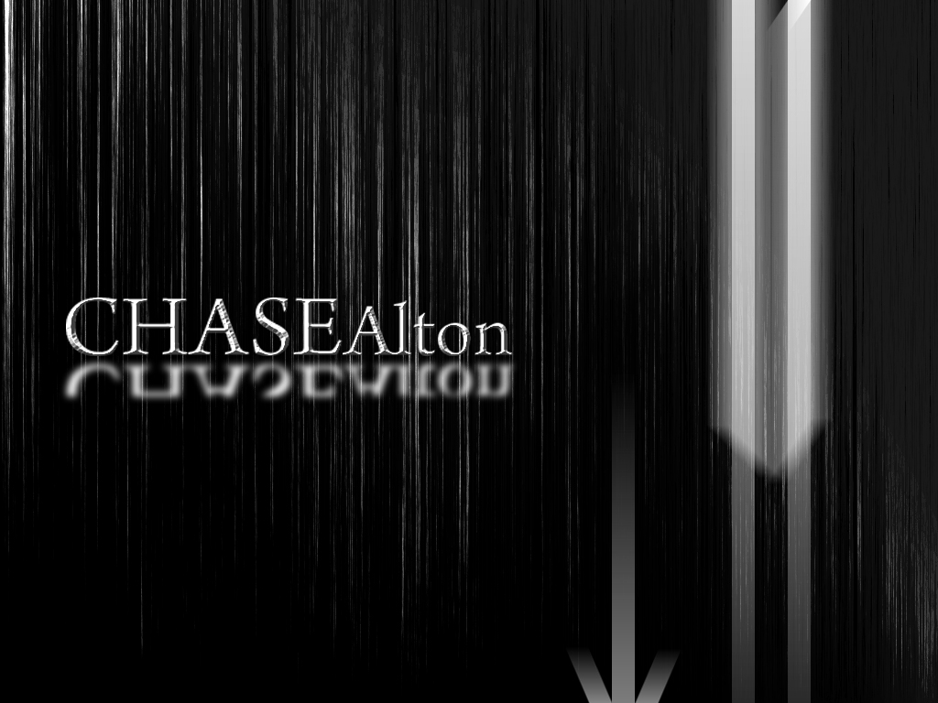Chase D. Alton
34490 NYS Route 12E,
Cape Vincent, New York 13618
(315) 408-2064, Calton@email.itt-tech.edu

Objective: To obtain a position in the multimedia field, doing web development work for a corporation that is on the cutting edge of design.

Skills summay: Several years of experience working with in Adobe Photoshop CS3, Illustrator CS3, Flash CS3, Premier CS3, 3DS Studio Max, and Sony Sound Forge to create and develop interactive websites. Proficient in Windows and Mac operating systems, Microsoft Word, and can quickly pick up any skill. Currently holding a leadership position in a company that requires management and leadership skills with customer interaction on a daily basis.

- Maintain, modify, and develop custom modules
- Prioritize tasks in a team environment and work independently
- Solve problems quickly and write procedures out, maintenance
- Video uploads to social networking sites, such as iTunes, Vimeo, and YouTube, blogging and blog postings
- Excellent verbal and written communication skills
- On-call support
- Created graphic projects (multiple one) and assisted in coordination of all graphic production scheduling and completed on time and to user's satisfaction.
- Interfaces with users to determine project details and best graphic medium.
- Trains other personnel in proper use of computer graphic equipment.
- Promotional displays, marketing brochures and design unique logos for customers.
- Good communication skills

Free Lance Work - Web Sites And Commercial Production___________________

Marine Officer Selection Office Syracuse: Participated on a team that developed a concept website for their office; my part on the team was to be in charge of general feel and layout for the company to design their homepage. I did the splash page for the website using Flash CS3 using HTML interface. The website allowed potential Marine Officers insight into the Marine Corp and what to expect all using a progressive feel.

Heretic Motorsports’ Commercial: Created a 30 to 40 second commercial an automotive tuning business to educate people on the benefits of tuning their car or truck to increase gas mileage and performance. The job including using Photoshop, aftereffects, and simple effects to sell the concept while grabbing the audiences’ attention.

Headlines Hair Company: Concept design for a local hair salon with automatic updates for the website.

Education:____________________________________________________________
ITT Technical Institute, Liverpool, New York 2009 2007-2009
Associates Degree Multimedia

Immaculate Heart Central Junior/Senior High School 2001- 2006
1316 Ives Street, Watertown New York

Work History:__________________________________________________________
Senior Game Advisor, GameStop Corp 2007 to Present

Major duties and responsibilities:
- Opening and closing the store
- stand in manager
- processing shipments
- operating a cash register
- stocking shelves
- in depth knowledge of products
- customer service
- Bank deposits

Achievements:
- perfect attendance awards

Activities:
- martial arts
- professional paintball player
- rebuild computers
- upgrade computers

E-Portfolio: can be supplied on request

