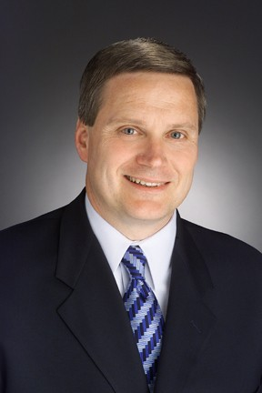

John Campanelli

John Campanelli has extensive executive experience in turnaround and growth environments, producing results for both large public multinational and smaller privately held companies. He is a visionary leader with a record of achieving dramatic changes and positive business results in short order. John is a keen business strategist with demonstrated success negotiating and quickly integrating accretive acquisitions. His most recent leadership experiences include:

John served as CEO of Classic Party Rentals from 2004 until recently. Headquartered in Los Angeles, Classic is the leading event rental business in the United States, with thirtyfour branches across the country.

Under John’s leadership, Classic Party Rentals’ sales grew from $40 million to over $250 million annually. The impressive sales growth was driven by organic sales in each market, strategic acquisitions and joint marketing agreements. Classic now enjoys national recognition for its complete “Tent Top to Table Top” product line, backed by impeccable service from 2500 employees (classicpartyrentals.com).

Prior to Classic, John worked for RR Donnelley, a fortune 500 commercial printing company headquartered in Chicago, for 24 years (rrd.com)

John last served as president of RR Donnelley’s $3 billion print business, the company’s largest business. As President of Print Solutions, he was responsible for magazine, book, telephone directory, catalog and newspaper insert printing serviced by 20,000 employees. In his first full quarter leading the business, John drove a year/year sales increase after three previous years of declining sales.

John also served as President of RR Donnelley Logistics, where he led the transformation into a leading provider of print and package logistics services for catalogers, e-retailers, publishers and financial services firms. RR Donnelley Logistics experienced 400 percent growth during John’s tenure, after a dramatic turnaround. The business went from losing $1.5 million/month, to making $1.0 million/month in John’s first 6 months.

John and his wife Kristina live in Los Angeles. John serves on the boards of Junior Achievement of Southern California and Los Angeles Sports and Entertainment Commission (LASEC). John is a graduate of Rensselaer Polytechnic Institute.

