Dustin Heeg

Professor Turner

Engl305

12 March, 2009

A Look into the Future of Processor Efficiency

In today’s world, efficiency is king. Society is working toward ways to become more efficient with gasoline consumption, waste production, and variety of other issues. The computing industry is also dealing with efficiency issues. As today’s computer processors become faster and more powerful, efficiency is becoming ever more important. Today’s high tech devices such as cell phones, mp3 players, and even appliances require increasingly faster processors in order to meet the demands of customers. Furthermore, consumers are expecting a longer battery life for their devices. Thus, efficiency in processors is important to both consumers and manufacturers. Researchers at the Advanced Computer Architecture Lab at the University of Michigan are trying to tackle the processor efficiency issue by proposing a new processor design called Razor.

The underlying problem with processors today is that the faster we make them, the more power they need. If they don’t get enough power, they will produce errors in their calculations. Figure 1 shows the relationship between processor speed and power consumption. As we have been able to make faster processors, they have had to use more and more power. Obviously, that would mean an increase in processor speed would lead to a decrease in battery life because it must use more power to work properly. That is a problem that manufacturers are pressured with because consumers demand both battery life and speed from their devices. After all, from the customer’s point of view, if we can send a man to the moon, why can’t the battery on my laptop last more than a few hours?

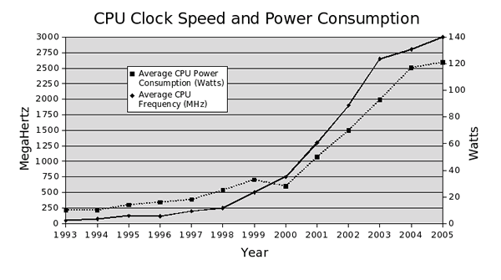

Figure

Perhaps the most crucial issue of processor efficiency is heat reduction. The more power that is pumped through a processor, the more heat the processor will produce. In the processor world, heat is not to be taken lightly. If a processor becomes hot enough it will start to generate errors in its calculations. In today’s computers, heat sinks and fans are used to transport heat away from the processor. Modern processors produce more than enough heat to destroy themselves in just seconds if no fan or heat sink is installed to carry heat away. Figure 2 shows that processors are on the verge of producing the same amount of heat as a nuclear reactor. The point is that we are reaching the limit of how hot we can make processors because fans and heats sinks can only do so much. In smaller devices that don’t have room for cooling equipment, such as laptop computers, designers have to take the heat issue with extreme caution because too much heat could cause the computer to malfunction, or even the user to get burned. That is the reason that processors in laptops, cell phones, and other devices are not as fast as the ones in full size desktop computers. So why not just develop better cooling techniques so processors can use more electricity? Then we could make processors a lot faster, right? Well, not quite. The problem with that approach is that the relationship between processor power consumption and heat production is exponential, meaning that we would not be able to gain much speed by increasing cooling capabilities.



Figure

Processor companies today have developed technologies to deal with efficiency issues. For instance, Intel has developed SpeedStep, AMD has developed Cool’n’Quiet and PowerNow!, and VIA has developed LongHaul. All of these processer efficiency technologies involve dynamic voltage scaling, or DVS. DVS involves regulating the power consumption and speed of the processor according to how much work it is doing. The idea is that a fast processor speed is not needed when the processor isn’t doing anything important. This method is much like driving a car slower in order to save gas. When the processor is not doing any work, its speed and power consumption are decreased so that it is only running at a fraction of its full speed and, thus, using a smaller amount of electricity. Then, if the processor is given some work to do it will speed up according to how much work it is given. For example, if it is only given a small amount of work it may run at half its potential speed and if it is given a large amount of work it will run at full speed and voltage to get the job done faster.

There are significant drawbacks to the current processor efficiency approach. Many variables such as temperature, power supply drop, and even the kind of program being run that affect the energy needs of the processor. As a result, when designing the processor the manufacturer must choose a relatively high voltage to run the processor at to make sure that it will function error-free in even the rarest of conditions. Figure 3 shows that traditional power savings techniques use voltages that are well above the voltage at which the processor starts to produce errors. Consequently, processors using the current energy savings approach are using overly conservative voltage settings and are not achieving maximum efficiency.

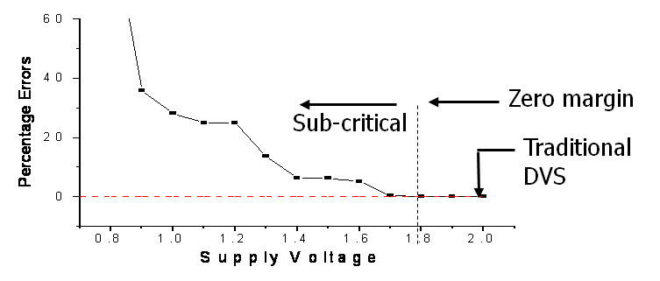

Figure

“Razor: A Low-Power Pipeline Based on Circuit-Level Timing Speculation”, written by a group of computer scientists at the University of Michigan Advanced Computer Architecture Lab, presents a new take on lowering the energy consumption of processors. The approach of the Razor system is to exploit the errors that the processor produces when it is not given enough power. The technique is sort of a guess and check procedure. In the Razor approach, the processor voltage is lowered until the processor starts to produce errors. In addition, the Razor circuit corrects the errors that were produced, guaranteeing error free output in any condition. Thus, in the Razor system, voltage is dynamically regulated according to the rate that errors are produced. In this way the processor will always be running at the lowest voltage possible, and consequently will be as efficient as it can be.

The important difference between today’s processor efficiency technologies and the proposed Razor technology is that the Razor system does not have to be overly conservative in its voltage usage because it can correct any errors that are produced. On the other hand, today’s technologies use “safe” voltages in order to ensure error are never produced in any condition. Obviously, the Razor design would provide a greater efficiency because always uses the lowest amount of power possible. However, there are some drawbacks to the Razor design. Because the processor must produce errors in order for the Razor system to work, there is a small decrease in speed. This is because a non-Razor processor doesn’t have to go back and fix its errors. A marginal amount of energy is also wasted when the Razor processor has to detect and fix its mistakes. However, the wasted energy is easily made up for in efficiency gains resulting from the Razor system. It is also important to keep in mind that the Razor approach is only an idea at the time, while the current technologies are tried and true. In other words, extensive testing needs to be done before it can truly be considered superior to current designs.

In addition to proposing the Razor efficiency approach, the researchers simulated a Razor processor. In order to evaluate the prototype processor, they ran several different programs on it and recorded energy consumption and performance. Figure 4 shows the results of the processor when several different programs are run on it. These simulations were run such that the processor would produce errors 1.5% of the time. The first column shows the energy savings of the Razor design compared to a non-Razor design. The second column shows the performance reductions that result from the error correction of the Razor design. The third column is the IPC of a Razor design compared to the IPC of a non-Razor design. IPC stands for instructions per cycle. A processor can be thought of as a calculator, where an instruction is a mathematical expression that is typed into the calculator by the user. A processor is also much like a very fast clock, where each cycle is like a tick of the seconds hand on the clock. So the number of math problems that a calculator can do per second is analogous to the IPC of a processor. The results show that the Razor design is was capable of up to a 63.6% savings in energy. On the other hand, the Razor design also showed up to a 4.13% performance hit. Overall, significant amounts of energy were saved, while performance reductions were fairly insignificant.



Figure 4

Processors have a long way to go in terms of efficiency. The current designs are not as efficient as they could be and need to be replaced with better approaches such as the Razor design. Although the Razor design looks promising, it hasn’t been fully implemented and tested. Additionally, the speed decreases that the Razor design incurs upon the systems leaves room for improvement. Aside from the few downfalls of the Razor design, it is a large step in the right direction. Because of ideas like the Razor design, the future of processor efficiency looks quite promising.

# Works Cited

Ernst, Dan. CPU Performance. Eau Claire, 2008.

Ernst, Dan. Razor: Dynamic Voltage Scaling Based on Circuit-Level Timing Speculation . 3 12 2003.

Ernst, Dan, et al. Razor: A Low-Power Pipeline Based on Circuit-Level Timing Speculation. Research Paper. Ann Arbor, 2003.

Linux-Mag.com. 11 March 2009 <http://www.linux-mag.com/i/articles/4311/figure_one.png>.