Open Dialog Box Program
Introduction:
Outcome:
This program is design accoeding to the requirement of my supervisor. It only needs to pass the directory file to the main project.
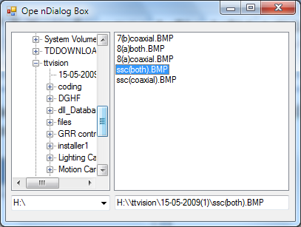
From the interface, by the folder at the tree node, the picture file of the folder will list down in the list view while the comboBox is use to change the disk directory. The testbox will show the full path of the file after the user select the picture file.

Excel file control program
Outcome:
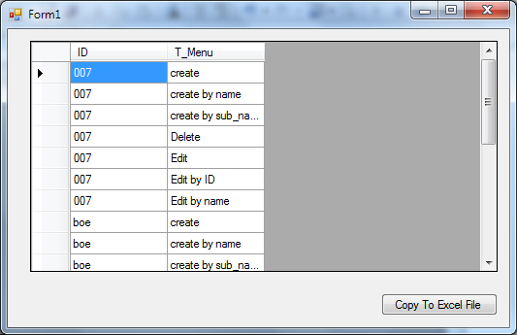
This is the interface of the program. If the user want to copy to excel file, yser just need to click on the button.

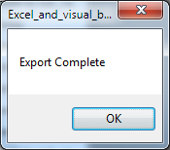
This message box will show out after the syste m finish comy the data to excel.

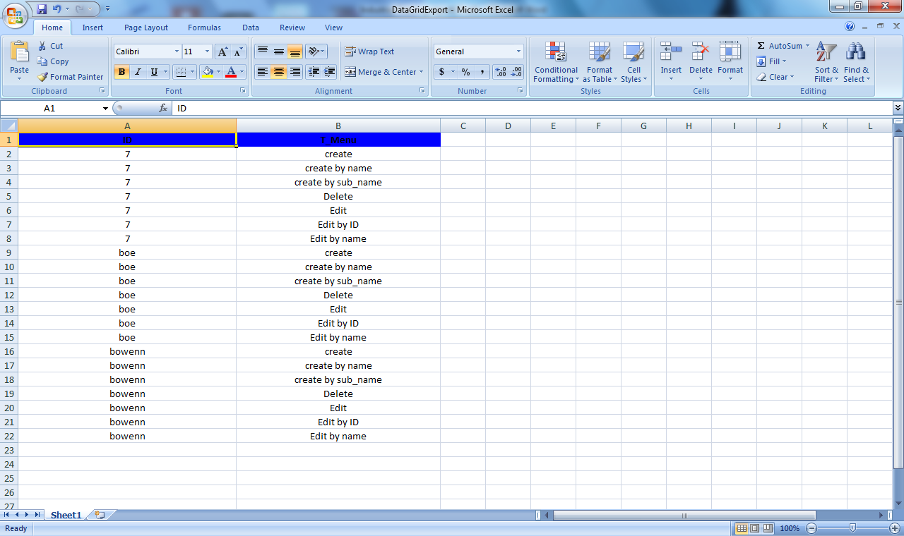
This is the result after copy the data to the excel file. The title of the column has been highlighted by the program.

Login Module Project
Outcome:
This is the ER diagram of the program. It is basic for the program database design.

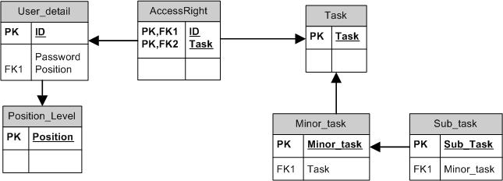

This is the result after copy the data to the excel file. The title of the column has been highlighted by the program.

Below is the interface for the first part of the project:
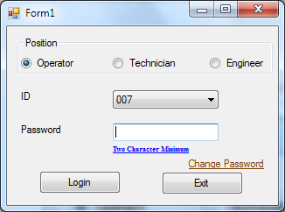
This part main function is to let user login base on their ID and password.
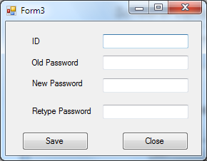
This is the interface for the user to change their password.
Below is the second part of the project:
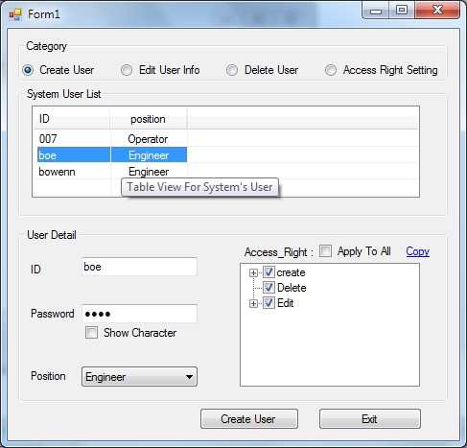
This is the main frme for the second part of the project. It can lets the user to create new user, edit user info,delete user or change the access right setting.
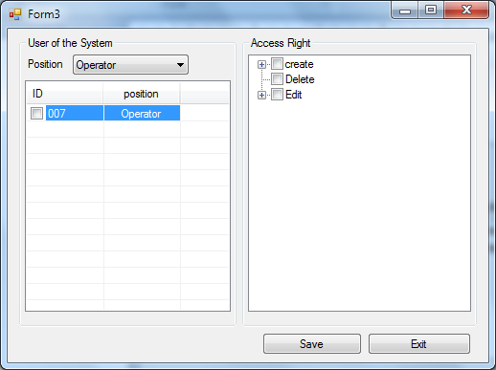
This is frame of the acces right setting. The frame function is to lets the admin to edit the user system access right according to the position and can edit the access right of the user which is more that one user at once.

.
Result Map Module
Outcome:
This is the Result Map of the program. The first chip should be can start at any corner.

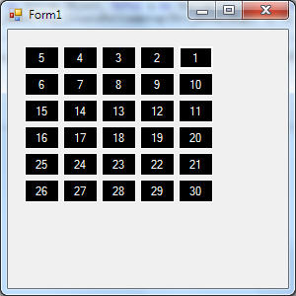

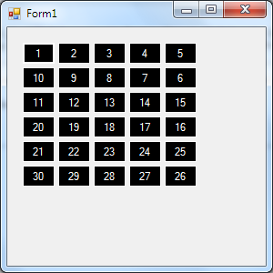
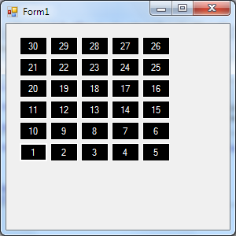
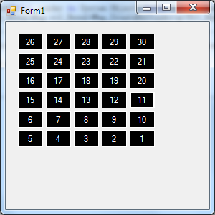

The chip can be click and a message box will show out and below.
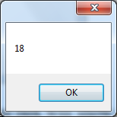

Besides that, the map also can be arrage in column.
