Team Foundation Server Lab
Monday 11/10/08
Travis Johnson
Nick Heidke

- Overview
In this lab you will create a project and save it to the Team Foundation Server so that permissions can be set to allow other users the availability of working on the same project. You will set these permissions and play with the source control so that you or your partner will be able to check out the project to work on and the other partner will only be accessible to the project in a read only format.

- Connect to our Team Foundation Server
Run Visual Studio 2008 and click View -> Team Explorer. Then click on the “Add Existing Team Project” button.
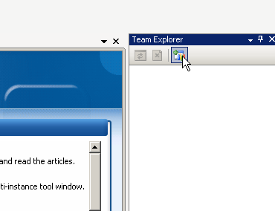
Then click on “servers. . .” and then “add. . .”
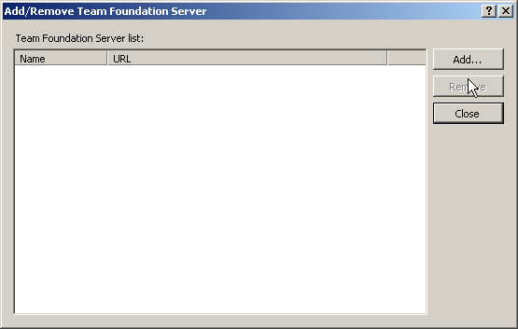
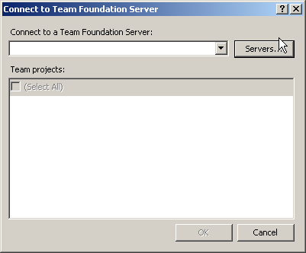

Next, enter “vsteam.cs.uwec.edu” into the server name text box and click “OK.”
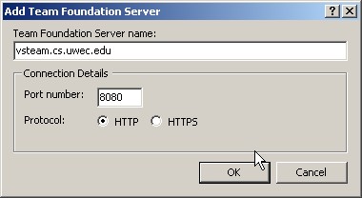

Then double click on “Source Control”

- Create a New Workspace Folder
Next we must create a new workspace so that we know where the local copies of our projects are being saved.

To do this we must click on the drop down tab on the workspace combo box and then click on workspaces…
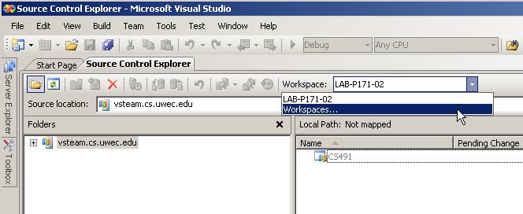

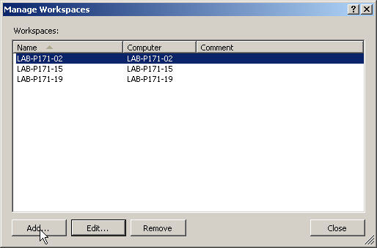
We will then click on “add. . .”

Change the name to “CS491.” Then click on the space that says “click here to enter a new working folder”

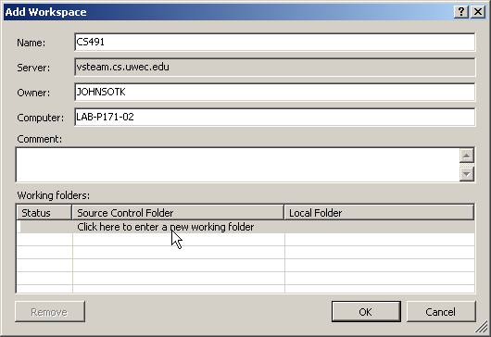

Next, click on the ellipse button in the source control folder column. This will pop up a new window. Click on the “CS491” folder and press ok.
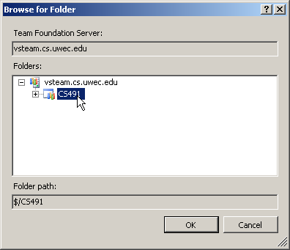

Now, click on the top row of the Local Folder column and then the ellipse button that appears in that same column.
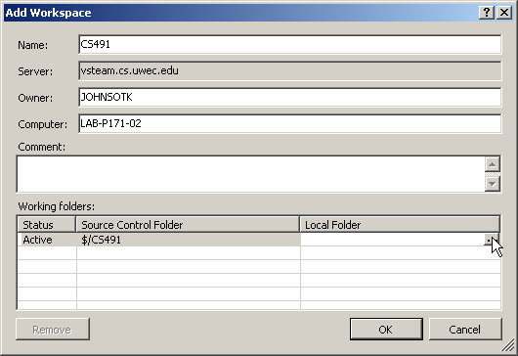

Then browse to the C:\Temp folder.
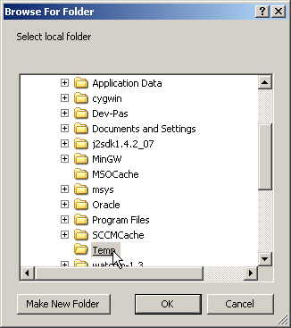

Then click ok, ok again, and then close. Next we must select the workspace folder that we decided to use. This is done by choosing it from the workspace drop down menu mentioned before.

- Get Current Code
We must get the most current code to work on so that we are not working with old code that has been changed since.
- Right click on “CS491”
- Select “Get Specific Version”
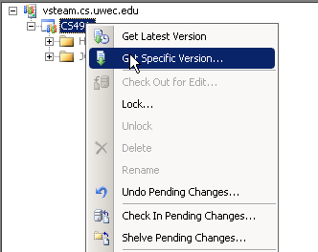
- Select “Overwrite Specific Version…”
- Select “Overwrite all files even if the local version matches the specified version”

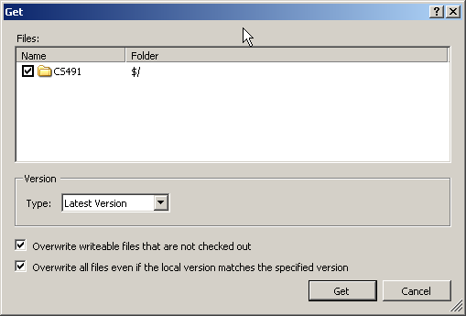

- Adding a Project
- Go to File -> New -> Project
- Type “Hello World” for the project name.
- Make it a VB -> Windows -> Console Application
- Select “Add to Source Control”
- Set the location to “C:\Temp\USERNAME”
- Select “Create directory for solution”
- Click “OK”
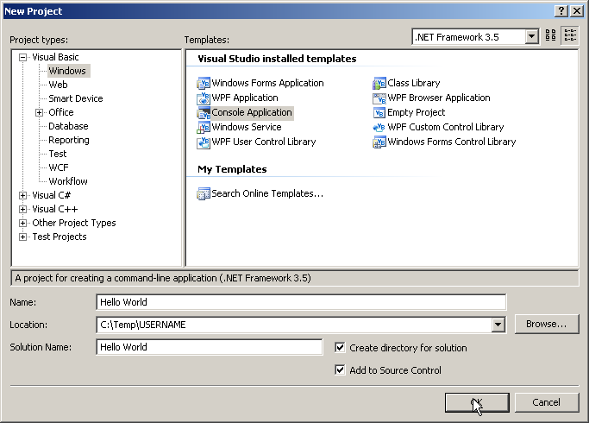

- Now we need to check the project in to save it to the source control. This is done by clicking View -> Other Windows -> Pending Changes. Then press “Check In”
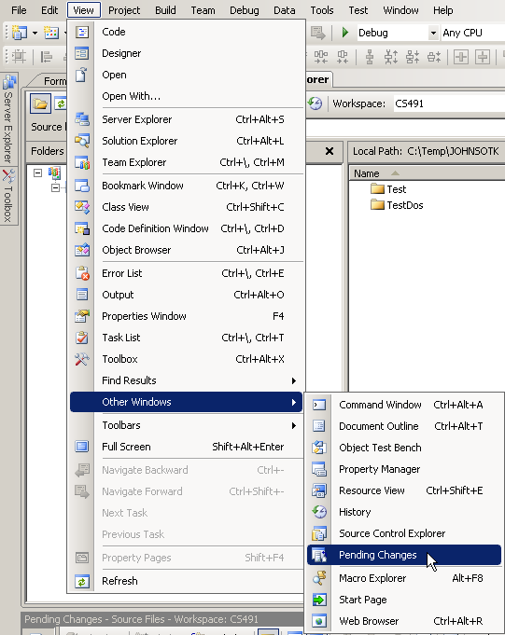

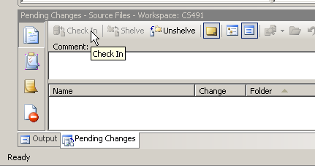

- Set Permissions for the new Folder
- Go to View -> Other Windows -> Source Control Explorer
- Select your username folder and expand
- Right click on the first folder named “Hello World” and select “Properties”
- Go to the “Security” tab
- Click “Add…” in the center of the dialog box

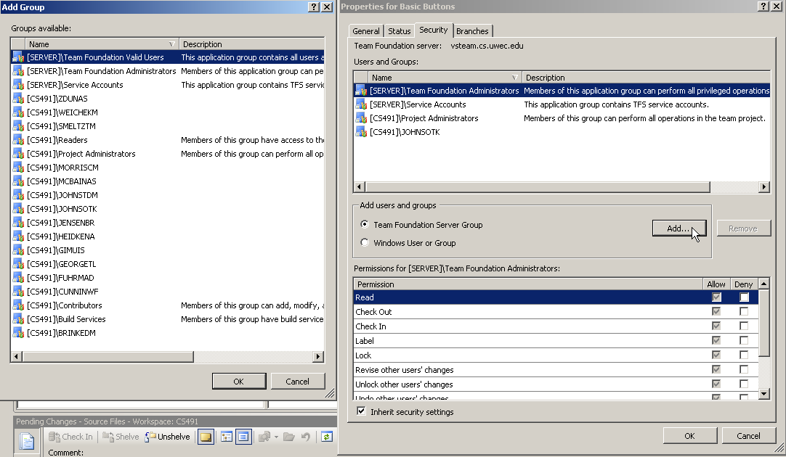

- Add the group that has the name of your partner
- Click “Allow” for each permission in the dialog box for your partner
- Click “OK”

