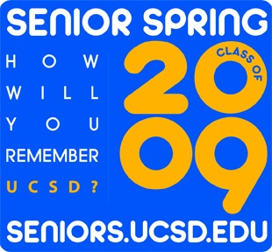
To Whom It May Concern:
Every year, UC San Diego seniors prepare for their June commencement in a variety of ways. To capture that spirit and energy, students are launching the inaugural Class of 2009 Senior Spring. The idea of Senior Spring is to mobilize the entire university to a quarter-long pre-graduation celebration, to create a buzz on campus that offers experiences unique to students in this important transition in their academic and personal lives.
We are on the threshold of something very exciting: the idea of a quarter of programming that connects students together before graduation, retaining their interest and connection to the university in the ten short weeks before commencement. The planning for senior events is already underway within your departments, and what we can help to provide is the organizational tools, financial support, and most importantly, a critical mass of students looking for these opportunities.
The concept of “Senior Spring” is new to UC San Diego, we are working campus-wide to include departments, colleges, and student organizations to create a foundation for a collaborative senior quarter. But Senior Spring needs your help. The potential of our website, seniors.ucsd.edu, as well as Senior Spring as a whole, requires your support. Without your information, we can not possibly produce the student enthusiasm or one-stop shop we aspire to create. What we can provide to you:
- An easily recognizable brand that can be identified along with events aimed at the 2009 graduating class. This branding is already coordinated with this year’s All Campus Graduation Celebration (ACGC), and available for all events that are a part of Senior Spring;
- Financial support for events that share the goal of uniting seniors, preparing them for their transition from the university or connecting them with alumni (see separate funding form);
- Service of a comprehensive and informative website with features similar to welcomeweek.ucsd.edu, including a fully functional calendar and organization by date and type of event. The website, seniors.ucsd.edu, contains a form for departments and organizations to easily submit their events and will be moderated by the Senior Spring Committee Chair; and a
- Marketing and publicity campaign drawing seniors to the website as well as promoting all of these events and deadlines
It is our vision that the coordination between campus groups that seniors.ucsd.edu provides will give the senior class the most comprehensive source of information available to them anywhere on the web. The website will feature not only your events, also serve as a portal for all pertinent graduation-related topics. By the beginning of Spring Quarter, it is our goal that any senior that reaches seniors.ucsd.edu will never wonder where to find graduation information ever again.

For more information regarding Senior Spring, please contact me at kgohd@ucsd.edu or staff advisors Cynthia Davalos (cdavalos@ucsd.edu) or Tracie Davee (tdavee@ucsd.edu).

Thank you!

