

the AXΩ Iota Nu-sletter

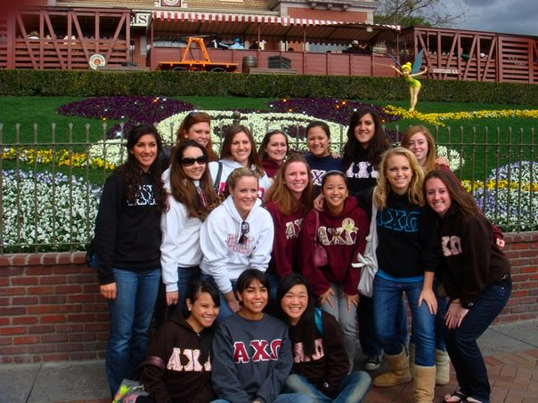

This Week in UCSD Greek Life:

**Tuesday 1/29: KATWalk** featuring Lisa Kamino and Alexa Stovner @ PC 7:30p

**Friday 2/1: Greek Week Kickoff** @ Round Table

**Saturday 2/2: Greek Week Games Day**   
@ Warren Lawn 12-3



**Find the lyres!** Write down the number you find with your name in the Say What Box and you can win a prize

February is an exciting month for our chapter and for the UCSD Greek Community as a whole. The majority of all-Greek programming happens this month, from Greek Week and the Excel Leadership Conference to Greek Awards on February 28th.

I encourage you to take advantage of these opportunities to get to meet other chapters and reconnect with people you haven’t seen since recruitment or last quarter!

Also, major props to **Julie Oh** and **Jamie Bradley** for all their work on AEPi Film Festival…our video is amazing!

**Say What? Box:**

*How is the new exec doing? Any comments/concerns?*  
      Bylaw Revisions: A lot of comments that you have about the chapter could be applied towards Bylaw Revisions. If you have any ideas, throw them in the Say What? Box.

**Bylaw Revisions:**

Submit any Bylaw Revision ideas by February 11th to me. CRSB will then compile the changes and have them available to you to view on the forum.  
  
**Bylaw of the Week!:**

**Article 5 Section 7: Special Status**

An active collegiate member who has extreme personal circumstances may request a Special Status from the Chapter Relations and Standards Board (CRSB).    
  
CRSB considers the worthiness of the request and, if approved, sets the terms of the Special Status.  These terms address participation in chapter activities, payment of financial obligations in addition to national dues and fees, and length of status. The affected member meets with CRSB to acknowledge acceptance of the terms of her Special Status.  The terms are signed by the member and CRSB members and entered into CRSB minutes.  
  
No more than 3% of the active collegiate members may be granted Special Status for extreme personal circumstances at the same time.



Alpha Chi at Disneyland!

Sisterhood Trip Jan.17th



Courtesy of A. Deemer

Chapter Relations and Standards—VP CRS Jessie Pease

The Best (February) You’ll Ever Have!



Don’t get your lyres in a bunch—get ready for Macdowell Month instead!

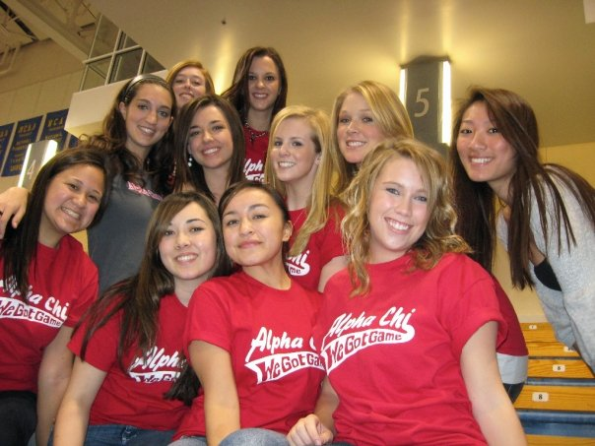

**Crush Dance is Sunday Feb. 17th**  
-We need your date names by midnight on February 8th if you want them to receive an invitation!

-We will be going into fraternity meetings on the 10th, so if your date is in a fraternity he will get his invitation delivered in meeting.

-If he’s not, we will give you the invitation in meeting on the 11th to give to him!

Social Calendar---VP Membership Development Janice Kim

Support **Lisa** and **Alexa** at KATwalk tomorrow at 7:00pm

Panhellenic Exec Applications extended, due Feb 8, 2008

Innertube H20 polo against Chi Omega Weds. Jan 30th.

8:30 pm @ Natatorium (in Muir)/ Sammy will be there to cheer us on!

Sisterhood with Kappa Kappa Gamma Feb 20th @ Time: TBA

**Greek Week announcements:**

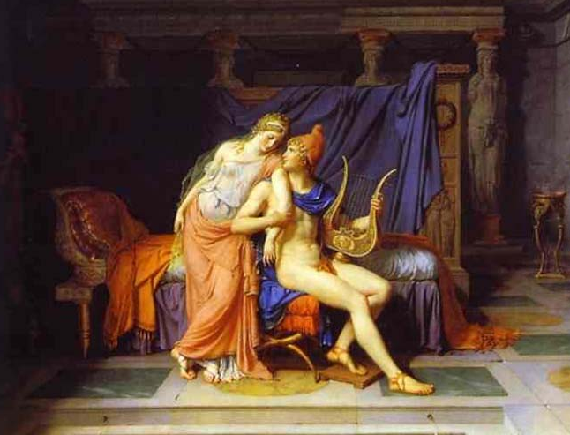

Iota Nu-sletter February Edition

Page of 3

Greek Life Updates---VP Panhellenic Catherine Huang

Philanthropy and Community Service ---VP FR Yao Leung

**Upcoming events/projects:**

Focus the Nation is on Thursday 31st from 11am-3pm at the Warren Mall

Checks for Mr. Alpha Chi Shirts to me by the end of the week (Friday or  
you WILL be C-22ed)

Mr. Alpha Chi update from **Kim** & **Jess**  
  
Get excited for MacDowell month!   
Our first event is Feb. 8th (Indie Film)  
  
Fundraiser on Thursday for Student Foundation, RAISE $ for Scholarships

Check the calendar for week-by-week updates!

**About MacDowell Month…**

The seven Founders of Alpha Chi Omega joined together for fellowship and to foster an interest in music and the arts.

In their honor, the Alpha Chi Omega Foundation supports the arts through an annual contribution for the maintenance of Star Studio at The MacDowell Colony, Peterborough, New Hampshire. Star Studio was built in 1911 with funds from Alpha Chi Omega Fraternity.

The MacDowell Colony was the very first altruistic project of Alpha Chi Omega.

"If you know your idea is good, stick to your guns and just say it.  You'll save time and earn respect."

-Betsey Johnson

Page of 3

Remember: Recruitment surveys are due Jan.29th!

Haven’t seen our site?

Visit us at:

[axoatucsd.moonfruit.com](http://www.widgets.msn.com/)

**Get Involved!**

Orientation Leader Applications are available at your college websites, check Tritonlink for details

**Stay on top of school!**

February 2nd is the last day you can drop or change the grading option on a class

Intellectual Development---VP ID Ashley Deemer

Chi Connection Updates--- VP Education Brittany Scotto

Chi Connection groups: When you go into fraternity or sorority meetings, please dress to pin!

Chi Connection groups will be assigned to each day of Greek Week.

Leaders, check your e-mails please

Feb 4th: FALL 2007 Chi Connection after meeting

Study Hours: Tuesday 4-6 @ Geisel basement (by the periodicals)   
  
Feb 13th: First mentor/mentee event!   
  
Pearls for people with 3.5+ GPA  
  
Be on the look out for MacDowell Month events in February.

Check the forum for test files archive! **Taryn** did an amazing job compiling them! *axoresourcechair@gmail.com*

SAY WHAT?!? Box notes