North Park Fact Sheet
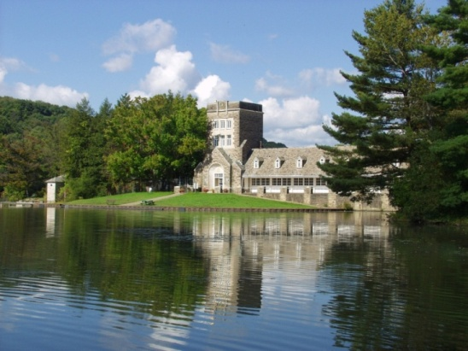

Background: North Park is a 3,010-acre (12 km²) county park in Allegheny County, Pennsylvania, United States. It is the largest in the county's 12,000 acre (49 km²) network of nine distinct parks.

Completed in 1931, North Park is sited 15 miles (24 km) northeast of downtown Pittsburgh in Hampton, McCandless, and Pine Townships. The park features the largest man-made body of water in the county, over 75 acres (300,000 m²), bordered by four miles of woodlands. Its swimming pool was considered in the 1930s to be the largest in the world; it holds 2 million gallons of water. The park also offers a golf course, ice skating rink, picnic groves, tennis courts, and miles of trails.

Agenda/Itinerary: Friday, September 25, 2009
8-9 a.m. —Registration
8:45-9:15—Introductions and safety briefing
9:30-11:30— Service Project
11:30-1 —Working lunch with Social Innovation discussion

Project Details: Cleaning Culverts:
Volunteers are needed to assist with the cleaning of culvert lids as well as cleaning out debris from the culverts.
Invasive Plant Removal:
Volunteers are needed to remove invasive plants throughout the park.
Pool Project:
Volunteers are needed to assist with scraping paint from the bottom and sides of the North Park pool.
Trail Restoration:
Volunteers are needed to work on various trails throughout North Park which are used for walking, biking and horseback riding. Tasks will include the removal of brush, dead trees and other debris from the trail.

How to get here: North Park Ice Rink
303 Pearce Mill Road
Allison Park, PA 15101

How to dress: Wear comfortable footwear as well as long sleeves and pants. Supplies like gloves, trash bags, etc. will be provided.

