Schenley Park Fact Sheet

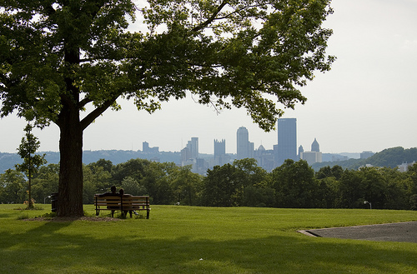
Background: Situated in the heart of Oakland, Schenley Park has come to be Pittsburgh’s civic park. A daily destination for university students, business people and outdoor enthusiasts, the park also hosts annual events such as the Vintage Grand Prix and the Pittsburgh Race for the Cure. Created in 1889 with land donated by heiress Mary Schenley, the park now contains 456(1.85 km²) acres of trails, woods, and attractions.
Agenda/Itinerary: Friday, September 25, 2009
8-9a.m. – Registration
8:45-9:15 – Introductions and safety briefing
9:30-11:30 – Service Project
11:30-1 – Working lunch with Social Innovation discussion

Project Details: Schenley Plaza Cleanup and Event Preparation:
Volunteers are needed to help with park beautification in and around Schenley Plaza.

How to get here: Schenley Plaza
4100 Forbes Ave
Pittsburgh, PA 15260

How to dress: Wear comfortable footwear as well as long sleeves and pants. Supplies like gloves, trash bags, etc. will be provided.

