J452—Writing Assignment-Instruction—Alison Guess

To set up your Netvibes account:
- Access the site by typing www.netvibes.com into your Internet browser.
- Click on the green box near the center of the page that says “Sign up.”
- Create a username.
- Provide a valid E-mail address.
- Create a password.
- Click the “I agree with the terms of service box.”
- Click the green “Sign up” button.
- Follow the instructions that appear in the box after you have clicked the green “Sign up” button.
- You are now ready to start using Netvibes!

To create your Netvibes page:
- Click on the green button in the upper left corner of the page that says “Add content.”
- You may now begin searching for widgets to add to your page.
- In the upper left corner, just below the box that says “Add content,” you will see four specific ways that you can search for information to put on your page.

If you know the Web site of a blog you want to place on your page:
- Click on the “Add a feed” page and type the address into the white box on the right.
- This should yield the page that you are looking for. Then, to add this page to your Netvibes page, click on the green “Add” button. It will then appear on your Netvibes page.

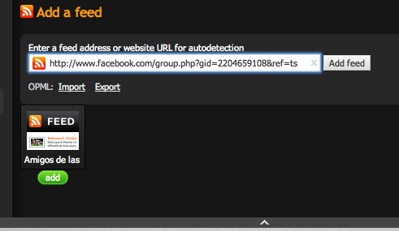

To browse widgets:
- If you are unsure of the exact widget you want to put on your page you may search the different categories of widgets. Click on the “Browse categories” widget.
- You will then be able to choose from nine types of widgets including: news, business, sport, etc.
- Click on the widget category that best suits what you are looking for and begin browsing through the pages

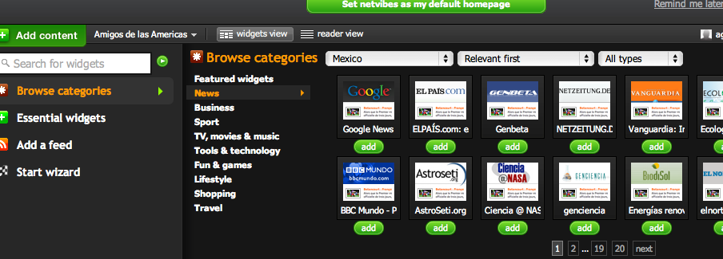

Once you have added several widgets and/or blogs to your page it will look something like this:

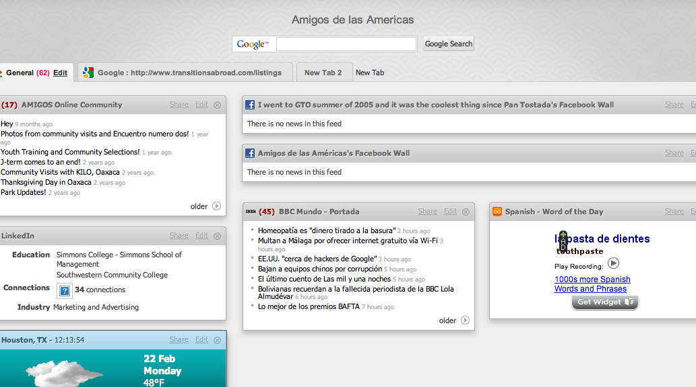

If you are satisfied with the items on your page, you are now ready to make your page public.
Do this by:
- Moving your cursor over the tab next to the “Add content” button.
- A pull down menu will appear. Click on the “Activate my public page” button.
- Then, simply fill out all of the information that is asked of you and your page will be open for public viewing.

