

DEMO KIT

COCJIN, CARLOS MIGUEL
IBASCO, RICHMOND
MENDOZA, NEIL ANDREW
RODRIGUEZ, EFREN

MARIVIC TANGKEKO
Thesis Adviser


Carlito Del Rosario recently inherited a piece of land and a herd of cattle from his father. He started his own farm with all the resources he inherited. After 5 months, he wanted to expand his farm and look for more sources of profit through having more livestock. He then learned from his barangay captain that the municipality of Imus, through the municipal agricultural office (MAO), gives out free livestock to farmers of Imus who request for it. The barangay chairman introduces him to the Imus Agricultural Portal (IAP). Before Mang Carlito can be able to request, he needs to register through the system.
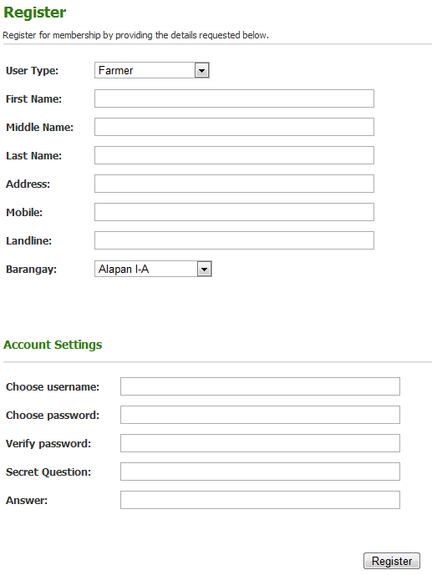


In the case of Mang Carlito, the User Type should be “Farmer” since he is a farmer of Imus.


User Type: Farmer
First Name: Carlito
Middle Name: Jacinto
Last Name: Del Rosario
Address: Anabu I-A Imus
Cavite
Mobile: 0906-4202894
Landline: 400-48-37
Barangay: Anabu I-A

Username: carlitodelrosario
Password: 123456
Secret Question: What is my pet’s name?
Answer: Bituin

Be careful in entering your Username and Password since they are both case sensitive.


After filling out the form, click “Register” to submit the application to register.

One Morning, the agricultural technologists, Glibert Remulla logs into the system and found out a pending request through the notification in the homepage. He learns that Mang Carlito sent a request to be registered into the system. After reading Mang Carlito’s registration form, he then approves Mang Carlito to use the system.

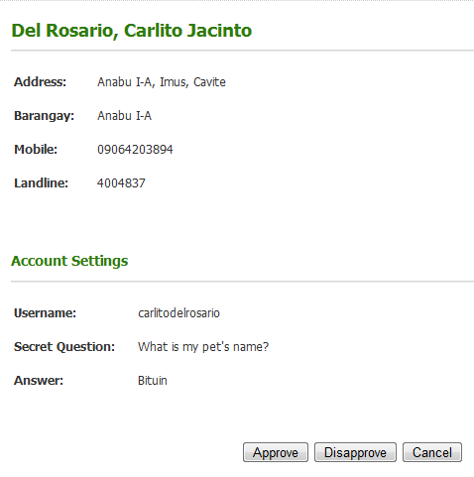

Kuya Gilbert will process the request and decide whether to approve or disapprove. The Password will not be shown to Kuya Gilbert

Just click whether the request is Approved or Disapproved.

Upon approval, Mang Carlito will receive a verification code from the system. Mang Carlito needs to enter the verification code in the system to complete the registration.



Verfication Code: (Randomly generated)

Your application for registration has been approved. Please enter the verification code as soon as you log in to your account. Your verification code is: 53183

Be sure to enter every character of the verification code.



After registration, the barangay captain teaches him about the features of the system, specifically the animal dissemination feature. He goes to the services tab to apply for the animal type he wanted. he will then fill the form to be sent to the agricultural technologist for approval.

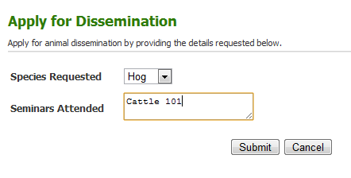
Species Requested: Hog
Seminars Attended: Cattle 101: Part 1, Cattle 101: Part 2, What do Hogs need from you?

Click Submit to finish the request.
You may put all the seminars that you’ve attended especially the ones that may help the Agricultural Technologist to decide whether to accept your request or not.

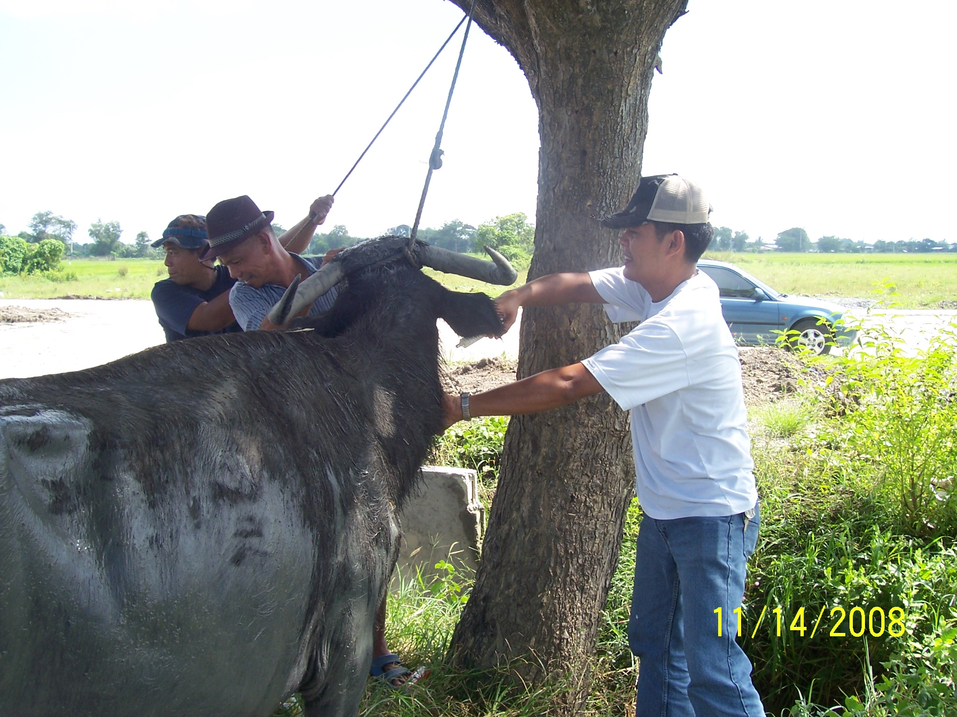

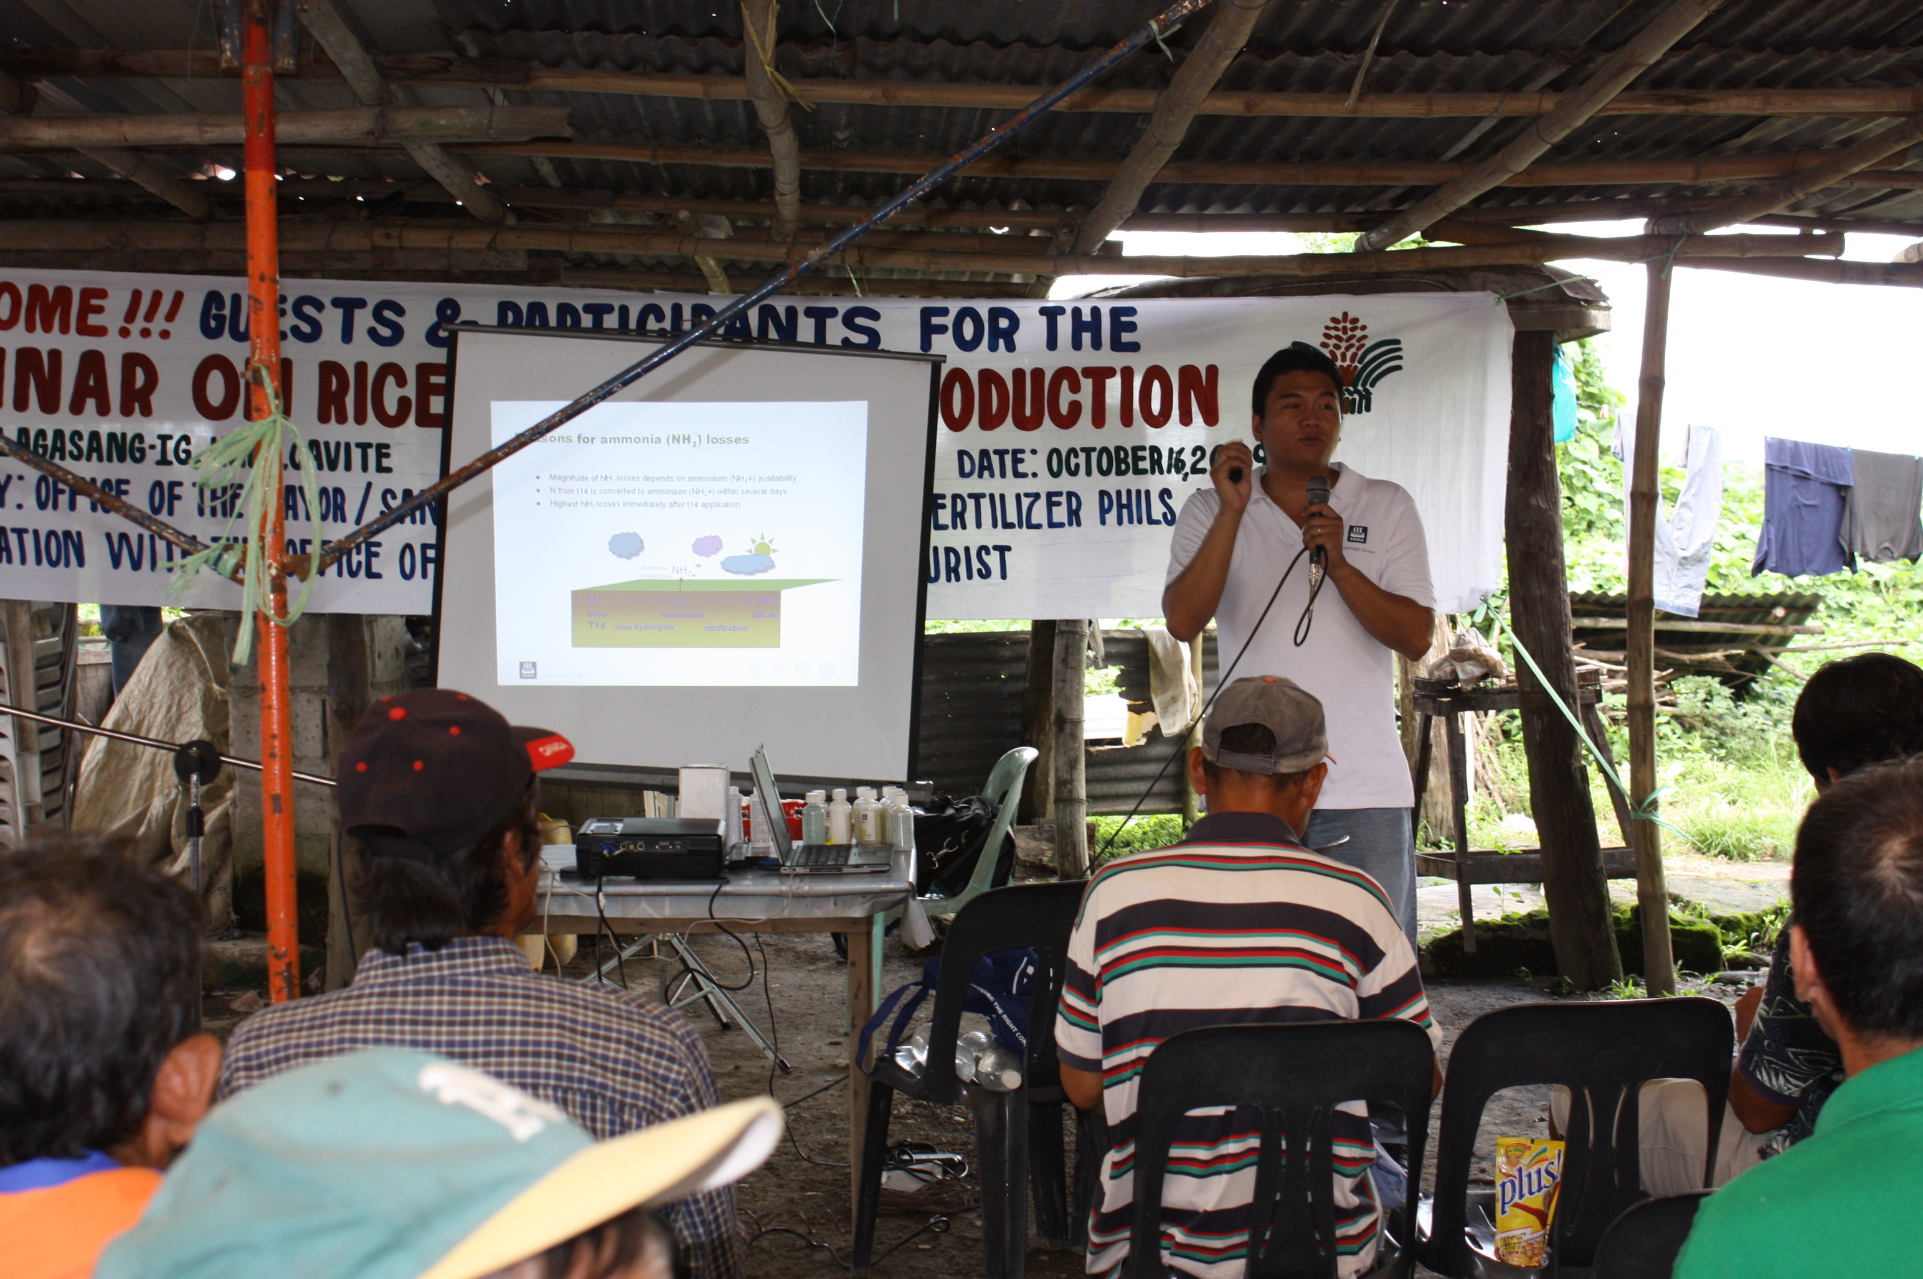

The following day, Kuya Gilbert seeing in the system the new pending application for animal by Mang Carlito, reviews the application and checks if Mang Carlito is capable of taking care of an animal. Seeing that Mang Carlito has a clean record and has some seminars attended. He decides to approve the application.

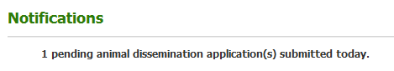

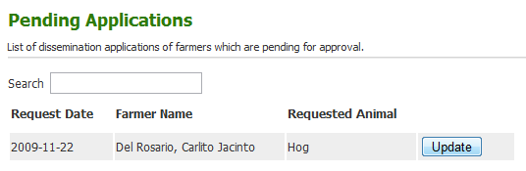
To process the request, just click on the Update Button.

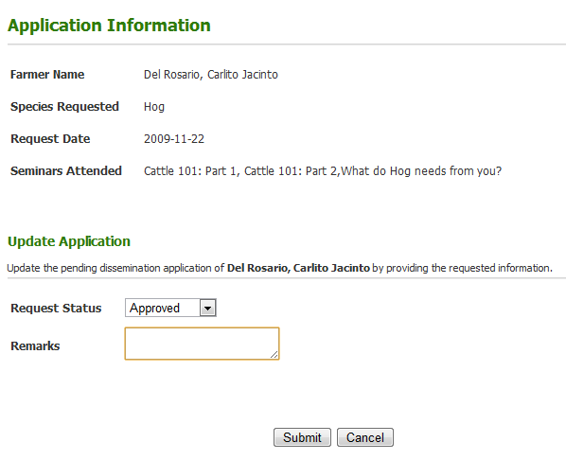

Kuya Gilbert will use all the information given by the applicant (farmer) and the past records of the applicant in being a farmer.

Kuya Gilbert will decide whether the application is approved or not. He may or may not write additional remarks.

Just click the Submit Button to finish the transaction.

Mang Carlito, while feeding his cattle, suddenly receives a message from the system notifying him that his application has been approved to complete the application he then need to go to MAO to have an animal assigned to him and to sign the memorandum of agreement (MOA).

An animal can only be assigned to a farmer after going to the MAO and signing the MOA.

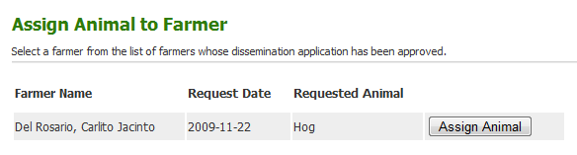
Click the Assign Animal Button to assign an animal to a farmer.

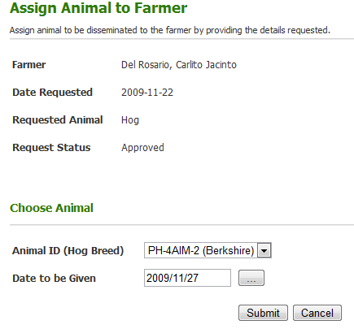

An animal can only be assigned if the Request has been approved already. An animal can only be assigned if there are available animals for dissemination.

Animal ID: PH-4AIM-2
(Hampshire)
Date to be Given: 2009/11/27

Click Submit Button to successfully assign the animal to a farmer



After 2 months, Mang Carlito noticed that the hog that was assigned to him was not eating properly and was starting to lose weight. He then notified the MAO about the situation of the hog.

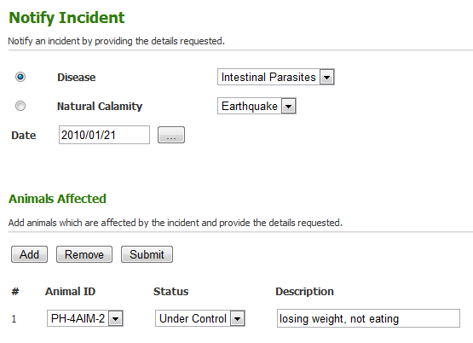

Disease: Intestinal
Parasites
Date: 2010/01/24

Click Add to add more animals, Remove to remove the animal and Submit if done.

Animal ID: PH-4AIM-2
Status: Under Control
Description: losing weight, not eating

It is important that you add all the animals that are affected by the incident because this will help MAO to scale the gravity of the situation

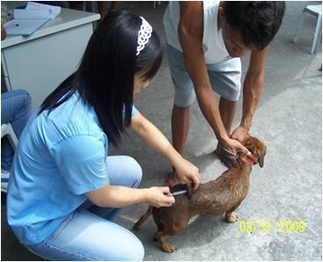

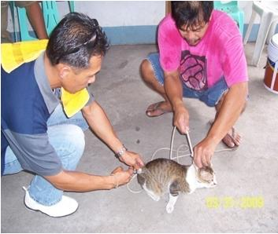

Kuya Gilbert with Dr. Mabel will visit manong douglas to check the hog. After checking the symptoms they found out that the hog is suffering from intestinal parasites and must be treated with Sodium Sulfamethazine medicine.

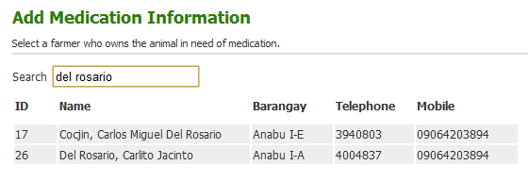

Click on the ID to view the details and Add Medical Information

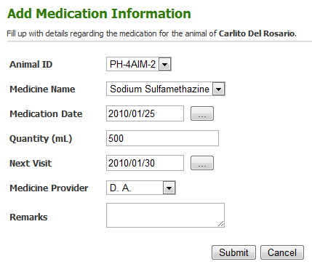

Animal ID: PH-4AIM-2
Medical Name: Sodium Sulfamethazine
Medication Date: 2010/01/29
Quantity: 500
Next Visit: 2010/02/05
Medicine Provider: D.A.

Click Submit to finish transaction



After 6 months, the hog gave birth to 12 piglets, Mang Carlito abiding by the contract, returns a female offspring. He then will notify the MAO about the birth of the offspring. the mao then added the offspring into the system and it will be ready for dissemination again to another farmer.

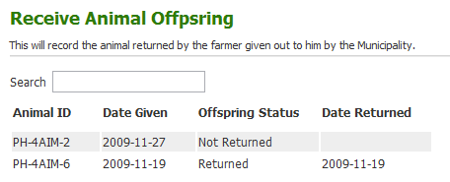

Click on the Animal ID to view the details

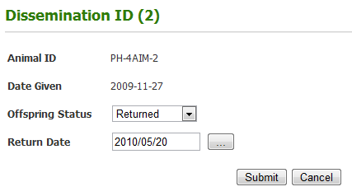

Offspring Status: Returned
Return Date: 2010/08/06

w

Click Submit to finish transaction.
It is included in the MOA that the first female offspring should be returned to MAO which will e ready to be disseminated to other farmers again.



A friend of the agriculturist, Kuya Gilbert, from the Department of Agriculture (DA) informed him that the DA will be having a series of seminars about crop planting. Gilbert Remulla, very excited about this, posted the seminars in the events section of the system.

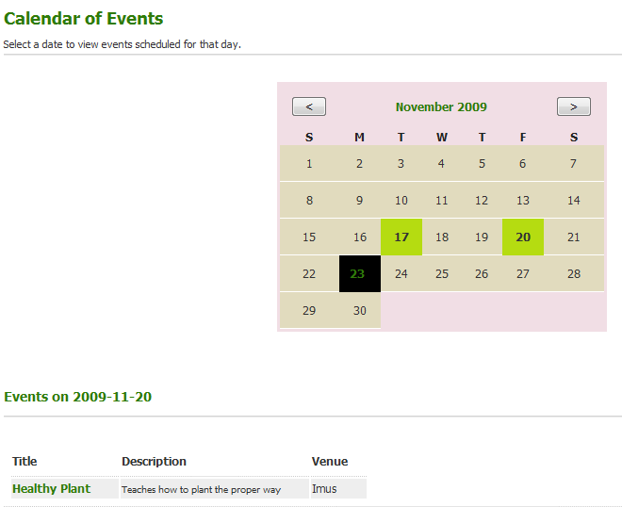

Only the ones highlighted in green are the ones with events scheduled on that date.

Just click on any date to see the upcoming events on that date.

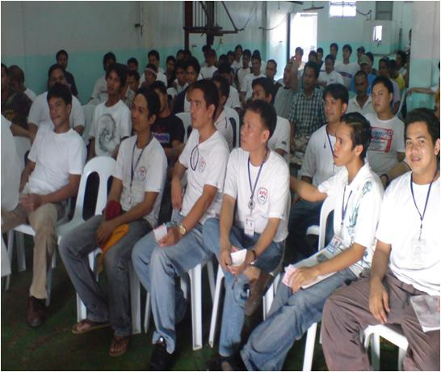
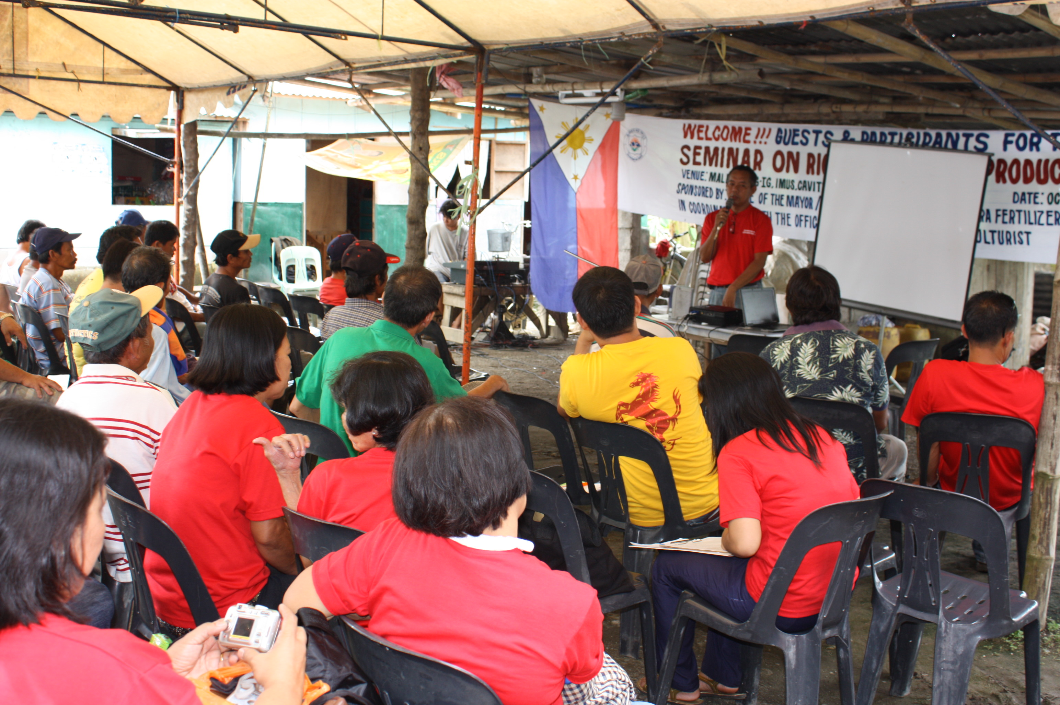



While Mang Carlito was browsing through the articles of the portal, he noticed a new event that was posted in the events section, entitled Crop Convention 2010. Seeing this, he was very interested in learning new ways to improve his farm. After attending the seminar he became more interested in planting crops and learned that MAO also gives out packets of seeds to farmers. He wanted to know which crops would yield much profit, so he texted “GETPRICE<space>WHOLESALE” to MAO text line.

GETPRICE WHOLESALE

The keywords are not case sensitive but you have to key in the right format to get the right results.



He went to the office and requested for seeds. Gilbert seeing that Mang Carlito just attended the seminar, approved his request and briefed him about the conditions in receiving seeds from the municipality. One of which is that the seeds should be planted and will be inspected by MAO for data analysis.

After 180 days, Gilbert noticed in the harvest inspection schedule that he needs to inspect the crops of Mang Carlito.

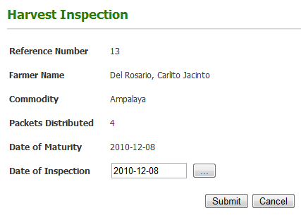

The agriculturist then proceeded to inspect the crops of Mang Carlito and entered his finding into the system.
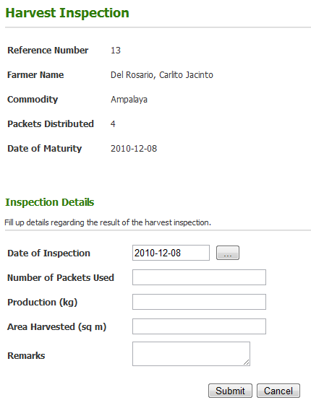

Date of Inspection: 2010-03-10
Number of Packets Used: 4
Production: 25 kg
Area Harvested: 30 m²
Remarks: good harvest

Click Submit to send Inspection Details



That night, Mang Carlito decided to sell his produce and he found out that the portal also offers an online market feature. In this feature, Mang Carlito noticed that a cooperative headed by Miguel de Guzman is offering to buy ampalaya at P16 per kilo. He wanted to sell his ampalaya to the cooperative.

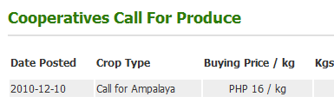
Click on the Date to view the details of the Call for Produce

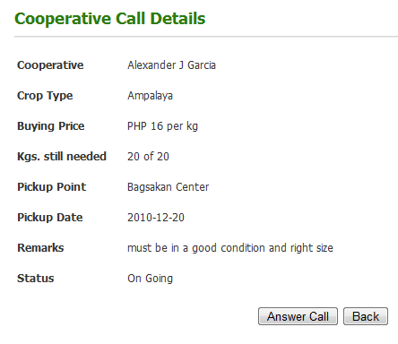

Click on the Answer Call to respond to the call

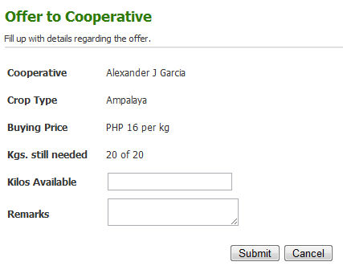

Kilos Available: 15
Remarks: relatively small compared to others

Click the Submit Button to finish the transaction.

That evening Miguel de Guzman checked his call for ampalaya and noticed that there was someone who answered his call for produce. Upon looking at the offer, he noticed that the ampalaya offered by Mang Carlito have a few discolorations and does not meet his requirements. Miguel de Guzman decided to reject Mang Carlito’s offer.

The following morning Mang Carlito checked the portal again and found out, to his dismay, that his offer was rejected. He then tried to find other ways to sell his crops. Luckily, there is another way for him to sell his crops. He posted his crops in the bidding section and a trader named Mang Jose bought his ampalaya.
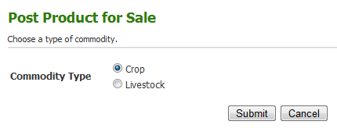

Click Submit to post the bidding

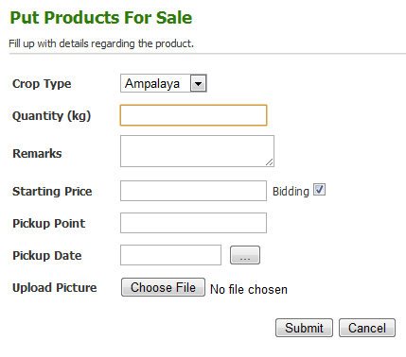

Crop Type: Ampalaya
Quantity: 15
Remarks: relatively short than others
Starting Price: 200
Pickup Point: Bagsakan
Center
Pickup Date: 2010/10/20

You may Upload a picture so that the prospected buyer may see the appearance of the crop

Click Submit to finish posting the bidding

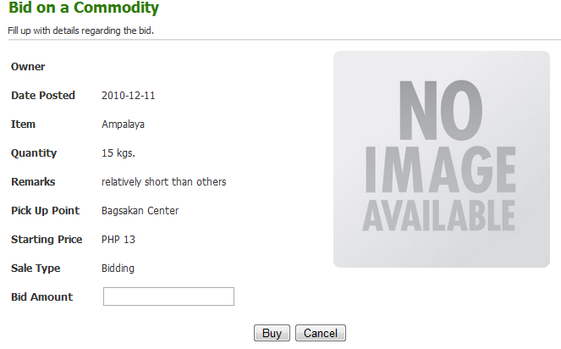

PHP 200

Bid Amount: 210

Click Buy to post you bid

Mang Carlito also decided that he can also sell his piglets to earn more. To do this, he also posted his livestock for bidding.

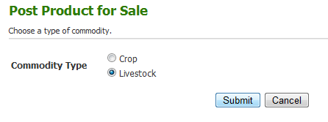

Click Submit to continue

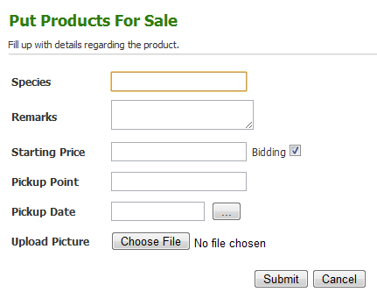

Species: Hampshire
Remarks: healthy
Starting Price: 1550
Pickup Point: Bagsakan
Center
Pickup Date: 2010/10/20

You may Upload a picture so that the prospected buyer may see the appearance of the crop

Click Submit to continue



Miguel De Guzman, while checking for his call for produce, wanted to update the market prices

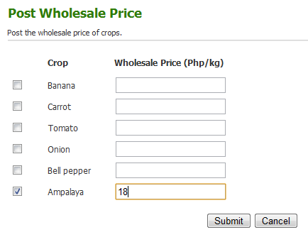

You may update the market price of specific crops at a given time.

Ampalaya: 18

Click Submit to Update Market Price

Mang Carlito, after selling his ampalaya produce to mang jose, watned to update the market prices through his cellphone. He texted POSTPRICE <SPACE> AMAPALAYA <space> 23.50.

You need to use the correct format of the keywords.

POSTPRICE AMPALAYA 23.50



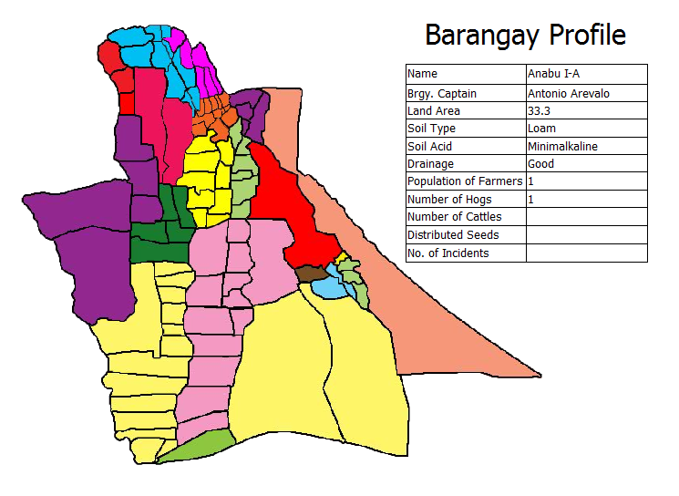
Kuya Gilbert decided to check the statistics of Barangay Anabu I-A and he used the Barangay Profile feature of the portal as an Agricultural Technologist.


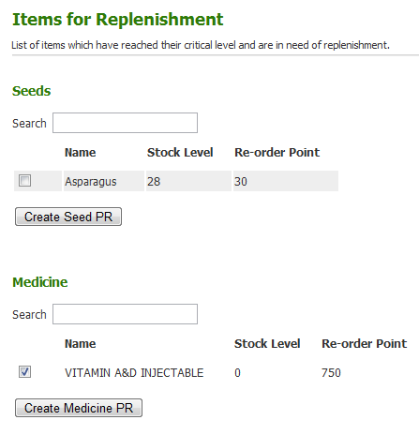
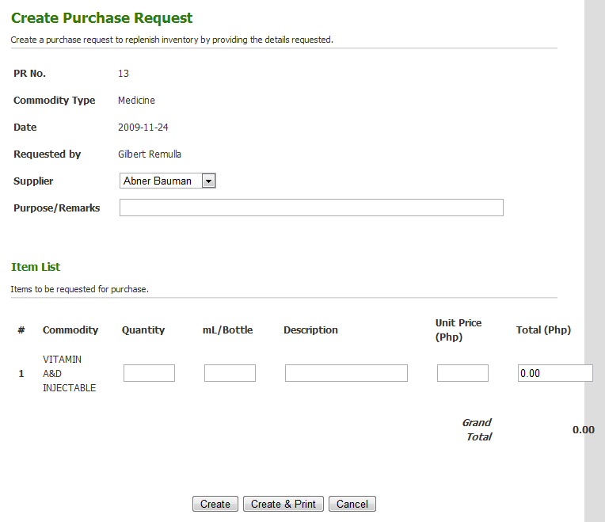
Click Create Medicine PR to continue
Check the checkbox of the medicine that you want to replenish.
Purpose: lack of supply
Quantity: 20
mL/Bottle: 100
Description: Vitamins
Unit Price: 250
Click Create to create PR, Create and Print to create the PR and afterwards, print it.

