Professor Debuts Writings at International Book Fair in Mexico

March 10, 2008
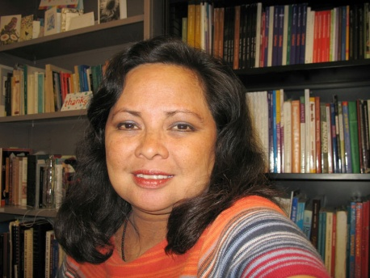
An OSU professor has given voice to an author who has been silent for more than three decades. Susana Perea-Fox (photo at right), an assistant professor in the department of foreign languages and literature, recently published her first book, Elena Garro and the Faces of Power.
Elena Garro and the Faces of Power, written entirely in Spanish, debuted in December at the International Book Fair in Guadalajara, Mexico. I was astounded when I saw the amount of people who came to the fair, which is considered the second most important book fair in the world, Perea-Fox said. I thought wow, what a place and was very happy I was able to be there.
Perea-Fox’s book explores the work of Elena Garro whose controversial writings were first printed in the 1930s in Mexico. In a time when women were urged to be silent, Elena Garro spoke out and challenged the role of women in society, Perea-Fox said.
Perea-Fox hopes her book will be translated to English so American audiences can discover the power of Garro’s writings, which include more than 40 works in Spanish, French, Italian and English. Perea-Fox considers it her mission to ensure the voices of Garro and other female writers from Mexico are heard in the world of literature. Garro has tons of novels, journalistic articles and essays that deserve critical attention, she said.
Perea-Fox discovered Garro’s work in her high school where Recollections of Things to Come was required reading. Published in 1963, the book is set in a dream-like setting during the Mexican Revolution. From then on, I started reading more of Garro’s theater works and short stories, Perea-Fox said. With time, her interest grew and eventually inspired her to write Elena Garro and the Faces of Power.
In 1986, Perea-Fox left her hometown of Cuernavaca, Mexico, to earn a bachelor’s degree in Spanish and Latin American literature from OSU. She then attended the University of Oklahoma, where she received a master’s and doctorate in Hispanic and Latin American literature. In 2002, she returned to OSU, eventually becoming an assistant professor of Spanish.
Although Perea-Fox is still in an early stage of her career, she already has received numerous professional distinctions, including an honor from the Southwestern Association of Naturalists. She says none compare to her biggest accomplishment, the publication of Elena Garro and the Faces of Power in 2007.
Garro, who died at 81 in 1998, has had a profound impact on the OSU professor. Perea-Fox now wants to share the experience with her students and others who appreciate international literature.
Even though Elena Garro was one of Mexico’s foremost writers, she’s relatively forgotten, Perea-Fox said. I want to help people discover and understand her because she is exciting and will make you change the way you see life, death and society.
To learn more about the department of foreign languages and literature, visit http://fllcourses.okstate.edu or phone (405) 744-5826.
Source: Alaina Jones, sophomore, journalism

