Tawnya Rojas, Research Director
CreativeSolutons10@gmail.com
(805) 558-4368

Campaign Introduction
The opening of the Associated Students Wildcat Recreation Center is an historic event for Chico State. Students will now have a dedicated area for recreation without having to leave campus. WREC is an example of the power of the students at Chico State: the students voted for the building construction, the students will operate the facility, and the students will use it. The “Your life, Your school, Your gym” campaign hopes to show students that this facility is theirs to use as they please. WREC provides an opportunity for Chico State to satisfy students’ fitness needs as well as make the university more competitive among other CSUs. The plan we are offering for the grand opening on August 27 will welcome students and faculty to the center and start off a successful future for WREC.

Situation Analysis
Where are we now?
Student surveys suggest that our target audiences are somewhat aware that WREC is being built and will be open for use in Fall 2009. However, most students and faculty are not aware that there will be a grand opening ceremony.
Where do we want to be?
We would like 90 percent of students on campus to be aware of the grand opening celebration. Ideally, we would like 20 percent attendance. We would like 90 percent of students to be aware of the grand opening before they leave for summer. We would like students to set aside August 27 in their minds.
What holds us back?
There is local competition from other gyms. Since the ceremony is scheduled for late summer or in the beginning of the school year, students and faculty may have other priorities. We also have limited time to target and inform out audience before the end of this school year. Surveys also suggest that some students are opposed to the student fee increase in tuition.
How can what holds us back be minimized?
We can set the date in the minds of our audience by starting as soon as possible. We can encourage students to attend by offering prizes and giveaways. We can optimize the time we have left by advertising the date of the grand opening everywhere to create awareness before students leave for summer. A “buzz” effect would lend itself well for this purpose. The more we can get students talking about WREC, the more likely their curiosity will drive them to attend the grand opening. As far as local competition is concerned, there is little we can do about students who are already committed to other gyms.
What is in our favor?
WREC is run by students, for students. Many students are excited for WREC to open and may want to see the facility as soon as possible. WREC is student owned and operated and this makes our position very favorable in the eyes of students. Students can identify with A.S. because they belong to the organization. WREC will feature brand new equipment and offers activities and services that are not available at other gyms. Also, the $175 per semester tuition increase equates to roughly $30 a month for membership, which is substantially less than other local gyms. WREC does not require a lengthy contract or hidden fees.
How can we make the most of what is in our favor?
We can emphasize that we are an A.S. production and use that as an underlying message. We will have free food, music, prizes, giveaways and games. We will involve A.S. programs and services as much as possible to help publicize the event.
What can we do to strengthen our position?
We can start plastering the date of the opening ceremony everywhere so that it resonates with students and faculty. If we start publicizing the date early it is likely that students and faculty will remember and set the date aside to attend. We can emphasize that we are a student organization and operation. Students will likely side with WREC over other local gyms for this reason alone.
Tawnya Rojas, Research Director
CreativeSolutons10@gmail.com
(805) 558-4368
SWOT Analysis
Strengths:

- WREC is a student governed facility,
- A.S. is a well-known organization with a positive reputation,
- Convenient, on campus location,
- Fees are included in student tuition so students will not have to pay a monthly membership fee,
- Features brand new equipment as well as unique equipment not offered at other gyms in town such as a climbing wall and an indoor running track,
- Constructed with green technologies and is expected to earn SILVER LEED certification,
- Will provide 80 to 100 new jobs and internships for students,
- $6,000 budget provides the opportunity to host a great grand opening event,
- Ownership by the A.S. will help provide advertising opportunities and food services for the grand opening,
- WREC promotes a healthy lifestyle which complements the mission of the university,
- Current recreational sports programs and sports clubs/ teams will use the WREC facility,
- WREC has the potential to offer wellness services, personal trainers and other services in the future.

Weaknesses:

- Narrow window of time to advertise since most students will be gone for the summer and the grand opening will be during the first week of school,
- Will take a long time to pay off this facility so no real income will be earned for the Associated Students until the building has been paid for,
- Lack of publicity to date means many students have not heard of WREC,
- The proposal for WREC was voted on in 2005 meaning many of the students who voted for the facility will not be the ones actually using the facility,
- The way the facility is being paid for could be a problem due to opposition by those who do not support the fee increase or those who will not be using the facility.

- Opportunities:

- WREC has the opportunity to team with other programs and organizations on campus such as summer orientation and CADEC and to increase awareness and encourage attendance,
- Opportunity to become the only gym in town used by Chico State students,
- Opportunity to help attract potential students to Chico State,
- Opportunity to team with local businesses (such as sporting goods stores) to donate prizes or have booths at the grand opening event,
- Opportunity to get coverage of grand opening event and advertising for the grand opening in local news media,
- Opportunity to involve prominent public figures in Chico in the grand opening,
- Opportunity to show the public the good things happening at Chico State to therefore gain public favor and improve our reputation in the community.

Threats:

- Competition from existing local gyms,
- Since the grand opening will be held during the day when students will be in class, there is a threat that attendance will be low,
- Local businesses may not be willing to work with WREC on the grand opening event,
- May be hard to get coverage in news media,
- Students who are opposed to the fee increase may not attend the grand opening event and may discourage their friends from attending,
- College students are a hard target audience to reach so lack of creativity in publicizing the event is a threat.

Target Audiences
Primary Audience
All students at Chico State.
Secondary Audience
Local media outlets in the Chico area.
Tawnya Rojas, Research Director
CreativeSolutons10@gmail.com
(805) 558-4368

Slogan and Key Messages

Slogan: Your life, your school, your gym.
Rational appeal: This slogan tells students that WREC is their gym. It is student owned, student operated, and student funded. We chose this slogan because it reaches all students at Chico State, and doesn’t favor only those involved in athletic pursuits. We hope that everyone at the university will embrace this slogan, including faculty, and that it complements Chico State’s vision.
Emotional appeal: This slogan does not exclude any member at Chico State, and welcomes all members of the university to visit and enjoy the facilities. We want students to feel like they are in control of their life - where they go to school and what they do with their time.

Key Message: Working out is just the beginning.
Rational appeal: WREC is more than just a gym, it is a social hub for students to relax between classes or during any off-time, and we would like to emphasize this. All students and faculty can visit WREC for whatever they want: socializing, homework, relaxing in the pool and much more.
Emotional appeal: Students can be themselves at WREC. We encourage anyone to use WREC, and let them know that they don’t have to work out to be welcome. WREC is for the students, by the students, and they should feel at home when they are there.

Key Message: There’s nothing Chico about it.
Rational appeal: WREC is a big change for Chico State – it is the largest building to be built on Chico State in recent years. It reaches out and adds a whole new lifestyle to all students at Chico State and potentially attracts new students. It puts Chico at a more competitive level with other universities in California.
Emotional appeal: To students who claim there is nothing to do in this small town, the WREC opening is an event that will have students forgetting they’re in a small town. Students will be a part of Chico history by attending this event, and usher in a new way of life for those who attend Chico State.

Key message: WREC belongs to the students.
Rational appeal: WREC is A.S. owned and operated. Students voted in 2005 to build this, students are paying for it, and students will be using it. WREC operates on student involvement.
Emotional appeal: This message goes along with our slogan. We want students to feel they are in control of their lives. Students helped to plan this event, and in return they will get what they asked for. We want them to know WREC is for them.

Tawnya Rojas, Research Director
CreativeSolutons10@gmail.com
(805) 558-4368

What will WREC find in this plan book?
Creative Solutions has worked hard on creating a campaign that will give students a taste of what to expect at WREC. We have broken this plan book up into sections for ease of reading. In the research section, you will find results from our survey of Chico State students, as well as an executive summary of key findings.
Following that is the goals and objectives section, where our campaign goals and objectives are laid out, including dates for the objectives to be realized, which are further detailed in the campaign timeline.
We have a total of 10 strategies planned for this event, varying from gathering students to attend to the actual day itself. Each strategy has at least two tactics in it to help explain and carry out the strategy.
Our timeline shows vital dates for the campaign, such as when items need to be ordered, when vendors must be contacted and so on. We have detailed these events and arranged them in a way that is easily viewable. The timeline also has a checklist, so events may be checked off as they are completed.
The budget is a thorough list of all items that WREC must purchase for this campaign. We listed the item, the vendor, sales tax and any shipping charges. These items are also located in the budget, should they need to be ordered before the event.
The evaluation section shows what WREC can do to evaluate the success of the campaign, broken up into our various objectives. We have surveys that should be sent out located there as well.
Finally, the appendix contains any other assorted materials WREC may need, such as e-mails, vendor receipts and so forth.

Tawnya Rojas, Research Director
CreativeSolutons10@gmail.com
(805) 558-4368

Research Executive Summary

The Wildcat Recreation Center survey was designed to gauge public opinion, knowledge and help identify target audiences at Chico State. Each question was formed to help better understand what students expect from a grand opening of the new recreation center. The survey asked about students’ physical activity and specifically what each student chooses to do during the exercise.
Demographics:
There were 125 surveys administered to help gain insight as to what students expect from the grand opening event. All of the students who participated were Chico State students. Out of the 125 students, 81 were female and 44 were male. Of the 125 students, 39 were freshmen, 23 were sophomores, 39 were juniors and 24 were seniors. The survey was conducted Feb. 23-27 at various locations at Chico State. The locations included inside the BMU, Holt Hall, Performing Arts Center, Whitney, Lassen and Shasta Halls, as well as outside Acker Gym.

Out of 125 students, 102 students had heard of WREC.

When participants were asked what student organization owns and operates WREC a total of 63 students did not know the answer, 24 students responded the Associated Students, 20 students answered Chico State and one student responded the Student Union.

Out of the 125 students surveyed, 100 students plan on using WREC.
A total number of 84 students knew that he or she would be able to use the center without a membership fee because student tuition would increase. A total of 25 students believed he or she would need to pay a membership fee to use the center. Finally, 18 students believed they would not have to pay for thecenter if they did not use it.

When students were asked if they belong to a gym a total of 41 students replied yes and 84 replied no.
Of the 125 students surveyed, 106 participated in some type of physical activity. The most popular activities were jogging, soccer and football.
Creative Solutions will use the key findings from the survey to craft a campaign that will solve the communication needs associated with the grand opening of WREC. We realize many students are not aware that WREC is an A.S. project, which is a problem. Therefore, we will include the A.S. logo in more of our outreach materials. We want students to be aware of the organization behind the grand opening of WREC.

Tawnya Rojas, Research Director
CreativeSolutons10@gmail.com
(805) 558-4368

Survey Results
Demographics:
1. Are you a Chico State student?
Yes: 125
2. Will you be attending Chico State in fall 2009?
Yes: 90 No: 35
3. What is your class level?
Freshman: 39
Sophomore: 23
Junior: 39
Senior: 24
4. What is your major?
Business: 18
Undecided: 27
Communications: 8
Biology: 6
General Music: 5
Musical Theatre: 5
Child Development: 4
Social Science: 4
Finance: 4
Journalism: 3
Music Education: 3
Musical Performance: 3
Recreation: 3
Engineering: 3
Psychology: 3
Kinesiology: 2
Liberal Studies: 2
Exercise Physiology: 2
English Education: 2
Nursing: 2
Political Science: 2
Construction Management: 2
Interior Design: 2
Marketing: 2
Accounting: 2
Art: 1
Women's Studies: 1
History: 1
Music Composition: 1
Theatre Arts: 1
Human Resources: 1
5. Gender:
Male: 44 Female: 81
Client Knowledge and Interest Area:
6. Do you exercise or participate in some type of physical activity regularly?
Yes: 106 No: 19
If yes, which activities do you do most often?
Basketball
Bicycling
Dance
Football
Gym workout
Gym class
Jogging
Martial arts
Running
Soccer
Softball
Ultimate Frisbee
Volleyball
Walking
How frequently do you do these activities?
Two to three times a week
What time of day do you normally do these activities?
Evening (5 to 8 p.m.)
Late afternoon (12 to 5 p.m.)
7. Do you currently belong to a gym?
Yes: 41 No: 84
If yes, which one?
In Motion: 32
Chico Sports Club: 8
Fit One: 1

8. Why do you go to the gym or exercise regularly?
To tone my body: 61
To be healthy: 62
To lose weight/body fat: 45
To build muscle: 36
To increase my performance in sports: 24
To socialize: 8
Other: 4

9. Please rate the following items based on their importance to as a gym member? (Answers are arranged most popular to least popular)
Very Important:
Cardio Machines
Swimming Pool
Free Weights
Flexible hours
Personal trainers
Somewhat Important:
Abdominal machines
Climbing wall
Exercise classes
Indoor running track
Nutritionists
Not Important:
Snack Cart
Social Lounge

10. Have you heard of the Wildcat Recreation Center?
Yes: 102 No: 23
If yes, when will the center be open for student use?
The majority stated next fall.
What features do you expect to find in the center once it opens?
Most of the answers were "general workout equipment."
11. How excited are you about the opening of the new recreation center?
Very excited 5 4 3 2 1 not excited at all
The average was a 4 on the above scale.
12. Do you plan to use the Wildcat Recreation Center once it opens?
Yes: 100 No: 25

13. What campus organization owns and operates the Wildcat Recreation Center?
Don't Know: 63
Associated Students: 24
Chico State: 20
Student Union: 1

14. Which of the following statements do you believe are correct?
a. Students who wish to use the center will need to pay a membership fee.
25
b. Students can use the center for free because all students will be charged extra fees as part of their tuition.
84

c. Chico State students who choose not to use the center will not be required to pay for the center.
18
15. My class is helping to plan a grand opening celebration for the recreation center. What types of activities would entice you to attend this event?
Most important:
Free food/drinks
Live music
Prizes/Giveaways
Somewhat Important:
Contest /Games
Equipment demonstration
Free nutrition consultations
Guest speakers
Guided tours
16. If there were door prizes available at this event, what types of items would you like to win?
Most important:
Bike
Gift cards
Personal training sessions
Water bottles
Workout towels

Media Usage Questions:
17. Do you pay attention to the following methods of advertising when you're on or off campus?
Most important:
Facebook invitation for events
Professors announcing upcoming events
Somewhat important:
Advertisements in The Orion
Fliers/posters on bulletin boards in buildings
MySpace invitation for events
Student e-mail announcements
Television commercials
Least Important:
Booth/tables
Facebook advertisements
MySpace advertisements
Radio commercials

Tawnya Rojas, Research Director
CreativeSolutons10@gmail.com
(805) 558-4368

Goals and Objectives
Goals

To host a successful grand opening event with a large number of students attending, ensuring future student use.

To set WREC off to a good start, gaining a positive image among Chico State students and the community.

Objectives

Awareness: Ninety percent of current students are aware what WREC is, when its grand opening is, and what organization owns and runs it by the end of spring semester, 2009.

Awareness: Ninety percent of incoming students aware of WREC’s grand opening and what events will be held that day by the beginning of fall semester, 2009.

Awareness: Major media outlets aware of WREC and its grand opening by two weeks prior to the event.

Acceptance: Sixty percent of all Chico State students realize WREC is the preferred place for students to work out by the beginning of fall semester, 2009.

Acceptance: Major media outlets accept the news value of the grand opening event.

Action: Major media outlets send reporters to the event and report positive feedback within one week of the opening.

Action: Twenty percent of all Chico State students attend the grand opening event.

Action: Based on survey results, 80 percent of all Chico State students visit WREC within two weeks of its opening. The biometric scanners can be used to verify this.
Tawnya Rojas, Research Director
CreativeSolutons10@gmail.com
(805) 558-4368

Action Strategy 1: Save the date

Start advertising the grand opening date at the end of this year so that it creates a buzz among students. Start publicizing the date and logo two weeks before finals week to create curiosity in the minds of our student audience before the summer break.

Action Strategy 1

Tactic 1: Chalk "August 27, 2009" on streets adjacent to campus, but not on campus.

Tactic 2: Post "August 27" fliers on campus message boards, in coffee shops and places where students congregate. See the attached flier on the following page.

Tactic 3: Write "August 27, 2009" on white boards in largely populated classrooms on campus.

Tawnya Rojas, Research Director
CreativeSolutons10@gmail.com
(805) 558-4368

Action Strategy 2: Getting A.S. Involved

We will utilize a variety of services offered by the Associated Students to help publicize the grand opening event. Since WREC is owned by A.S., this provides many opportunities for us as far as publicizing the event. This is a good way to reach a large number of students without paying for advertisements. It is also a cost-effective strategy since A.S. is willing to give us free publicity, labor and equipment.

Our research shows that college students are a hard target audience to reach using traditional advertising methods. Therefore we will need to use outside-the-box methods to target students. A.S. offers a few ways we can do this.

Action Strategy 2

Tactic 1: WREC employees will come to classes during the first week of school to give announcements about the grand opening of WREC. According to our research results, students pay attention to announcements in class. The logic behind this is that they are already sitting there in class so they might as well pay attention. We spoke with Teresa through e-mail in April and she ensured us that there will be WREC employees available to come give announcements in class during the first week of school. Since the grand opening is on Thursday, the talks will take place Monday, Aug. 24, through Thursday, Aug. 27. Since we are trying to reach the largest number of students possible these talks will be given in a variety of classes with a large amount of students such as general education and theme classes.

Tactic 2: When students purchase books during the first week of school, the bookstore will give out raffle tickets for prizes to be won at the grand opening. Each student will be given a ticket to fill out and drop half off into a bucket on the way out the door when their receipt is checked. This tactic was chosen because it publicizes the event while giving people a reason to come. If students were not previously planning on attending the grand opening, they will now have a reason to because this is the only way they can redeem their prize. See e-mail in appendix for approval.

Tactic 3: A.S. owned dining services will have WREC logo and slogan on coffee sleeves during the last week of spring semester to advertise the grand opening. These sleeves will display the WREC logo and the date of the event. This tactic will be used because we have found that advertisements in odd places attract people's attention. Students will also be buying a lot of coffee during this time because they will be working on final projects and studying for final exams. The A.S. dining services are willing to work with us on this tactic (see e-mail in the appendix).

Tawnya Rojas, Research Director
reativeSolutons10@gmail.com
(805) 558-4368

Action Strategy 3: Getting Freshman Interested

Freshmen students comprise a main part of our primary target audiences because these students will be attending Chico State in the fall of 2009. Freshmen students are excited to finally attend college and many will look for different activities to engage in during the first week to meet different people and experience campus life. Many freshmen students do not have a car and may use WREC because they are not able to drive to a local gym. With this said, it is very important to target freshmen students before school starts and provide them with the necessary information about the grand opening event. According to the Admissions Office's records, 2,200 freshmen were admitted into Chico State for 2009-2010. This may not be the number of freshmen who will be attending in the fall. In order to ensure that we have enough materials, we are assuming the 2,200 students that have been admitted are attending summer orientation.
Creative Solutions will be using a few tactics in order to reach this audience.

Action Strategy 3

Tactic 1: Creative Solutions will be providing all freshmen students with an informational flier. This flier will include information regarding the grand opening event. Summer orientation for freshmen students starts June 16 and will continue until July 23. Each student who participates in the orientation will receive a packet. The flier will be provided in the packet for the student to review. The flier is located on the next page.

Tactic 2: As stated before, summer orientation starts June 16 and will continue until July 23. During summer orientation students are given a tour of the campus. Creative Solutions will incorporate a tour of WREC during the normal school tour. Students who are leading the tour will give information on the building, such as the sustainable features, and the different features and equipment the center has to offer students. In addition, the student will also state the date of the grand opening event and what will occur at the event.

Tawnya Rojas, Research Director
CreativeSolutons10@gmail.com
(805) 558-4368

Action Strategy 4: Utilizing relevant departments

This strategy involves tactics that have somewhat of a bribing nature. We realize that students aren’t likely to attend an event that doesn’t benefit them in any way. Students will be more likely to attend if they get something out of it, even if it is receiving class credit or extra points. We hope that by E-mailing the chair of Construction Management, and Kinesiology departments that their influence will encourage students to attend the grand opening. These departments are relevant to WREC because of the nature of content in their curriculum.
The Sustainable Institute has been contacted and would like to have a table at the grand opening to demonstrate the sustainable aspects of WREC construction. A copy of the email is located in the appendix.
We would like students enrolled in sustainable courses to attend the grand opening too. A green course listing is available at: http://cypress.csuchico.edu/APO/Course_net1/GreenCourses.aspx

Professors who are willing may offer extra credit or point opportunity to students who attend the WREC grand opening. Proof of attendance would be entirely up to the professor but examples of which are submitting a write-up of the grand opening, returning with an item from the grand opening, or potentially offering a way for teachers to take attendance at the grand opening. We have created a memo which will be included in the tactics section.

Action Strategy 4

Tactic 1: Email department chair

Construction Management
Lori A. Brown, E-mail: cm@csuchico.edu

Kinesiology
Duane Knudson, Ph.D., E-mail: deknudson@csuchico.edu

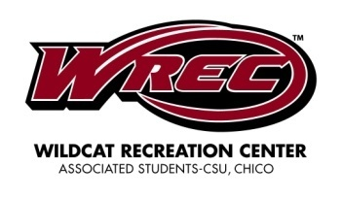
MEMORANDUM

August 17, 2009.

TO:

FROM:

SUBJECT: WREC Grand Opening

The grand opening of the Wildcat Recreation Center is upon us and we hope you are as excited as we are for the new center. We hope you will join us for the grand opening event on August 27, 2009.

We also encourage you to spread the word to your department professors and their students. We would like to see maximum occupancy at the grand opening so your influence is much appreciated.

This is completely up to your department’s discretion, but if you can encourage students to attend the grand opening by offering credit or a way to earn points this would increase the likelihood that they would attend.

The grand opening is relevant to your department and its students because of the sustainable aspects of WREC and its construction.

Tawnya Rojas, Research Director
CreativeSolutons10@gmail.com
(805) 558-4368

Action Strategy 5: Alliances and Coalitions

Creative Solutions wants to attract as many students as possible to the grand opening event for WREC. In efforts to do so, local businesses such as Sports LTD, Big 5 and Cycle Sport will have the opportunity to set up a booth for their organization. The businesses that decide to attend the event will have a positive effect on the event. They will also be putting themselves in a positive light in the minds of attendees.

Local businesses will find many advantages with their attendance at the event. These advantages include:
- The opportunity to engage with students, considering how students provide the main source of sales for most local businesses in Chico.
- Businesses will have the opportunity to engage in product exhibition. These products will relate specifically to the event and can include camping gear, climbing wall gear and athletic gear.
- Businesses will have the opportunity to build a better reputation among the students.
- Businesses that choose to have a booth will have the opportunity to build a relationship with A.S., the students and the campus community as a whole. Doing so will ensure customers in the future as well as beating out the competition.

The grand opening event will find many advantages of having local businesses attend. These advantages include:
- Generate energy, hype and cooperation among students.
- Students may be more willing to attend the event if they know some of their favorite local stores will be attending.
- Different local businesses will donate gift cards and a variety of products that will be used as prizes or giveaways.
- A.S., the students and the campus will gain a positive reputation among the local businesses that attend the event.

In efforts to have local businesses attend the event, Creative Solutions will use a variety of tactics.

Action Strategy 5

Tactic 1: Creative Solutions spoke with representatives from Sports LTD, Big 5 and Cycle Sport. We spoke with Matt Smith, owner of Sports LTD, in April. Smith said his store would love the opportunity to have a booth set up at the event. He also said the store would be more than willing to donate $25 gift cards. In addition, we have talked with Mitch Johnson, supervisor at Big 5, who said the store would be willing to donate gift cards as well as having a booth. Mike Pevy, supervisor of Cycle Sport, would like the opportunity to have a booth.

Creative Solutions will provide Sports LTD, Big 5 and Cycle Sport with an informational brochure. The brochure will include all necessary information the business needs to participate in the event, such as the advantages of having a booth, what their attendance can provide the event, time, date and place.

Tactic 2: According to our research, the most important prizes that students would like to win at the event were gift cards. Students who were polled also said they would be more willing to attend the event if prizes or giveaways were involved. All of the businesses who will be attending the event have agreed to donate gift cards and certain products. Sports LTD and Big 5 agreed to donate $25 gift cards. We spoke with the supervisor at Pita Pit, Bobby, as well as the manager at Best Buy, Adam Potts, and they both agreed to donate gift cards as well. These gift cards as well as iPods purchased will be used as prizes for different games during the event for the raffle.

Tawnya Rojas, Research Director
CreativeSolutons10@gmail.com
(805) 558-4368

Action Strategy 6: SWAG and Prizes

Creative Solutions believes that WREC offers students many amenities that they did not have before. We also believe that the grand opening event offers them the perfect opportunity to come see exactly what they are getting from their gym, and an opportunity for them to see that WREC is more than just a gym. To show students everything that they can do at WREC, we want as many people as possible to come to the event and see everything first hand. To do this, Creative Solutions has built an entire action strategy around students using the different amenities through tours, demonstrations, games and competitions.

Not only will students be able to receive raffle tickets when they purchase their books during the first week of school, but they will also be able to get raffle tickets if they take a tour of WREC at the grand opening event. Raffle tickets will make students eligible to be in the running to win some of the amazing prizes that Creative Solutions has come up with, based on student responses in our initial surveys.

Action Strategy 6

Tactic 1: SWAG

During the first week of school, we will advertise that the first 120 people in to the event will get a free gift, or SWAG. Based on student responses from the survey, students said one of the things they would want to get at the grand opening event would be a workout towel.

Creative Solutions has found a Website where WREC can purchase hand-towel sized terrycloth towels in bulk. They have to be ordered in orders of 120 towels. At only $0.71 each, the towels would cost $170.40. We have also contacted Dragon Graphics, in Chico, who said they would be able to print “WREC” on the towels for $4 per towel. This will give the first 120 people in the door their very own WREC workout towel that they can bring with them whenever they come to WREC to work out.

Tactic 2: Prizes

Based on the survey, most students seem very interested in the possibility of winning prizes while they attended the grand opening event. Creative Solutions has partnered up with some local businesses that would be willing to donate some prizes, or give discounts on some of the items we have selected for prizes. We also have allotted some of the money from the budget to go toward bigger prizes, such as bicycles.

Businesses:

Klean Kanteen:
Klean Kanteen is a local green company that makes stainless steel water bottles to reduce the use of plastic water bottles. Klean Kanteen offers a 40 percent discount to schools, making the popular kanteens a great prize option. Creative Solutions has designed WREC logo stickers that will be printed from printedblue.com. These stickers will be placed on the Klean Kanteens, making them personalized for WREC. The Klean Kanteens must be ordered in cases of six, so Creative Solutions decided that 24-27 oz. brushed stainless Klean Kanteens with loop caps would be a good amount for raffle prizes. The Klean Kanteens are normally $17.95 each. With the 40 percent discount, 24 Klean Kanteens will cost $258.48. See the appendix for Klean Kanteen discount form.

Best Buy
According to its mission statement, Best Buy is a multinational retailer of technology and entertainment products and services with a commitment to growth and innovation. In fiscal 2009, Best Buy donated a combined $33.4 million to improve the vitality of the communities where its employees and customers live and work.
Best Buy in Chico is happy to donate two $25 gift cards as prizes at grand opening of WREC. See the appendix for Best Buy donation request form. Creative Solutions will also be purchasing two iPods from Bets Buy at $149 each.

Sports LTD
Sports LTD is a local sporting goods store in Chico that sells almost everything a sports enthusiast could be looking for. To go with the theme of WREC, Creative Solutions has partnered up with Sports LTD, who has offered to donate several $25 gift cards as prizes for the grand opening of WREC.

Big 5
According to its mission statement, Big 5 Sporting Goods is one of America's top retailers of name brand sporting goods and accessories. Their product mix includes athletic shoes, apparel and accessories, as well as a broad selection of outdoor and athletic equipment for team sports, fitness, camping, hunting, fishing, tennis, golf, snowboarding and in-line skating.
Big 5 in Chico is happy to donate four $25 gift cards for prizes for the grand opening of WREC. See the appendix for donation request form.

Pita Pit
According to its Website, Pita Pit was founded on the idea that people want an exciting alternative to fast food restaurants—a place with great tasting food that is healthy, fresh and still served fast. Pita Pit is a firm believer in giving back to local communities and supports a variety of youth and sport-oriented causes.
Pita Pit in Chico is happy to donate two $10 gift cards as prizes for the grand opening of WREC.

Chico Bike and Board
Chico Bike and Board is a local bike and skate shop that offers a wide variety of biking and skating equipment. According to our survey, Chico State students listed a bike as one of the top prizes they would want to win at the grand opening of WREC. With this in mind, Creative Solutions will purchase two beach cruisers, one geared toward females and one geared toward males to give away as prizes at the grand opening. Chico Bike and Board offers a wide selection of beach cruisers at $297 each.

Tawnya Rojas, Research Director
CreativeSolutons10@gmail.com
(805) 558-4368

Action Strategy 7: Online Events

According to the survey conducted by Creative Solutions, students said that they pay attention to online invitations more than any other type of advertisement. Creating a Facebook invitation and Uloop posting for WREC’s grand opening will ensure that even more students hear about the event and will know what WREC and the grand opening have to offer.

Action Strategy 7

Tactic 1: Facebook Event Invitation

There are currently over 15,200 people in the Chico State network on Facebook. Although some of these people are alumni or people who may not go to Chico State anymore, Facebook still provides a way for people to see the event invitation.

To Create A Facebook Account:
- www.facebook.com
- Fill in name, e-mail, password, gender and birthday.
- Facebook will then send an e-mail confirmation to the e-mail address you provided to finish setting up the account.

To Create a Facebook Event Invitation:
- Once logged into Facebook, there is a section labeled “events.”
- Once in the events section, click “Create an event.”
- Fill out the information, and upload a photo
- Send the event invite out to the Chico State network

Tactic 2: Uloop event posting

This tactic involves utilizing Uloop.com to create an event that targets the student population. Uloop is basically like the craigslist.com for students and campus life. By posting our grand opening event on this website we can minimize communication to an audience we aren't trying to reach and directly target our key public. Directions to creating an event on Uloop.com are fairly simple and only require an .edu e-mail address to a make a Uloop account.

Tawnya Rojas, Research Director
CreativeSolutons10@gmail.com
(805) 558-4368

Action Strategy 8: Contacting Local Media

The included media kit, located in the appendix, can be sent to local media outlets for maximum publicity. Local newspapers would likely cover the grand opening event because it is relevant to the Chico community. This media kit includes a press release and media alert. The media contact list provides addresses and phone numbers to the local newspapers.

Tawnya Rojas, Research Director
CreativeSolutons10@gmail.com
(805) 558-4368
Action Strategy 9: WREC is Sustainable

Emphasize the sustainable building technologies used to construct WREC. Since sustainability is a buzz-word right now, this strategy should draw our target audience's attention. It will also help attract students who may not normally attend the grand opening but are interested in sustainability. This will show our target audience that A.S. is concerned about the environment and the economy.

Action Strategy 9

Tactic 1: Members from Otto Construction, the company that built WREC, will give a talk at the grand opening. Ideally, this talk will be short and interesting to keep people’s attention. Manager Steve Ihhurburg will be the first speaker of the day at about 4 p.m. He will talk about the LEED certification, some examples of what was done on the building, and working with A.S. to make it all happen. This will inform people about the exact technologies used on the building. Having the manager of the construction company speak will help personalize the building process and people will see his enthusiasm about this project.

Tactic 2: Tours will take place throughout the day during the grand opening. These tours will highlight not only the equipment offered at WREC, but will also show the features of the building that make it sustainable and cost efficient. These tours will take place after the talk by Steve Ihhurburg so people will be able to visually see and better understand what he was talking about. Students will also receive a raffle ticket after taking a tour.

Tawnya Rojas, Research Director
CreativeSolutons10@gmail.com
(805) 558-4368

Action Strategy 10: The Opening Day
Creative Solutions wants the students who attend the grand opening event to have things to do and to show them they can have fun while working out. Our goal is for students to realize WREC is more than just a gym- it’s a place to hang out and have fun.
In addition to tours given out by faculty, students will be able to engage in a number of activities, such as rock climbing races or aquatic volleyball matches. The goal of these activities is for students to have fun with friends while doing something to encourage physical fitness.
Our slogan is “Your life, Your school, Your gym.” and we want to stress this during the opening day. Students should know that WREC belongs to them, and these events that are planned are due to their survey results. We hope that students will feel welcomed and relaxed at WREC, and know that they don’t have to work out to enjoy WREC; they can just have fun with friends.

Action Strategy 10

Tactic 1 - Speeches 4-4:45 p.m.
Chico State President Paul Zingg, the A.S. president and more will be speaking at the opening event. These speeches will inform the students more about just what it took for this building to be completed, and what a huge step forward it is for all students at Chico State, past and present.
This event marks the official ribbon-cutting and opening of WREC, allowing all students to enter and engage in the activities.

Tactic 2 - Tours 4:45-7:30 p.m.
Following the ribbon-cutting and official opening of WREC, tours will be available throughout the evening, led by WREC employees. These tours will show the students the layout and give them more details on the construction and other design aspects that make up the building.
In addition to providing useful information to students, the tours will give students a raffle ticket, good for the raffle at 7:30 p.m. Students need to simply grab a ticket at the end of the tour from the employee who led the tour, and they are granted a spot in the raffle.

Tactic 3 - DJ 5-8 p.m.
Creative Solutions has contacted a DJ from Class Act Entertainment to be at the event. The DJ will be there to play music, announce events, and so on. Research showed students respond very positively to music at the event, and a DJ would bring personality to the event while music is being played.

Tactic 4 - Rock Climbing Race 5-6 p.m.
Towering over the basketball courts and running track, the rock wall is a sight to behold for Chico State students. The rock wall at WREC will challenge students to their physical limits and give a thrill of overcoming a sheer rock wall. Creative Solutions seeks to capitalize on this, giving students a preview of what to expect from this new feature.
During the event, students will be able to choose to enter a Rock Climbing Race on the rock wall. Entrance will be free to all who attend and sign the safety waiver. Students will go two or three at time, and the fastest time overall wins.
Depending on participants, there might be different races, broken up by gender or even age. Prizes will vary, depending on what is available, but the top five winners of each category will win items such as gift cards, t-shirts and more.
Tactic 5 - 3-point Shot Contest 5-6 p.m.
Basketball is an American classic, but it’s not for everyone. It’s a grueling match of intense aerobic fitness. However more people may enjoy shooting 3-point shots. These shots test even the best of players, yet lure in casual fans with the thrill of making a shot from more than 20 feet away. Beginning at 5 p.m., students will be able to enter a free 3-point shot contest. Groups will be broken up by gender, and the contest rules are simple: score as many shots as you can in 30 seconds. Whoever has the highest score at the end wins. The top five students from each group will receive prizes.

Tactic 6 - Water Volleyball Tournament 5:45-7 p.m.
There’s no denying that summer is cruel in Chico. With temperatures in the 90s, something everyone can enjoy is a refreshing dip in the pool. WREC’s new pool will be open to all students, and what better way to cool off than with a friendly competition and the possibility of some fun prizes?
Beginning at 5:45 and ending at 7 p.m., the pool area will be swept up in a game of water volleyball. Teams will be divided according to the number of people present, and selected at random.
There will be a tournament bracket set up, with the number of games held depending on the number of teams present, the size of teams, and so on. The winning team will receive a prize.
Before and after the event, the pool will remain entirely open to all students for their use to cool off and enjoy the new facilities.

Tactic 7 - Slap shot Contest 5:45-7 p.m.
While typically enjoyed more by our neighbors to the North, hockey is still an event that most sports enthusiasts can get behind. Regardless, who doesn’t enjoy smacking a puck with a stick?
Beginning at 5:45 and ending at 7 p.m., WREC’s indoor hockey area will be open to a slap shot contest. All students who are at the center at this time will be welcome to join. Participants will have 30 seconds to shoot as many shots as possible from center ice (or court, in this case), and whoever has the most pucks in the goal at the end wins. In the event of a tie, the contestants will face off in a sudden death round, where the first person to score a goal wins.
Depending on participants, there may be more than one winner to this contest. Participants don't need to worry about skates, just come in whatever shoes they have. The objective is to hit the puck into the goal, not move around.

Tactic 8 - Raffle 8 p.m.
Survey research has shown that students are more likely to attend events such as this when they have a chance to win free items. Creative Solutions will ensure that students have a good chance to win a number of fun prizes just for coming.
When students take a guided tour of WREC, they will receive a ticket good for the raffle to be held at 8 p.m. Students must be present at the drawing in order to win.
In addition to tickets received from taking tours, students may also get tickets from purchasing their textbooks at the bookstore. Each ticket will have the same chance of winning, and the drawing will be completely random.
The raffle prizes will include two bicycles, two iPods, and much more.
Tawnya Rojas, Research Director
CreativeSolutons10@gmail.com
(805) 558-4368

Timeline

Date | Activity | Details | Reference  Page | Completed
Friday,  May 8,2009 | Print fliers for freshmen orientation, Contact and book DJ | Rapid Graphics, Class Act Entertainment
Friday, May 15, 2009 | Include fliers for freshmen  orientation in packets | Copy of flier included
Monday, May 18,2009 | Survey for awareness objective  implemented | Survey included in Evaluation section
Monday, June 1,2009 | Tour of WREC outlined & completed
Thursday,  June 25, 2009 | Order towels  for S.W.A.G. | www.imagetextile.  com
Monday,  July 13, 2009 | Print Brochures for local businesses | Rapid Graphics
Wednesday, July 15, 2009 | Brochures sent to local businesses | Sports LTD  Big 5  Cycle Sports
Friday, July 24, 2009 | Send towels to Dragon Graphics  for image | (530) 879-9666
Monday, August 3, 2009 | Complete Klean Kanteen donation form  -Send form to complete | www.kleankanteen.  com  -donation form  included
Friday August 7, 2009 | Order misters &canopy | www.walmart.com
Friday, August 7, 2009 | Order raffle tickets | www.nationaltickets.  com
Monday, August 17, 2009 | Memo to be sent out
Date | Activity | Details | Reference Page | Completed
Monday, August 17, 2009 | News release to be sent out | Appendix
Friday, August 21, 2009 | Media alert to be sent out | Appendix
Friday August 21, 2009 | Raffle tickets given to bookstore
Monday, August 24, 2009 | Fall semester begins, WREC employees sent to classes
Monday August 24, 2009 | Facebook event invite completed
Monday, August 24, 2009 | Uloop event invite completed
Thursday, September 3, 2009 | Evaluate media feedback on event

Tawnya Rojas, Research Director
CreativeSolutons10@gmail.com
(805) 558-4368

Budget

Item | Vendor | Quantity | Price Per  Unit | Total
Raffle  Tickets | www.nationalticket.com | 36,000 | $12 per roll | $271.92
Shade  Canopy | www.walmart.com | 2 | $198 | $432.67
Misting System | www.walmart.com | 6 | $23 | $203.15
Bicycle | Bikes and Board | 2 | $297 | $643
Stickers | www.printingblue.com | 1,000 | $2.46 | $266.83
T-shirts | Dragon Graphics | 100 | $5 | $541.25
Brochures | Rapid Graphics | 3 | $0.95 | $2.70
Towels | www.imagetextile.com | 120 | $0.71 | $611.83
Canteens | Klean Kanteen | 24 | $10.77 | $279.80
Disc Jockey | Class Act Entertainment | 3 hours | $250 | $750
iPods | www.bestbuy.com | 2 | $149.99 | $311.96
Total |  |  |  | $4,315.11

Tawnya Rojas, Research Director
CreativeSolutons10@gmail.com
(805) 558-4368

Evaluation
Creative Solutions will evaluate the success of the WREC grand opening according to the following plan:
- We will evaluate awareness objectives by noting exposure patterns: how many students do we see carrying around coffee cups with the WREC sticker? How many students received raffle tickets from the bookstore? What impression did students get of WREC from orientation? This will mostly be done informally through observation of students. A focus group could be done with freshman after their orientation to analyze what they learned about WREC and if the message they received is consistent with our key messages.
We will also do a survey of random students during the week of May 18 to see if awareness has increased as compared to the last survey that was done in February. We can use this survey to analyze how effective our communications efforts have been so far.
- We will evaluate acceptance objectives by: tracking hits on WREC’s Web site to see how many people are seeking more information about WREC. We will encourage A.S. employees at the bookstore, coffee shops and other A.S. owned services on campus to communicate with us regarding inquiries about the grand opening event. We will also survey WREC and other A.S. employees to find out what information they are telling people who ask about the grand opening. Is this consistent with our key messages? We will evaluate the media’s acceptance by looking at whether they printed an event announcement in their paper. We will also do a content analysis of any information printed to see if facts are correct and consistent with what we want to portray.

- We will evaluate action objectives by measuring attendance at the grand opening event. Did 30 percent of all Chico State students attend the grand opening? We need to look at not only whether our target audience attended, but also how they acted at the event. Did the audience participate in games, tours and other activities offered at the event? Did people generally seem to have a good time? Did they stay for at least an hour? This will be done informally by observation at the event. We will also offer a brief questionnaire that students will be asked to fill out after their tour. We will ask what they liked and disliked about the event and if they have any suggestions for improvement.
We will also evaluate action objectives by looking at media coverage of the event. We will do a content analysis of the stories reported. Did the important media outlets attend the event and cover it accurately and positively? What sort of impression will people get about WREC from reading these articles?

Questionnaire (to analyze audience awareness)
This questionnaire will be given at a variety of locations around campus to try to find a wide range of students. These locations will include the BMU, Holt Hall, the Performing Arts Center, freshman dorms and Acker Gym.

- Have you heard of the Wildcat Recreation Center?

- If so, how did you hear about it?

- When will it be open for student use?

- Do you know when the grand opening ceremony will be?

- Can you name any activities that will be happening at this event?

- What campus organization owns and operates the center?

Questionnaire (to measure success of grand opening)
- Please rate your overall satisfaction of the event on the following scale:
        - 1 2 3 4 5
        - best worst

- Will you continue to use WREC in the future?
  - Yes
  - No

- How did you hear about this event? (circle one)

    - A WREC employee came to my class

    - Word of mouth

    - Facebook invitation

    - Orientation

    - Article in local paper

- What was the best part of this event?

- Please provide any additional comments you see fit that could help us make this event better.

Tawnya Rojas, Research Director
CreativeSolutons10@gmail.com
(805) 558-4368

Appendix

Media Contacts

Chico Enterprise Record
400 E. Park Ave.
Chico, CA
95928
(530) 891-1234
www.chicoer.com

Chico News & Review
353 East Second St.
Chico, CA 95928
(530) 894-2300
Editorial Fax: (530) 894-0143
Contact Projects Editor (Sustainability and special sections) Melissa Daugherty
www.chiconewsandreview.com

Synthesis
210 W. 6th Street
Chico, CA
95928
(530) 899-7708
Media materials can be submitted online at www.synthesis.net

The Orion
Department of Journalism
CSU, Chico
Chico, CA
95929
Editorial: (530) 898-4033
Fax: (530) 898-4799
www.theorion.com

Tawnya Rojas, Research Director
CreativeSolutons10@gmail.com
(805) 558-4368

Business Contact List

Best Buy
(530) 566-1012 Adam Potts, General Manager

Big 5 Sporting Goods
(530) 891-1545 Mitch Johnson, Supervisor

Chico Bike & Board
(530) 343-5506 Brian Daellenbach, Owner

Cycle Sport
(530) 345-1910 Mike Pevy, Manager

Pita Pit
(530) 899-2847 Bobby Bauer, Manager

Sports LTD
(530) 894-1110 Matt Smith, Owner

Class Act Entertainment Darren Braemer, Owner/DJ
(530) 345-4487

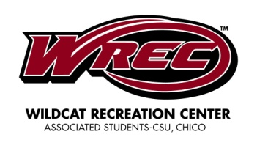
For Immediate Release
August 21, 2009

MEDIA ALERT

WILDCAT RECREATION CENTER GRAND OPENING

WHO Associated Students of California State University, Chico

WHAT Grand opening ceremony of the Wildcat Recreation Center

WHEN August 27, 2009.

WHY WREC has been in the works since 2005 when students passed a referendum to approve its construction. Associated Students is very proud of its completion and invites you to come join the celebration. The grand opening represents a positive impact on campus life.

###

For further information, contact Teresa Clements: (530) 898-4248,
E-mail: tclements@csuchico.edu

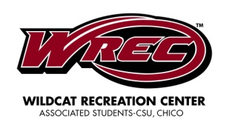
Wildcat Recreation Center
Associated Students
California State University, Chico
Chico, CA 95926
(530) 898-5701
http://www.aschico.com/WREC

ASSOCIATED STUDENTS’ WILDCAT RECREATION CENTER
- The Wildcat Recreation Center is necessary because current facilities are below standard and inadequate for the current student demand at CSU Chico.
- WREC is scheduled for completion in summer 2009. The grand opening is August 27, 2009.
- The building is 109,000 square feet and two-stories high.
- Facilities include a three-story climbing wall, an indoor elevated track, four exercise studios, three basketball courts, an in-ground spa, weight and cardio equipment, and social lounge areas. The outdoor pool will take up another 16,000 square feet.
- The project will cost a total of $65 million and will increase tuition for students by $175 a semester. However, WREC will cost around $30 a month which is less expensive than most local gyms.
- The building is being constructed with renewable and sustainable technologies. It is LEED certified and compliant with the university’s sustainable mission.
- The Recreational Sports department will be housed in the facility and will conduct intramural leagues and other activities within the facility as well.
- Approximately 80-100 student jobs and internships will be created. These jobs and internships may include customer service, custodial, fitness trainers and marketing.
The purpose of Associated Students is to enrich the quality of campus life at California State University, Chico and to complement the educational mission of the University providing full actualization of the university experience through student governance, Bell Memorial Union facilities, a broad spectrum of programs, services and integral campus commercial enterprises.

2/2/2009
###

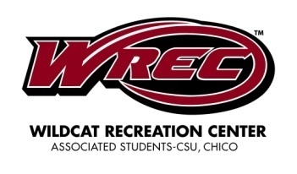
Wildcat Recreation Center
Associated Students
California State University, Chico
Chico, CA95929- 0763
For Immediate Release
August 17, 2009

ASSOCIATED STUDENTS GRAND OPENING OF WILDCAT RECREATION CENTER

August 17, 2009- CHICO, Calif.-- Associated Students will officially open the doors of the Wildcat Recreation Center to the students at the grand opening on August 27, 2009.

The long awaited completion of the building comes after an eight year struggle for A.S. to get the recreation center plans passed.

WREC is a recreation center featuring state-of-the-art equipment and facilities that include a three-story climbing wall, an indoor elevated track, four exercise studios, three basketball courts, an in-ground spa, weight and cardio equipment, and social lounge areas. An outdoor pool will take up another 16,000 square feet.

In the referendum language passed by the students in March 2005, WREC was promised to be built as a LEED Certified SILVER building and compliant with the university’s sustainable mission.

WREC is still on track to receive LEED silver certification by the U.S. Green Building Council, based on the renewable and sustainable technologies and products integrated into the facility. WREC is currently under evaluation to receive the gold rating.

Approximately 80-100 student jobs and internships will be created. WREC will also be the new home to Adventure Outings and REC Sports.

The purpose of Associated Students is to enrich the quality of campus life at California State University, Chico and to complement the educational mission of the University providing full actualization of the university experience through student governance,
Bell Memorial Union facilities, a broad spectrum of programs, services and integral campus commercial enterprises.
For further information, contact Teresa Clements: (530) 898- 4248
E-mail: tclements@csuchico.edu

###
Tawnya Rojas, Research Director
CreativeSolutons10@gmail.com
(805) 558-4368

Creative Solutions Personnel

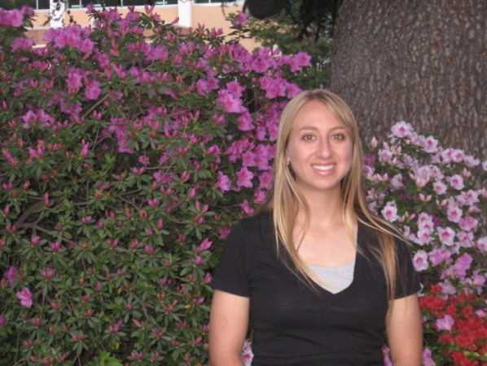

Amy Nelms

Account Supervisor

Amy is a senior at Chico State majoring in public relations with minors in English and agriculture. In her spare time, Amy enjoys playing the violin, riding horses, photography and training puppies for Guide Dogs for the Blind. After graduation, Amy hopes to go to graduate school and someday work for a magazine or for Guide Dogs for the Blind.

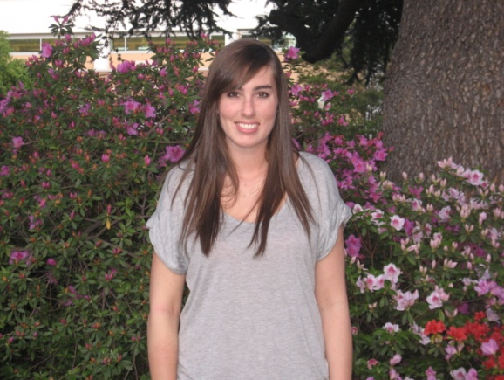

Brooke Ratzlaff

Production Director

Brooke is a senior at Chico State majoring in public relations with a minor in marketing. In her spare time, Brooke enjoys traveling, being outdoors, sports, shopping and spending time with family and friends. After graduation, Brooke hopes to get her masters degree in sports and entertainment public relations from San Diego State University. After graduate school, Brooke hopes to get a job at a PR firm and someday, work in the public relations department for a major sports team.

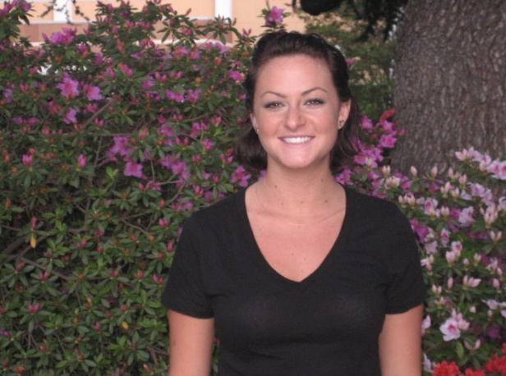

Diana Boiteux

Media Relations Director

Diana is graduating with a degree in public relations and a minor in psychology. Diana enjoys reading outside, wakeboarding and soccer. She is moving to the Los Angeles area after graduation and hopes to pursue her career in public relations.

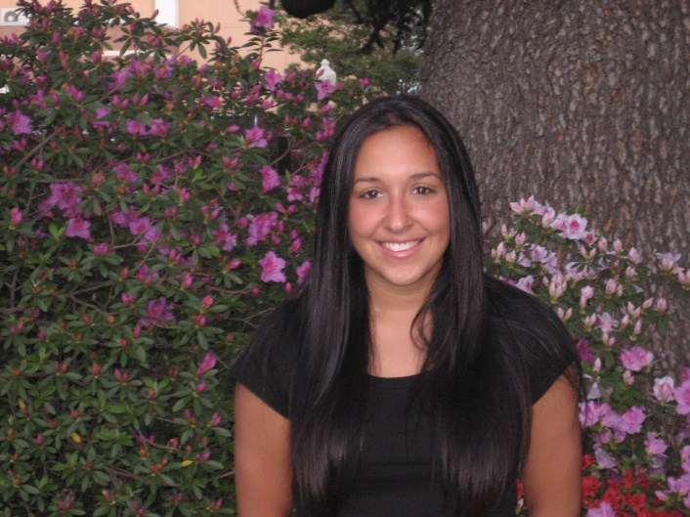

Tawnya Rojas

Research Director

Tawnya is a junior at Chico State majoring in public relations with a minor in marketing. She is a member in International Association of Business Communicators and has volunteered with CAVE. In her spare time, Tawnya enjoys being outdoors, snowboarding, shopping and spending time with her friends and family. After graduating in the spring of 2010, Tawnya hopes to work at a PR agency or corporation in the sports action industry.

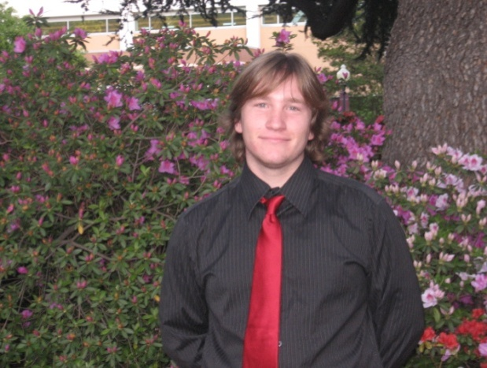

Tor Messer

Editorial Director

Tor is a senior at Chico State majoring in public relations with a minor in sociology. After graduation, Tor hopes to be a PR representative for a video game company. In his spare time, he enjoys playing video games, watching movies, going snowboarding, and hanging out with friends.

