Aileen Marshall J740
7 Jenbeck Court Search Assignment
Fredericksburg, VA 22407 Grade:

Table of Contents

1. Description of Topic and End-User……………………………………………….. 2

2. Summary of Results……………………………………………………………….. 3

3. Summary Table……………………………………………………………………. 6

4. Online Systems (5) – Samples ……………………………………………………. 8

- CSA……………………………………………………………………… 8

- Dialog………………………………………………………………….… 9

- EBSCO………………………………………………………………….. 11

- Nexis…………………………………………………………………….. 12

- Web of Science Citation Databases…………..……………………….… 13

5. Search Engines (4) – Samples……………………………………………………..14

- Google……………….…………………………………………………... 14

- Bing……………………………………………………………………… 15

- Clusty ………………………………………………………………….… 16

- Scirus…………………………………………………………………….. 17

6. Comparison of Systems & Conclusion………………………………………….…18

7. The Perfect Search Tool………………………………………………...…………24

1. Description of Topic and End-User

This paper summarizes the results of a research project on the social behavior of the great white shark, Carcharodon carcharias. It aims to educate laymen about this fascinating creature. Thanks to movies like Jaws and other thrillers as well as real shark attacks blown out of proportion in the news, public opinion about the great white is far from being good or even decent. Portrayed as cruel, malicious, mindless killer and man-eater, it is perceived as the worst nightmare that could possibly emerge from the ocean.
Unfortunately, despite of years of research, surprisingly little is known about this animal. Variables like size and speed make observation and research difficult. Furthermore, it is nearly impossible to hold a white shark in captivity in order to thoroughly study it. In fact, there are only two occasions when great whites could be successfully held in captivity. Until the year 2004, researchers were only able to hold a white shark for sixteen days. In August 2004 a very young female white shark was accidentally caught off Huntington Beach, California, and transferred to the Monterey Bay Aquarium. Researchers believe her age was the only reason why she did not bash her head against the walls to escape, like so many other great whites before her. She might not have been able to understand that that the Outer Exhibit was not her natural environment. On March 31, 2005, she was outfitted with a transmitter and released to the Pacific.
Over the years, researchers have found out that great white sharks display complex social and conflict-resolving patters when interacting with others of their kind. We are far from understanding the ways of this animal, but the bits and pieces known to us might help to change the general perception of the shark and accept that this elegant, perfectly adapted hunter is worth protecting.

2. Summary of Results

They are known by many names: white death, great white, white pointer … the great white shark, Carcharodon Carcharias. But by no means are these animals as mindless and antisocial as people think. Years of research have afforded a glimpse into their social behavior.
The researchers Martin and Martin, in their article Sociable Killers describe the predator-prey game of a white shark with a seal and the social behavior displayed when another great white enters the scene. This rare experience, which not many people are lucky to witness, reveals that, for white sharks, socializing trumps dining. The first shark, Sneaky, acknowledges the newcomer (Couz), and both swim side by side for about half a minute, sizing each other up. This behavior is well-known and is displayed each time two sharks meet. Then, suddenly, Sneaky hunches his back and lowers his pectoral fins in response to Couz’s threat. Sneaky is an about eleven-and-a-half foot male, Couz is about one-and-a-half foot larger. Both sharks veer apart. Bad luck for the winner though as a female shark sweeps in and steals the remaining meal from both.
This scene is just one of many that have been taken place at Seal Island. This rocky, five-acre island in False Bay is located twenty-two miles south of Cape Town and is home to thousands of Cape fur seals, gulls, penguins, and other seabirds. Over the years, observations taking place at Seal Island have revealed that white sharks are intelligent, curious and oddly skittish. Upon an interesting discovery, they nip and nibble with their teeth and sensitive gums. Number and depths of scars on their bodies suggest that some individuals are braver than others. Some are even timid enough to flinch and swim away if they notice the smallest change in their environment. They will come back and examine their target from a greater distance. Over the years, researchers could establish personality profiles for individual sharks: bravery, approach to a target such as angle and speed rarely change over time for each individual.
Their social behavior is much more complex and sophisticated than scientists have thought possible. Social interactions are most likely in times of mating and hunting, as encounters are inevitable during these times. After all, the ocean is a pretty big territory and without something attracting their attention it is not very likely that two sharks run (or swim) into each other.
Over the past five years, twenty distinct social behaviors in great white sharks have been catalogued; half of them new to science. Many of them seem to be related to establish hierarchy. Year after year, the sharks return to their feeding ground in groups of two to six individuals. Researchers do not know if group members are related, but they get along peacefully. Similar to a wolf pack, each member has an established rank, and each group has an alpha leader. Size seems to be the predominant factor, although the rights and sex of the squatter also play a role. Larger sharks dominate smaller ones, established residents dominate newcomers and females dominate male sharks. Scientists believe that this hierarchy avoids unnecessary combat between the sharks. Members of two different clans avoid combat by rituals and display as fights are costly and risky. Complex social as well as predatory behavior implies intelligence and the ability to learn. Some of the patterns that have been identified are listed below:
- Swim side by side to compare size
- Parade past each other in opposite directions or swim in circles
- Directly splash at another by trashing the tails
- Leap out of the water in the other’s presence and crash to the surface

Perhaps the two most interesting (and certainly the funniest) rituals can be described as “venting frustration” and “the chicken game”. Researchers were able to observe sharks, which have been missing their prey many times, stick their head out of the water and rhythmically open and close their jaws. In 1996, a shark investigator named Wesley R. suggested that this behavior might be a socially non-provocative way to show and vent frustration. The “chicken game” refers to a ritual that most likely establishes dominance. Both sharks swim towards each other. The first to swerve cedes dominance, and the ranks are established.
In conclusion the research conducted for this paper shows that there is much more to great white sharks than many people think. They are not just giant jaws longing for human flesh; in fact, we are not even on their favorite menu. As their need for calories is extremely high, their main prey –like seals- have large amounts of fat and blubber, which approximately delivers twice as many calories as protein. Humans are way too muscular and simply not fat enough for their taste. Even their behavior when attacking a human differs from normal predatory behavior. They approach much slower, circling, which indicates curiosity. Sometimes great whites simply mistake humans for prey, especially surfers lying on a surfboard with their arms stretched to the side as they are similar to a seal’s silhouette. Some are simply curious enough approach and nibble just a little bit to see what “this thing” tastes and feels like.
There is much more to explore about these animals. Dedicating time and effort will hopefully result in a better understanding of these misunderstood creatures, and we will be able to protect them as well as our beaches from attacks and panic.

3. Summary Table

Vendor | Database(s) | Search Strategy | Relevant Hits
CSA | - ASFA: Aquatic Sciences and  Fisheries Abstracts  1980-2010  - Biology Digest  - Conference Papers Index | (great white shark* OR white shark* or carcharodon carcharia*) AND (behavior* OR behavior* OR interaction*) AND social*  Removed duplicates | 8/10 from all databases combined
DIALOG | - Marine Science  Files 5,6,34,58,89,96,99,185,  245,292,434  - Veterinary Science  Files 10,35,50,65,143,144,  154,155,203,399 | social?(5W)behavio? AND (white()shark? OR great()white()shark? OR carcharodon()carcharias)  Removed duplicates | 4/5 from both databases combined
EBSCO | - Academic Search Premier  - EBSCO Animals  - Funk & Wagnalls New  World Encyclopedia  - MLA International  Bibliography  Using the Visual Search Interface | social* N7 behavio* AND white shark* OR great white shark* OR carcharodon carcharias  Date range 1980 – Aug. 2009 | 23 /249 from all databases combined.  Relevant hits were retrieved by narrowing the subject using the visual search interface.
Nexis | - News, All (English, Full Text), all available dates | ATLEAST3(white shark) OR (carcharodon carcharias) W/5 social! OR behavio!  Added index term Oceanography  Relevancy: Major Terms only | 7/13,  2 duplicates.
Web of Science Citation Database | - SCI-Expanded  - SSCI  - A&HCI | TS=(white shark) OR TS=(carcharodon carcharias) AND TS=(social*)  Refined by subject areas Marine & Freshwater Biology, Zoology, Fisheries, Oceanography  Refined by topic behavior | 9/30 from all three databases combined
Google | n/a | “social behavior” AND “great white shark”  Limited to English language  Limited to date: past year | 13/179  Relevant hits have been retrieved from the first 30 links  5 broken links
Bing | n/a | "great white shark" AND social* AND behavior* | 12/~38,100  Relevant hits have been retrieved from the first 30 links
Clusty | n/a | "social* behavior" AND ("great white shark" OR "carcharodon carcharias")  Limited to English language | 8/~874  Relevant hits have been determined from the first 30 links  7 broken links
Scirus | n/a | Advanced Search:  “great white shark” AND  “social behavior”  Limited to date: 1980-2010  Refined by subject white shark | 8/629  Relevant hits have been determined from the first 30 links  2 broken links

4. Online Systems (5) – Result List Samples

- CSA

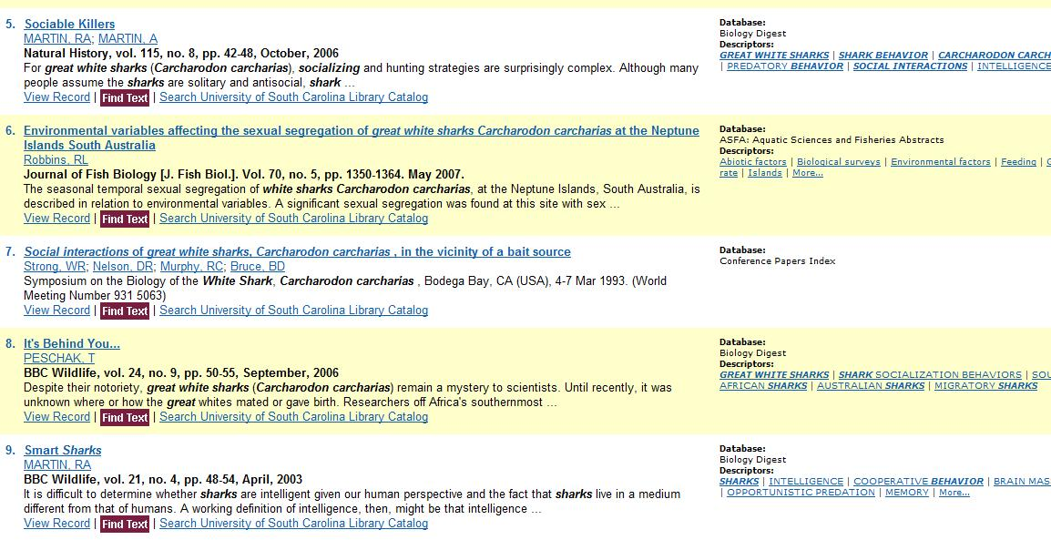

- DIALOG

19/3,DE/1 (Item 1 from file: 5)
DIALOG(R)File 5: Biosis Previews(R)
(c) 2009 The Thomson Corporation. All rights reserved.
09140499 Biosis No.: 198885109390
INTERACTIONS BETWEEN BOTTLENOSE DOLPHINS AND SHARKS IN MORETON BAY QUEENSLAND AUSTRALIA
Author: CORKERON P J (Reprint); MORRIS R J; BRYDEN M M
Author Address: DEP ANATOMY, UNIV QUEENSLAND, ST LUCIA, 4067, AUSTRALIA**AUSTRALIA
Journal: Aquatic Mammals 13 ( 3 ): p 109-113 1987
ISSN: 0167-5427
Document Type: Article
Record Type: Abstract
Language: ENGLISH
Descriptors: WHITE SHARK TIGER SHARK ECOLOGICAL DISTRIBUTION FEEDING BEHAVIOR WOUNDING
DESCRIPTORS:
Major Concepts: Behavior; Ecology--Environmental Sciences; Nutrition; Pathology
Biosystematic Names: Chondrichthyes--Pisces, Vertebrata, Chordata, Animalia; Delphinidae-- Cetacea, Mammalia, Vertebrata, Chordata, Animalia
Common Taxonomic Terms: Fish; Animals; Cetaceans; Chordates; Mammals; Nonhuman Vertebrates; Nonhuman Mammals; Vertebrates
--------------------------------------------------------------------------------------------------------------------------------------------
19/3,DE/2 (Item 1 from file: 99)
DIALOG(R)File 99: Wilson Appl. Sci & Tech Abs
(c) 2009 The HW Wilson Co. All rights reserved.
1152892 H.W. Wilson Record Number: BAST94021457
The predatory behavior of the white shark
Klimley, A. Peter ;
American Scientist v. 82 (Mar./Apr. '94) p. 122-33
Document Type: Feature Article ISSN: 0003-0996
Descriptors: Sharks; Predation (Zoology) ;
--------------------------------------------------------------------------------------------------------------------------------------------
19/3,DE/3 (Item 1 from file: 185)
DIALOG(R)File 185: Zoological Record Online(R)
(c) 2009 The Thomson Corp. All rights reserved.
03879560 BIOSIS No. 12600045192
Sharks caught in the protective gill nets of Natal, South Africa. 2. The great white shark Carcharodon carcharias (Linnaeus).
Authors: Cliff, G.; Dudley, S.F.J.; Davis, B.
Source: South African Journal of Marine Science 8 1989:131-144. [Print]
Document Type: Article
ISSN: 0257-7615
Languages: English Summary Languages: Afrikaans
Record Type: Citation
Descriptors:
Carcharodon carcharias--Size, Gender differences, catch data, Natal (marine), Physiological condition, Prey, Composition in diet, Gut contents, Prey composition, Scavenging, Sexual dimorphism, Aggregating behaviour, Age class distribution, Population sex ratio, Distribution within habitat, South west Indian Ocean, Natal, Distribution & biology
--------------------------------------------------------------------------------------------------------------------------------------------
19/3,DE/4 (Item 2 from file: 185)
DIALOG(R)File 185: Zoological Record Online(R)
(c) 2009 The Thomson Corp. All rights reserved.
03190745 BIOSIS No. 11500048276
Problems in studies of sharks in the southwestern Indian Ocean.
Authors: Bass, A.J.
Source: Hodgson, E.S.; Mathewson, R.F. [Eds]. Sensory biology of sharks, skates and rays. US Government Printing Office, Washington D.C. 1978: i-xi, 1-666. Chapter pagination: 545-594. [Print]
Document Type: Book chapter
Record Type: Citation
Descriptors:
Pisces--Social behaviour, Inter & intra specific relationships, south west Indian Ocean
Carcharhinus leucas, Carcharhinus obscurus, Carcharodon carcharias, Chondrichthyes, Holohalaelurus regani, Odontaspis taurus, Scylliogaleus quecketti--South west Indian Ocean, Distribution & inter & intra specific social relationships
--------------------------------------------------------------------------------------------------------------------------------------------
19/3,DE/5 (Item 1 from file: 292)
DIALOG(R)File 292: GEOBASE(TM)
(c) 2009 Elsevier B.V. All rights reserved.
0010517673 Supplier Number: 2323686
The hunting strategy of white sharks (Carcharodon carcharias) near a seal colony
Klimley A.P.; Le Boeuf B.J.; Cantara K.M.; Richert J.E.; Davis S.F.; Van Sommeran S.; Kelly J.T.
Author Email: apklimley@ucdavis.edu
Corresp. Author/Affil: Klimley A.P., Bodega Marine Laboratory, University of California, P.O. Box 247, Bodega Bay, CA 94923 , United States
Corresp. Author Email: apklimley@ucdavis.edu
Journal : Marine Biology (Mar. Biol. ) , v138, n3, (617-636) , 2001 , Germany
Publication Date: May 1, 2001 (20010501 )
Coden: MBIOA
ISSN: 0025-3162
Publisher: Springer Verlag
Record Type: Abstract; New
Document Type: Article
Languages: English Summary Languages: English
No. of References: 29
Controlled Descriptors:
activity pattern; foraging behavior; shark; social behavior
Species Descriptors:
Carcharias; Carcharodon carcharias; Chondrichthyes; Lamnidae; Otariidae; Panthera leo; Phocidae
- EBSCO

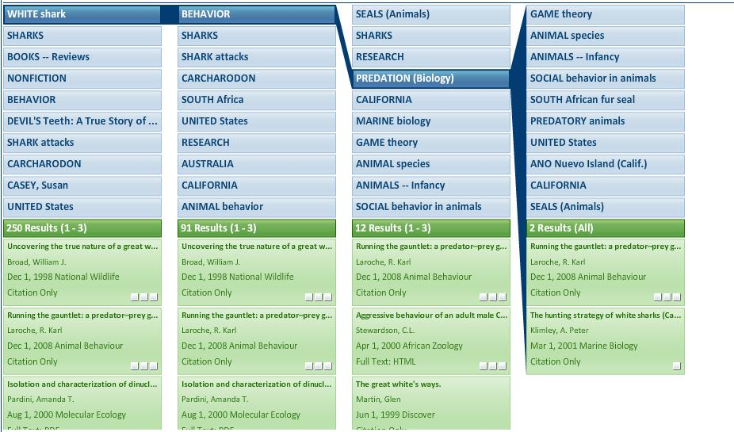

- Nexis

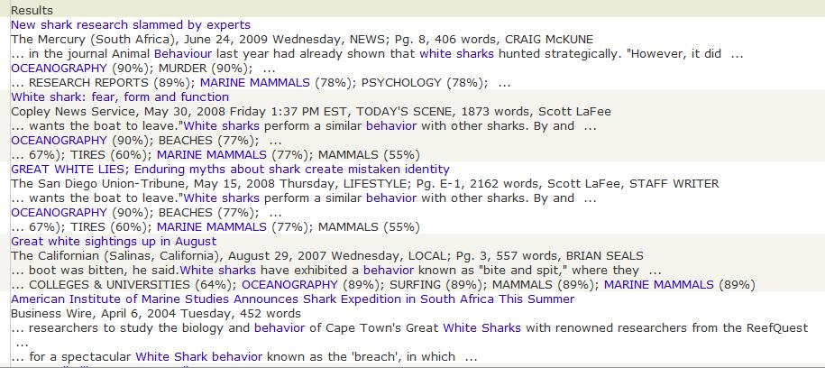
- Web of Science Citation Databases

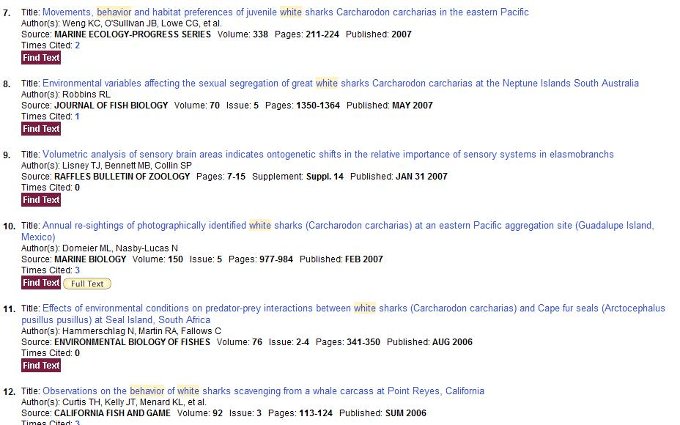

5. Search Engines (4) – Result List Samples

- Google

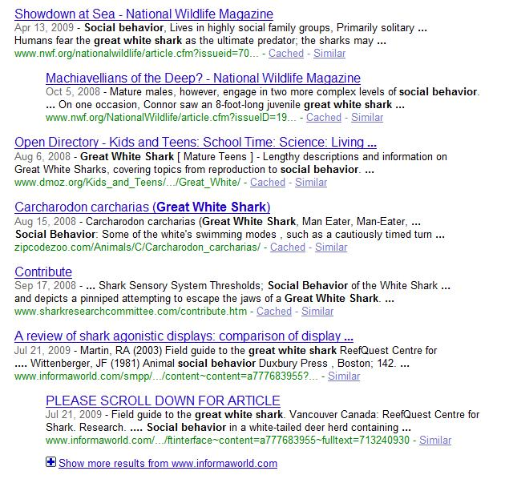

- BING

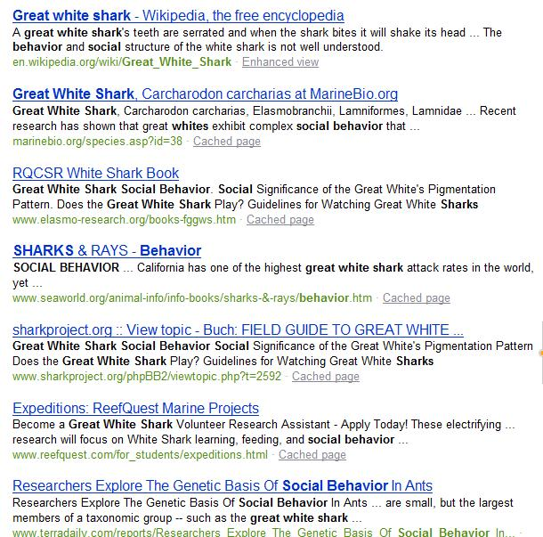

- Clusty

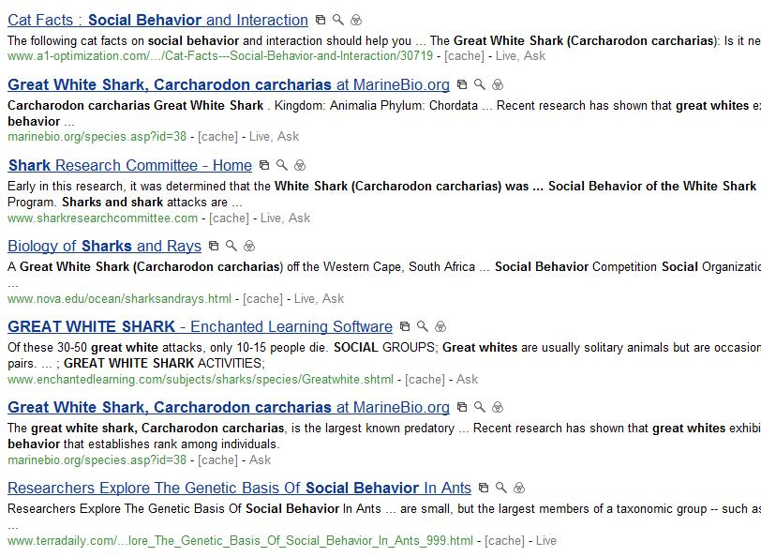

- Scirus

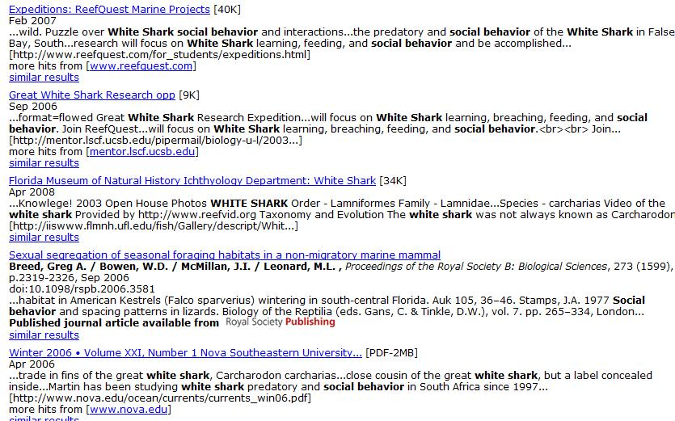

6. Comparison of Systems & Conclusion
All systems I chose for this assignment were interesting to work with. For my topic I found CSA, Dialog and EBSCO most helpful. It was amazing to see what sources I could dig up in comparison to using internet search engines. I think that sometimes internet engines can be more useful to get a quick overview and get familiar with a topic. Wikipedia is more comprehensive and summarizing than most articles an academic engine will retrieve, simply because the articles are so specialized. But other than that I think I am cured from the Google-virus. In fact, every time somebody tells me “just to google it real quick” I flinch and I am tempted to refer the person to other resources.
For the purpose of this analysis I will compare CSA, Nexis, and the Web of Science Citation Databases with each other and then continue with Dialog and EBSCO Visual Search as the latter two differ significantly from the other three.
CSA, Nexis, and the Web of Science Citation Databases display similar features in their advanced search. I liked that all engines allow the user to resort to command search. I prefer this type of search, so this worked out well for me. In my opinion command search enables researchers to be more precise; they are not restricted in any way by the search boxes. However, people preferring the search boxes are able to add as many rows as they would like, which makes it possible to enter complex queries that have many part to them. Nexis worked best for me as far as the searching goes. The command language is well explained on the help page, and the possibility of adding index terms and setting a date range was very useful. However, I do not like the way sources are displayed. I would like some way to see what “News, All (English Full Text)”, “Magazine Stories, Combined” etc. are comprised of. I would like to know if I am searching music magazines, sports publications, history journals, or food-related publications. For my search about great white sharks, none of these magazines would have proven helpful. I liked the way different document sections can be selected. Although I did not use it for my search, it has been helpful for other searches I conducted for other assignments. I am amazed that the results list is so much worse than the interface. It is crowded and unclear. The way to sort by result groups to the left of the results and the show- and sort-options do not really make up for this, although they display a pretty good idea of how results can be sorted and filtered. Although I like the search engine in general, the way results are displayed is kind of a turn-off for me.
Nexis’ interface is closely followed by CSA in terms of personal preference. The user may select a field code from the drop down menu which will then be added to the command search box. This menu takes getting used to as it is so extensive. Although I only used it sporadically, I think that it allows for very good construction of search queries. The subject areas available were by far not broad enough. For my search it would have been helpful if I had the option to select something within the realm of Natural Sciences, like oceanography or marine science. I am sure that more choices would be useful for other searches as well. The choice of date range is nicely done. I noticed that the “more search options” only show the databases used in a particular subject search. The user is able to search the database for very limited fields. I am not quite sure if I would use this feature. The results list is so much better than the one Nexis offers. I like that each article has a note on which database it was retrieved from and which descriptors showed up. This allows for browsing and might help to broaden the search and discover other relevant results. The option to save, print, or email the results is a huge advantage. I actually saved all my results to an html-page and stored it on my desktop. This is a feature I love and that I would (or will) use on a regular basis. I also like the option to browse scholars, although I have to say that many of them were not relevant to my topic, so I wonder how they were even listed. But maybe this demands a bit more research on the scholars themselves. Overall this system gave me no significant problems; I was able to find results fairly quickly and I liked the way searches were executed.
The Web of Science Citation Databases was my least favorite system. It was interesting that the basic search looks more like the advanced search in other systems; and the advanced search comprises of a box for command search. Although the interface is not bad, constructing searches seemed a lot more cumbersome. Once I got familiar with the command language, it got a little easier to construct a search, but it remained difficult to get it right to obtain relevant results. I liked that, at the bottom of the page, the system allowed for various options to be selected, such as date, language, and specific subject area. The fact that it allows for sets from the search history to be combined reminded me of DIALOG; however, it did not work very well for me, so I chose not to use this feature. The most annoying thing was that once I entered my search terms and pressed Search, the page would not change to the result page. Instead, it just looked as if the page reloaded, and it took me a while to figure out that I have to scroll down all the way to see and access the sets that the system created. The result list is, again, better than the one Nexis provided (which is not difficult). It is neither better nor worse than CSA’s, it is just different. The results are nicely split up, and the user can refine results by subject area, document type, author, etc. This system gave me the least amount of results. It even came up with articles about the social behavior of cats and ants … I was a little surprised by that. It is unlikely that I will use this engine for my research on a regular basis.
I am still very fond of the way DIALOG works. I love the command language, I like the way databases can be selected, and the Bluesheets are a great help. All of this keeps the interface simple because all options are executed via commands. It was a little difficult to get into it at first, but the way search queries can be built and sets can be combined makes it my favorite system. It is a little tricky to figure out how to structure the search best, but it is also fun to try different things. The results list is acceptable; it gets a little hard to read if a set is typed out in format=full, but I think this is something I could live with.
EBSCO lets the user choose between a familiar interface for the advanced search and a Visual Search interface. EBSCO Visual Search is my favorite interface, and I love the way results are displayed. The search box allows me to construct my query. The results list looks soft and pretty (which is, I have to admit, important to me), and I think that the way to navigate, access, and interact with the search results is great. The options for sorting the results are few but comprehensive: group results by subject or publication, sort results by date or relevance, filter results by date and display results in column or box style (whereas I favor the columns). I also like the way articles can just be dragged and dropped into a folder for later use, and how a short summary pops up when clicking the squares that resemble the collected articles. It would be nice to see just the title when hovering over the squares. The subjects that are chosen to interact with the results are sometimes confusing. I think the first row of topics should resemble a broader approach to the topic. The following screenshot shows the choices for my search:
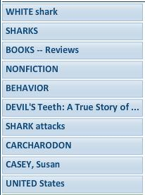

In my opinion, this first choice of topics should be broader. I don’t see a point in listing one author, one book, or one country. Instead the topics should resemble general areas of interest in regards to a search. For my search it would have been helpful if the system had given me choices like White Shark, Habitat, Food, Attacks, Books, Authors, Research etc. I think this could be solved if the semantic web will be developed further so that more appropriate categories will be chosen. Despite this factor, this system was interesting to work with and came up with a lot good results.
Turning to the web search engines Google, Bing, Clusty, and Scirus, Google still brought up the most (relevant) results. I like Google’s advanced search, the way Boolean operators are implemented without the user even knowing about them as the rows say “search all of these terms”, “but not these terms” and “any of these terms”. Restrictions to file type and domain have always been useful for me. I also like that I can put emphasis on license issues and the region.
Bing goes not even offer to switch over to advanced search on its starting screen. This is a feature that the developers need to implement, at least in my opinion, if they want Bing to become more successful. By clicking on “My settings” below the search box, Bing allows to customize certain options … but still no advanced search option. The homepage is very pretty though, and the pictures are informative and encourage browsing. The Explore-options are too general and boring. I have not clicked on one of them so far.
Bing’s and Google’s result lists look similar; they offer a few pictures and a lot of links. Bing also offers the related search feature on the left, which is nicely placed and makes it interesting to browse these topics. Google has more advertisement on the results page.
Clusty offers an advanced search option, which allows the user to select the host, the file type, the language as well as the adult content filter. As I was exploring this engine in another assignment I can say that I was kind of disappointed by it. The best feature, in my opinion, is the clusters that the engine generates. They are even better than the one EBSCO shows for their visual search as they offer broader terms related to the subject
All three web engines offer auto-suggest in the search box, which can be very useful, especially if a user is not quite sure how to spell a difficult term. This is a feature I like and I wonder if this could be implemented into academic engines. But I guess that people who use the latter should be able to look a term up before searching for it.
I was really disappointed by Scirus. I just could not get the feel for it. The advanced search offers a lot of options such as dates, information types, file format, content source, and subject areas. The user has only two rows to construct a search, and the fields available are not exhaustive enough. The results list, however, is satisfactory. The results can again be filtered in several ways and the results popping up for a simple search (such as just “great white shark”) are informative. I got the feeling thought that complex searches give this system trouble. For me it came up with a lot of irrelevant results.
In conclusion, all engines have their advantages and disadvantages, but it was interesting to work with all of them to see which system works best for me. EBSCO (Visual Search) and DIALOG remain my favorite systems.

7. The Perfect Search Tool
The perfect search tool does, of course, not exist. But I think that with everything that we have learned and seen during this class we have a pretty good idea of what features a search engine should have in order to satisfy at least my needs.
Starting with the interface I would like to see a visual interface like EBSCO offers. I would add a choice between search rows -with the option to add rows- and a box for command search. The following list shows options that I would add my perfect search tool (in no particular order):

- Smart Text searching
- Option to create and combine sets
- Restrict by date, file type, language, publication type, full-text, peer-reviewed, document type
- Chose from pre-defined index terms or create a new index term by choosing sources (similar to what Nexis offers) and the option to restrict to major terms
- Chose subject areas, going from broad to more specific
- Chose a set of databases according to subject, or manually choose databases
- For images: Chose file type, black-white/color, map, chart, diagram,
- Search company, people, industry, public records, country profiles and legal (Nexis offers this feature and I found it very useful)
- A link to help site explaining the search commands with examples
- Display of search history

For the result list (displayed like the visual search from EBSCO) I would chose the following options to manipulate the results:

- Sort by date or relevancy
- Filter by date
- Group by subjects
- Group by publications or authors
- Group by document and file type
- Remove duplicates
- Show various formats (short, full, KWIC ect.)
- Display 10/25/50/100 results per page
- Drag and drop articles into a folder displayed by blocks (Visual Search); when hovering over the blocks display article title
- Show native database and descriptors/subject terms next to or below the article in the results list

All the features above are taken from the systems we have worked with in this class. If I actually had the chance to build my own engine I would, of course, tweak it here and there; see what works together and what does not, what could be improved and which layout makes sense. The most difficult task would be, as Geri Corson indicated, to select which databases are to be searched by my engine. These choices depend on where the engine is used. In a public library I would probably chose a variety of general databases. A specialized college, let’s say for dance, music and fine arts would definitely be better off with subject-specific databases. And I am sure they would appreciate the visual interface as it looks artistic. And last, but not least, I would assign appealing colors (pink and yellow!) and would come up with a striking name and logos to place on the library’s web site. After all, libraries, their resources and staff don’t sell themselves.

