CHILDREN’S CANCER CENTER OF STILLWATER AND STILLWATER NATIONAL BANK
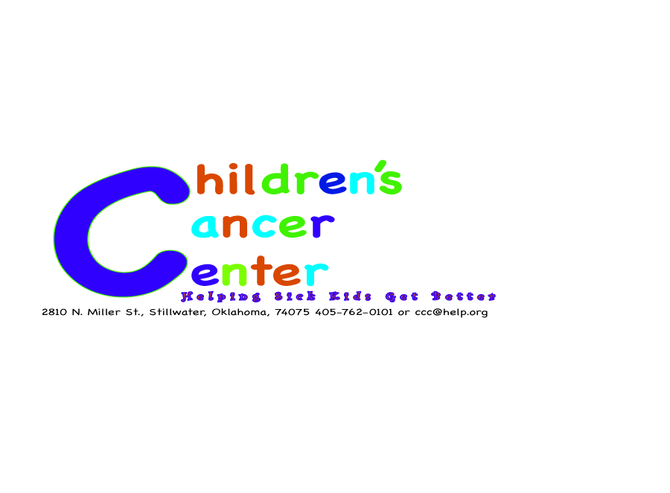
FACT SHEET

- Children’s Cancer Center of Stillwater is a nonprofit institution
- CCCS serves children all over Oklahoma
- CCCS helped more than 450 children in 2007
- CCCS operating cost is $5 million per year
- CCCS helps kids get better, regardless of their family’s ability to pay
- CCCS helps children with no insurance. Last year 50 percent of its patients had no insurance
- Stillwater National Bank has raised more than $1 million for local charities since 2000.

NEWS RELEASE
Dec. 12, 2008 Contact Information:
FOR IMMEDIATE RELEASE Rachel Newton
Phone: (580)-301-3265
E-mail: rachel.newton@okstate.edu

MUSIC’S BIGGEST NAMES COME TO STILLWATER TO FIGHT LEUKEMIA
Providing Entertainment and Hope

STILLWATER, OKLA.---Some of music’s biggest celebrities are coming to Gallagher Iba Arena in December to raise money for Children’s Cancer Center of Stillwater to fight childhood leukemia.
Stillwater National Bank sponsors the event, filling the entertainment card with Carrie Underwood, All American Rejects, Toby Keith, Garth Brooks and Reba McEntire. Tickets are $150 per person and the goal of the evening is to raise $250,000 to fight childhood Leukemia, the most common childhood cancer, affecting more than 500 Oklahoma children each year. The event is scheduled for Dec. 15, 2008, from 7-10 p.m.
“Too many kids suffer with Leukemia,” Garth Brooks said. “I hope we can double the goal this year. I’m personally donating $100,000 to the charity, as well as my time.”
Garth Brooks is not the only entertainer giving back more than their time for the event. Carrie Underwood said she would help the charity by giving $50,000 in addition to her time.
Children’s Cancer Center of Stillwater (CCCS) is a nonprofit institution serving children all over Oklahoma. In 2007, CCCS helped more than 450 children, regardless of their family’s ability to pay. CCCS helps children with and without insurance; last year, 50 percent of its patients did not have insurance. Stillwater National Bank has raised more than $1 million for local charities since 2000. For more information, contact Rachel Newton at (580)-301-3265 or e-mail at rachel.newton @okstate.edu.
-###-
CONTACT:
Rachel Newton
Office: 580-482-8453
Cellular: 580-301-3265
E-mail: rachel.newton@okstate.edu

MEDIA ADVISORY

Stillwater National Bank is sponsoring Hope for the Holidays, an entertainment event filled with music’s top performers to benefit the Children’s Cancer Center of Stillwater (CCCS). The concert is open to the public and will cost $150 per person. The goal of the night is to reach $250,000 to donate to the CCCS to help them in the fight against childhood Leukemia, which affects more than 500 Oklahoma children each year. Stillwater National Bank raised more than $1 million for local charities since 2000.

WHO: Carrie Underwood
All American Rejects
Toby Keith
Garth Brooks
Reba McEntire

WHAT: Concert with music’s biggest names as a fundraiser for the Children’s Cancer Center of Stillwater. Anyone is invited.

WHEN: December 15, 2008, 7-10 p.m.

WHERE: Gallagher Iba Arena
Oklahoma State University
Stillwater, Oklahoma 74078

WHY: To reach or exceed a goal of $250,000 to help the Children’s Cancer Center of Stillwater fight childhood Leukemia.

Clients: Stillwater National Bank and Children’s Cancer Center of Stillwater
Contact: Rachel Newton
(580)-301-3265
rachel.newton@okstate.edu
Length: :20

DO YOU WANT TO SEE ALL YOUR FAVORITE BANDS

AND FIGHT CHILDHOOD CANCER AT THE SAME TIME?

JOIN REBA, TOBY, GARTH, CARRIE, AND THE ALL

AMERICAN REJECTS DECEMBER FIFTEENTH IN

GALLAGHER IBA ARENA TO BRING HOPE FOR THE

HOLIDAYS. FOR TICKETS OR MOREINFORMATION CALL

580-301-3265 OR VISIT STILLWATER NATIONAL BANK.

Clients: Stillwater National Bank and Children’s Cancer Center of Stillwater
Contact: Rachel Newton
(580)-301-3265
rachel.newton@okstate.edu
Length: :30

DO YOU WANT TO SEE ALL YOUR FAVORITE BANDS

AND FIGHT CHILDHOOD CANCER AT THE SAME TIME?

JOIN REBA, TOBY, GARTH, CARRIE, AND THE ALL

AMERICAN REJECTS DECEMBER FIFTEENTH IN

GALLAGHER IBA ARENA TO BRING HOPE FOR THE

HOLIDAYS. PROCEEDS GO TO THE CHILDREN’S CANCER

CENTER OF STILLWATER. FOR TICKETS AND MORE

INFORMATION CALL 580-301-3265 OR VISIT STILLWATER

NATIONAL BANK.

CONTACT:
Rachel Newton
Office: 580-482-8453
Cellular: 580-301-3265
E-mail: rachel.newton@okstate.edu

MEDIA PHOTO & INTERVIEW OPPORTUNITY SUGGESTIONS

Music’s biggest names join representatives from Stillwater National Bank and Children’s Cancer Center of Oklahoma for photo and interview opportunities before Hope for the Holidays, an entertainment concert to raise money for the fight against childhood Leukemia. Each entertainer has offered thirty minutes of their time before rehearsals to give to the media. Entertainers may stay longer than their allotted time, but have only guaranteed to be at the OSU Alumni Center’s Click Alumni Hall for their allotted thirty minutes.

WHO: Carrie Underwood, 2:00-2:30 p.m.
All American Rejects, 2:00-2:30 p.m.
Toby Keith, 2:30-3:00 p.m.
Garth Brooks, 3:00-3:30 p.m.
Reba McEntire, 3:30-4:00 p.m.
Representatives from Stillwater National Bank and Children’s Cancer Center, 2-4p.m.

WHAT: A specific time and place arranged for the media to have the opportunity for photos and interviews with the performers and representatives.

WHEN: December 15, 2008 from 2-4 p.m.

WHERE: ConocoPhillips Oklahoma State University Alumni Center
Click Alumni Hall
Stillwater, OK 74078

WHY: To give the media photo and interview opportunities with the performers and representatives.

NEWS RELEASE
Dec. 16, 2008 Contact Information:
FOR IMMEDIATE RELEASE Rachel Newton
Phone: (580)-301-3265
E-mail: rachel.newton@okstate.edu

STILLWATER CHARITY RECEIVES MORE THAN $250,000 FROM MUSIC EVENT
Providing Entertainment and Hope

STILLWATER, OKLA.---Some of music’s biggest celebrities raise more than $250,000 for the Children’s Cancer Center of Stillwater to fight childhood leukemia, exceeding the sponsor’s goal for the event.
Stillwater National Bank sponsored Hope for the Holidays, filling the entertainment card with Carrie Underwood, Toby Keith, Garth Brooks, Reba McEntire and All American Rejects, who are from Stillwater. The event raised $555,000 to help the Children’s Cancer Center of Stillwater fight childhood Leukemia. Along with ticket sales, entertainers Garth Brooks donated $100,000 and Carrie Underwood donated $50,000 to the charity. The event took place on December 15, 2008.
“Stillwater Organizations are important to us and Children’s Cancer Center has helped so many kids and their families,” Tyson Ritter of the All American Rejects said. “We like to give back to the community that supported us.”
Children’s Cancer Center of Stillwater (CCCS) is a nonprofit institution serving children all over Oklahoma. In 2007, CCCS helped more than 450 children, regardless of their family’s ability to pay. CCCS helps children with and without insurance; last year, 50 percent of its patients did not have insurance. Stillwater National Bank has raised more than $1 million for local charities since 2000. For more information, contact Rachel Newton at (580)-301-3265 or e-mail at rachel.newton @okstate.edu.
###

