BOS 341A
Professor Podoshen

Allie Shi

[Case Study 1 – VOSS Artesian Water from norway]
[Type the abstract of the document here. The abstract is typically a short summary of the contents of the document. Type the abstract of the document here. The abstract is typically a short summary of the contents of the document.]

Part I – Executive Summary
VOSS is a young Norwegian bottled water company that targets U.S. as its primary market. Despite VOSS’ ultra-premium price, the firm has successfully established itself as one of the most luxurious water brands around the world. The primary distribution channels for VOSS are on-premise locations such as high-end restaurants, hotels, clubs, as well as off-premise locations in selected gourmet and specialty stores that target high-end consumer demographics. However, as the U.S. high-end market for glass water on-premise is getting more competitive, VOSS is facing serious challenges to reach the goal of doubling its sales by the end of 2009. By analyzing the firm’s current situation and examining its SWOT, I have come up with four marketing strategies that combine distribution and product initiatives to get a broader customer base while maintaining the loyal VOSS consumers. The key point is to develop two product and brand extensions as well as opening up more distribution channels in order to achieve VOSS’ sales goals.

Part II – VOSS Internal Strengths
There are several key factors that have driven VOSS to be a successful ultra-premium water brand.
First of all, VOSS has done a great job in its marketing mix. Among the twelve mix elements defined by Silk, the most important four major aspects are Product, Place, Promotion, and Pricing. VOSS’ brand core attribute is ultra-premium water packaged in an elegant bottle. This unique positioning has differentiated the brand as a high-end product as opposed to many other brands such as Deer Park or Aquafina. In order to coordinate with the brand image, VOSS has charged its customers a high mark-up price for each bottle of the water and also strategically selected high-end restaurants, hotels and clubs as its exclusive on-premise marketing channels.
Moreover, with this distinctive high-end value proposition, VOSS has successfully become the exclusive bottled water for high-profile and celebrity-driven events such as the 2006 Golden Globe Awards. Although VOSS has not spent money on mass advertising, this promotional strategy has provided the brand a great buzz in the public. By combining the Product, Place, Promotion, and Pricing strategies, VOSS has reinforced its ultra-premium and exclusive positioning in the market, which has attracted many loyal customers who are craving for the products.
Secondly, since VOSS identifies itself to follow an exclusive marketing strategy, the firm has managed to track and obtain monthly data on sold accounts. Contrarily, most water companies can barely collect these data due to their vast distribution channels and sales. Thus, the capability of collecting detailed data from customers provides VOSS a great advantage over the other competitors in regards to positioning. As elaborated by Silk, one of the three questions that a good positioning statement should answer is “Who are the customers? ” By understanding its customers through the data, VOSS can thus sell to the right crowd to strengthen its positioning statement in the market.
Last but not the least, VOSS has a premium brand equity. Although the products have significant costly mark-ups, customers have demonstrated high brand loyalty towards VOSS. One primary example is that Madonna made the headlines for not checking into hotels that did not stock VOSS. Hence, the firm can utilize its high brand equity to maintain the long-term customer base as well as pull in new consumers.

Part III – VOSS Internal Weaknesses
Although VOSS has achieved tremendous success and established itself as one of the strongest brands in on-premise locations in the U.S., it still has weaknesses that might hinder the firm from potential growth.
Since VOSS does not give away free products or discounts in order to maintain its high-end brand image, the firm has far less power to seize the market share than those large industry players. Because of the same reason, VOSS has experienced difficulties in selling into off-premise channels such as gourmet and specialty stores. This weakness will prevent potential customers from knowing the brand. As a consequence, it will hurt VOSS’ sales volume potentially and its brand presence in the market.
Another weakness that the firm has is its lack of marketing research. VOSS spends almost no money on market research and only relies on managerial instinct for most of its strategic decision-making. Only through empirical market analysis, can VOSS utilize the detailed selling information to adjust its marketing strategies toward the need of customer segments. In addition, “the dynamic nature of the marketplace can make a before-and-after comparison of sales result unreliable.” Thus, the firm’s deficient effort putting into the market research will hurt VOSS’ long-term sales goal and marketing strategy.

Part IV – VOSS External Opportunities
VOSS has worked very hard to build and maintain its ultra-premium brand image ever since the business began operations. Although the U.S. high-end market is not as big as the firm initially thought, the fast-growing global markets such as the BRIC nations – Brazil, Russia, India, China and the oil-rich Middle East countries have quickly emerged as new sales opportunities for luxury products. Thanks to the rapidly growing economies, average consumer in these markets have more money than ever – they are looking for spending money on things that they wanted but could not buy before. People in these countries are seeking to display their new financial status through having luxurious accessories. Many ultra-premium make-up and clothing products such as Chanel, Gucci, and Dior have already established themselves in these markets and gained substantial market shares. Therefore, with a suitable marketing plan, VOSS has a great potential to expand its international business to these markets.
Furthermore, a global trend of living healthy has led to more water consumption instead of high-calorie drinks demand. As shown below, the bottled water per capita consumption in the U.S. is far below the number of many other developed countries (26.1 as compared to 50.5 in Italy in 2005). This indicates that the water market in the U.S. has much capability to grow. Thus, VOSS can take advantage of this opportunity to market the brand from the “healthy” approach and create performance gaps to attract consumers to buy the products.
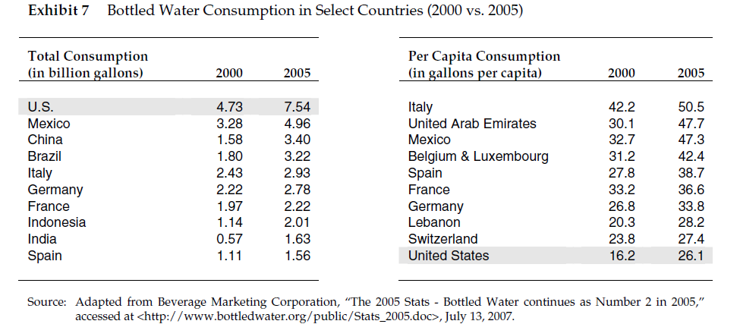

Part V – VOSS External Threats
In terms of market shares, Pepsi’s Aquafina and Coca-Cola’s Dasani are the water industry’s two top brands. Although these brands have an unshakable power in the low-end day-to-day consumption water market, VOSS focuses on the high-end and does not target these market segmentations.
At the premium end of the market, major competitors include brands such as Perrier, Evian, San Pellegrino, and Fiji. Each of their customer base and positioning is indicated below:
- Perrier: This French sparkling Mineral Water Company has been in the U.S. market since 1978. The brand has established a loyal customer base because of its prestige in the market.
- Evian: The French still Mineral Water brand is the most visible luxury water in the world. The brand has a large customer base but because of its selling in gas stations and drugstores, Evian has lost a lot of its premium cachet. The company is in process of rebuilding its brand image.
- San Pellegrino: The Italian sparkling water brand was positioned as premium water for Italian fine dining, however, because it has been too common in other restaurants, the brand has been diluted.
- Fiji: A recent premium Fiji Islands’ water company that is becoming a popular day-to-day drinking water.
All of these competitors exert pressure upon VOSS’ sales since each of the brands has established their own loyal customer base. However, VOSS brands as an “ultra-premium” icon which has differentiated itself from these described above. Nonetheless, the competition in this ultra-high-end market has become white-hot. Competitors include the Beverly Hills-based Bling H2O, Welsh Tau, etc.
The market environment also imposes serious threats to VOSS. VOSS’ primary market – the U.S. high-end market for glass on-premise is not big enough to double the firm’s sales volume as initially planned (as predicted in the article, the on-premise business in the U.S. will only grow another 10-15% over the next few years). Moreover, the economic downturn of 2007 forces consumers to be more price sensitive which creates difficulties for VOSS to sell as luxury products in the current market.

Part VI – Strategies
By closely examining VOSS’ SWOT, I propose that the firm should utilize its internal strengths to fix its weaknesses so that the company can make use of the present opportunities. Furthermore, VOSS should highlight the brand’s high-ground of exclusivity as well as creating accessible means for consumers to get a piece of what VOSS is offering but not the whole thing. Together with the effort of a multi-platform advertising campaign, innovative line and products extensions, VOSS can achieve its goal of doubling sales by the end of 2009.
The first strategy involves the development of a product extension – customized and designers’ limited edition glass bottles of water for gift or event purposes. More products are creating the augmented products to bundle with their core products to differentiate the brands in the market. In this strategy, we address the importance of VOSS’ augmented product. Any water can serve to quench thirst. However, by creating the augmented product, VOSS will dominate consumers’ “emotional space” and market itself as something much superior to ordinary water – a pure, glamorous, metropolitan, and high-end lifestyle that people can emotionally relate to. For VOSS’ customers, the augmented product clearly outweighs the core product and this is exactly where we should market. Specifically, we will focus on pampering VOSS’ most loyal customers. By placing customized and designers’ limited editions glass bottles as a purchase option on the VOSS website, we will use Internet technology to allow people to imprint a few words on the body of the bottle or simply select a designers’ limited edition water bottle to a friend as a gift. People will also be able to customize bottles for a private event such as birthday or New Year party to add a final touch of elegance to the occasions. Afterwards, VOSS will ship these products to the households directly. Because of the complicated procedures involved in customization, VOSS will charge a high mark-up to each product (10% to 15% higher of the same product comparable). This personalization scheme will prevail because everyone wants their own lifestyles. If VOSS continues to provide this unique service, people will stay with the brand for longer because customization makes individual consumer feel special, which subsequently leads to purchasers’ long-term brand loyalty.
The second strategy is to develop a brand extension – opening exclusive high-end spas in three of the most metropolitan cities in America – Los Angeles, New York, and Miami. Since VOSS has successfully established itself as an ultra-premium water brand through its subtly designed marketing mix, the spas should bare the same name in order to attract loyal customers and charge premium mark-ups on the spa services. The spas will be entirely using VOSS water (see below for descriptions of the artesian water) to market for its purity. In addition, VOSS should hire the top professionals to offer the finest spa services while only issuing a certain number of elite memberships per year to market for its exclusivity. Through this fashion, VOSS broads its horizon, builds a closer and more lasting relationships with the loyal customers who will in turn pull in new consumers through word-of-mouth. This strategy also fits the ultra-premium, glamorous and metropolitan brand image. Nonetheless, opening VOSS spas in Los Angeles, New York and Miami – three of the most well-known cities in the U.S. and the world, will create great PR to introduce the brand to a wider audience. By offering limited number access to the spas as well as charging expensive mark-ups for the luxury spa services, VOSS will maintain its ultra-premium and exclusive brand image while also gaining sales volume through an innovative brand extension.
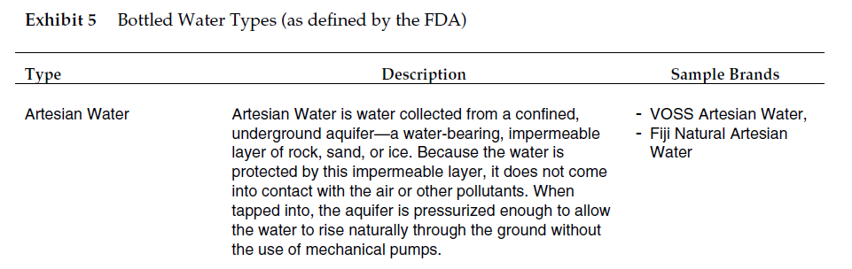
The third strategy is all about creating accessible price points to get wider market reorganization. Consumers’ price sensitivity may rise during the economic hardships. As the economy crashed in 2007, people are looking for cheaper things so they may not go to high-end restaurants, clubs, or hotels as often. This phenomenon holds back the sales of VOSS Glass and VOSS Silver but does not necessarily affect the sales of VOSS Red due to its accessibility in stores. Furthermore, it is worth noticing that U.S. off-premise sales have grown at a 398% rate as opposed to U.S. on-premise sales growth rate of 111% from year 2006 to 2007. All of the facts suggest that the U.S. off-premise market is a great opportunity to invest in more. If VOSS does not go for mass commercialization, this luxury brand risks others doing the same and taking the advantage. However, this approach does not mean that VOSS has to downgrade the brand. Even VOSS reaches out to a broader market; the firm must still protect the essence of its luxury brand image. If VOSS only focuses on its sales volume by reducing the price and selling into gas stations and convenience stores during the economic hardship, the company jeopardizes its ultra-premium positioning and brand image in consumers’ mind. Furthermore, when the economy gets better in the near future, people will no longer connect “ultra-premium” with the brand and eventually, VOSS will lose its brand equity that the firm has built for long. Therefore, the firm should continue strengthening its sales forces for VOSS Red in gourmet and specialty stores that target a higher class of consumers. As noticed in the SWOT analysis, VOSS has experienced difficulties in selling into these distribution channels. One possible strategy to solve this problem is to increase consumers’ needs for VOSS and subsequently use buyers’ purchasing power to force its sales in these stores. This goal can be only achieved by a multi-platform and multi-media advertising campaign.
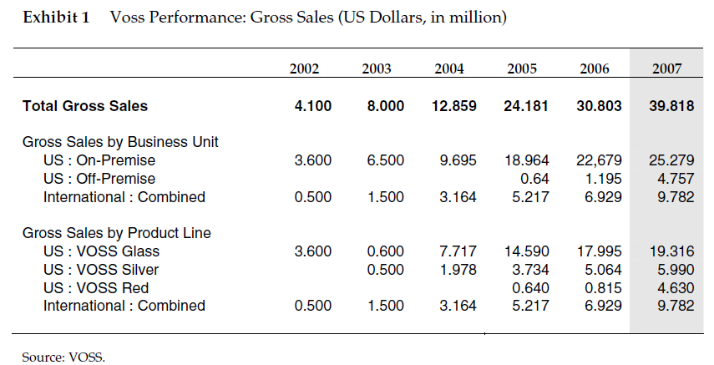
This multi-platform and multi-media advertising campaign focuses on rising consumers’ awareness and creating performance gaps which can be only satisfied by purchasing VOSS. While people can consume tap water anywhere, bottled water in developed nations has become a status symbol rather than a fulfillment of basic need. For example, a person carrying a bottle of Evian is to be understood as belonging to a specific socio-economic class with money and luxury to follow trends. This phenomenon can be also seen in the coffee industry whereas Starbucks cup of coffee symbolizes a unique luxury lifestyle. Evian’s high-end positioning is highly endorsed by its marketing and advertising campaign – we have seen Evian’s ads on major magazines, billboards as well as various internet sites. Although VOSS has exposed itself in many celebrity-driven and high-end events, the firm lacks a comprehensive advertising campaign which can further raise awareness among consumers. First of all, the firm should budget more on marketing research to see whether consumers have perceived VOSS as an ultra-premium icon. Then, as described in Silk’s book, there are three stages that consumers will go through before purchasing a product – cognitive, affective and behavioral stages. Therefore, I propose that VOSS’ advertisements must not only make consumers aware of the existence of the product (cognitive stage) but also drive consumers to prefer the product over the other options and finally have an intention to buy it. Thus, the ads ought to focus on addressing the augmented product of VOSS water, which includes the attributes such as purity, metropolitan, fashion, glamour, luxury, and sexy. Accordingly, the use of sex appealing ads is appropriate under the circumstance to market VOSS like a luxury product. Through the advertisements, VOSS should be linked to an elite-class status which can affect and produce consumers’ needs to purchase the products with the need of feeling belonged to this privileged class. Then, in order to target the right consumers – people from age 18 to 49 with money to spend on luxury goods, we will distribute print ads on high-end fashion magazines such as Vogue and famous billboards such as the ones in Times Square in New York. In addition, ads should be placed on selected internet sites such as Facebook in tone with the advertising campaign to target the Generation Yers who consume more information online rather than from traditional media such as radio or newspapers. Likewise, I suggest that VOSS should produce a small series of classy and sexy relationship episodes (each around 10-15 seconds) that are involved around VOSS water to be played on TV. This method is pioneering yet risky to use in the water industry. However, I believe people will remember the ads and the brand name more easily because that this miniseries is almost like a TV show where people’s thoughts are actively involved. Lastly, by implementing this advertising campaign, VOSS will get a wide reorganization and also consumers’ preferences. Subsequently, the purchasing power generated from the ad campaign can force VOSS’ sales in stores and in turn increase sales volume.
The last strategy is regarding to the global market. By securitizing VOSS’ gross sales performance from 2002 to 2007, I have observed that U.S. on-premise sales are increasing at a decreasing rate while both U.S. off-premise and International sales are increasing at considerable increasing rates. Specifically, VOSS international sales are growing at a significant 144% rate from year 2006 to 2007. This significant growth rate implies that the international markets worth more investments. Global sale has been a hot topic for many brands over the last few years. As more markets such as the so-called BRIC nations – Brazil, Russia, India, China and the oil-rich Middle East countries are opening up, companies believe them to be the new lucrative markets. Many brands have already invaded in these world’s fastest-growing economies and have had their piece of the pie. Despite the challenges and unsettled current state of luxury retailing in several of these markets (such as the Chinese government regulations imposed on selected imported goods), the future of the luxury products is very bright. I propose that VOSS should start selling its products in Shanghai, China. Shanghai is one of the most metropolitan cities in China and is renamed by many foreigners as the “Eastern New York.” The city is becoming the financial and fashion center of Asia that attracts a lot of foreign investors as well as local business men. Therefore, the westernization and materialism cause consumers in Shanghai to purchase luxury goods in order to display their new financial status. Evian has seized this opportunity and successfully established the brand in China over the past few years. At the ultra-premium end of water market in Shanghai, Evian will be the only competitor to VOSS. Because the Chinese consumers are always fascinated by new foreign goods, with the unique implementation of the advertising campaign, VOSS has a great potential in leading the high-end water market as a better luxury brand.
In conclusion, I suggest that VOSS should combine the strategies described above to achieve the goal of doubling sales volume by the end of 2009. Although VOSS has established a loyal customer base, it should keep the momentum going by introducing new products and services which can be achieved by employing the first two strategies. The third strategy involves creating accessible price points for consumers to get a piece of VOSS is offering. While still keeping VOSS out of grocery stores and gas stations, I propose a multi-platform advertising campaign to gain more awareness about the brand which can push VOSS’ sales into more gourmet and specialty stores. Moreover, the sex appealing ads will create performance gaps among consumers – needs to belong to an elite class that can be only satisfied with VOSS water. At last, I recommend that the firm should take an international stand while selling its products. Due to Shanghai’s unique mix of socio-economic factors and consumers’ psychological features, I suggest that this city should be the next market for VOSS to step in. By combining these four strategies, VOSS will be able to achieve its goal of doubling sales volume by the end of 2009 as well as keeping the ultra-premium and exclusive brand essence.

Page 9. Silk, Alvin J. 2006. What is Marketing. Boston, Massachusetts: Harvard Business School Press.
Page 90. Silk, Alvin J. 2006. What is Marketing. Boston, Massachusetts: Harvard Business School Press.
Page 146. Silk, Alvin J. 2006. What is Marketing. Boston, Massachusetts: Harvard Business School Press.
Page 7. Exhibit 7.
Page 12. Exhibit 5.
Page 14. Exhibit 1.
Page 135, Figure 6-2. Silk, Alvin J. 2006. What is Marketing. Boston, Massachusetts: Harvard Business School Press.
Page 14. Exhibit 1.

