Rainie, Searls Interview: The future of open source, innovation, and value April 30, 2010

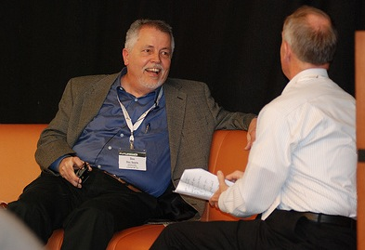
In the last session of the second day, Lee Rainie sat down with Doc Searls, the Linux Journal senior editor, and fellow at Harvard’s Berkman center. Searls is part of the Pew’s closest network, and has praised the Pew Research Center from early on.

Lee Rainie, left, interviews Doc Searls in a special session of FutureWeb. (Photo: Dan Anderson, Elon University)

Searls briefly discussed how he got into the Linux community, and said the appeal came from his observation that the Internet empowered individuals as much as it empowered larger organizations. He also talked of the connection between the Internet and construction, saying he had the inkling that “the language of writing code was the language of construction.”

Throughout the interview, Searls continued to relate the Net to construction and geology. He sees the Internet as the foundation for web ‘construction’ sites. “Buildings come and go, but the geology doesn’t, and the geology is the Net,” Searls said.

As a “correctly-labeled ‘Techno-uptopian’”, Searls maintained his optimism for the future of the Internet throughout the majority of the talk. When Rainie asked what he believes threatens innovation, Searls responded by saying that the originality of human beings could be endless. He elaborated by discussing some of his exciting initiatives, such as the Listen Log, which allows users to log what the listen to. In terms of public radio and other radio, Searls loves the idea of “giving people a way to see what it is they value.”

Rainie then moved to a question about the notion of property, and what the current world has wrong with its very definition.

“Intellectual property is an oxymoron,” Searls said. “We would not have the Internet now if people had asserted intellectual property control.”

Searls explained value beyond the physical realm, and how morality can play a role in the creation of this value. He contrasted two morality principles: the exchange, where one item is traded for another; and the relationship, where there is no transaction taking place, and there is no price put on love.

According to Searls, the Internet falls in the second category, where it is something so inherently generous, yet no transaction is taking place.
Rainie challenged this generosity concept, and asked the normally optimistic Searls what worries him for the future. He discussed global warming prospects, and the notion of running out of Earth’s vital elements.

He compared our long-term state to the condition of ants with a hill on the sidewalk, metaphorically implying that eventually someone will step on (us).

“I hope the Internet will help us see that,” he said.

- By Katie Roberts

