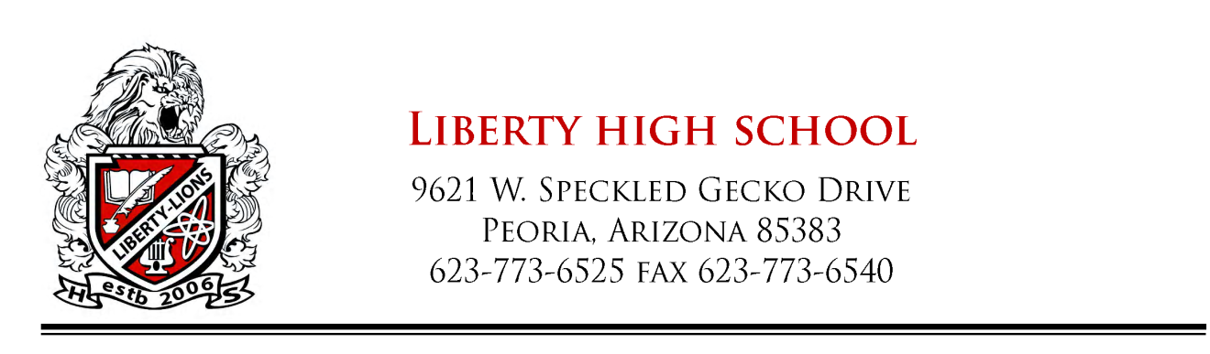
May 3, 2010
Letter of Recommendation for: Nicole Petersen

To whom it may concern:

Nicole Petersen has completed her culinary studies at Liberty High School. She finished with a 94.1% - A- in the advanced class this past fall. She did so with a work ethic and maturity that if far above students her age. Whenever I asked her to take care of something, I never had to check up on her to make sure it was done right. But she checked with me often because she has the utmost respect for teachers and her family.

I know that whatever career she chooses to excel in, she will be a huge asset to any company that hires her. I wish her the best and know she will do very well.

Thank you,

Jeff Stanhill
Culinary Arts Instructor
Culinary Arts Club Advisor
Liberty High School, Peoria Unified School District, Peoria, AZ
jstanhill@peoriaud.k12.az.us

