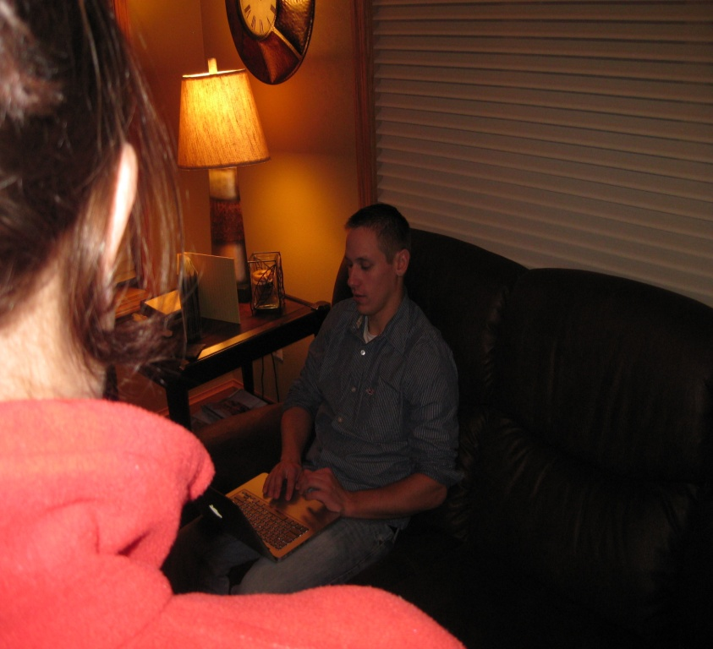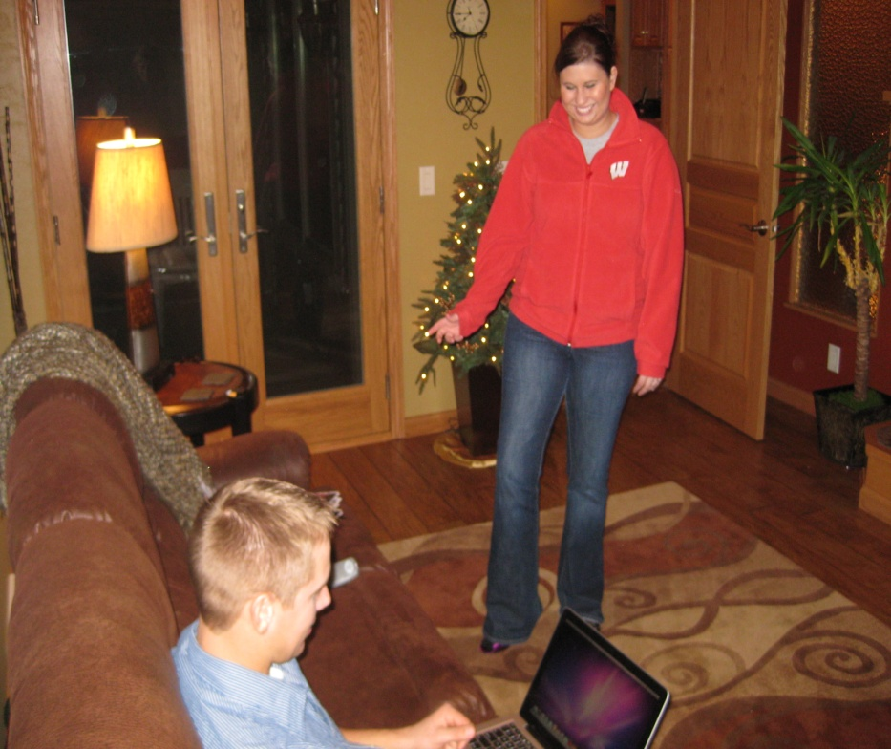

HUSBAND: Yeah, I’ll get to it someday.

WIFE: And I thought you said you were going to hang the new wallpaper in the kid’s room?

HUSBAND: I will, hopefully soon!

WIFE: I thought you said you were going to repair the drywall in the kitchen?



HUSBAND: Well honey, as you can see, I’m pretty swamped with work right now.

WIFE: And what about the living room? I thought you said you were going to give it a fresh paint job?

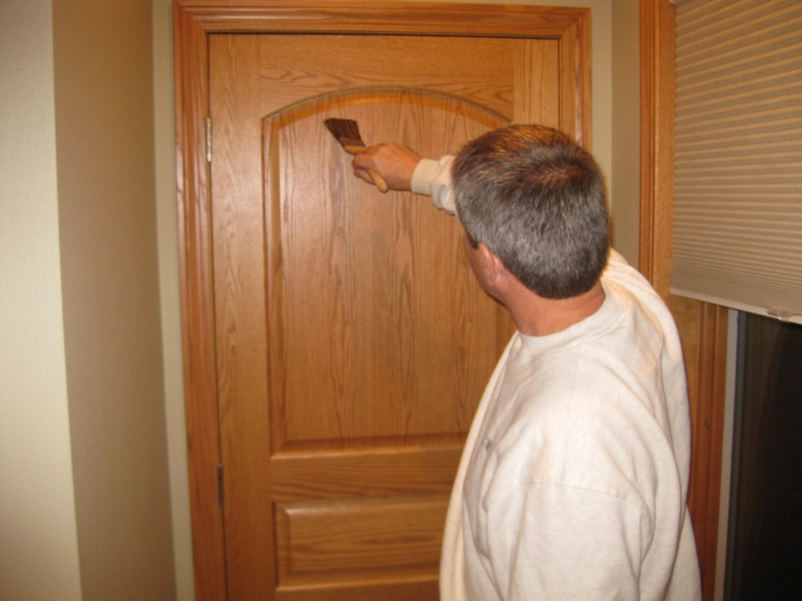

HUSBAND: Over 30 years huh? Well does he know how to wood grain doors because our front door could use some work.

WIFE: Well then I’m calling Syens Painting. Not only has he been in business for over 30 years, with his wide variety of skills, he’ll be able to get these jobs done in no time!

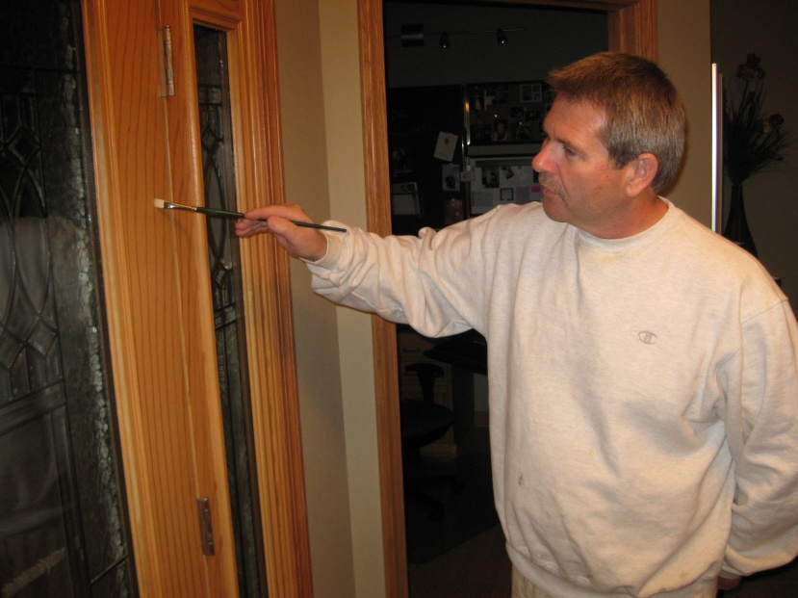

HUSBAND: Well what are we waiting for! Let’s call now!

WIFE: As a matter of fact, yes! I went over to our neighbor Shelly’s house last week and I couldn’t even tell that their door was really a metal door!



DAVE SYENS: Your home should look as beautiful as the people living in it. Let me help you achieve that!

SFX: MUSIC OUT AT :30

SFX: SMOOTH JAZZ UP AND UNDER

DAVE SYENS: Dave Syens here, owner and operator of Syens Painting. For the best in interior and exterior painting and woodwork, call me for a free estimate! Call (920)296-3272. I will not leave the job site until you are completely satisfied with my work!