TO: Dr. Keys-Mathews

FROM: Michelle Jones

DATE: November 22, 2009

SUBJECT: Situational Analysis of a Developing Country

Introduction

Finding out the source of why a country is the way it is today consists of situational analysis of the developing country. The African country Libya will be demographically, socially, and economically characterized. In this process Libya will be compared to similar countries. The countries that will be compared and contrasted are: Algeria, Chad, Niger, Mali, Egypt, and Sudan. These countries were chosen because of their location. Figure 1 shows the location of these countries. These countries are either bordering Libya or relatively close to the country.

The focus of this analysis is to provide an overview of Libya’s historical events that have shaped the country, the spatial organization of Libya, and the current demographic, social, and economic situations of Libya. Research of Libya’s historical events is the foundation of this analysis. These events have shaped the country. Once the analysis is complete, the future of this country can be predicted.

Country History
For the majority of the past, the population of Libya has been subjected to varying degrees of foreign control. The Phoenicians, Carthaginians, Greeks, Romans, Vandals, and Byzantines ruled all or parts of Libya. Although the Greeks and Romans left impressive ruins at Cyrene, Leptis Magna, and Sabratha, little else remains today to testify to the presence of these ancient cultures. Next, the Arabs conquered Libya in the seventh century A.D. In the following centuries, most of the indigenous people adopted Islam and the Arabic language and culture. The Ottoman Turks conquered the Libya in the mid-16th century. Libya remained part of their empire until Italy invaded in 1911 and made Libya a colony (Stategov, 2009).

In 1934, Italy adopted the name "Libya" as the official name of the colony, which consisted of the Provinces of Cyrenaica, Tripolitania, and Fezzan. King Idris I, Emir of Cyrenaica, led Libyan resistance to Italian occupation between the two world wars. From 1943 to 1951, Tripolitania and Cyrenaica were under British administration, while the French controlled Fezzan (Werenfels, 2009). In 1944, Idris returned from exile in Cairo but declined to resume permanent residence in Cyrenaica until the removal in 1947 of some aspects of foreign control. Under the terms of the 1947 peace treaty with the Allies, Italy relinquished all claims to Libya (Stategov, 2009). On November 21, 1949, the UN General Assembly passed a resolution stating that Libya should become independent before January 1, 1952. When Libya declared its independence on December 24, 1951, it was the first country to achieve independence through the United Nations and one of the first former European possessions in Africa to gain independence. Libya was proclaimed a constitutional and a hereditary monarchy under King Idris (Werenfels, 2009).

Libya had been one of the world's poorest countries to become extremely wealthy when there was the discovery of significant oil reserves in 1959 and the subsequent income from petroleum sales. Although oil drastically improved Libya's finances, popular resentment grew as wealth was increasingly concentrated in the hands of the elite. This discontent continued to mount with the rise throughout the Arab world of Nasserism and the idea of Arab unity (Stategov, 2009).
Following a 1969 military coup, Col. Muammar Abu Minyar al-Qadhafi began to espouse his own political system, the Third Universal Theory. The system is a combination of socialism and Islam derived in part from tribal practices and is supposed to be implemented by the Libyan people themselves in a unique form of "direct democracy." Qadhafi used oil funds during the 1970s and 1980s to promote his ideology outside Libya, supporting subversives and terrorists abroad to hasten the end of Marxism and capitalism. In addition, beginning in 1973, he engaged in military operations in northern Chad's Aozou Strip. This was to to gain access to minerals and to use as a base of influence in Chadian politics. Although, he was later forced to retreat in 1987 ( Timewell 1, 2009).

Qadhafi's confrontational foreign policies and use of terrorism, as well as Libya's growing friendship with the U.S.S.R., led to increased tensions with the West in the 1980s. Following a terrorist bombing at a discotheque in West Berlin frequented by American military personnel, in 1986 the U.S. retaliated militarily against targets in Libya, and imposed broad unilateral economic sanctions, news reporters stated (Statgov, 2009).
After the 1988 bombing of Pan Am flight 103 over Lockerbie, Scotland, UN sanctions were imposed in 1992. UN Security Council resolutions (UNSCRs) passed in 1992 and 1993 obliged Libya to fulfill requirements related to the Pan Am 103 bombing before sanctions could be lifted. Qadhafi initially refused to comply with these requirements, leading to Libya's political and economic isolation for most of the 1990s (Werenfels, 2009).
Since the beginning of the decade, when the Great Socialist People's Libyan Arab Jamahiriya was still in isolation, a lot has changed. At that time, price controls, multiple exchange rates and the heavy hand of government added extra burdens to the country's pariah status. But in 2003, the government began implementing major economic reforms and the decision in 2003 to admit to civil responsibility for the bombing of a Pan Am jet over Lockerbie, Scotland, in 1988 (Timewell 1, 2009).

A key turning point also came in 2005 when relations with Libya's long-time foe, the US, were normalised. This process of political reintegration has allowed for Libya's rehabilitation into the global economy and for the country's huge economic potential to begin to be realized, stated Stephen Timewell.

After being isolated for so long, the government has begun a programm of institutional and structural reforms. The reforms are both domestic and foreign, aimed at increasing non-oil economic growth and creating viable employment opportunities for its relatively small population of 6 million. Libya's position on reform is made more comfortable by the widespread level of support for the process which is being done in a way that is consistent with the domestic fabric of society (Gavin, 2009).
Spatial Organization

Libya’s history has impacted the spatial organization of the country by the population density locations and location of resources. Clearly, people are going to live where the resources are. In the past Tripoli was the main port and is now the nation’s capital as well as the most populated city in Libya (Figure 3). Population densities are normally higher in areas of imports and exports such as the city of Tripoli (Figure 6). Libya has many natural resources but the main focal is the oil production. Figure 2 and Table 2 show the comparison of the compared countries’ oil production per day. Libya and Algeria produce the most oil out of the comparing countries. While Figure 2 and Table 2 show the oil production comparison, figure 4 is showing the actual oil fields in Libya. Recent maps are hard to come by in developing nations. These maps are clear but not completely up to date. The oil fields really can not change a whole lot but recent up dates have occurred.

The government dominates Libya's socialist-oriented economy through complete control of the country's oil resources, which account for approximately 97% of export earnings. Libya’s oil revenues constitute the principal source of foreign exchange. It is shocking that most of the country's income has been lost to waste, corruption, conventional armaments purchases, and attempts to develop weapons of mass destruction. Also, large donations made to developing countries in attempt to increase Qadhafi's influence in Africa and elsewhere (Timewell 2, 2009).

Although oil revenues and a small population give Libya one of the highest per capita GDPs in Africa, the government's mismanagement of the economy has led to high inflation and increased import prices. These factors resulted in a decline in the standard of living from the late 1990s through 2003 (Timewell 1, 2009).

Transportation is very limited in Africa. It is limited because of the desert areas. Libya is mostly desert and has little transportation routes (Figure 5). Figure 5 shows the transportation routes and varieties and Figure 6 shows the desert areas in explanation for the small amount of routes. In the urban areas there are paved roads. Libyans also have cars, taxis services, as well as bus routes in the bigger cities. There are two large international airports in the two larger cities. Figure 6 shows the location of the two airports. The airports are located in Tripoli and Banghazi. This is because these areas are more densely populated and they are more urbanized as compared to the other cities in Libya with the smaller air ports. Table 1 shows that in comparison to the other countries, Libya has the highest percentage in urbanization. This is due to many factors such as population, industries, agriculture, resources, etc.

Demographic, Social, and Economic Situation
Muammar Qadhafi’s most recent economic plan for Libya is the “Wealth Distribution Plan.” This means the government aims to eliminate the majority of Libya’s main ministries in favor of the direct distribution of oil wealth to the people. Instead of channeling oil revenues to the people through layers of bureaucracy, the idea is to streamline and transform the whole state apparatus.

Libya has seen a number of “transformational visions” from Qadhafi, and it remains to be seen how this one will play out in 2009. So far, despite efforts to diversify the economy and encourage private-sector participation, there remain extensive controls on prices, credit, trade, and foreign exchange, all of which act to constrain growth and discourage private investment. Import restrictions and inefficient resource allocations by government departments and agencies have caused periodic shortages of basic goods and foodstuffs (QFinance, 2009).
Although agriculture is the second largest sector in the economy, Libya imports most of its foods. The climatic conditions and poor soils severely limit output, while higher incomes and a growing population have caused food consumption to rise. Domestic food production meets about 25% of demand (WorldFactBook, 2009).

Any developing country in Africa has its problems ranging from lack of water access to a high HIV/AIDS population. The focus of this analysis was to determine where exactly Libya is going economically. According to the data found Libya is improving but has a long way to go. According to the statistics found on Table 1, Libya is the more developed compared to the rest of the contrasting countries. Libya has the lowest population but this could be because of the desert area in the country. It has a higher life expectancy at birth of 77%.

Libya is slightly lower than average between the comparing countries in birth rate, death rate, and total fertility rate. This is because Libya is more urbanized than the other comparing countries and children are not needed for cheap labor in the family. There are more job opportunities in Libya. Table 1 shows that the percentage of the population living below poverty line in Libya is only 7.4%. This is extremely low. This could be because of the low total fertility rate that Libya has. There are not as many mouths to feed in the families in Libya therefore, they are saving money. There are many factors contributing to these statistics.

Urbanization, developmental projects, and high oil revenues have enabled the Libyan government to elevate its people's living standards. The social and economic status of women and children is particularly improving. There is a high percentage of population with accent to water (Table 1). The expansion of educational facilities has elevated the literacy rate. As compared to the other countries, Libya has an extremely high literacy rate for males and females.
The labor force in Libya is a good rate. Table 3 shows the labor force for Libya. This table is divided up into sectors. There are three different sectors showing the labor statistics. The first sector is agricultural labor. This percentage is the lowest of the three. From facts stated earlier, this make since because most of the land in Libya is desert. The climate condition and poor soils severely limits the output production. This makes it hard to keep an agricultural job in this area. Comparing the female and male percentages in the agricultural sector of labor shows that double the amount of females work in this sector than males. This could possibly be because women were not treated as equals and were mainly recommended to work around the house and farm. The men were to go out and get jobs and educated. Although this is changing there are still many poor families that stick to the old traditional culture.

The next sector analyzed is the industrial labor. These statistics are still relatively low compared to the overall population of the country. Industrial labor deference in male and female is much like the agricultural difference. There are twice as many females in this labor force than male.

The last analyzing labor sector is service. The services category of labor has 59% of the total labor force overall. The female and male ratio is almost the same with the females at 54% and the males at 53%. Service jobs are easier to come by with a growing population and developing nation. Also, women and children are treated more equally these days and are getting the same education as males.

Summary
The transformation of Libya's economy is not easy and cannot be changed overnight. It is a gradual process that is designed to help increase human and institutional capacity. Maintaining a stable economic environment has been a main goal and this has been helped by the country's substantial assets, built up through what Standard & Poor's describes in its July rating report as "the relatively prudent management of the surge in oil receipts in recent years" (Timewell 1, 2009). It is obvious that by the history of the country, that the leader Qadhafi had a huge impact on the country. He participated in dirty business along with being the cause for the isolation.

The nation is growing in population and developing over time. According to the statistics of Libya and the compared countries, Libya is ahead of the game. The different comparing fields in Table 1 show that Libya is far beyond isolation now. Qadhafi lead the country in the wrong direction but this may have helped the country in the long run by making them more focused on improving quickly.

Figure 3
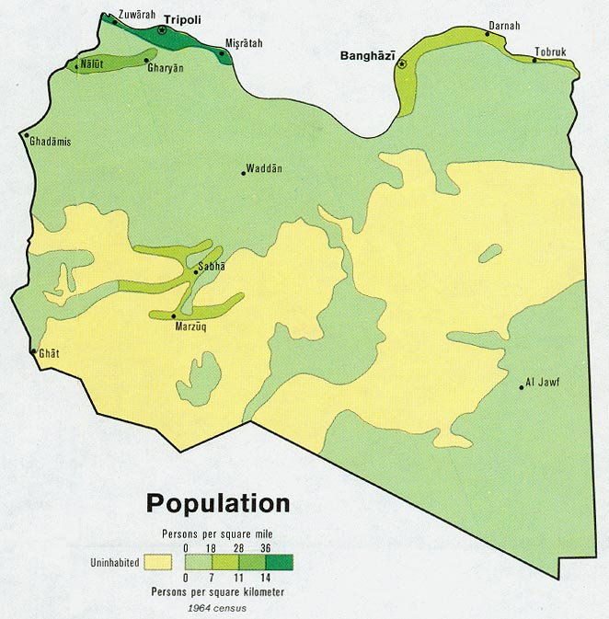
This figure shows the population range throughout the country.
Sources: University of Texas Library and/or the U.S. Central Intelligence Agency (CIA)

Figure 4
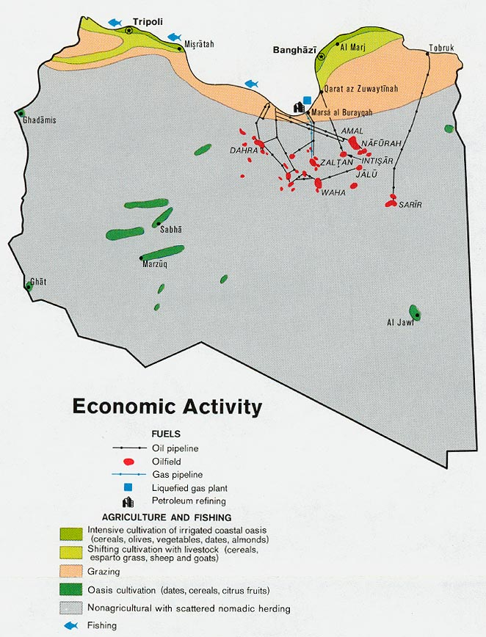
This figure shows the economic activity of the country. This shows the agricultural regions and industrial areas as well. The natural resources are also included.
Sources: University of Texas Library and/or the U.S. Central Intelligence Agency (CIA)
Figure 5
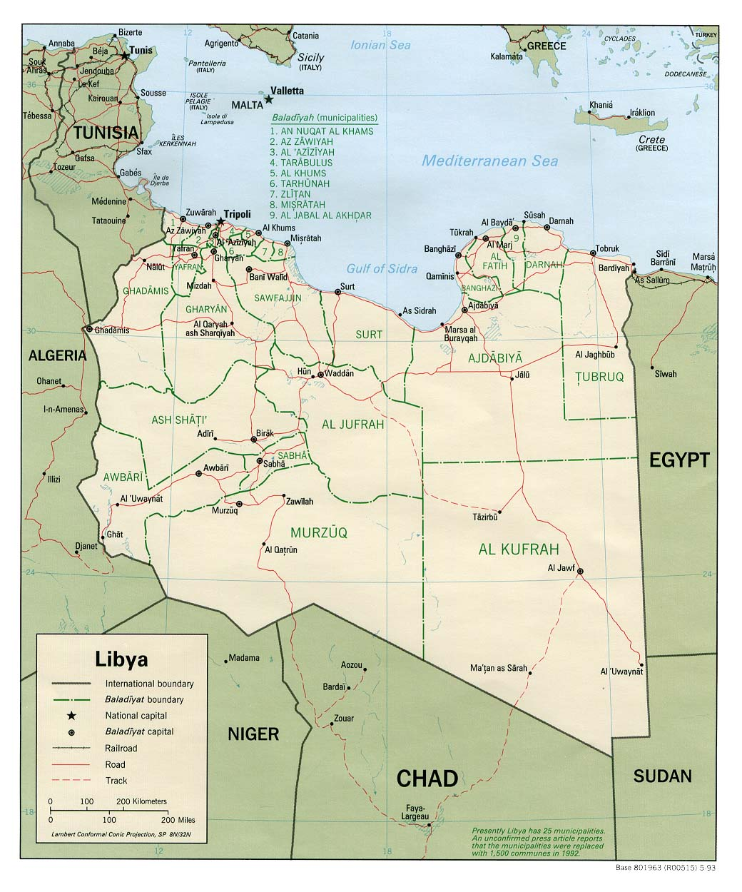This figure shows the transportation routes throughout the country.

Sources: University of Texas Library and/or the U.S. Central Intelligence Agency (CIA)

Figure 6
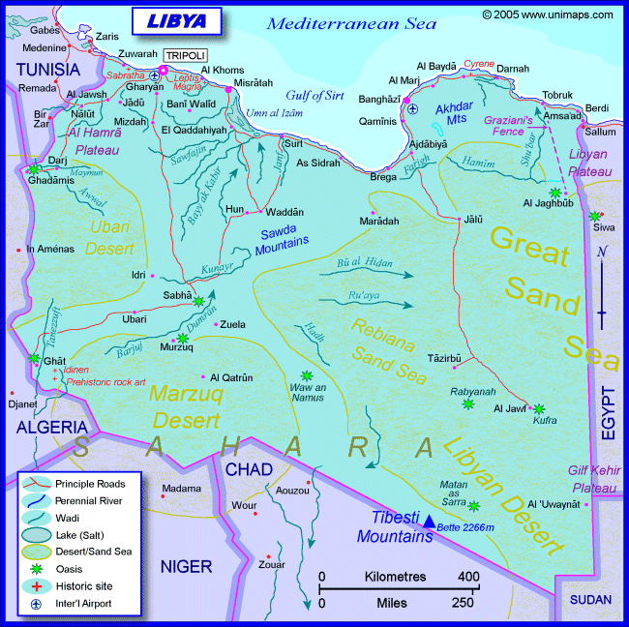
This is a thematic map of Libya that indicates different regions in the country. Also shows political, major cities, country capital city, major river systems, major deserts and major lakes.
Source: Maps and Information ©2005 UniMaps.com

Bibliography

Data Finder.Population Reference Bureau 2009. Last visted on November 24, 2009 .http://prb.org/DataFinder.aspx

Factbook. Central Intellegence Agency. 2009. Last visited on November 24, 2009. https://www.cia.gov/library/publications/the-world-factbook/rankorder/rankorderguide.html

Gavin, James. "Libya: gearing up for the post-sanctions era." MEED Middle East Economic Digest 43.15 (1999): 10. Academic OneFile. Web. 24 Nov. 2009.

Maps and Information ©2005 UniMaps.com Last visited on November 24, 2009

QFinance. Bloomsbury Information Ltd. 2009, Last visited on November 23, 2009. http://www.qfinance.com/country-profiles/libya

Stategov. U.S. Department of State. Bureau of Near Eastern Affairs. March 2009. Last visited on November 23, 2009. http://www.state.gov/r/pa/ei/bgn/5425.htm

Timewell, Stephen. "In from the cold: Libya: From isolation to integration." The Banker (2009). Academic OneFile. Web. 22 Nov. 2009. <http://ezproxy.una.edu:2053/gtx/start.do?prodId=AONE&userGroupName=naal_una>.

Timewell, Stephen. "Growth beyond oil: Libya: From isolation to integration." The Banker (2009). Academic OneFile. Web. 23 Nov. 2009.
<http://ezproxy.una.edu:2053/gtx/start.do?prodId=AONE&userGroupName=naal_una>.

University of Texas Library and/or the U.S. Central Intelligence Agency (CIA) Last visited on November 24, 2009.

Werenfels, Isabelle. “Libya: From Colony to Independence.” Middle East Journal; Spring2009, Vol. 63 Issue 2, p337-338, 2p

