Report on the Findings of the

Arizona Physician Survey on

Health System Reform

Sponsored by
XXXX

Conducted by

The Institute for Social Science Research

at Arizona State University

October 2007

Introduction
During summer 2007, the Institute for Social Science Research at Arizona State University conducted a mail and web survey of physicians who are licensed to practice medicine in Arizona on the topic of healthcare system reform. The survey also included questions about community involvement and the use of computers and electronic medical records.

Overall, the survey found that most Arizona physicians – both medical doctors and doctors of osteopathy – consider the current health system flawed but they disagree on how to reform it. The disagreement largely hinges on what role government should play in healthcare. Some physicians prefer that the government stay out of healthcare, many advocate tax incentives, and others favor a single-payer national or statewide healthcare system.

In response to a general question about the overall condition of Arizona’s healthcare system, seven in ten physicians (69 percent) said that “there are some good things about our healthcare system, but significant changes are needed” and 19 percent indicated that “the health system has so much wrong with it that we need to completely restructure it.” Only 11 percent opined that Arizona’s health system works “pretty well, and only minor changes are needed to make it work better.”

Moreover, when asked to rank five health system reform options from one to five with one indicating the respondents’ first choices and five indicating their last choices, only 9 percent said that “maintaining the current system” was their first choice while 36 percent gave that option as their last choice.

Other than tax incentives, there is little agreement among physicians on how to reform the healthcare system. Presented with 10 proposals to reform the system and asked to rank them on a scale of one to 10 with one indicating strong opposition to the proposal and 10 indicating strong support for it, the highest ranked proposal received a mean ranking of 7.5 and it advocated expanding current tax incentives to employers to offer insurance to more employees and their families.

A national health plan that provides coverage for all Americans received lukewarm support. Among the 10 proposals to reform the healthcare system, that proposal rated a mean of 5.1, the lowest rating, and it tied with “create a quasi-governmental statewide health plan which would provide health insurance coverage for all Arizonans.”

This option, however, has more support than maintaining the current system. Among the five options that respondents were asked to rank as their first choice, second choice and so on, maintaining the current system was ranked fifth or last by 36 percent, as mentioned previously. In comparison, 25 percent ranked “create a system of ‘Medicare for all’” fifth or last. Additionally, 31 percent of physicians rated that option either their first or second choice; only 17 percent ranked “maintain the current system” as their top two choices out of the five presented.

None of the five choices, however, was ranked first by a majority of physicians. In fact, the option that received the most first choices was “expand eligibility of existing public insurance programs” at 23 percent.

Additional survey findings include:
- Physicians are almost evenly split on issues pertaining to healthcare overall. When choosing between dichotomous statements, 43 percent chose “Everybody is entitled to the same level of healthcare” while 47 percent selected “Medical care is like anything else you buy – those who can pay more should be able to get something better.”
- In another question that involved choosing from among two statements, about a quarter (27 percent) chose “People have the responsibility to be prepared for the high cost of serious illness or injury” compared to 62 percent who chose “No one should be forced into financial ruin because of high medical expenses.”
- Views on healthcare system reform tend to differ primarily by political affiliation and age.
- In an open-ended question in which respondents were asked to provide comments about healthcare system reform in their own words, the most common comments dealt with the need for tort reform and concerns about the role and profits being made by insurance companies.
- The use of computers in physicians’ practices is limited. Sixteen percent of respondents said they communicate with patients via email “always,” “frequently” or “occasionally.” And although 34 percent of physicians indicated that they always utilize an on-line billing or claims processing system, 29 percent “never” use an on-line system.
- Physicians, however, largely agree that the use of electronic medical records can “significantly decrease the frequency of medical errors.” Fully 73 percent either “strongly” or “somewhat” agrees with that statement.
- Widespread agreement exists that physicians should advocate for direct social and economic influences on health such obesity, nutrition and tobacco control with 93 percent of respondents saying that it is “very” or “somewhat important” for doctors to advocate for those issues.
- Only 13 percent of respondents said that they have “frequently” been politically active in health related matters in the past several years whereas 59 percent indicated that they “frequently” or “occasionally” had spoken with their patients to influence their opinions about the healthcare system.

These and other findings are discussed in more detail in this report. Results from by various demographic indicators such as gender, age, income, specialty and so forth are provided when a significant difference exists. Quotes are provided throughout the report were responses to an open-ended question in which physicians were invited to comment about health system reform in their own words. A section on methodology is provided at the end of the report.

General Views on Healthcare
Physicians are divided on whether everyone should be entitled to the same level of healthcare and whether healthcare should be treated like any other public good. More agreement, however, exists about financial responsibility for serious illnesses and tax incentives.

Respondents were given four sets of dichotomous statements regarding healthcare and asked to choose which one was closest to their views. In one set of dichotomous statements, 43 percent chose “everybody is entitled to the same level of healthcare” and 47 percent selected “medical care is like anything else you buy – those who can pay more should be able to get something better.”

Answers to this question vary primarily by political affiliation and gender. Few differences exist among age groups, specialties or whether a physician practices in an urban or rural setting. However, about a third (34 percent) of physicians who are Republican or are leaning Republican chose the statement “everybody is entitled to the same level of healthcare” compared to two-thirds (65 percent) of Democrats or those leaning Democratic. Nearly half (48 percent) of those who said they have no political preference selected that statement.

Although the differences are not as pronounced as with political affiliation, men and women also answered the question somewhat differently. Fully 45 percent of men said everybody is entitled to the same level of healthcare compared to 57 percent of women. (See Figure 1.)

“[A] basic level of healthcare should be available to all but those who wish to purchase [a] higher level of care should be free to do so.”
-- Survey respondent

“Healthcare like education is a human right. Every citizen should have equal access to the best healthcare. This should not be dictated by insurance companies which limit care, restrict where and who you can see and are driven by profit.” -- Survey respondent

Figure 1: Levels of Healthcare
Question: There are many opinions about the pros and cons of options for improving the healthcare system. A few of them are provided below. For each set of statements, please indicate which one comes closest to your point of view… Everybody is entitled to the same level of healthcare; OR Medical care is like anything else you buy – those who can pay more should be able to get something better.
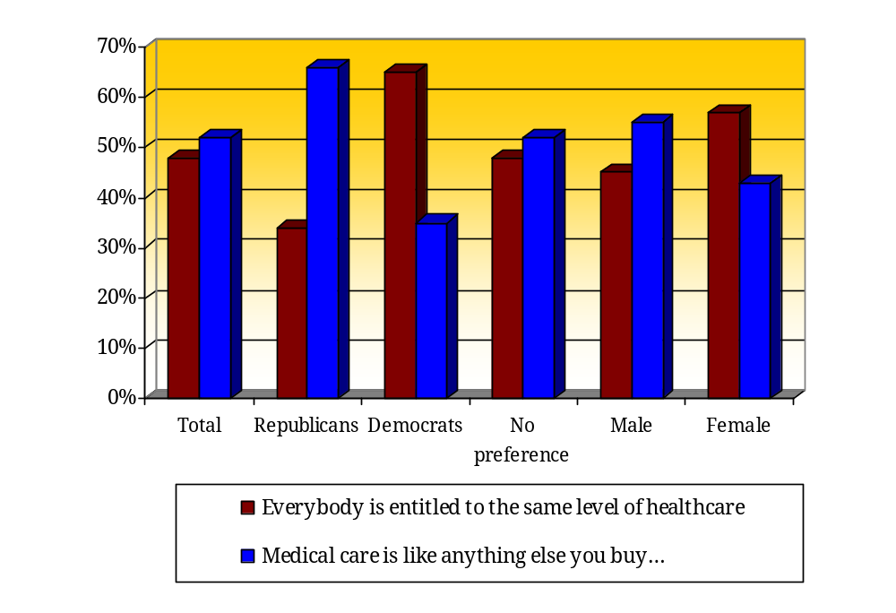
In another pair of dichotomous statements, the results were again almost evenly split. Respondents were asked to choose which statement came closer to their point of view:
- Just like electricity, water or public education, we should ensure that all Arizonans have access to healthcare. Healthcare should be treated like any other public good: paid for by all residents, managed for the benefit of all residents and accessible to all residents. OR
- What we need in healthcare reform is to use the power of consumer spending to ensure that people get the health insurance they need. If people were directly responsible for buying their own insurance, the free market would result in insurers developing products to meet consumers’ expectations.

Fully 43 percent chose “a” and 47 percent chose “b.” Responses varied according to political affiliation, gender, and type of physician (i.e. MD or DO). Only 29 percent of physicians who are Republican (including leaners) chose statement “a” compared to 76 percent of Democrats (including leaners). Among males, 46 percent selected “a” as did 56 percent of females. And, 50 percent of medical doctors (MDs) opted for “a” whereas 40 percent of doctors of osteopathy (DOs) gave that answer. (See Figure 2.)

“Put the money back in patients’ hands and allow the free market to work. No government program will be successful… Just look to the past. Has the government ever done anything under budget, not wasteful and current?” -- Survey respondent

“Since healthcare is not a simple good or service like others, leaving it to the free market system unchecked won’t work.” -- Survey respondent

Figure 2: Access to Healthcare
Question: There are many opinions about the pros and cons of options for improving the healthcare system. A few of them are provided below. For each set of statements, please indicate which one comes closest to your point of view… Just like electricity, water or public education, we should ensure that all Arizonans have access to healthcare. Healthcare should be treated like any other public good: paid for by all residents, managed for the benefit of all residents and accessible to all residents. OR What we need in healthcare reform is to use the power of consumer spending to ensure that people get the health insurance they need. If people were directly responsible for buying their own insurance, the free market would result in insurers developing products to meet consumers’ expectations.
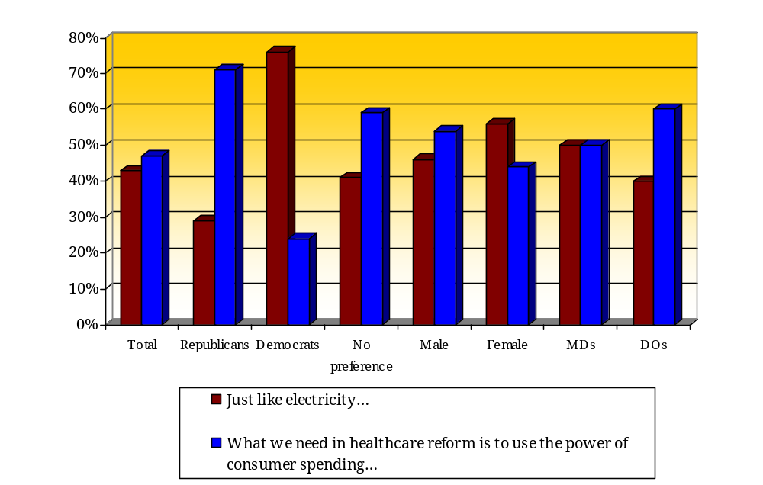
The other two dichotomous statements produced more agreement among physicians. About six in ten (62 percent) selected “No one should be forced into financial ruin because of high medical expenses” compared to only 27 percent who chose “People have the responsibility to be prepared for the high cost of serious illness or injury”

Results, however, vary according to age, gender and political affiliation. Younger physicians – those ages 45 and younger – chose the first statement in the paragraph above more frequently than older physicians; 39 percent of physicians in that age group selected the first statement compared to 28 percent ages 46 to 60 and 23 percent of those ages 61 and older. Among males, 33 percent chose the first statement; 23 percent of females gave that answer. And 41 percent of Republicans selected the first statement whereas only 17 percent of Democrats did so. (See Figure 3.)

Figure 3: Financial Responsibility for Healthcare
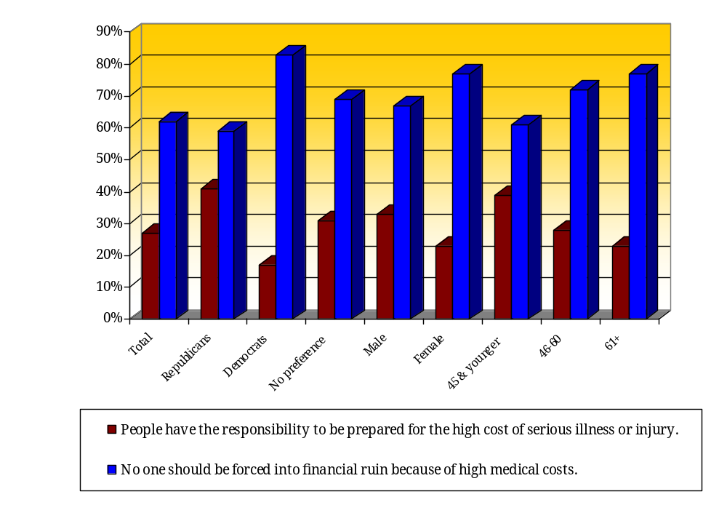Question: There are many opinions about the pros and cons of options for improving the healthcare system. A few of them are provided below. For each set of statements, please indicate which one comes closest to your point of view… People have the responsibility to be prepared for the high cost of serious illness or injury OR No one should be forced into financial ruin because of high medical costs.

“All individuals have a right in society to basic healthcare whichever way provided and protect[ion] from catastrophic health events.”
-- Survey respondent

“Americans need to take more responsibility and stop relying on the government to pay for their poor decisions.” -- Survey respondent

Results were similar in another pair of dichotomous statements that deal with government involvement in the healthcare system. Three in ten (28 percent) physicians said that the following statement comes closest to their views: “To help lower the cost of healthcare, the government should deal directly with insurers, hospitals and doctors to establish standardized fee schedules or other limits on what they can charge.” On the other hand, more than half (56 percent) selected the statement, “To help lower the cost of healthcare, the government should give consumers tax incentives to buy health plans with high deductibles and co-payments, and encourage them to shop for the best value based on comparisons of price and quality among hospitals and doctors.”

Answers to this question varied by gender and political affiliation. Nearly five in ten women (46 percent) chose the first statement above compared to only 30 percent of men. And, 58 percent of Democrats selected the first statement but only 17 percent of Republicans did so. (See Figure 4.)

“None of us can afford all the different medical and dental services that are available. Health savings accounts allow people to pick what coverage they want and for what price. Government should get out of healthcare provision and stick only to licensing and certification. Between obesity and smoking you have roundly neglected the incredible burden on healthcare done by idiotic patients. You smoke? I don’t care about your problems. 100 pounds overweight? Uninsurable. If people don’t take care of themselves first, why should you and I worry about it? Get real!” -- Survey respondent

“Healthcare cannot be reduced to business models.” -- Survey respondent

Figure 4: How to Lower Healthcare Costs
Question: There are many opinions about the pros and cons of options for improving the healthcare system. A few of them are provided below. For each set of statements, please indicate which one comes closest to your point of view… To help lower the cost of healthcare, the government should deal directly with insurers, hospitals and doctors to establish standardized fee schedules or other limits on what they can charge. OR To help lower the cost of healthcare, the government should give consumers tax incentives to buy health plans with high deductibles and co-payments, and encourage them to shop for the best value based on comparisons of price and quality among hospitals and doctors.
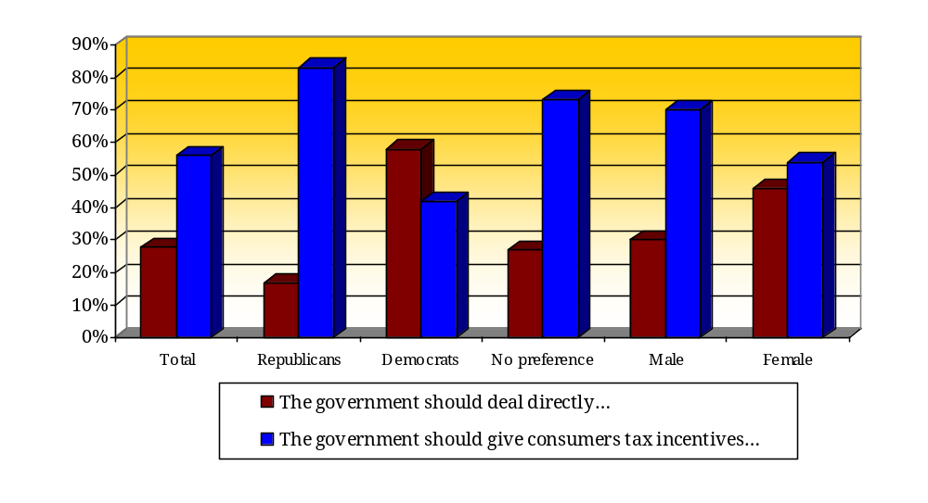
“The fragmented US healthcare system is inequitable and wasteful of resources. We should join the rest of the civilized world and make healthcare available to all. Private practice no longer exists anyway. No use pretending it does. Resistance to national healthcare is creating suffering all around.” -- Survey respondent

The Need for Change in the Healthcare System
Physicians widely agree that substantial change in the healthcare system is needed. Respondents were given three response choices regarding the need for change ranging from the need for minor changes, significant changes or a complete overhaul. Almost seven in ten physicians (69 percent) indicated that “There are some good things in our healthcare system, but significant changes are needed to make it work better.” Only 11 percent chose the following response: “The healthcare system in Arizona works pretty well, and only minor changes are needed to make it work better.” And 19 percent said that “the healthcare system has so much wrong with it that we need to completely restructure it.”

“Most MD’s I associate with are very dissatisfied with the state operated insurance plans. Most of these plans deny payment for a multitude of reasons, all loopholes so that MD’s don’t get their rightful payments and reimbursements. The system should be eradicated and start from scratch.”
-- Survey respondent

Responses to this question primarily vary by political affiliation. Among Democrats, 27 percent indicated that the healthcare system needs to be restructured compared to 12 percent of Republicans. (See Figure 5.)

Figure 5: Assessments of the Amount of Change Needed in the Healthcare System
Question: Which of the following is closest to your opinion about the healthcare system in Arizona… The healthcare system in Arizona works pretty well, and only minor changes are needed to make it work better. OR There are some good things in our healthcare system, but significant changes are needed to make it work better. OR The healthcare system has so much wrong with it that we need to completely restructure it.
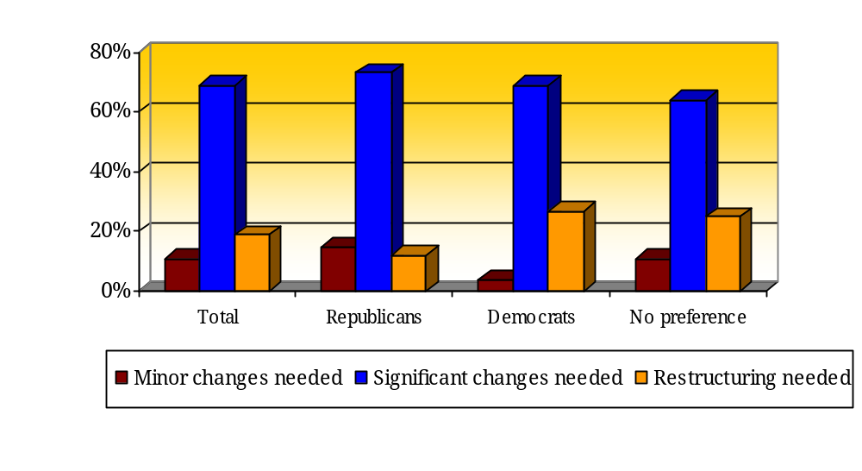
“The healthcare system, that is hospitals, doctors, nurses, etc., works better here than anywhere. It’s the healthcare financing system that is broken and so fundamentally flawed that it can’t be repaired the way it is.” -- Survey respondent

“I would not like to see healthcare directed by a government agency as we may see a FEMA debacle over and over again.” -- Survey respondent

A slight majority of physicians said they have little if any familiarity with current healthcare system reform measures. Nearly five in ten physicians (45 percent) said they are either very or somewhat familiar with current reform measures; 56 percent said they are not too familiar or not familiar at all with the measures. (See Figure 6.)

Interestingly, the more familiarity with reform options, the more likely the respondent is to say that complete restructuring is needed. Among those who are very familiar with the measures, 38 percent said the healthcare system needs complete restructuring compared to 10 percent who are not familiar at all with the measures. (See Figure 7.)

Figure 6: Familiarity with Current Healthcare System Reform Measures
Question: In general, how familiar are you with current health system reform measures that are being discussed by Arizona policymakers?
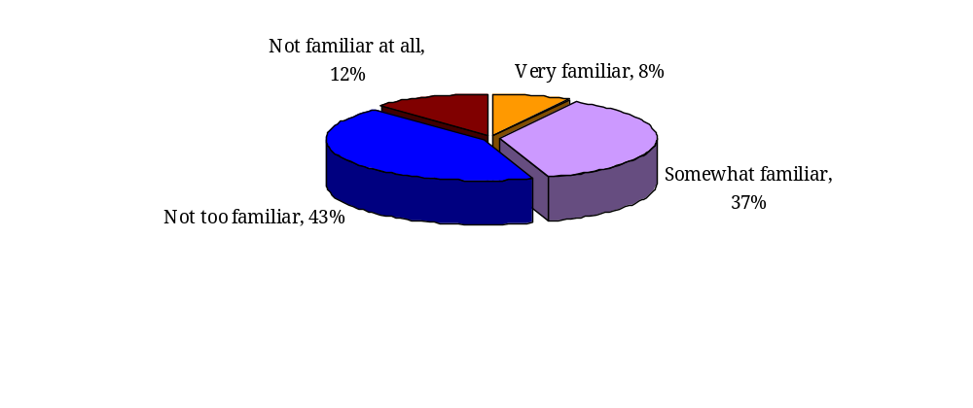

Figure 7: Familiarity with Reform Measures & Assessments of the Need for Change
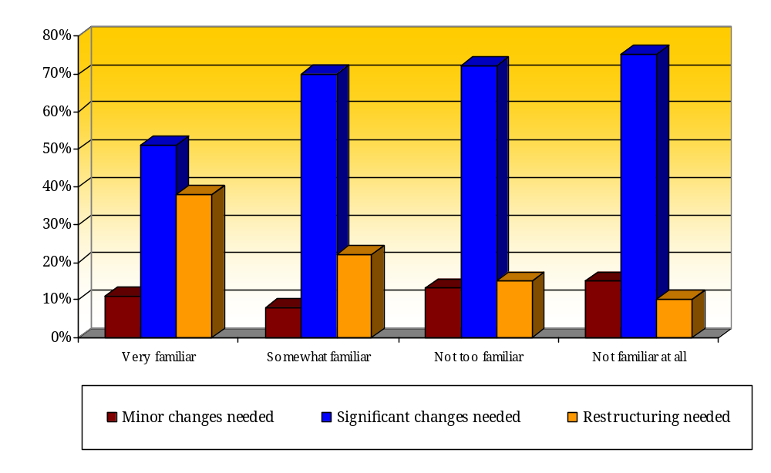

Opinions on Healthcare System Reform Options
Physicians were asked to rank five general healthcare system reform options from the one they preferred the most to the one they preferred the least. “Expand eligibility for existing public insurance programs” was the most preferred option with 48 percent of respondents choosing it as their first or second choice. “Maintain the current system” received the least support with 52 percent giving it their lowest or fifth priority. (See Figure 8.)

Figure 8: Rankings of Five Healthcare System Reform Options
Question: Please rank the following general health system reform options using a scale of 1 to 5 with 1 indicating the option you favor the most and 5 indicating the option you prefer the least. Each option should have a different number from 1 through 5. (a) Create an employer “pay or play” mandate (b) Establish a mandate requiring all individuals to purchase health insurance (c) Expand eligibility for existing public insurance programs (d) Create a system of “Medicare for all” (e) Maintain the current system.
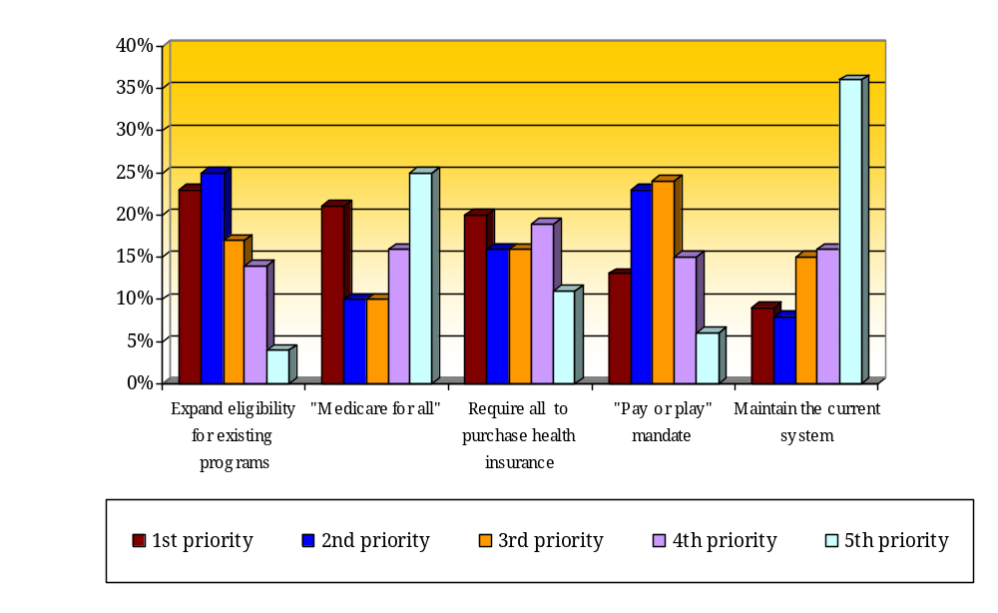
Answers to the ranking question vary primarily by age and political affiliation with Democrats and older physicians more supportive of a “Medicare for all” system and Republicans and younger physicians more apt to prefer to “maintain the current system.” (See Figures 9 and 10.)

Figure 9: “Medicare for All” Rankings by Age and Political Affiliation

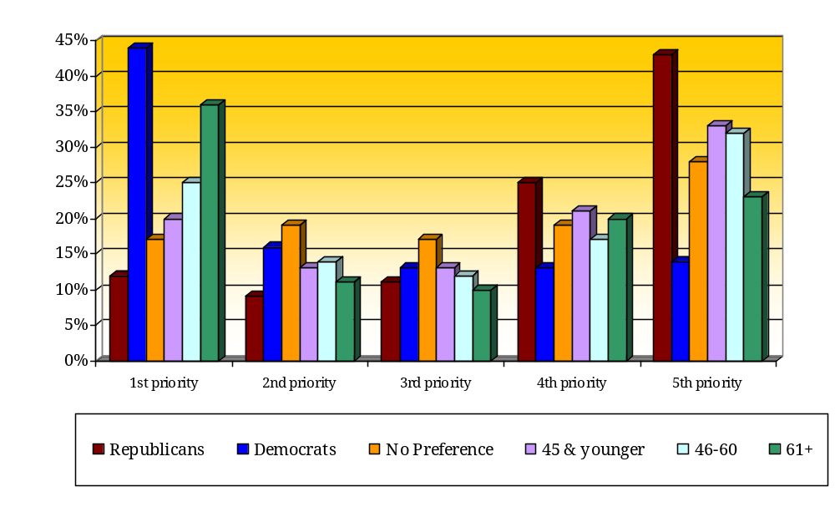

Figure 10: “Maintain the Current System” Rankings by Age and Political Affiliation
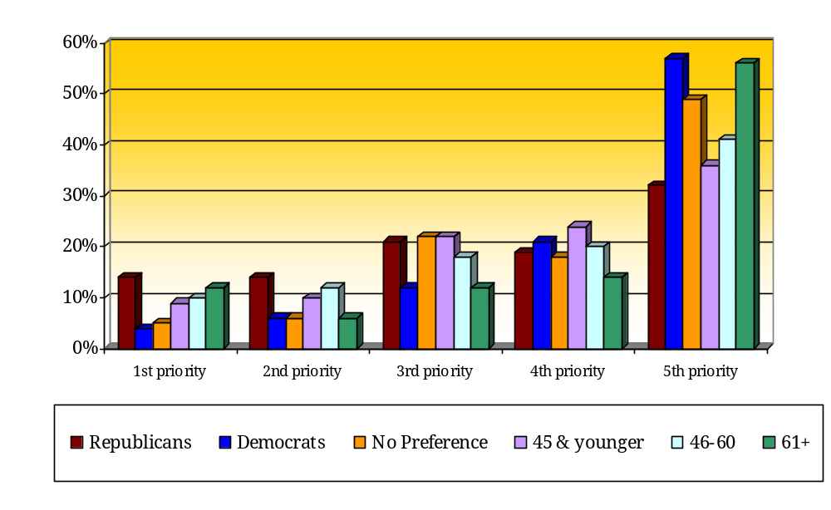

Next, respondents were asked to rate 10 specific healthcare system reform measures using a scale of one to 10 with one indicating strong opposition and 10 indicating strong support. Means or averages were calculated. Measures involving tax incentives rated the highest while a national health plan and a statewide quasi-governmental health plan rated the lowest. (See Figure 11.)

Figure 11: Ratings of Specific Healthcare System Reform Measures
(Mean scores on a 1 to 10 scale)
Question: Several measures to change Arizona’s healthcare system have been proposed. A few of these measures are summarized below. Please indicate whether you personally support or oppose each measure using a scale of 1 to 10, where 1 means you strongly oppose the measure and 10 means you strongly support it. (a) Offer uninsured Arizonans income tax deductions, credits or other financial assistance to help them purchase private health insurance of their own. (b) Provide coverage to more uninsured Arizonans by expanding state government programs, such as AHCCCS or KidsCare. (c) Create a quasi-governmental statewide health plan which would provide health insurance coverage for all Arizonans. (d) Open up enrollment in national federal programs like Medicare or the Federal Employees’ Health Benefits Plan. (e) Require all businesses to offer health insurance to their employees. (f) Expand neighborhood clinics. (g) Create a taxpayer-financed, national health plan from which all Americans would get their health insurance. (h) Require that all Arizonans obtain basic health insurance coverage, either public or private. (i) Increase states’ flexibility to use federal funds (such as AHCCCS and KidsCare) to maximize coverage. (j) Encourage more employers to offer insurance to more workers and their families by expanding current tax incentives available to them.

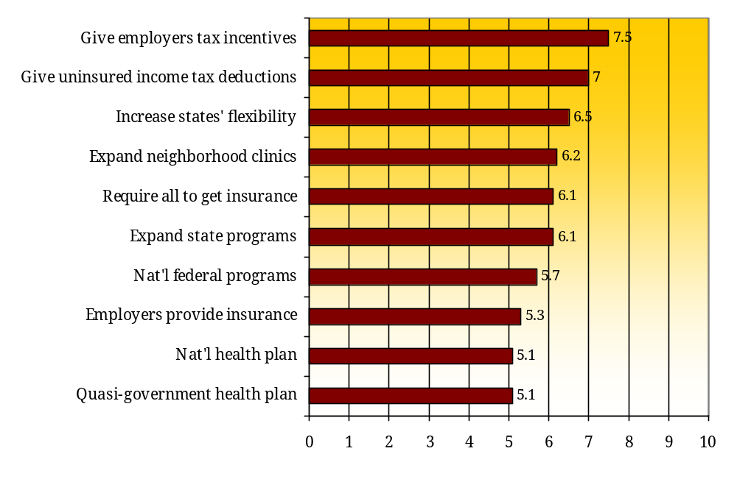
“Tax credits. Who are you kidding? Most Arizonans have trouble finding a decent job and wage.” -- Survey respondent

As in similar previous questions, answers to this set of reform options vary primarily by political affiliation. Republicans tend to endorse tax incentives and requiring all to obtain insurance while Democrats are more likely to favor expanding state programs, increasing states’ flexibility and a national health plan. (See Figure 12.)

Figure 11: Ratings of Specific Healthcare System Reform Measures

by Political Affiliation
(Mean scores on a 1 to 10 scale)
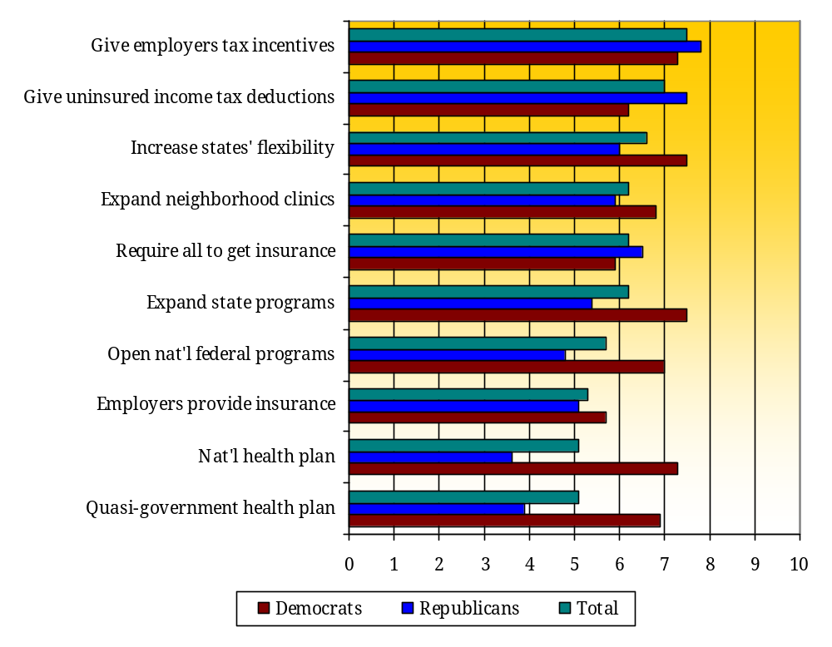

“All of the above options would help, but many of them place undue burdens on poor and middle-class people.” -- Survey respondent

“Being a Canadian-trained MD, all I can say is socialized medicine doesn’t work. Try long wait lists for tests. Try 52 percent taxes on $60,000.” -- Survey respondent

“Get rid of the insurance industry. It is an immoral system. Insurance should not be tied to employment.” -- Survey respondent

“We are the only professional group in the US living in an isolated Socialist economy thanks to the mafia like tactics of third party payers; we have no (or little) control over our reimbursements. Doctors are bitter and resentful -- yet too overwhelmed by daily responsibilities to challenge the system.” -- Survey respondent

Use of Computers and Electronic Record Keeping
In general, physicians have been somewhat slow to adopt new technology to their practices. The majority of physicians either “rarely” or “never” communicates with patients using email (84 percent), orders diagnostic tests through a computerized system (67 percent), or maintains or utilizes electronic medical records for patients (52 percent). The most common use of electronics among physicians is on-line billing or claims processing systems with 57 percent of respondents saying they always or frequently use it. Nonetheless, more than a third (37 percent) either rarely or never use on-line billing or claims systems. (See Figure 12.)

Although some physicians communicate with each other using email, many do not. A quarter (25 percent) always or frequently communicate with email to other clinicians while nearly half (49 percent) rarely or never email other physicians. Age is not an important factor in whether physicians email patients but it is a factor when emailing each other. Three in ten physicians (30 percent) ages 45 and younger either always or frequently communicates with colleagues via email; only 19 percent of physicians age 61 or older do so.

Additionally, physicians are far from united in agreeing on the usefulness of electronic medical records with majorities saying that such records decrease medical errors and reduce the number of redundant or unnecessary tests and procedures. Although three-quarters (75 percent) of physicians said they either strongly or somewhat agree that using electronic medical records can significantly decrease the frequency of medical errors, barely half (54 percent) agree that electronic medical records reduce healthcare costs. Further, physicians are almost even split over whether electronic medical records more it more difficult to ensure patients’ privacy with 54 percent agreeing with the statement, “The use of electronic medical records makes it more difficult to ensure patients’ privacy” and 46 percent disagreeing. (See Figure 13.)

Views on this topic vary by age with younger physicians more likely to embrace electronic medical records. For example, 36 percent of physicians ages 45 and younger said they strongly agree that electronic medical records can significantly decrease medical errors compared to 21 percent among those ages 61 and older. And nearly a quarter (24 percent) of younger doctors (age 45 and younger) strongly agree that electronic medical records can significantly reduce healthcare costs whereas only 12 percent of those ages 46-60 gave that answer as did only 14 percent of physicians ages 61 and older.
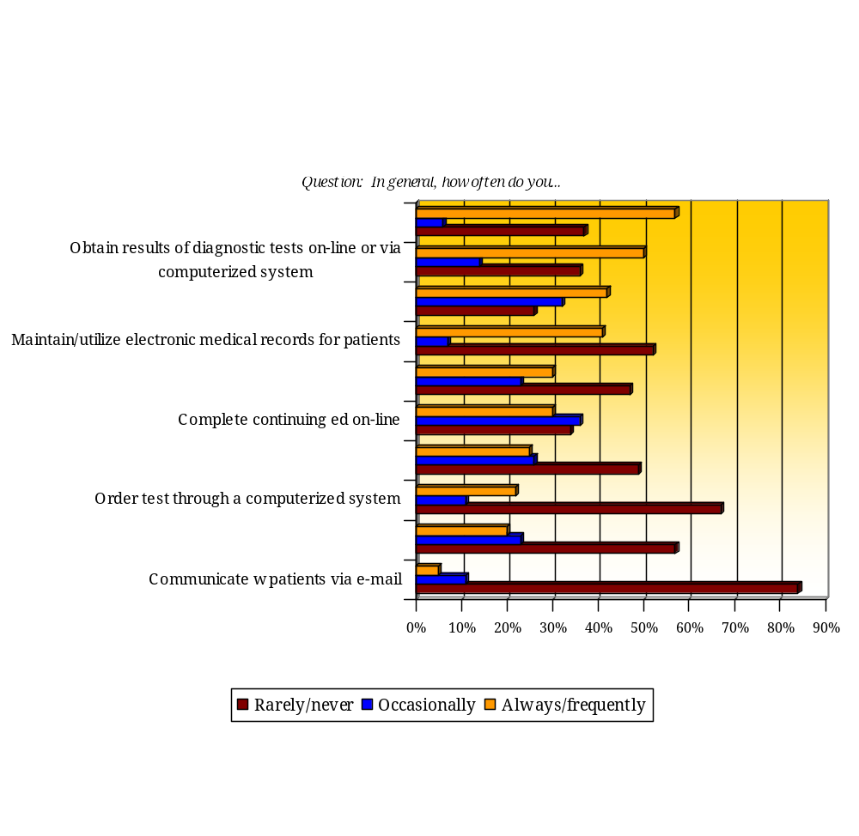

Figure 13: Usefulness of Electronic Medical Records
Question: Please indicate whether you agree or disagree with each statement. The use of electronic medical records…
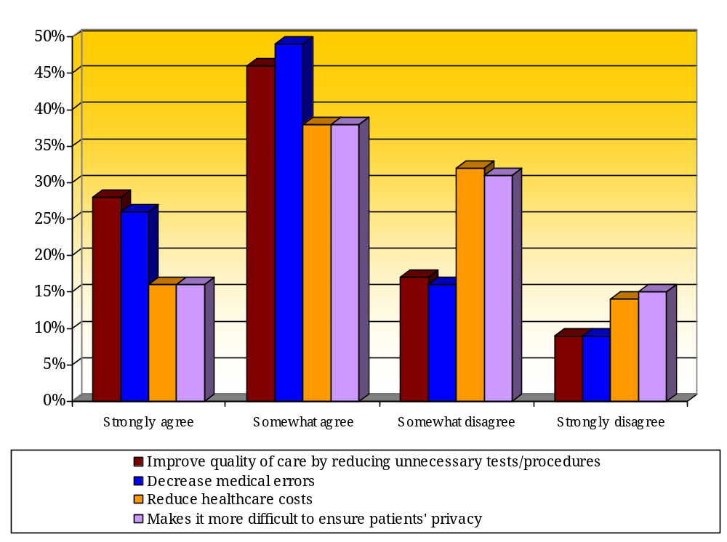

The Importance of Advocacy among Arizona Physicians
Physicians largely agree that they should advocate for healthcare issues. Not surprisingly, the vast majority of physicians said it is either very or somewhat important (81 percent and 17 percent, respectively) for physicians, either individually or collectively, to advocate for an individual patient’s care. Most physicians also agree that it is important to advocate for access to healthcare services (53 percent said very important and 41 percent said somewhat important) and direct social and economic influences on health such as reductions in obesity, air pollution and tobacco control (65 said very important and 30 percent said somewhat important).

Less but nonetheless substantial agreement exists on the importance of advocating for indirect social and economic influences on health such as reducing unemployment or increasing minimum wage. Only 30 percent indicated that advocating for indirect social and economic influences was very important; 46 percent said it was somewhat important. (See Figure 14.)

Views on advocacy are consistent across demographic groups although some differences in opinion emerge by age group and political affiliation. Older physicians, ages 61 and older, tend to consider advocacy as more important than their younger counterparts. For example, 62 percent of those at least age 61 said that advocating for access to healthcare services is very important compared to 51 percent of those ages 60 and younger. And, 62 percent of Democrats consider such advocacy to be very important while only 47 percent of Republicans agreed.

Figure 13: The Importance of Advocacy
Question: How important is it that physicians, individually or collectively, advocate for the following…
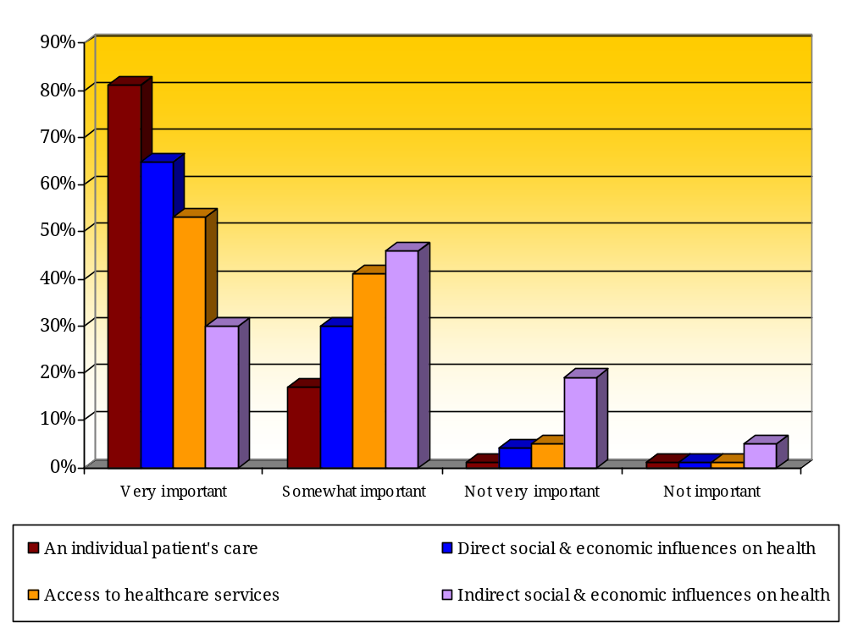

Pluralities of physicians have occasionally advocated for healthcare issues in the past several years. Nearly four in ten (37 percent) physicians indicated that they have occasionally spoken with patients to influence their opinions about the healthcare system; a quarter (25 percent) said they have frequently spoken with patients about the healthcare system. Answers to this question vary little among demographic groups.

More than half (56 percent) of physicians provided health-related expertise to local community organizations in the past several years (14 percent frequently and 42 percent occasionally). Again, answers to this question vary little among demographic groups.

And half (50 percent) of respondents have been politically active in health related matters at the local, state or national levels in the past several years (13 percent frequently and 37 percent occasionally). Older physicians are more likely to have been politically active than younger doctors. Fully 17 percent of physicians ages 61 and older have frequently been politically active compared to 9 percent of those ages 45 and younger. Three in ten (31 percent) younger physicians have never been politically active in the past few years compared to 19 percent of physicians over age 60.

Similarly, 41 percent have encouraged their medical professional societies to address public health or policy issues that are not concerned with physician welfare (10 percent frequently and 31 percent occasionally). Results are similar among demographic groups.

Figure 14: Frequency of Advocacy
Question: How often, if at all, in the past several years have you…
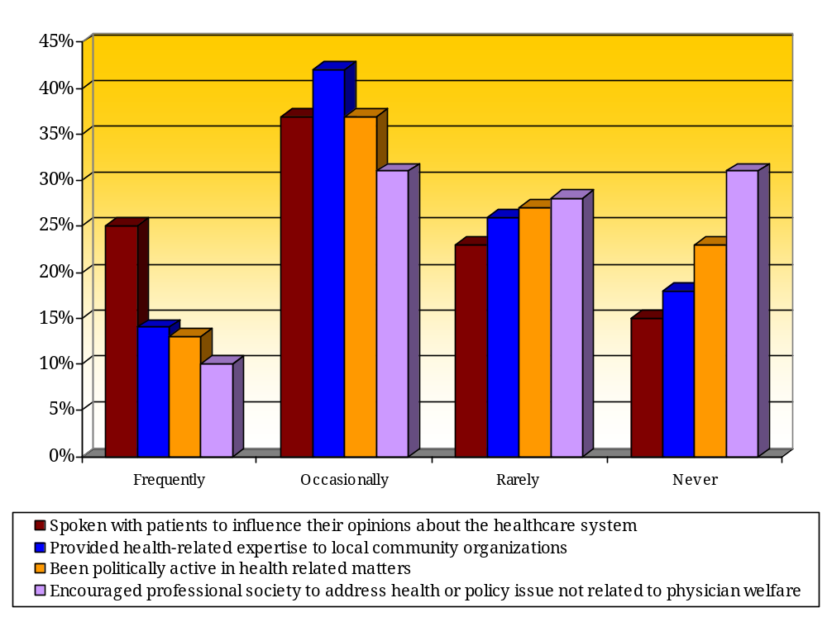

Nevertheless, physicians indicated that it is important for them to be involved in their communities. Fully 64 percent said it is very important for physicians to encourage medical organizations to advocate for the public’s health and another 32 percent said it was somewhat important. Answers varied only slightly among demographic groups.

Almost half (47 percent) consider it very important for be politically involved (other than voting) in health related matters at the local, state and national levels. Another 46 percent said it was somewhat important. Physicians with higher incomes tended to say that political involvement in health issues was very important with 55 percent of those making at least $250,000 annually providing that answer compared to 44 percent of physicians making $200,000 a year or less.

Similar percentages of physicians gave those answers to providing health-related expertise to community organizations. Nearly half (46 percent) said it was very important to be politically involved in health-related matters. Again, older physicians tend to consider this activity more important than younger clinicians. Fully 55 percent of physicians over age 60 said it was very important to share their expertise with community organizations; 42 percent of those ages 45 and younger provided that answer.

Figure 15: The Importance of Community Involvement
Question: Next, how important is it for physicians to…
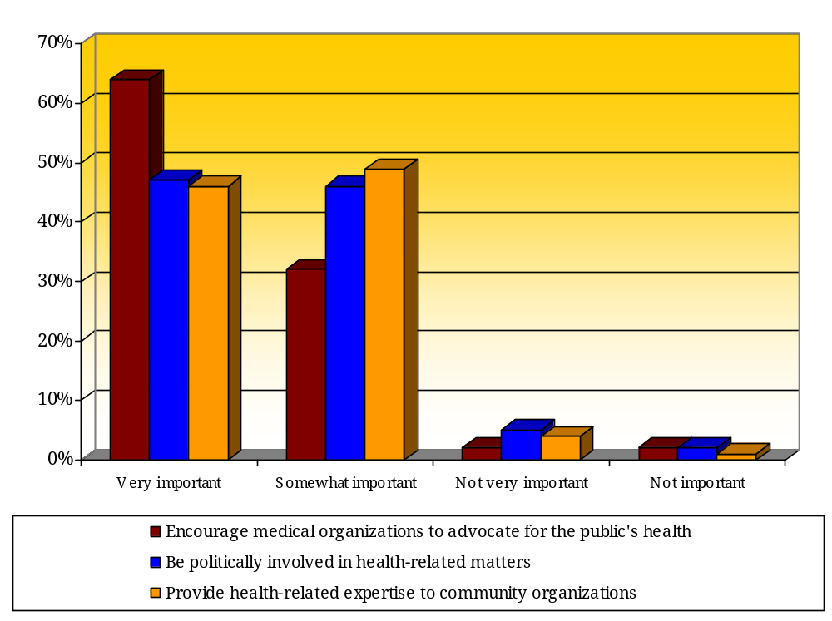

Physicians indicated that they are frequent voters. A large majority – 80 percent – of physicians always vote in national elections, 56 percent always vote in state elections and about a third (34 percent) always vote in local elections. (See Figure 16.)

Older physicians and medical doctors report voting more frequently than others. More than nine in ten (94 percent) of physicians ages 61 and older always vote in national elections compared to 67 percent of those ages 45 and younger. And 82 percent of medical doctors always vote in national elections compared to 74 percent of doctors of osteopathy.

The gap in percents of physicians who said they always vote increases substantially in statewide and local elections. Only 37 percent of physicians ages 45 and younger always vote in statewide elections while 78 percent of the older physicians do so. In local elections, half (50 percent) of physicians older than age 60 always vote compared to 20 percent of the younger doctors.

Figure 16: Voting Habits among Physicians
Question: Understanding that most people do not vote in all elections, how often do you vote in…
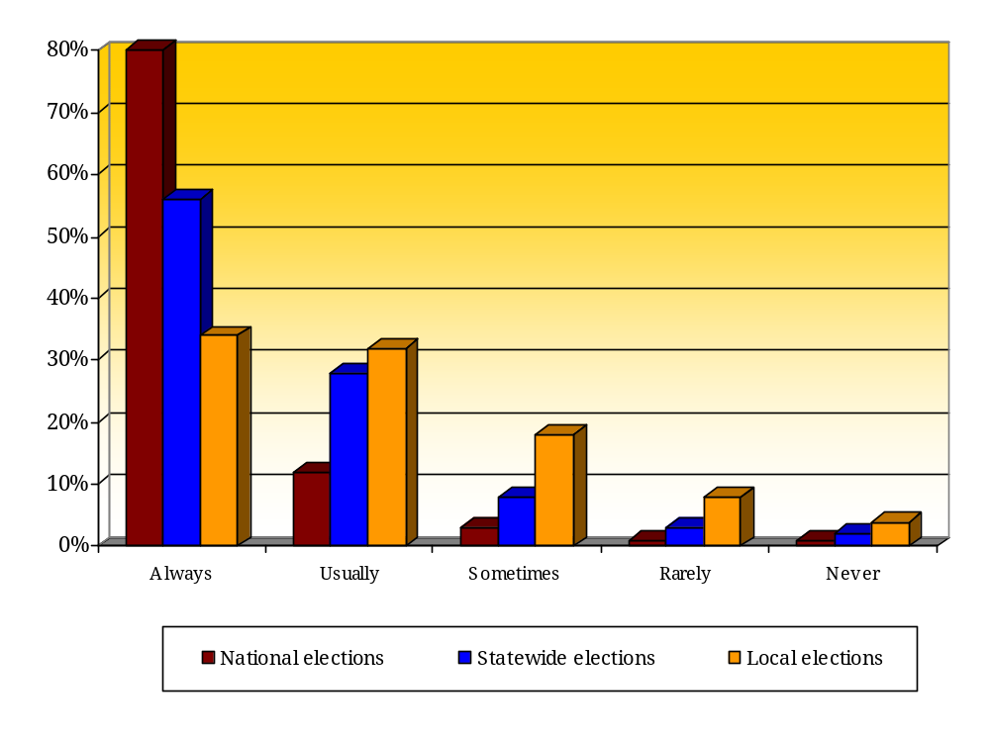

Figure 17: Voting Habits in National Elections among Physicians by Age
Question: Understanding that most people do not vote in all elections, how often do you vote in national elections?
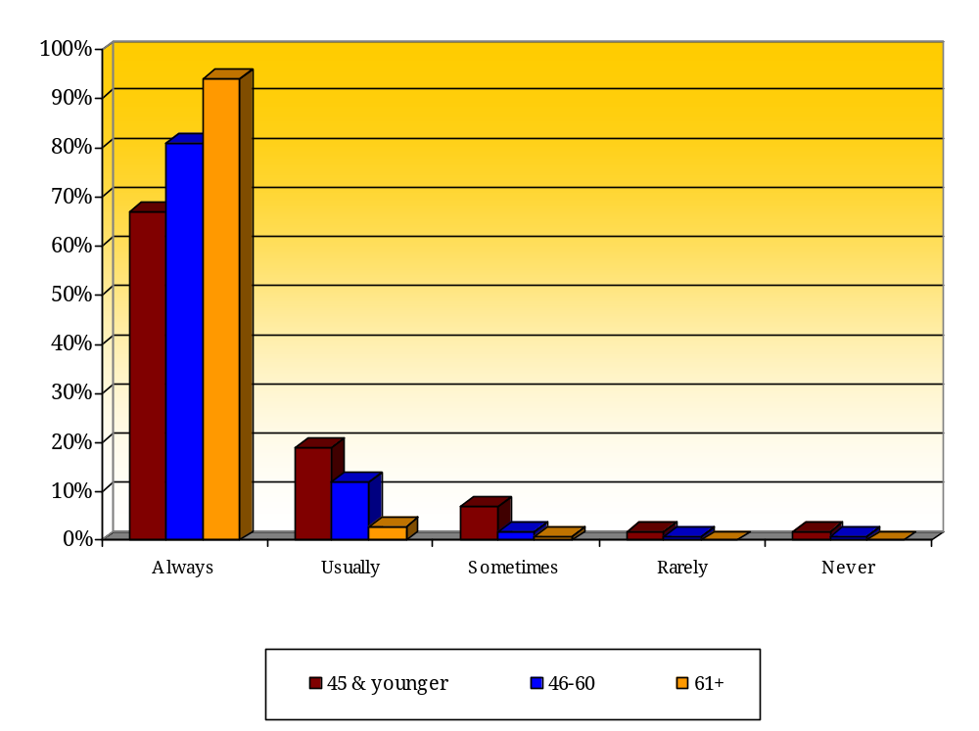

Physicians were also asked about their membership in four types of organizations. The results indicate that most physicians (86 percent) are members of their specialty medical association with 68 percent characterizing their membership as “active” and 18 percent saying they are “currently a member but not active.” (See Figure 18.) Physicians with higher annual incomes tend to belong to a specialty group more than others. Nearly eight in ten (79 percent) of physicians making at least $250,000 annually are active members of a specialty group; 62 percent of those making $200,000 a year or less are active members of a specialty association.

In contrast, 59 percent of respondents are members of a general medical association including 36 percent who are active members and 23 percent who are members but not active. MD’s are much less likely to belong to a general medical association than DO’s. Six in ten (60 percent) DO’s are active members of this type of association compared to only 28 percent of MD’s. Additionally, Republicans are almost twice as likely as Democrats to be active members of a general medical association with 41 percent of Republicans saying they are active members compared to 30 percent of Democrats.

Minorities of physicians are members – active or not – of advocacy or community groups. About four in ten (39 percent) are either active members (23 percent) or members but not active (16 percent) of civic or community organizations such as Kiwanis, Thunderbirds, or homeowners’ associations. More physicians who are Democrats are active members of an advocacy group compared to Republicans. A quarter (25 percent) of Democrats is an active member of such a group; 15 percent of Republicans are active members.

Similarly, 35 percent of respondents reported being members of an advocacy group such as the Sierra Club, AARP or the Arizona Public Health Association. Only 17 percent said they are active members and 18 percent reported being members but not active. Answers to this question vary little by demographic group.

Figure 18: Membership in Organizations
Question: How would you characterize your membership in the following organizations?
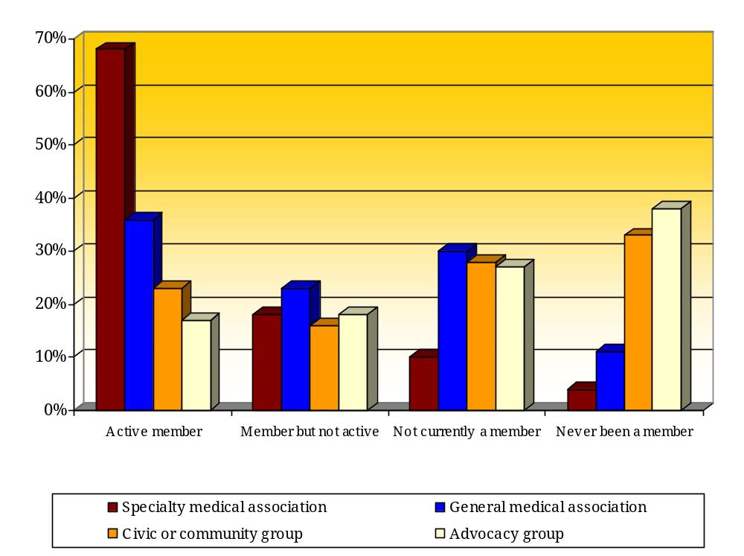

Types of Patients
Respondents were asked what percentages of their patients are insured by Medicare, Medicaid, private or commercial health insurance or are uninsured. Most physicians report that their patients have a variety of insurance types. For example, 28 percent of physicians said their practices include 40 to 60 percent of patients with private or commercial insurance and 21 percent said their practices include 40 to 60 percent of patients with Medicare. Eight in ten (81 percent) indicated that their practices include less than 20 percent of patients who are uninsured. (See Figure 19.)

Figure 19: Percentages of Patients by Insurance Type
Question: To the best of your knowledge, what percentages of your patients are insured primarily by…
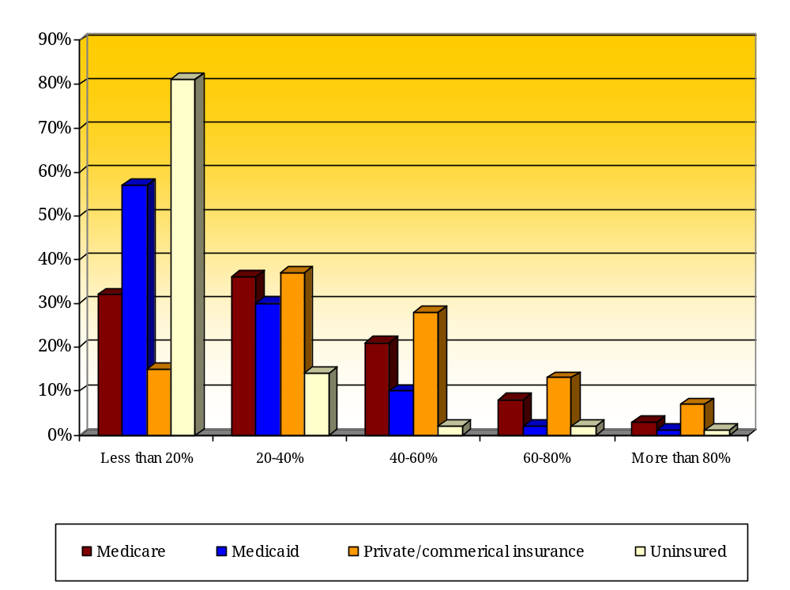

How Physicians Spend Their Professional Time
Most physicians spend most of their time in the office seeing patients. Respondents were asked to identify what percentage of their time is spent in the office seeing patients, in the hospital seeing patients, teaching or precepting, performing administrative activities and doing other patient related activities. More than half (55 percent) of physicians reported spending at least 60 percent of their time in their offices seeing patients. Three-quarters (75 percent) indicated spending less than 20 percent of their time doing administrative activities. (See Figure 20.)

Figure 20: How Physicians Spend Their Professional Time
Question: What percentage of your professional practice time do you spend…
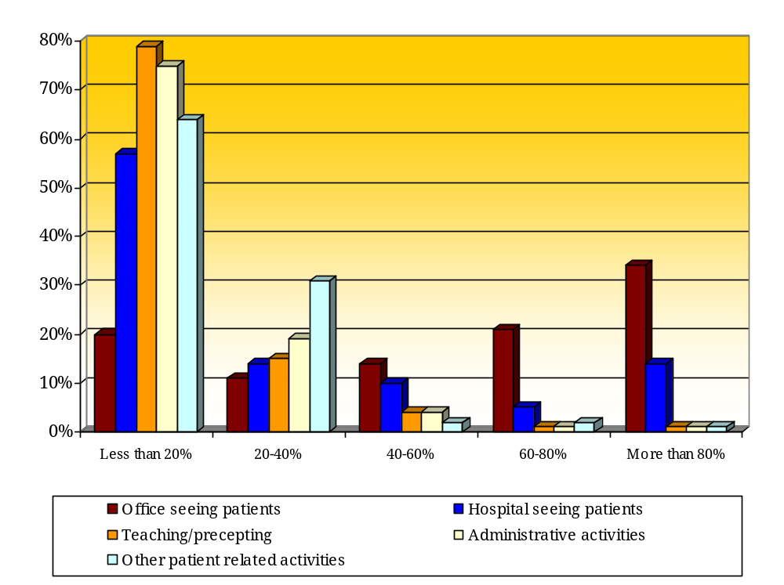

Overview of Respondents
Physicians from 40 areas of medical practice ranging from family practice to cardiology answered the survey. Most physicians reported that they practice medicine in a solo practice (43 percent); only 2 percent said they practice in an HMO. (See Figure 21.)

Figure 21: Types of Organizational Settings among Respondents
Question: Which of the following best describes the organizational setting in which you practice medicine?
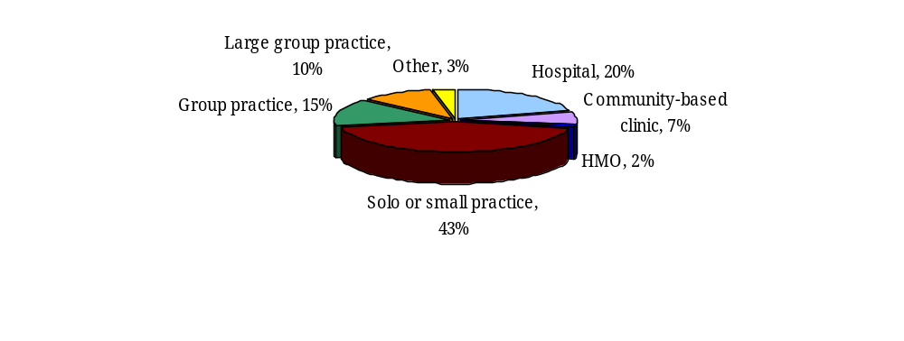A plurality (31 percent) of respondents made a net income in 2006 of less than $150,000. Only 15 percent reported incomes of more than $300,000. (See Figure 22.)

Additionally, a plurality (27 percent) of respondents said that their 2006 income was about the same as their income several years ago. About a quarter (24 percent) made significantly or slightly more in 2006 than in previous years while a third (34 percent) made significantly or somewhat less in 2006 than in previous years. (See Figure 23.)

Figure 22: Reported Incomes of Respondents
Question: What was your net income from all professional and practice-related sources in 2006?
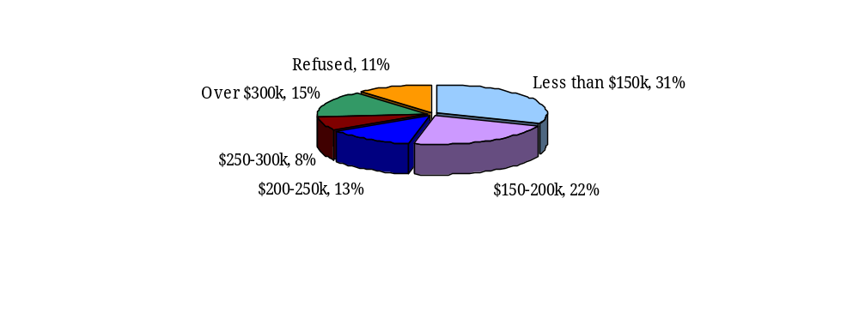

Figure 23: How Physicians’ Incomes Have Changed
Question: How does your 2006 income differ from that of several years ago?
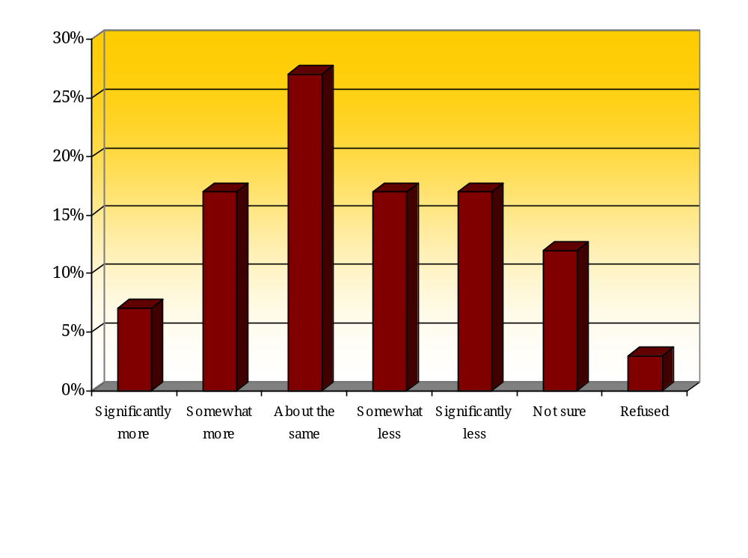

A plurality (33 percent) of respondents indicated they are Republicans and another 18 percent said they lean Republican. On the other hand, 19 percent of respondents reported being Democrats with another 14 percent leaning Democratic. One in ten (11 percent) have no preference for political party affiliation. (See Figure 24.)

Figure 24: Political Affiliations of Respondents
Question: In politics today, do you consider yourself a…
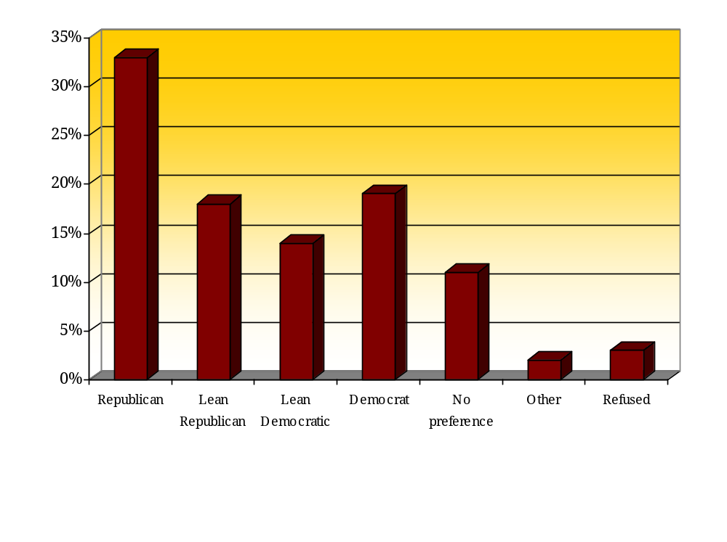

Figure 25: Age of Respondents


Figure 26: Gender of Respondents


Figure 27: Respondents by Arizona County

County | Percent
Maricopa | 60%
Pima | 24%
Yavapai | 4%
Coconino | 3%
Mohave | 2%
Pinal | 2%
Cochise | 1%
Gila | 1%
Graham | 1%
Navajo | 1%
Yuma | 1%
Apache | *
La Paz | *
Santa Cruz | *
Total | 100%

*=Less than .5%

Methodology
The survey mode for the Arizona Physician Survey on Health System Reform was mail and web. The survey was fielded from June 21 to September 1, 2007.

The Arizona Physician Survey on Health System Reform questionnaire was constructed by XXXX staff members. The questionnaire was pretested by a group of physicians. The Institute for Social Science staff reviewed the questionnaire and suggested a few minor revisions. Once XXXX finalized the questionnaire, it was printed for mailing and programmed as a web survey.

A random sample of 3,600 physicians – 2,000 medical doctors and 1,600 doctors of osteopathy – was selected from lists provided by the Arizona Medical Association. The lists included MD’s who are and are not members of that organization. An oversample of DO’s was selected to ensure adequate representation from that group. Data was subsequently weighted to reflect the actual populations of these two types of physicians. After the first mailing, the invalid sample (sample returned by the Postal Service) was replaced. Invalid sample was not replaced after the second and third mailings.

A letter was prepared by XXXX and mailed to all physicians in the sample along with a printed copy of the survey and a self-addressed, postage-paid envelope with which to return it. The letter included a URL address that respondents could use to access the survey online. Two more similar mailings were sent.

The web survey was programmed using WinCati software produced by Sawtooth Technologies.

Physicians who did not respond to the survey and for whom the ISSR had valid phone numbers were phoned in August 2007 and reminded about the survey.

In total, 3,330 valid sample addresses received the survey and 1,054 completed surveys were received. The response rate was 32 percent. Sixty-eight physicians completed the survey online. The margin of error is plus or minus 2.9 percent.

See the section on Methodology for information on how the survey was conducted, the response rate and margin of error.

