Rashida Cooper
Database SPSS 3
March 16,2010
DR. Zahay

1.
Statistics
Gender
N | Valid | 50000
 | Missing | 0

Gender
 |  | Frequency | Percent | Valid Percent | Cumulative Percent
Valid | Female | 33302 | 66.6 | 66.6 | 66.6
 | Male | 16698 | 33.4 | 33.4 | 100.0
 | Total | 50000 | 100.0 | 100.0

The percentage of Book Binders customers that are female are 66.6%.

2.
Statistics
 |  | Customer acct # | State
N | Valid | 50000 | 50000
 | Missing | 0 | 0

State
 |  | Frequency | Percent | Valid Percent | Cumulative Percent
Valid | APO (Military) | 5 | .0 | .0 | .0
 | Connecticut | 2512 | 5.0 | 5.0 | 5.0
 | District of Columbia | 339 | .7 | .7 | 5.7
 | Delaware | 711 | 1.4 | 1.4 | 7.1
 | Massachusetts | 4252 | 8.5 | 8.5 | 15.6
 | Maryland | 4172 | 8.3 | 8.3 | 24.0
 | Maine | 343 | .7 | .7 | 24.7
 | New Hampshire | 665 | 1.3 | 1.3 | 26.0
 | New Jersey | 11068 | 22.1 | 22.1 | 48.1
 | New York | 16530 | 33.1 | 33.1 | 81.2
 | Pennsylvania | 8718 | 17.4 | 17.4 | 98.6
 | Rhode Island | 402 | .8 | .8 | 99.4
 | Virginia | 27 | .1 | .1 | 99.5
 | Virgin Islands | 45 | .1 | .1 | 99.6
 | Vermont | 211 | .4 | .4 | 100.0
 | Total | 50000 | 100.0 | 100.0

According, the three states which account for the largest percentage are New York, (16,530) New Jersey, (11,068) and Pennsylvania (8,718) this indicates that these three states like to read books

3.
Descriptive Statistics
 | N | Minimum | Maximum | Mean | Std. Deviation
Total $ spent | 50000 | 15.00 | 479.00 | 208.3183 | 101.35726
Total # purchases | 50000 | 1.0 | 12.0 | 3.890 | 3.4763
Months since last purchase | 50000 | 1 | 35 | 12.36 | 8.153
Valid N (listwise) | 50000

There is a mean (average) of total spent is 479, Total purchase 3.89, and Month since last purchase is 12.36.
4.

Correlations
 |  | Total $ spent on non-book products | Total $ spent on books
Total $ spent on non-book products | Pearson Correlation | 1 | .157**
 | Sig. (2-tailed) |  | .000
 | N | 50000 | 50000
Total $ spent on books | Pearson Correlation | .157** | 1
 | Sig. (2-tailed) | .000
 | N | 50000 | 50000
**. Correlation is significant at the 0.01 level (2-tailed).

There is a significant difference between total spent and spending on non books at 0.01 levels which indicate a very strong association.

5.
Descriptive Statistics
 | N | Minimum | Maximum | Mean | Std. Deviation
Bought "Art History of Florence?" | 50000 | 0 | 1 | .09 | .287
# purchases, Geography books | 50000 | 0 | 7 | .55 | .841
# purchases, Art books | 50000 | 0 | 6 | .39 | .680
# purchases, Reference books | 50000 | 0 | 5 | .31 | .604
# purchases, Do-it-yourself books | 50000 | 0 | 7 | .46 | .766
# purchases, Cookbooks | 50000 | 0 | 8 | .94 | 1.185
# purchases, Youth books | 50000 | 0 | 6 | .39 | .683
# purchases, Children's books | 50000 | 0 | 8 | .85 | 1.120
Valid N (listwise) | 50000

The most books that were sold were cookbooks, Children’s, do it yourself and geography. This information would be helpful to a Book Store owner to know what are their most and least bought books.

6. 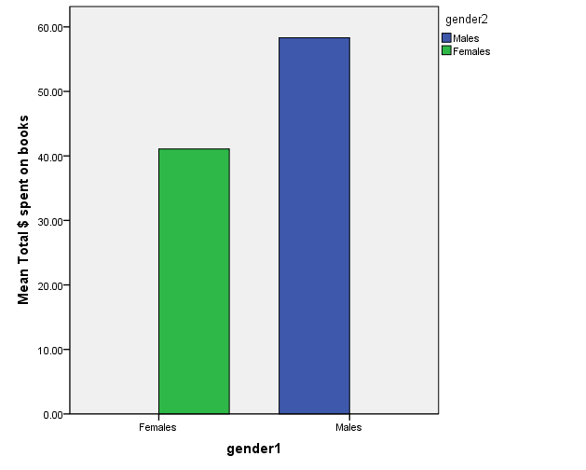

Chart above shows the average total spending for males and females book purchase.
7.
Case Processing Summary
 | Cases
 | Included |  | Excluded |  | Total
 | N | Percent | N | Percent | N | Percent
Bought "Art History of Florence?" * Gender | 50000 | 100.0% | 0 | .0% | 50000 | 100.0%

Case Summaries
Bought "Art History of Florence?"
Gender | N | % of Total N
Female | 33302 | 66.6%
Male | 16698 | 33.4%
Total | 50000 | 100.0%

The total number for males are (16698) 33.4% Females (33302) 66.6%

8.
Case Processing Summary
 | Cases
 | Included |  | Excluded |  | Total
 | N | Percent | N | Percent | N | Percent
Total # purchases * Gender | 50000 | 100.0% | 0 | .0% | 50000 | 100.0%

Case Summaries
Total # purchases
Gender | Mean | % of Total N | N
Female | 3.362 | 66.6% | 33302
Male | 4.943 | 33.4% | 16698
Total | 3.890 | 100.0% | 50000

For females the total number of purchase is 33,302 males 16,698 the mean are Female 3.3 Male 4.9 and 66.6%, 33.4% total number. In this case males purchased more than females so finding a marketing strategy for females would likely increase sales.

9.
Descriptive Statistics
 | N | Minimum | Maximum | Mean | Std. Deviation
Months since first purchase | 50000 | 1 | 99 | 25.67 | 18.379
Months since last purchase | 50000 | 1 | 35 | 12.36 | 8.153
Valid N (listwise) | 50000

The descriptive statistics min of 1 max 99 and mean 25.67 are the customer’s average number of months between first purchase and recent purchase.

10.
Case Processing Summary
 | Cases
 | Valid |  | Missing |  | Total
 | N | Percent | N | Percent | N | Percent
repeat * Bought "Art History of Florence?" | 50000 | 100.0% | 0 | .0% | 50000 | 100.0%

repeat * Bought "Art History of Florence?" Crosstabulation
 |  |  | Bought "Art History of Florence?" |  | Total
 |  |  | No | Yes
repeat |  | Count | 31282 | 3598 | 34880
 |  | % within repeat | 89.7% | 10.3% | 100.0%
 | no | Count | 14196 | 924 | 15120
 |  | % within repeat | 93.9% | 6.1% | 100.0%
Total |  | Count | 45478 | 4522 | 50000
 |  | % within repeat | 91.0% | 9.0% | 100.0%

10.3% of repeat customers bought the Art of History. This indicates that most repeat customers are not interested in the book or need to be more marketing in place for the Art of History.

