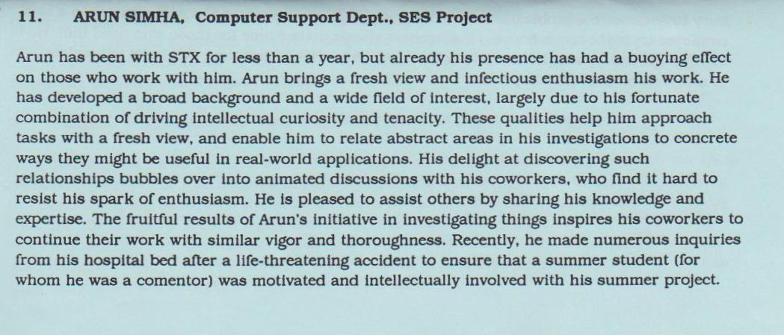
-Hughes STX/NASA, 1990

“Arun is as hard working an executive as one could hope for. He also has a particular knack for distilling complex concepts into a tangible graphic or model.” January 30, 2008
Greg Stayin , Chief Operating Officer, pureIntegration, LLC
managed Arun at pureIntegration

“Arun is a great leader who takes the time to make an investment in his people. He is a dynamic individual who has the ability to transform organizations.” March 13, 2008
Steven Moskowitz , Delivery & Project Manager, pureIntegration
worked indirectly for Arun at pureIntegration

