San Antonio daily gets boost from perforated ads
- Story
- Comments (0)
- Image (3)

Share
Send this page to your friends
Print
Create a hardcopy of this page
Font Size:
Default font size
Larger font size
Ads can be easily removed from pages after they are perforated with the system.
- 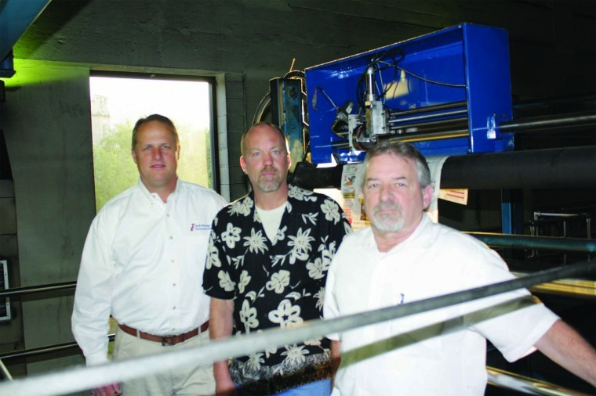
- 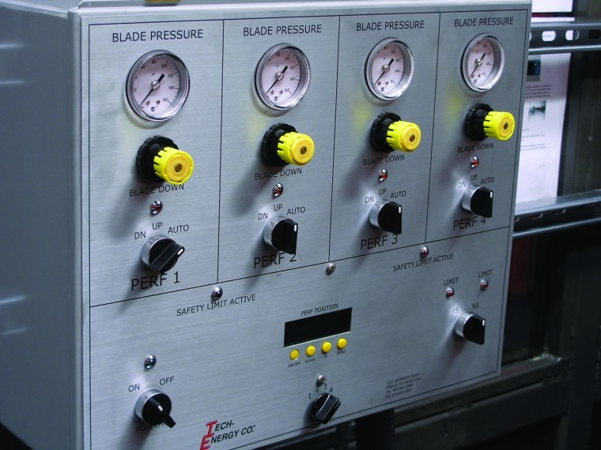
Posted: Tuesday, June 1, 2010 12:00 pm | Updated: 7:24 am, Tue Jun 1, 2010.
By Chuck Moozakis Editor In Chief | 0 comments
The San Antonio Express-News is offering perforated ads and other perforated promotions to area advertisers after installing a specially designed device manufactured by Tech Energy Co.
The Tech Retrofit Inline Perforator gives the Express-News inline perforation capabilities as needed, said John Martin, vice president of production. The system can perforate either single or multiple columns, across any number of pages, he said.
The device takes the place of the pipe roller on the web lead and can be automatically adjusted to either apply a perforation or allow the web to travel unimpeded, said Dave Moeller, Tech Energy's general manager.
"Installation is a piece of cake," he said. "Once it's mounted, it perforates when needed and when it's not perforating then the head is elevated and it runs just like a pipe roller," he said.
The Express-News has 12 perforators installed across its three Goss International Colorliner presses. Its sister newspaper, The Houston Chronicle, is also testing the device, Moeller said.
The spark fueling the development of the perforator came as Martin and Pressroom Manager Ken Coates attempted to find a cost-effective way to perforate a spadea that was running with the newspaper's comics.
"We said, ‘Wouldn't it be great if we could perf it and rip it right out of there,'" Martin said.
Express-News production staffers experimented with a few different designs and then tested the concept with the Laredo (Texas) Morning Times, a sister paper that the Express-News produces.
"They used the idea to run half-page perforated coupons in their daily editions," Martin said, adding that the Express-News followed suit with its own coupons as well as a full-page, tear-out poster featuring the San Antonio Spurs.
But the prototype only allowed limited flexibility. Tear-out ads could only run on certain pages. So, Martin, Coates and other technicians developed another concept that would permit the newspaper to use perforation throughout the paper. Once the initial design was sketched out, Tech Energy stepped in to machine and fabricate the device that ultimately became the Retrofit Inline Perforator.
Any existing press
Moeller said the gadget can be retrofit on any existing single- or doublewide press, and that it sports automation and other control and safety features that permit newspapers to easily determine where perforated ads and promotions will be produced.
The firm is also working with the Express-News to develop a plowfold that would permit the production of perforated gatefolds.
Moeller said Tech Energy plans to begin marketing the perforator to newspapers beginning this month. Prices are still being determined.

