Friday, March 19, 2010

**          **

**FOR IMMEDIATE RELEASE**

**Out There with Melissa DiMarco is a Hit Canadian Music Week International 2010.**

TORONTO, ON— Melissa DiMarco and her *Out There* crew took over the 2010 Canadian Music Week International event. The entertainment show landed exclusive interviews and CMW headliners in the *Out There* VIP Lounge and Interview Suite at the Fairmont Royal York Hotel from March 10-14.

*Out There’s* VIP suite saw Melissa DiMarco collaborate with music legends such as the Eurythmic’s **Dave Stewart** and singer-songwriter **Dan Hill**. Melissa DiMarco also landed the exclusive green room television interview with CMW’s celebrity interview **Slash**. Hall of Fame inductees **Platinum Blonde** did an extensive interview with Melissa following their award ceremony. Afterwards the band members and their whole family joined us for lunch in the *Out There* VIP lounge.

Top CMW guests such as Anvil stopped in for a surprise following Melissa’s sit down with CNN’s **John Roberts** and **Kyra Phillips**. In suite interviews also welcomed CMW headliners such as **Karl Wolf, Stereos, Danny Fernandes, Dean Lickyer** and many more popular music names.

Over 600 music industry movers and shakers came by *Out There’s* VIP lounge where **Indie Love Radio** provided live music and live to air broadcasts. Musicians, industry types and guests were networking in our lounge while enjoying the variety of hot and fresh pizza and pasta items provided by **Pizza Pizza** throughout the event.

Melissa DiMarco was fun and fashionable styling in **Le Château** clothing during every interview and music week event. Interview artists and guests were able to lounge and network on classy and comfortable designs by **Roomy Interiors**. In suite signage was printed by **Guerilla Printing** and refurbished computers were provided by the green-friendly company **Reboot Canada**.

For more music week buzz please visit [www.outtherewithmelissa.com](http://www.outtherewithmelissa.com) and catch *Out There with Melissa DiMarco* nationwide.



**About Out There with Melissa DiMarco**

Out There reaches cross-platform markets across Canada with its star and host Melissa DiMarco *(Degrassi-The Next Generation).* The Award- winning show attracts A-list celebrities with Melissa's warm interview style and original storylines.

**For interview and media requests, please contact:**

Rebecca Taylor                                                             Melanie Carrey

Story Producer                                                              Publicity and Marketing

Out There Productions Inc.                                            Out There Productions Inc.

O. 416-466-7620                                                            O.416-466-7620

C. 416-723-3533                                                            C.416-526-8114

[info@outtheretv.net](mailto:info@outtheretv.net)                                                       [pr@outtheretv.net](mailto:pr@outtheretv.net)

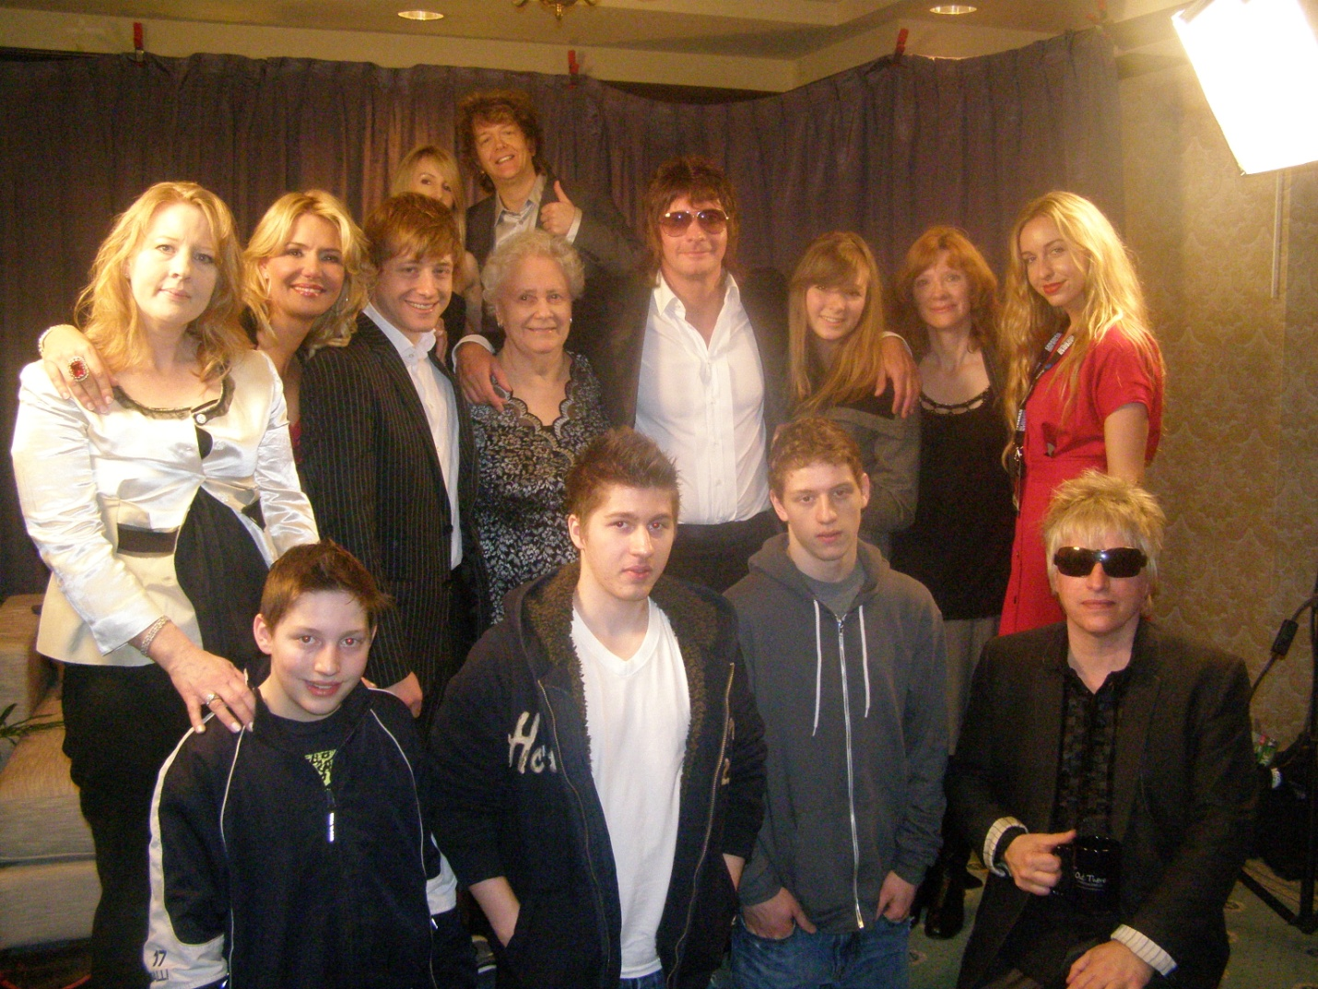

-30