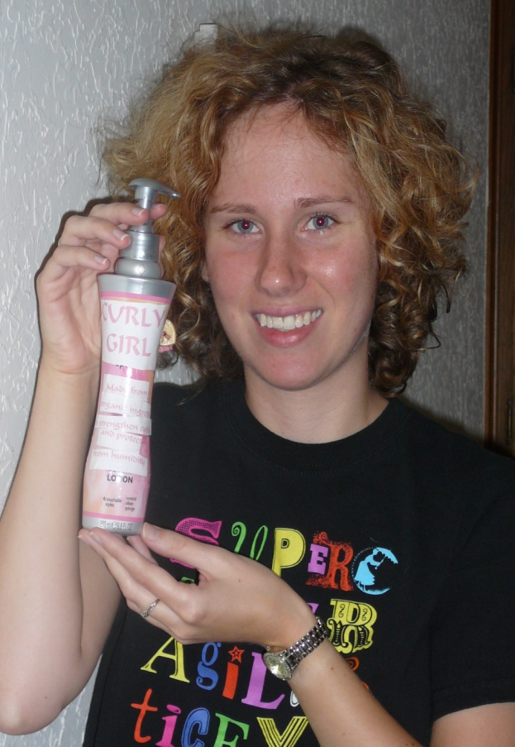
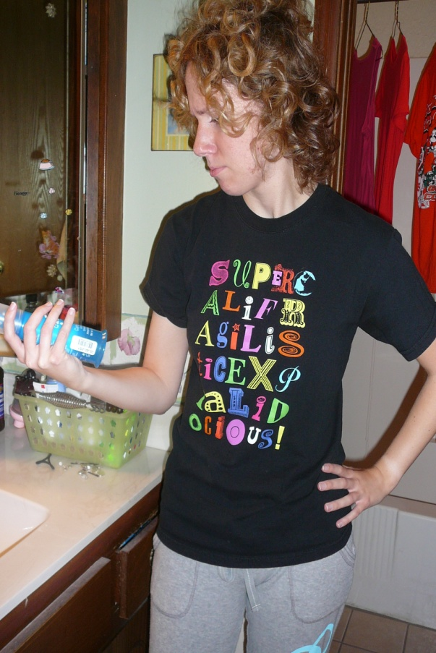
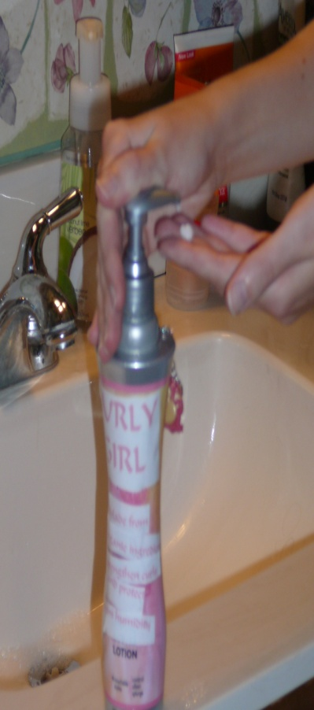
Are you tired of having bad hair days because you have curly hair? Have you tried different hair products without a result? Then it’s time to try Curly Girl, the first hair gel made from all organic ingredients! With Curly Girl, your curls will not only look amazing, but will become stronger and tighter over time. The organic ingredients will prevent big, frizzy hair in humid weather. Curly Girl will give you salon quality hair all at the low cost of $5! Don’t spend another day with bad hair. Start looking fabulous today with Curly Girl!

