It is 10 P.M. on a Friday night, and the front-man of the funk trio Jesus and the Kennedys improvises a solo while another student recites Allen Ginsberg poetry into the microphone. It is an unexpected end to an eventful evening at this month’s open mic night, hosted by the campus radio station WVAU.
One Friday every month, about 60 AU students gather to attend the open mic night. Anyone is allowed to perform at the two hour events, which showcase AU’s top musical, poetic, and comedic talents. Attendance at the monthly event is growing.
There are as many reasons to attend open mics as there are attendees. Sophomore Malina Keutel attended her first open mic last year to support a few of her friends who were performing. Seth Shamon, a junior who is also a DJ 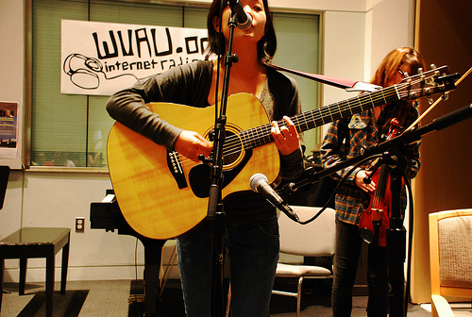 Kyoko Takenaka and Dara Hirsch play at open mic, photo courtesy of Louise Brask

for WVAU, was drawn by the promise of “free performances by peers.” Keutel and Shamon now rarely miss an open mic.
Much of the appeal of WVAU open mics is the opportunity to witness peers’ abilities. “I keep coming back to
open mics because the talent at this school never ceases to amaze me,” said sophomore Danielle King. For Keutel, the camaraderie that comes with belonging to a small community within AU is the main draw. “I absolutely love listening to my friends perform,” Keutel said.
King, Keutel, and Shamon are not only enthusiastic fans, but performers as well. As a freshman, Keutel was “was anxious to find my place within the AU community.” She put past stage fright behind her and pulled together a song that she played on piano while a friend sang. Keutel has since performed many times, and always finds the experience “exhilarating, fun, and a great way to bond with my friends.”
Shamon realized that after attending and appreciating many open mics during his AU career, it was time to “give back to WVAU.” He shared a Ginsberg poem that he had stumbled upon at a bookstore earlier in the day. His performance was such a hit that he was invited back for a collaborative
encore with the aforementioned funk-soul act Jesus and the Kennedys.
“The setting is comfortable and welcoming,” said King, explaining why she chose to sing a duet with a friend. “The intimacy at open mics creates an environment of sharing that can at times be difficult to find on a college campus.”
This sentiment was echoed by King’s peers. “I think WVAU open mics have become a very welcoming space,” said Keutel. “Performers can try out new material or just revel in the joy of making music.”
These feelings are exactly what WVAU General Manager Iliana Berkowitz wishes to create. She hopes that each open mic is a safe space where members of the community can “feel proud of their talents.” Now a senior, Berkowitz led an effort in 2007 to institute a regular open mic through WVAU. Prior to 2007 many groups on campus hosted open mics as one-time events, but it wasn’t until WVAU started having them regularly that open mics became associated with the radio station. “They started out in the Davenport,” Berkowitz said. “Soon, they became so popular that we needed a larger space.” Berkowitz feels that as the most prominent musical organization on campus, WVAU is responsible for ensuring that open mics occur.
The next open mic takes place on Friday, March 23rd from 8-10 in Battelle Atrium.

