- Thai Cuisine: A Curry Theme

- The Kingdom of Thailand
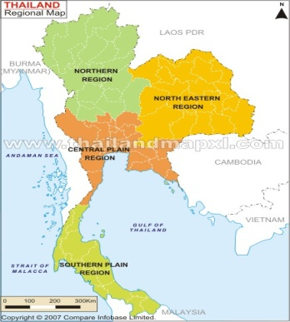
- The Typical Thai Diet
  - Staple Food
  - Spices & Herbs
  - Curry
  - Naturally Sweet Dessert
- Preparation & Presentation
  - Traditional Thai Methods
  - Chinese Influence on Thai Cooking
  - Food Etiquette
- Thai Sample: Red Curry Chicken & Rice
- Thai Cuisine: A Curry Theme

- The Kingdom of Thailand
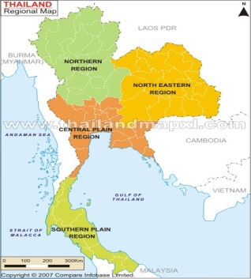
- The Typical Thai Diet
  - Staple Food
  - Spices & Herbs
  - Curry
  - Naturally Sweet Dessert
- Preparation & Presentation
  - Traditional Thai Methods
  - Chinese Influence on Thai Cooking
  - Food Etiquette
- Thai Sample: Red Curry Chicken and Rice

